ThorlabsLTS 150M User Manual

DESY

1. **Introduction:**

Install and run ThorlabsLTS150M device on new computer.

1. **Procedure:**

* **Steps to install kinesis software:**

1. Click on the link shown below:

<https://www.thorlabs.com/software_pages/viewsoftwarepage.cfm?code=Motion_Control>

There are 3 options available

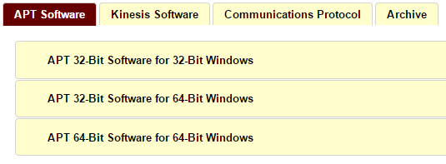

First 2 available for 32 and 64 bit operating system. Third option does not support labview

(32 bit) software.

1. Click on download button.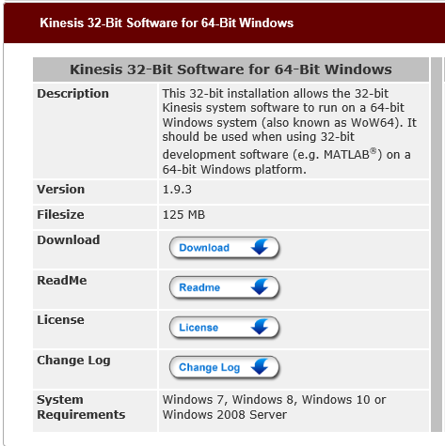

1. Download setup file and install it.

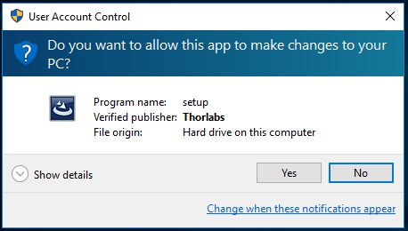

1. Setup will extract files.

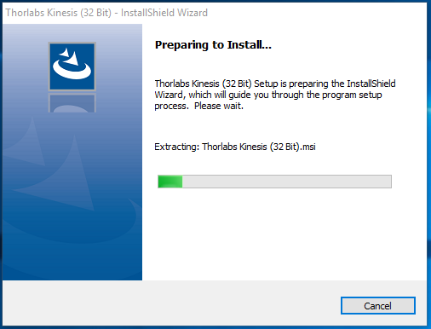

1. Click on Next

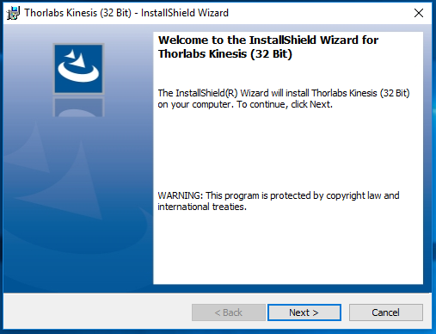

1. Accept license agreement

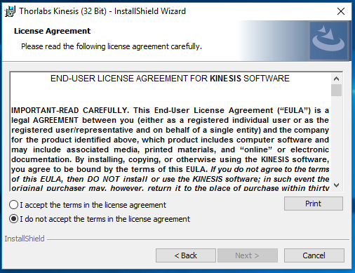

1. Write information

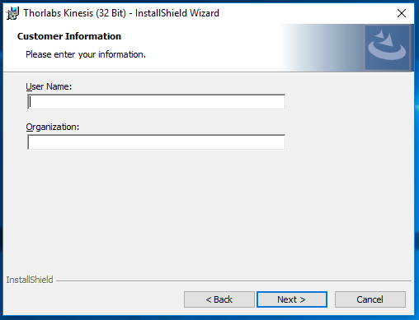

1. Select Complete option

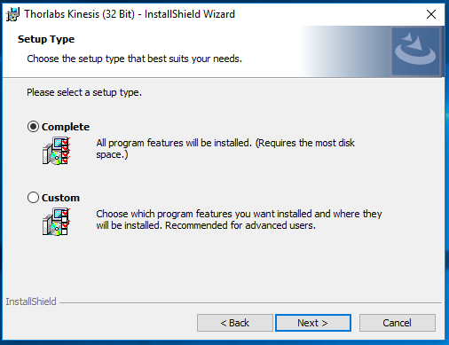

1. Click on install

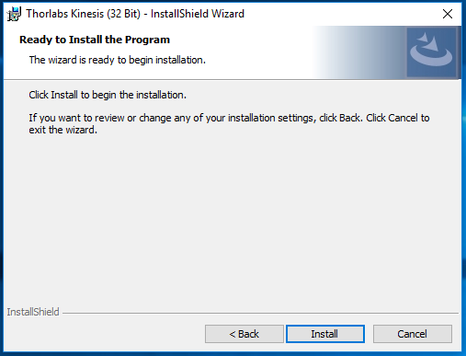

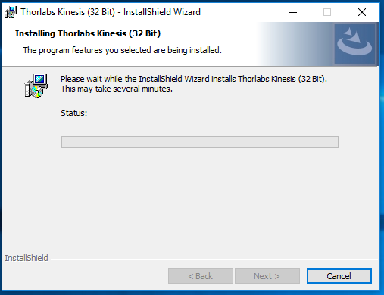

1. Click on Finish

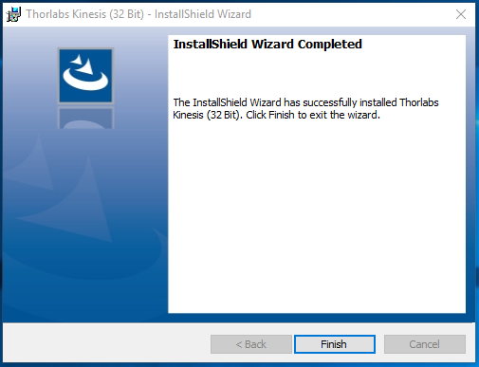

* **Create New Device For ThorlabsMDT Devicetype:**

1. Open Master control system. There is “DB Editor” button available. Click on that.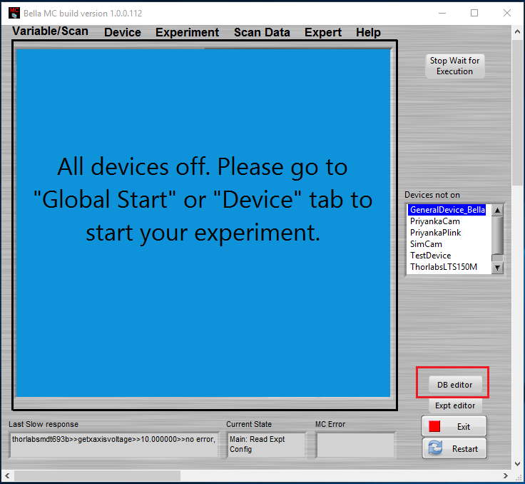

1. Database Editor will open.
2. Then go to Device ops > Device > New Devicetype.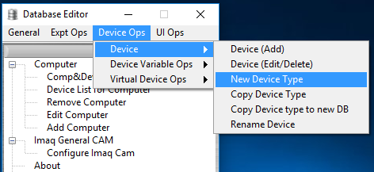
3. Then Enter password window will open. Enter password ”controlsystem”.

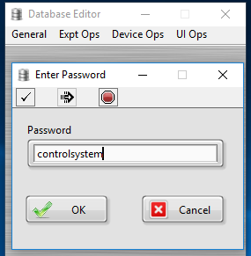

1. Enter Name “ThrolabsLTS” and Relative Path “ThorlabsLTS\ThorlabLTS.lvclass” and click on create/Modify Devicetype.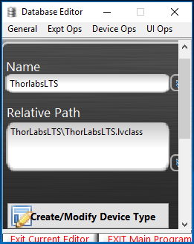
2. Click on Exit Main Program.

* **Create New ThorlabsLTS150M device:**

1. Go to DB Editor.
2. Click on Device Ops > Device > Device (add).

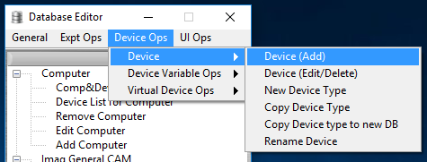

1. Fill all details as shown below.

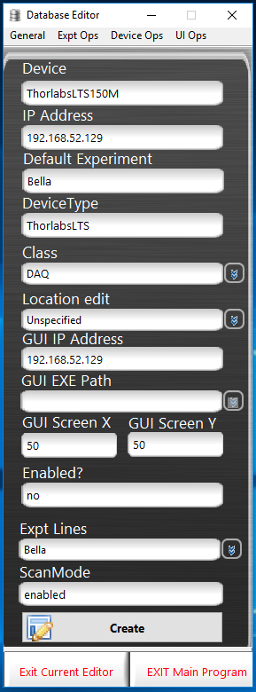

* **Launch New ThorlabsLTS150M device:**

1. Go to devices tab in master control.

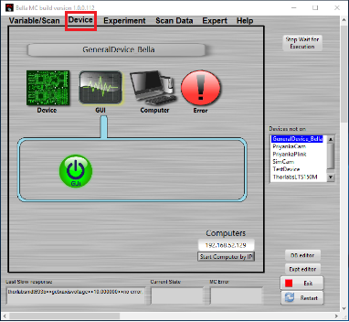

1. Select ThrolabsLTS150M Device from list.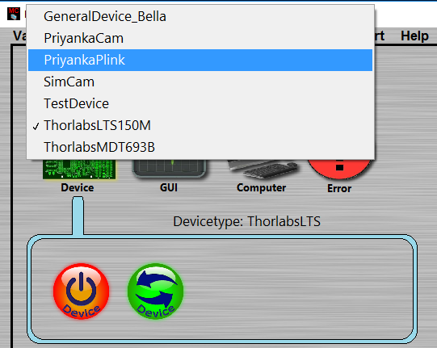

1. Click on red button under Device tab.

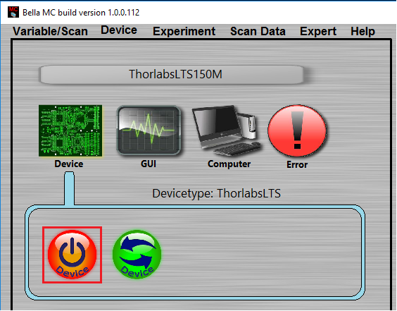

1. Then Device driver window of ThorlabsLTS150M will launch. 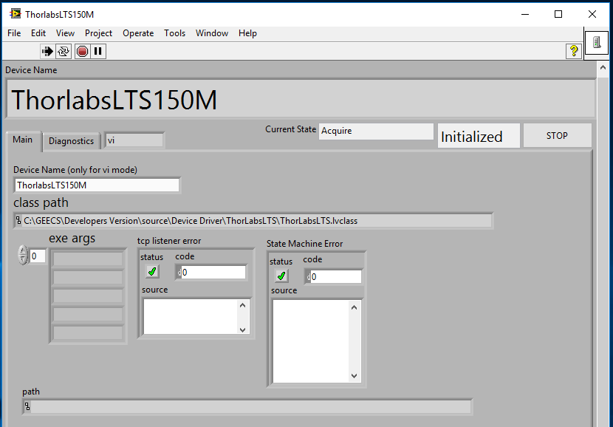
2. When device launched successfully red button on master control will turn into green color.
3. Then click on Stop button under diagnostic tab in device. 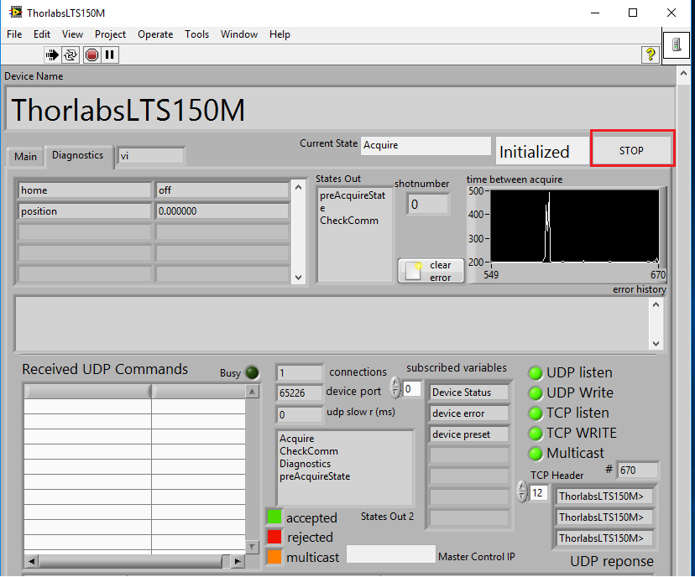
4. Device will close.

* **Modify Devicetype Variable for ThorlabsMDT693B device:**

1. Click on “DB editor” button again.
2. Go to Device Ops > DeviceType variable Ops > Devicetype Variable (Add/Edit/Delete).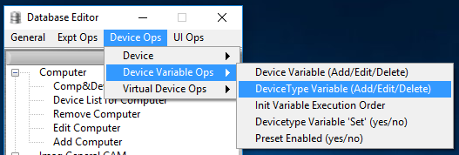
3. New Windows will open. Select “ThrolabsLTS”Devicetype from that list of Devicetype.

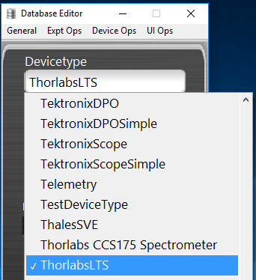

1. Then Click on variable.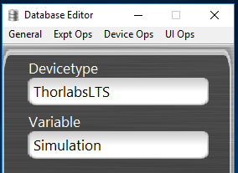
2. Select Simulation Variable from list.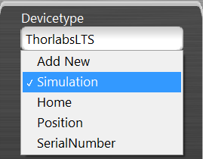

1. Click on Default value choices and select off.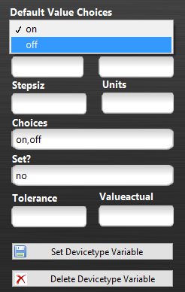
2. Click on Set Devicetype Variable Button.
3. Then Simulation mode for device ThorlabsLTS150M will turn off.
4. Select Serial Number variable and set its default value 83841487.

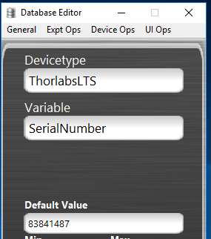

1. Click on Exit Main Editor.
2. Again Launch Device as per steps shown under “**Launch New ThorlabsLTS150M device”.**
3. In Master Control, Select Device ThorlabsLTS150M device in Device selector.

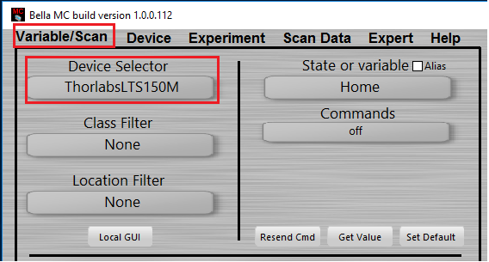

1. User can change devicetype variable and value.

