|  |  |
| --- | --- |
| Name Of The Student | GEETHU ANIL |
| Internship Project Topic | RIO-125: Classification Model- Build a Model that Classifies the Side Effects of a Drug Batch |
| Name of the Organization | TCS ION |
| Name of the Industry Mentor | Himalaya Aashish |
| Name of the Institute | ICT ACADEMY OF KERALA |

|  |  |  |
| --- | --- | --- |
| Date | Day # | Hours Spent |
| 24-3-2021 | 13 | 2 |
| Activities done during the day:  **Check number of drugs per condition,** | | |

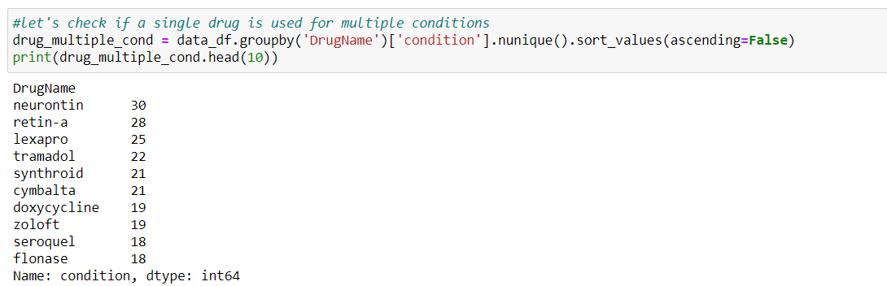

##There are many drugs which can be used for multiple conditions