|  |  |
| --- | --- |
| Name Of The Student | GEETHU ANIL |
| Internship Project Topic | RIO-125: Classification Model- Build a Model that Classifies the Side Effects of a Drug Batch |
| Name of the Organization | TCS ION |
| Name of the Industry Mentor | Himalaya Aashish |
| Name of the Institute | ICT ACADEMY OF KERALA |

|  |  |  |
| --- | --- | --- |
| Date | Day # | Hours Spent |
| 10-5-2021 | 30 | 1 |

After Scaling Again Modelling can be done,

GRADIENT BOOSTING

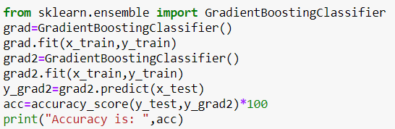

Accuracy = 47.42

Comparing all these classification models KNN has the highest accuracy value i.e,59.9033

*Project Modelling and Project Report has compleated