A modern autonomous robotic system is composed of many software building blocks (SLAM, path planning, scene interpretation), most of them depending on some form of localization and mapping. Therefore, there is a need for an API that allows these different elements to communicate, with as little interdependency as possible.
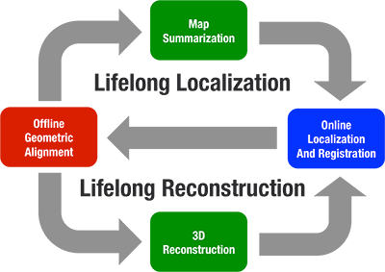

- Online localization and registration: Real-time ego-motion estimation (SLAM) from the robot's sensors is combined with updates from a previously known map (Localization). This allows the robot to continuously estimate it's pose in a global frame of reference and thus execute it's tasks.
- Offline geometric alignment: The data captured online by the agents needs to be aligned and registered to previously known reference data such as models of buildings or maps created by other agents. This is most commonly done by using loop-closure algorithms. The combined data is then jointly optimized to achieve the best (maximum likelihood) estimate for all involved quantities (3d-structure, trajectories etc.)
- Map summarization: In order to generate a compact representation of the environment we need to remove redundant information from the maps and focus on the most informative parts. The resulting model should contain only the part of the data which is most informative for localization (step 1).
- 3d-reconstruction: In order for the robot to be able to avoid obstacles and navigate the environment it is important to build a richer representation of the environment than what is given by the SLAM algorithm from step 1.

The maplab framework consists of two major parts:an online frontend ROVIOLI and the offline maplab console.

ROVIOLI frontend (RObust Visual Inertial Odometry with Localization Integration)
consists of an estimator, which is an adaptation of an existing estimation pipeline, ROVIO, and additional maplab modules for binary feature extraction and tracking, map building and localization.
- online frontend for mapping and localization,
- extends ROVIO with 6DoF localization constraints,
- standalone operation for single-sessions,
- multi-session map support using the console (see below).

Offline maplab console
It permits to refine the map, merge multiple maps together and use them e.g. for the dense reconstruction. The features include, among others, the following:
- a convenient console user interface and a map manager to access the maps,
- a plug-in architecture to easily extend it with new commands and algorithms,
- visual-inertial least-squares optimization that can be extended with additional sensors,
- robust pose-graph relaxation using switchable constraints,
- BRISK/FREAK-based loopclosure,
- map summarization for lifelong mapping,
- dense reconstruction and an interface to Voxblox.
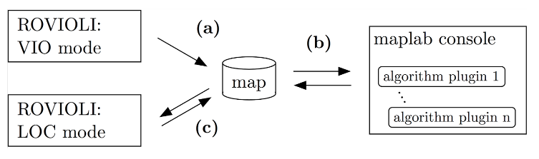
- (a) Build maps using ROVIOLI in the VIO mode.
- (b) Refine the maps using the maplab console. Merge multiple maps together. Perform experiments and apply your algorithms of choice.
- (c) optional: Use the resulting map to localize using ROVIOLI in the Localization Mode. The localization increases the accuracy of the visual-inertial pose estimation.

