Sample Stratified OSM Validation Method for Active Travel Transformations
• Study Scope: Validate OpenStreetMap (OSM) data for active travel infrastructure (bike lanes, pedestrian streets) across seven European cities for two periods:
◦ Cities: Barcelona, Milan, Warsaw, Ljubljana, Utrecht, Malmö, Paris.
◦ Periods: 2015–2019 and 2019–2023.
• Sampling Design:
◦ Census Tracts: 60 per city (420 total), stratified by central/peripheral and high-density/low-density.
◦ Validation Points: 80 per census tract (33,600 images in total).
▪ 40 points for bike lanes (20 per period).
▪ 40 points for pedestrian streets (20 per period).
• Image Collection:
◦ Source: Google Street View (GSV) API.
◦ Orientation: Images facing the street (optimized for visibility of the section).
◦ Selection:
▪ For each period (2015–2019 and 2019–2023), 10 points per census tract are randomly selected from locations with OSM changes detected (to check for false positives).
▪ For each period (2015–2019 and 2019–2023), 10 points per census tract are randomly selected across the entire network (except in locations with OSM data) to check for false negatives.
▪ This is done separately for bike lanes and pedestrian streets, making a total of 40 points per type and per period in each census tract.
• Validation (MTurk):
◦ Users classify each image by answering "Yes" or "No" to:
▪ Bike Lane
▪ Pedestrian Area
◦ Consistency: Each image is reviewed by three users.
◦ Reliability Check: If all three agree, the classification is accepted. If not, a fourth reviewer is assigned.
• Metrics Calculated:
◦ Accuracy: Proportion of correctly mapped OSM features (true positives).
◦ Completeness: Proportion of real-world features present in OSM.
◦ SCI (Spatial Completeness Index): Variation in completeness across tracts.
• Total Estimated Images:
◦ Cities: 7
◦ Census Tracts: 7 x 60 = 420
◦ Validation Points: 420 x 80 = 33,600 images

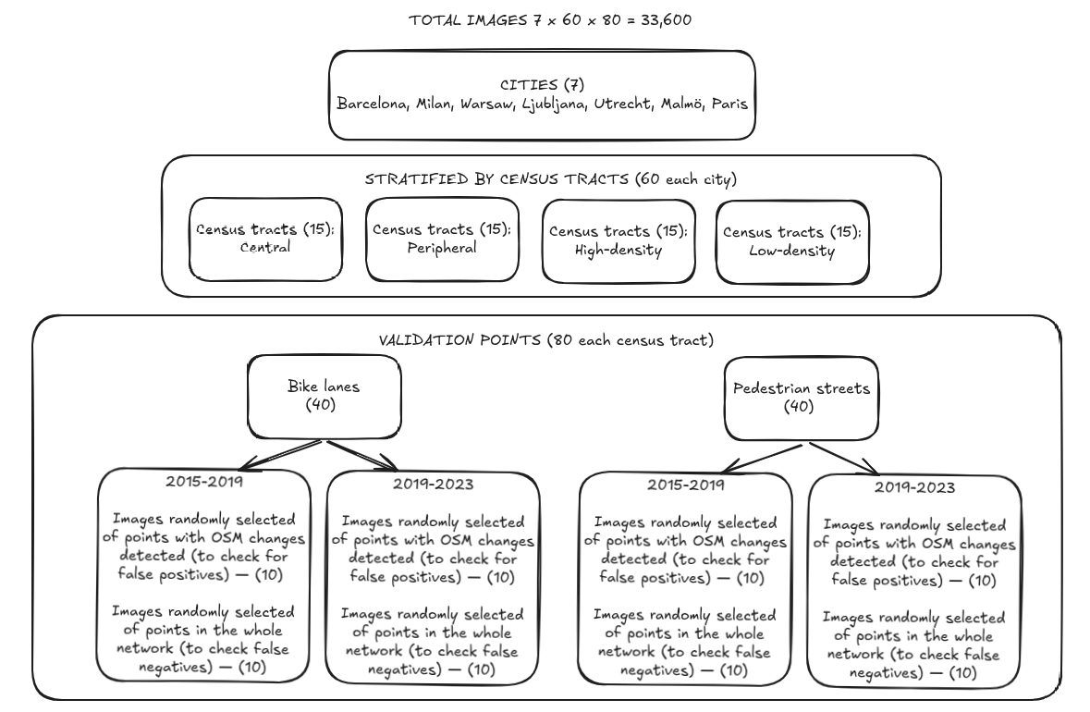
Figure 1: Process Flow Diagram

