Validating OpenStreetMap for detecting cycling-infrastructure change: A Barcelona pilot using Google Street View (2015–2023)
Eugeni Vidal-Tortosa
Oriol Marquet

1 Introduction
In recent years, many cities worldwide have expanded their cycling networks in pursuit of cleaner, healthier and more equitable mobility (Szell et al. 2022; Buehler and Pucher 2021). Reliable data on how these networks evolve are essential to guide fair and evidence-based planning and to enable robust longitudinal research on their impacts. Yet longitudinal information is often missing: official inventories are rarely maintained consistently, while local field audits, though accurate, are costly and difficult to reproduce at scale. As a result, even in cities with substantial cycling expansion, consistent and longitudinally comparable data on infrastructure change are often limited and fragmented.
The growing availability of Volunteered Geographic Information (VGI) (Goodchild 2007) offers new opportunities to address these data gaps. Among such sources, OpenStreetMap (OSM) stands out for providing open, editable and time-stamped spatial data on a wide range of urban features. In principle, OSM could enable the reconstruction of past infrastructure networks and support empirical studies of built-environment transformations.
However, the use of OSM for longitudinal analysis faces several challenges. Previous research has shown that not all edits correspond to physical change (false positives), some genuine changes may remain unmapped (false negatives), and even valid updates are not always recorded at the time they occur (Barron, Neis, and Zipf 2014; Ferster et al. 2020; Vierø, Vybornova, and Szell 2025). These uncertainties raise questions about whether OSM’s temporal record can be trusted to detect infrastructure additions and removals.
This study addresses these questions by evaluating the reliability of OSM for detecting cycling-infrastructure change in Barcelona between 2015 and 2023, using Google Street View (GSV) imagery as ground truth. It assesses OSM’s ability to identify added and removed cycle lanes and introduces a simple calibration framework to adjust OSM-based estimates to real-world conditions. The work forms part of the ATRAPA project (The Active Travel Backlash Paradox), which studies how people perceive and respond to built-environment sustainable-travel interventions across European cities (GEMOTT Research Group 2025).

2 Data and methods
The analysis followed a five-step reproducible workflow (@ fig-workflow) with two main components: temporal differencing of dated OSM extracts to detect additions and removals of cycling infrastructure, and stratified GSV validation to check a sample of these detected changes. All stages were implemented in R using open-source packages, including osmextract to retrieve dated OSM snapshots.
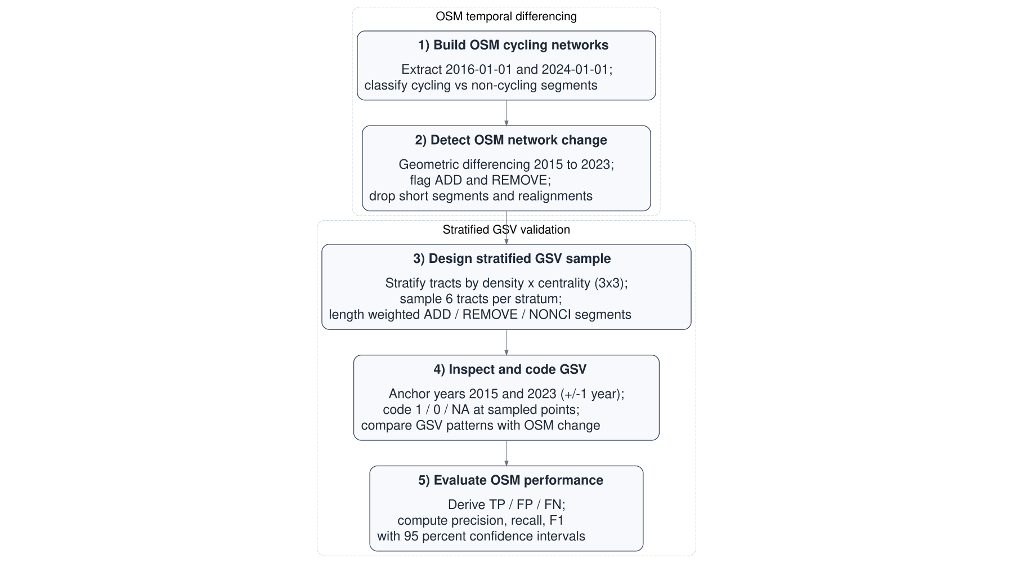
Figure 1: Main workflow steps (2015–2023).

2.0.0.1 OSM temporal differencing
Baseline and follow-up cycling networks were built from OSM extracts dated 1 January 2016 and 1 January 2024 (approximating 2015 and 2023). Road segments tagged as cycleways or otherwise designated for bicycle use were classified as cycling infrastructure; all other urban segments were treated as non-cycling.
After cleaning and projection, the two cycling network layers were compared geometrically to identify added segments (present in 2023 only) and removed segments (present in 2015 only). Small positional realignments, where added and removed segments lay very close together, were excluded so that minor mapping adjustments were not misclassified as physical change.

2.0.0.2 Stratified GSV validation
To validate these OSM-detected changes, we used a stratified sample of Barcelona’s 1,063 census tracts. Tracts were cross-classified by population density and centrality into nine strata, from which six tracts per stratum were randomly selected (54 in total). Within each tract, up to two added, two removed, and one non-cycling segment were sampled, with selection weighted by length. The midpoint of each sampled segment served as the validation point and was linked to the nearest available GSV panorama.
Each validation point was then assessed by two trained coders using GSV panoramas for 2015 (baseline) and 2023 (follow-up). When imagery for the target year was unavailable or obscured, the closest available years were used (2024 and 2022 for follow-up; 2014 and 2016 for baseline). Coders assigned 1 if cycling infrastructure was visible, 0 if absent, and NA if indeterminate. Agreement was high: in 91 of 95 usable cases (95.8 %) both coders assigned the same code; disagreements were resolved by consensus. Based on these observations, OSM-detected additions were classed as True Positives (TP) when GSV showed a 0 to 1 pattern and as False Positives (FP) otherwise; removals were treated analogously using 1 to 0 patterns, and non-cycling segments were used to identify False Negatives (FN). Examples of TP additions and removals are shown in Figure 2.
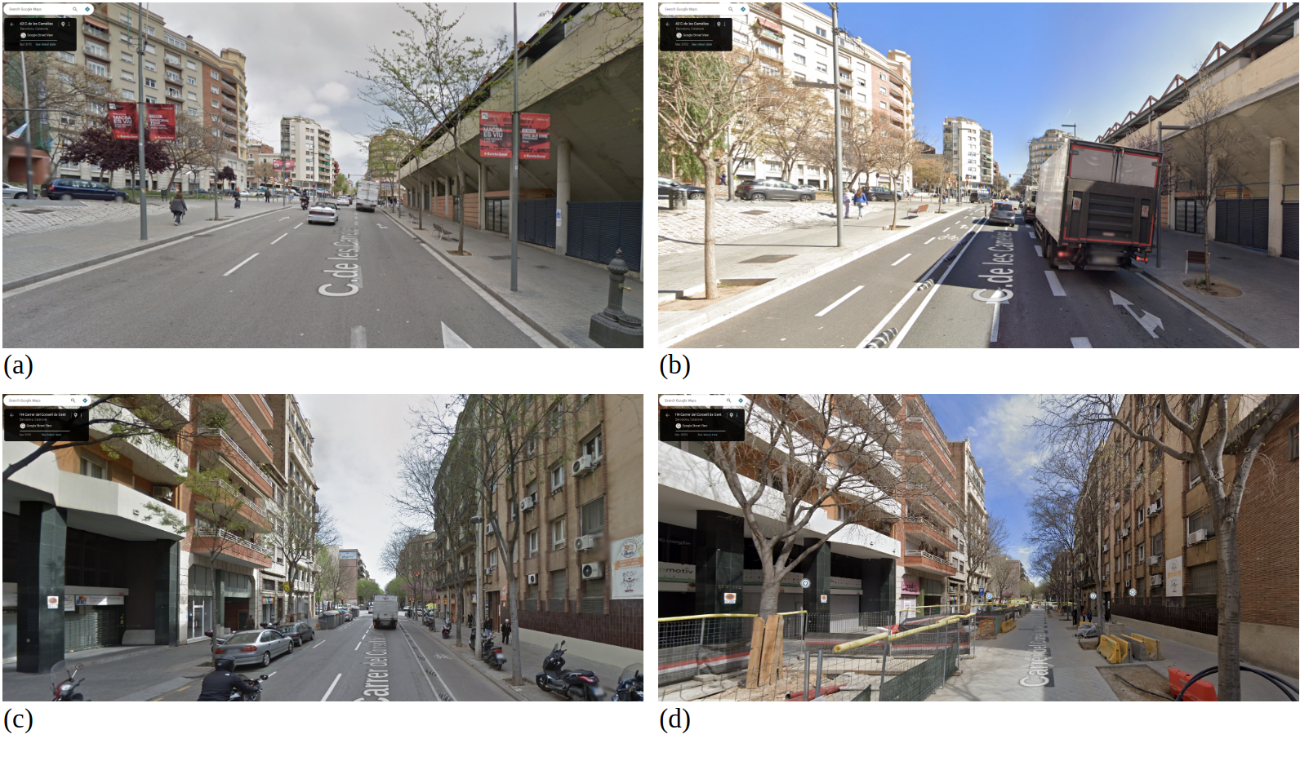
Figure 2: Examples of True Positive changes observed during GSV validation: (a) 2015 baseline with no cycling infrastructure; (b) 2023 follow-up showing a new segregated track (0→1); (c) 2015 baseline with a cycle track; (d) 2023 follow-up showing its removal during a street redesign (1→0).
Validation accuracy was then assessed using standard metrics. Precision (TP/(TP+FP)) captures the share of OSM-detected changes that were real. Recall (TP/(TP+FN)) captures the share of real changes correctly detected by OSM. The F1 score is the harmonic mean of precision and recall. Ninety-five per cent Wilson confidence intervals (CI) were computed for each measure.

3 Results

3.0.1 Network change detected by OSM
- OSM cycling network grew 153.6 → 288.4 km (+88%)
- Segment differencing results: 156.0 km added, 24.8 km removed
file:////tmp/RtmpPnpUhE/file7f37e2622eea9/widget7f37e8491181.html screenshot completed
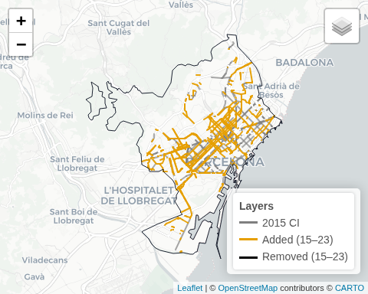
Figure 3: Distribution of validation points (with GSV links).
Table 1: Consistency between yearly totals and differencing estimates (2015–2023, Barcelona)
Metric | Value
Total 2015 (km) | 153.6
Total 2023 (km) | 288.4
Net growth (km) | 134.8
Added (km) | 156.0
Removed (km) | 24.8
Added − Removed (km) | 131.2
Gap: (Added−Removed) − Net | -3.6
- Additions were concentrated in dense–central tracts (D1_C2, D1_C3, D3_C2), which together accounted for ≈58% of total added length.
- Removals were concentrated in intermediate-density tracts (D2_C1, D2_C3, D1_C2), representing ≈62% of total removed length.
Table 2: OSM-estimated additions and removals (2015–2023) by density × centrality stratum
stratum | Added_km | Removed_km | Added_pct | Removed_pct
D1_C1 | 0.7 | 0.1 | 8.9% | 9.2%
D1_C2 | 1.8 | 0.1 | 22.5% | 18.6%
D1_C3 | 1.4 | 0.1 | 18.5% | 9.0%
D2_C1 | 0.4 | 0.1 | 4.9% | 18.6%
D2_C2 | 0.8 | 0.0 | 10.2% | 0.0%
D2_C3 | 0.6 | 0.1 | 8.0% | 24.5%
D3_C1 | 0.2 | 0.0 | 2.5% | 0.0%
D3_C2 | 1.3 | 0.0 | 16.5% | 0.0%
D3_C3 | 0.6 | 0.1 | 8.0% | 20.2%

3.0.2 Validation results
- 105 sampled points across 9 strata (48 ADD · 8 REMOVE · 49 NONCI)
- 93 usable validation points (both periods coded)
(42 ADD · 7 REMOVE · 44 NONCI)
Table 3: Validation points by class and stratum (usable points only)
stratum | ADD | REMOVE | NONCI | Total
All | 0 | 0 | 0 | 0
TOTAL | 0 | 0 | 0 | 0

Table 4: Validation performance (usable points only)
Class | n (usable) | TP | FP | FN | Precision (95% CI) | Recall (95% CI) | F1
ADD | 0 | 0 | 0 | 0 | NA [NA-NA] | NA [NA-NA] | NA
REMOVE | 0 | 0 | 0 | 0 | NA [NA-NA] | NA [NA-NA] | NA
Pooled | 0 | 0 | 0 | 0 | NA [NA-NA] | NA [NA-NA] | NA

4 Interpretation and calibration

4.0.1 Interpretation
- OSM captures nearly all true additions (recall = 1.00) but includes several false positives (precision ≈ 0.81).
For removals, OSM rarely identifies true cases (precision ≈ 0.29) and often flags false ones, although recall remains high for the few real removals present.
- Most errors stem from re-tagging, micro-geometry adjustments, or short-term mapping churn, which can appear as artificial additions or removals between snapshots.
- Overall, OSM is a reliable proxy for additions but a weak proxy for removals, slightly overstating net cycling-network growth.

4.0.2 Calibration potential
- These metrics can be used to calibrate OSM-derived estimates of network change.
For example, with precision = 0.81, multiplying OSM-detected additions by 0.81 yields a closer estimate of true additions.
- Stratified validation can further support spatial calibration and cross-city comparability in multi-city analyses.

5 References

6 Supplements

6.0.1 S1. Google Street View coding protocol (PDF)
Download here

6.0.2 S2. Raw validation workbooks: coder 1 and coder 2 (XLSX)
Download coder 1
Download coder 2

6.0.3 S3. Final adjudicated validation results (XLSX)
Download joined results
Barron, Christopher, Pascal Neis, and Alexander Zipf. 2014. “A Comprehensive Framework for Intrinsic OpenStreetMap Quality Analysis.” Transactions in GIS 18 (6): 877–95. https://doi.org/10.1111/tgis.12073.
Buehler, Ralph, and John Pucher, eds. 2021. Cycling for Sustainable Cities. Urban and Industrial Environments. Cambridge: MIT Press.
Ferster, Colin, Jaimy Fischer, Kevin Manaugh, Trisalyn Nelson, and Meghan Winters. 2020. “Using OpenStreetMap to Inventory Bicycle Infrastructure: A Comparison with Open Data from Cities.” International Journal of Sustainable Transportation 14 (1): 64–73. https://doi.org/10.1080/15568318.2018.1519746.
GEMOTT Research Group. 2025. “ATRAPA – The Active Travel Backlash Paradox.” https://webs.uab.cat/atrapa/.
Goodchild, Michael F. 2007. “Citizens as Sensors: The World of Volunteered Geography.” GeoJournal 69 (4): 211–21. https://doi.org/10.1007/s10708-007-9111-y.
Szell, Michael, Sayat Mimar, Tyler Perlman, Gourab Ghoshal, and Roberta Sinatra. 2022. “Growing Urban Bicycle Networks.” Scientific Reports 12 (1): 6765. https://doi.org/10.1038/s41598-022-10783-y.
Vierø, Ane Rahbek, Anastassia Vybornova, and Michael Szell. 2025. “How Good Is Open Bicycle Network Data? A Countrywide Case Study of Denmark.” Geographical Analysis 57 (1): 52–87. https://doi.org/10.1111/gean.12400.

