Validating OpenStreetMap for detecting cycling-infrastructure change: A Barcelona pilot using Google Street View (2015–2023)

Eugeni Vidal-Tortosa
Monika Maciejewska¹
Oriol Marquet^{1,}

1 Introduction and motivation
In recent years, many cities worldwide have expanded their cycling networks in pursuit of cleaner, healthier and more equitable mobility (Buehler and Pucher, 2021; Szell et al., 2022). Reliable data on how these networks evolve are essential to guide fair and evidence-based planning and to enable robust longitudinal research on their impacts. Yet longitudinal information is often missing: official inventories are rarely maintained consistently, while local field audits, though accurate, are costly and difficult to reproduce at scale. As a result, even in cities with substantial cycling expansion, consistent and longitudinally comparable data on infrastructure change are often limited and fragmented.
The growing availability of Volunteered Geographic Information (VGI) (Goodchild, 2007) offers new opportunities to address these data gaps. Among such sources, OpenStreetMap (OSM) stands out for providing open, editable and time-stamped spatial data on a wide range of urban features. In principle, OSM could enable the reconstruction of past infrastructure networks and support empirical studies of built-environment transformations.
However, the use of OSM for longitudinal analysis faces several challenges. Previous research has shown that not all edits correspond to physical change (false positives), some genuine changes may remain unmapped (false negatives), and even valid updates are not always recorded at the time they occur (Barron et al., 2014; Ferster et al., 2020; Vierø et al., 2025). These uncertainties raise questions about whether OSM’s temporal record can be trusted to detect infrastructure additions and removals.
This study addresses these questions by evaluating the reliability of OSM for detecting cycling-infrastructure change in Barcelona between 2015 and 2023, using Google Street View (GSV) imagery as ground truth. It assesses OSM’s ability to identify added and removed cycle lanes and introduces a simple calibration framework to adjust OSM-based estimates to real-world conditions. The work forms part of the ATRAPA project on Active Travel Transformations and Acceptability, which develops comparative analyses of sustainable-mobility interventions across European cities (GEMOTT Research Group, 2025).

2 Data and methods
The analysis followed a five-step reproducible workflow (Figure 1), combining OSM temporal differencing with stratified GSV validation. All stages were implemented in R using open-source packages from the sf, osmextract, and tidyverse ecosystems.
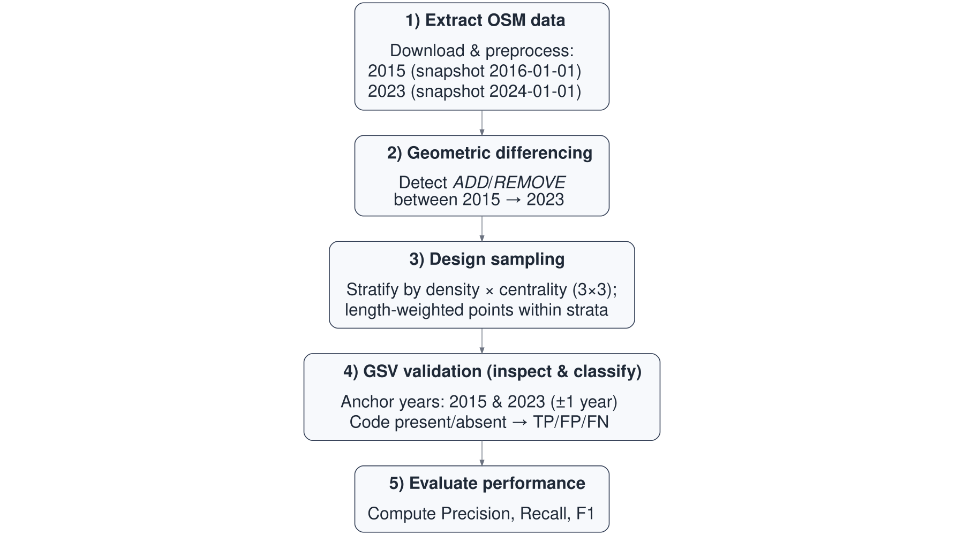
Figure 1: Workflow for detecting and validating OSM-based cycling-infrastructure change, 2015–2023
Two OSM snapshots dated 1 January 2016 and 1 January 2024, approximating 2015 and 2023, were used to construct baseline and follow-up cycling-infrastructure networks. Streets tagged as cycleways or otherwise designated for bicycle use were classified as cycling infrastructure, while all other urban roads were treated as non-cycling infrastructure.
After data cleaning and projection, the two cycling network layers were compared geometrically to identify change between 2015 and 2023. Segments present in 2023 but not in 2015 were considered additions, and those present in 2015 but absent in 2023 as removals. Minor positional or tagging inconsistencies can create artificial differences, so small realignments were identified and excluded.
To ensure spatial representativeness, Barcelona’s 1,063 census tracts were cross-classified by population density and centrality into nine strata. Six tracts were randomly selected within each stratum, yielding 54 tracts in total. Within each tract, up to two added, two removed, and one non-cycling segment were sampled. The midpoint of each segment served as a validation point and was linked to the nearest available GSV panorama.
Each sampled segment was then validated using GSV imagery for 2015 (baseline) and 2023 (follow-up). Two trained coders independently inspected each point. When imagery for the target year was unavailable or obscured, neighbouring years were consulted in a fixed order (2023 → 2024 → 2022 for follow-up; 2015 → 2014 → 2016 for baseline) until a clear view was obtained. Codes were: 1 if cycling infrastructure was visible, 0 if clearly absent, and NA if indeterminate. Agreement was high: in 91 of 95 usable cases (95.8 %), both coders assigned the same code. All disagreements were resolved by consensus. After inspection, ADD cases were True Positives when GSV showed a 0→1 pattern and False Positives otherwise (NA if either year was uncodeable). REMOVE cases were True Positives when GSV showed 1→0 and False Positives otherwise (NA likewise). NONCI cases were used to identify False Negatives, that is, real changes not captured by OSM.
Figure 2. Examples of True Positive changes detected during GSV validation (a) 2015 baseline with no cycling infrastructure. (b) 2023 follow-up showing a new segregated lane (True Positive addition, 0→1). (c) 2015 baseline with a painted cycle lane. (d) 2023 follow-up showing its removal during street redesign (True Positive removal, 1→0).
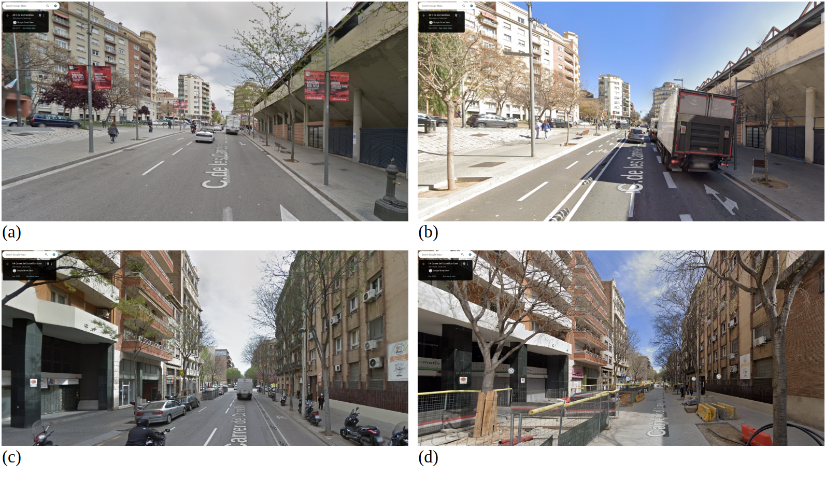

Validation accuracy was then assessed using standard metrics. Precision (TP/TP+FP)) captures the share of OSM-detected changes that were real. Recall (TP/TP+FN)) captures the share of real changes correctly detected by OSM. The F1 score is the harmonic mean of precision and recall. Ninety-five per cent Wilson confidence intervals (CI) were computed for each measure.

3 Results and discussion
Between 2015 and 2023, the OSM-derived cycling network in Barcelona increased from 153.6 to 288.4 km, representing an 88 % expansion (Figure 3). Geometric differencing indicated 156.0 km of added and 24.8 km of removed infrastructure, corresponding to a net gain of about 131 km. The small gap between this estimate and the change in totals (–3.7 km) suggests good internal consistency. Additions were concentrated in dense and central tracts – particularly high-density areas close to the city core – which together accounted for roughly 58 % of the new network length. Removals were much less common and tended to occur in intermediate-density areas.
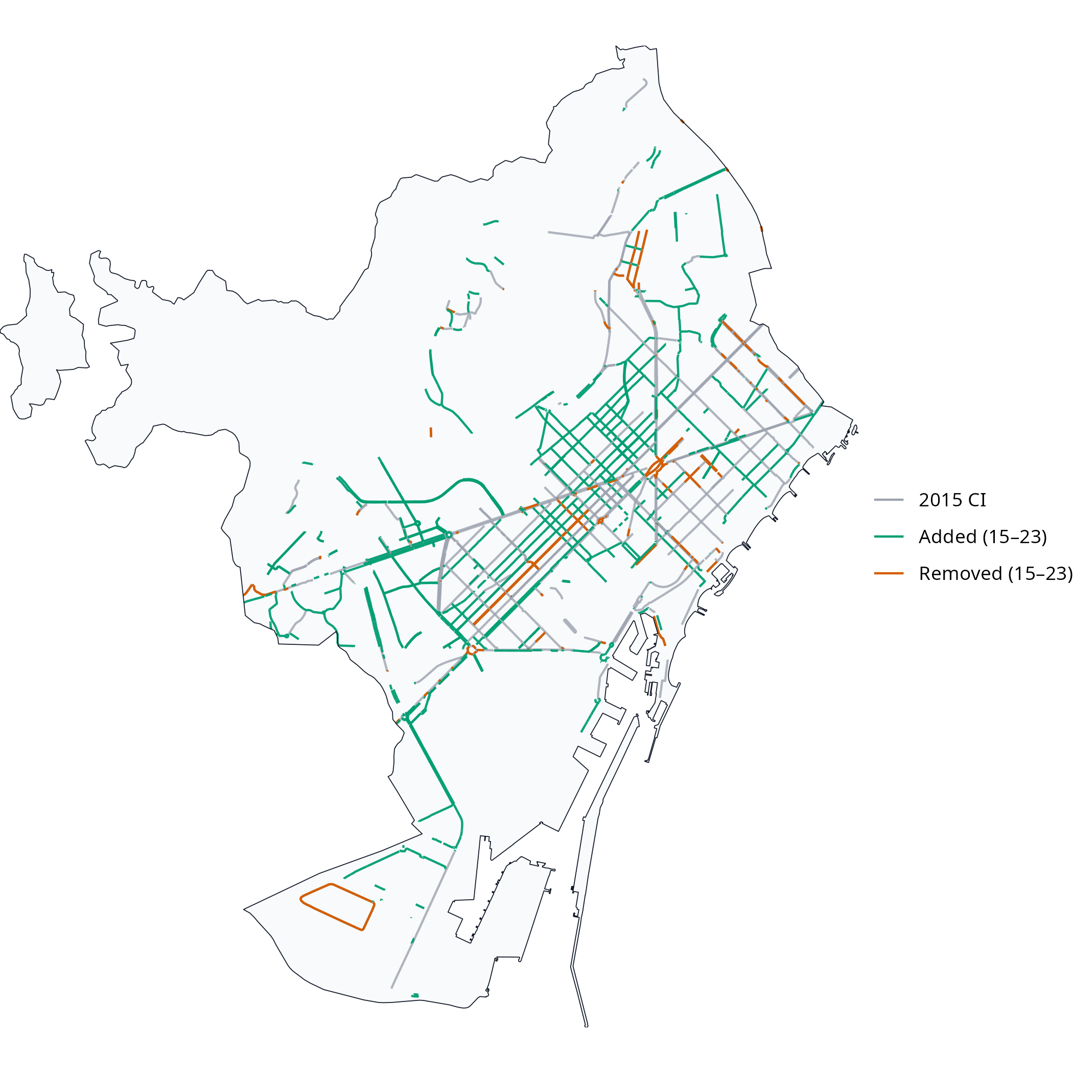
Figure 3: OSM-detected cycling-infrastructure changes in Barcelona, 2015–2023
Out of 105 sampled sites, 95 (90 %) provided usable GSV imagery, including 44 OSM-detected additions, 7 removals, and 44 non-cycling controls. Table 1 summarises the validation outcomes.
Table 1: Validation metrics for OSM-inferred cycling-infrastructure changes (2015–2023). “ADD” = segments present in 2023 but not in 2015; “REMOVE” = segments present in 2015 but not in 2023; “Pooled” = both change types combined"
Class | n (usable) | TP | FP | FN | Precision (95% CI) | Recall (95% CI) | F1
ADD | 44 | 34 | 10 | 0 | 0.77 [0.63-0.87] | 1.00 [0.90-1.00] | 0.87
REMOVE | 7 | 2 | 5 | 0 | 0.29 [0.08-0.64] | 1.00 [0.34-1.00] | 0.44
Pooled | 51 | 36 | 15 | 0 | 0.71 [0.57-0.81] | 1.00 [0.90-1.00] | 0.83

Results show that OSM captures all observed additions (recall = 1.00, 95 % CI [0.90–1.00]) but also includes some false positives (precision $≈$ 0.77). For removals, recall was likewise 1.00 but with a wide confidence interval due to the small sample size, while precision drops sharply to around 0.29, meaning that most apparent deletions do not correspond to true infrastructure loss. Overall precision across all changes is 0.71 with an F1 of 0.83.
Together, these results suggest that OSM is a strong proxy for additions but a weaker one for removals. Although all real changes were captured, OSM tended to flag more additions and removals than were visible in GSV. Because the volume of apparent additions greatly exceeded that of removals, this imbalance likely produces a slight overestimation of net network growth when using raw OSM differencing.
A simple calibration using the observed precision values (0.77 for additions, 0.29 for removals) can adjust OSM-based estimates of change, reducing bias in net growth calculations. As validation was stratified by density and centrality, calibration factors can be adapted to specific urban contexts.
Methodologically, the study demonstrates a transparent, open-source framework for assessing the temporal reliability of OSM data on cycling infrastructure. The workflow – combining historical differencing, stratified sampling, and visual inspection – is reproducible in any city with sufficient Street View coverage. It underpins the ATRAPA Built Environment Transformations Dataset, which will extend this validation approach to other European cities including Milan, Ljubljana, Warsaw, Utrecht, Malmö, and Paris.
Theoretically, this work supports the view of OSM as a dynamic socio-technical system rather than a static dataset. Temporal variation in OSM reflects both genuine infrastructure evolution and the rhythms of community mapping activity. By distinguishing true from apparent edits, the approach contributes to a broader framework for assessing the temporal validity of VGI – an essential step for longitudinal research in transport, health, and environmental studies.
Several limitations should be acknowledged. True removals were few, producing wide confidence intervals for that category. GSV imagery dates vary within each anchor year, occasionally creating minor temporal mismatches. Although inter-rater agreement was high, subtle interpretive differences – for example, in deciding whether a feature should count as cycling infrastructure or not – remain possible. Finally, Barcelona’s large and active mapping community likely ensures relatively high data quality; replication in less-mapped cities will be required to test generalisability.

4 Conclusions and implications
This Barcelona pilot demonstrates that OSM can reliably detect additions to cycling infrastructure but struggles to capture removals. Overall, OSM slightly overstates network growth. Despite these limitations, OSM remains a valuable, low-cost resource for longitudinal analysis of cycling infrastructure when accompanied by empirical calibration.
The study introduces a transparent validation framework that combines OSM historical data, stratified sampling, and GSV-based inspection to generate quantitative precision and recall metrics. These can be used to correct OSM-derived measures of change and to support comparisons within the ATRAPA framework. More broadly, the findings strengthen confidence in using VGI for temporal urban analysis while highlighting the need to understand the social and temporal dynamics behind its production.

Acknowledgements
This research forms part of the ATRAPA project, which has received funding from the European Union (ERC, Horizon Europe, grant agreement No. 101117700) and from the Spanish Ministry of Science, Innovation and Universities (Ministerio de Ciencia, Innovación y Universidades, grant PID2022-136314OB-I00).
The authors gratefully acknowledge Víctor González Parra for his collaboration as second coder during the Google Street View validation, and thank the OpenStreetMap community for their invaluable contributions to open and reproducible research.

References
Barron, C., Neis, P., Zipf, A., 2014. A Comprehensive Framework for Intrinsic OpenStreetMap Quality Analysis. Transactions in GIS 18, 877–895. https://doi.org/10.1111/tgis.12073
Buehler, R., Pucher, J. (Eds.), 2021. Cycling for sustainable cities, Urban and Industrial Environments. MIT Press, Cambridge.
Ferster, C., Fischer, J., Manaugh, K., Nelson, T., Winters, M., 2020. Using OpenStreetMap to inventory bicycle infrastructure: A comparison with open data from cities. International Journal of Sustainable Transportation 14, 64–73. https://doi.org/10.1080/15568318.2018.1519746
GEMOTT Research Group, 2025. ATRAPA – The Active Travel Backlash Paradox.
Goodchild, M.F., 2007. Citizens as sensors: The world of volunteered geography. GeoJournal 69, 211–221. https://doi.org/10.1007/s10708-007-9111-y
Szell, M., Mimar, S., Perlman, T., Ghoshal, G., Sinatra, R., 2022. Growing urban bicycle networks. Scientific Reports 12, 6765. https://doi.org/10.1038/s41598-022-10783-y
Vierø, A.R., Vybornova, A., Szell, M., 2025. How Good Is Open Bicycle Network Data? A Countrywide Case Study of Denmark. Geographical Analysis 57, 52–87. https://doi.org/10.1111/gean.12400

Department of Geography, Universitat Autònoma de Barcelona (UAB), Bellaterra Campus, Building B, Carrer de la Fortuna, s/n, 08193, Bellaterra, Barcelona, Spain
Institute of Environmental Science and Technology (ICTA-UAB), Building ICTA-ICP, Carrer de les Columnes s/n, UAB Campus, 08193, Cerdanyola del Vallès, Barcelona, Spain

