understanding how YOLO works

**PyTorch**

* Creating the layers of the network architecture (Darknet)

**Configuration File**

* + There are 5 types of layers that are used in YOLO
  + Shortcut layer is a skip connection
  + Output of shortcut layer is obtained by adding feature maps from the last convolutional layer to previous convolutional layer in backwards

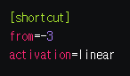

* + ‘stride = 2’ -> upsamples the feature map using bilinear upsampling

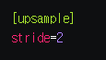

* + Route layer can have one or two attributes

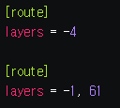

‘layers = -4’ has one value -> it outputs feature map from 4th layer in backwards from the Route layer

‘layers = -1, 61’ has two values -> it outputs feature maps from previous layer which is 60st layer, and the 61st layer

* + YOLO layer corresponds to the detection layer

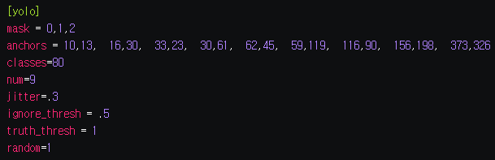

There are 9 anchors but only first, second, and third anchors are used because of the value of mask is 0,1,2 ->each cell of the detection layer predicts 3 boxes

->detection layers at 3 scales, making up for 9 anchors

* + In the **darknet.py**, store every block as a dictionary and returns blocks from configuration file

Implementing the forward pass of the network: Convolutional and Upsample Layers, Route Layer

Confidence Thresholding and Non-maximum Suppression (Image processing)

Designing the input and the output pipelines

**Github**

Pull upload documents from my branch to master branch