1. User Login

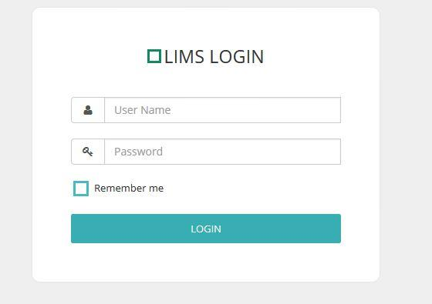

Users can login to the system by entering the correct username and password.

1. Admin

Admin Level users will be redirected to the admin interface.

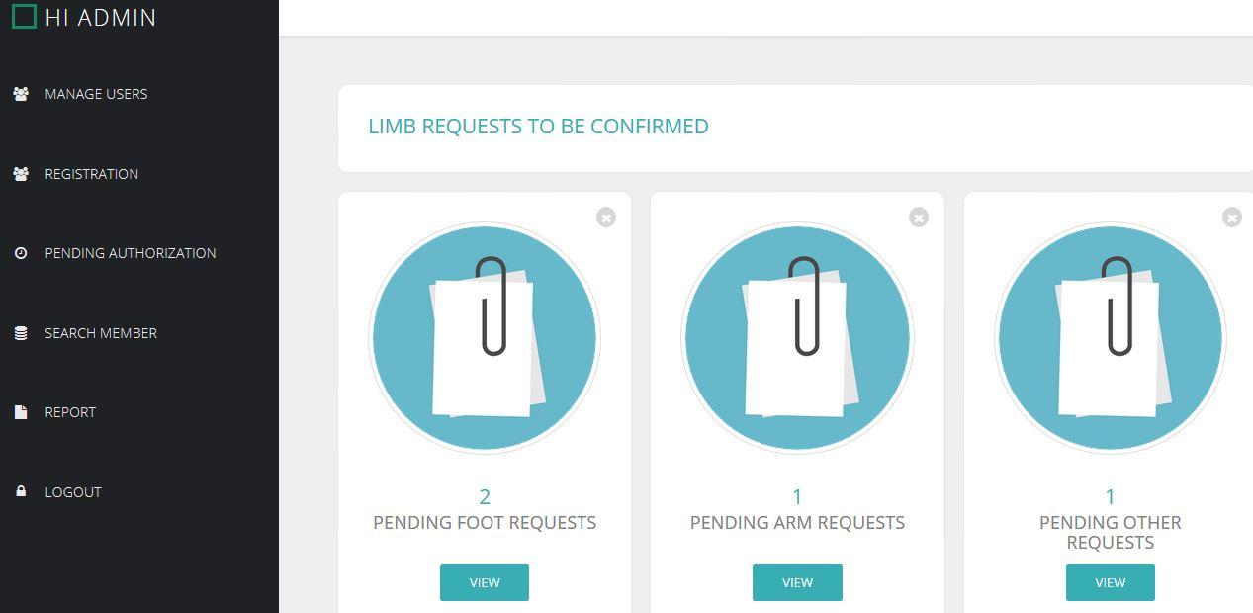

3. Manage Users

In this module, Admin can add, edit or delete users.

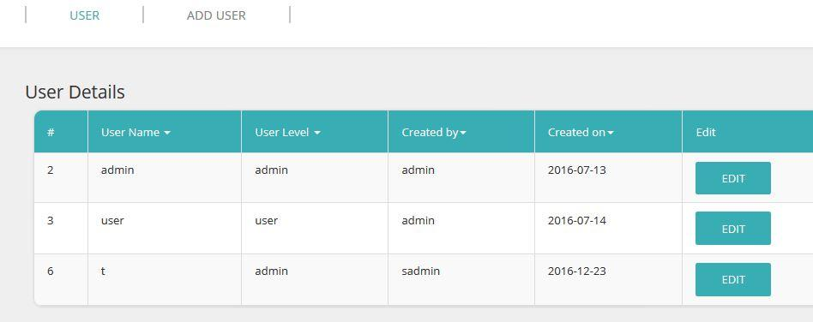

4. Registration

Patient Registration can be done in both Admin level and User levels. Registration form has to be completed with mandatory fields and Old registration form can be used to register a patient with the registration number.

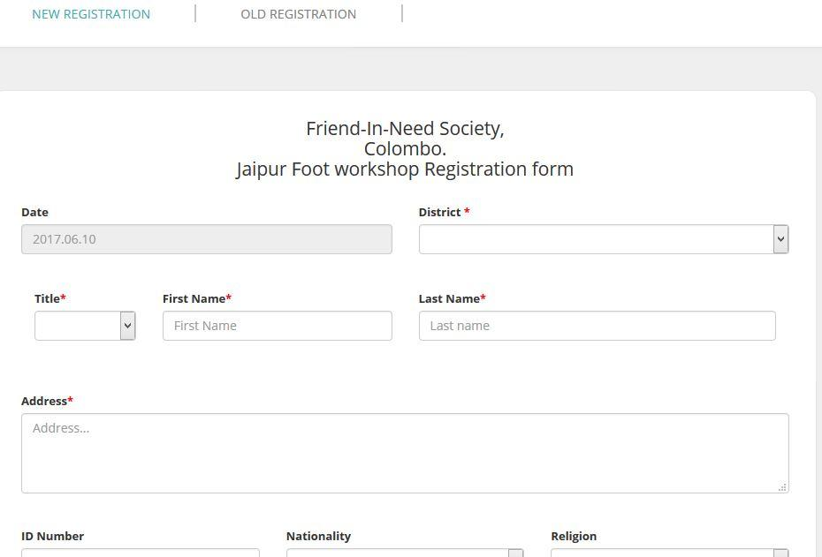

5. Search

Users can search a member by Registration number, NIC number, District, Patient name and cause of amputation.

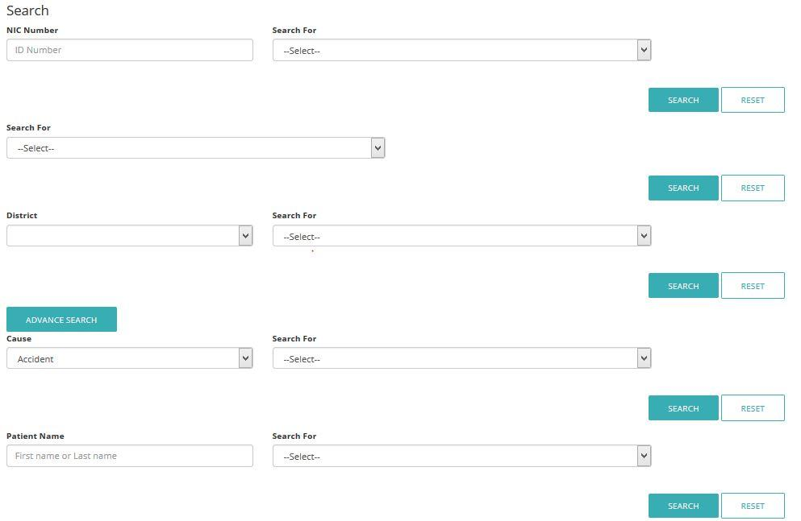

6. Apply new Limb

After selecting the patient, user can apply a new limb . Or repair limb, and edit Limb details.

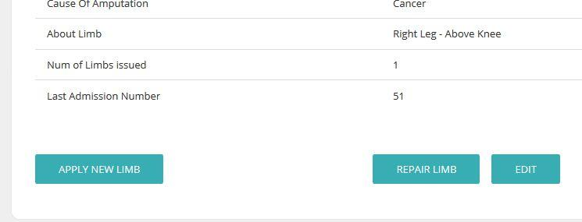

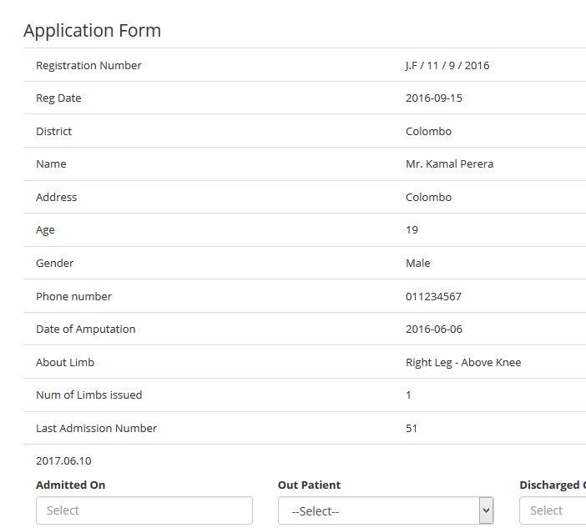

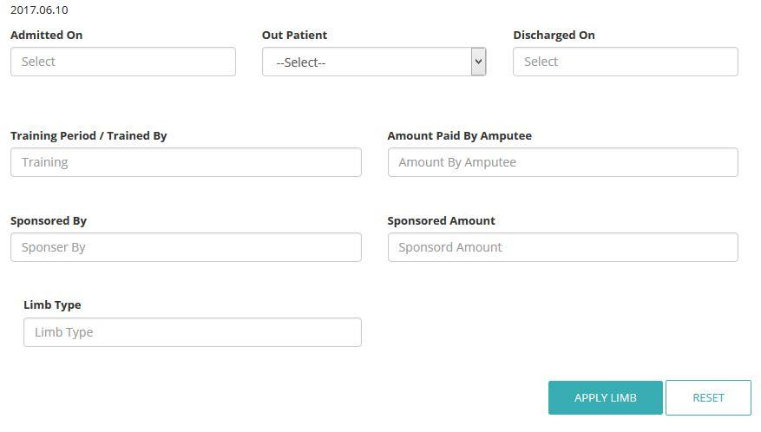

7. Confirmation

After the the Limb is created by the technician, the admin has to check on it and, Confirm that it matches to the patient.

Until it is confirmed, it will display in the pending list as shown in 01 module. Admin can select the pending Limb and confirm it as a Discharge.

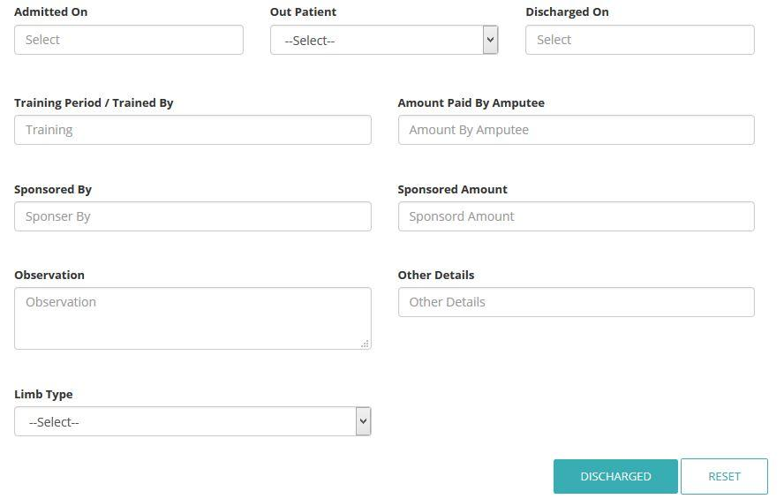

08. Report / Record

Here user can get the report of issued Lims and record tab will display the last registered Users.