

GENIVI MapViewer API

Release 3.0.1
Status: Approved

22 May 2014

Accepted for release by:
This document has been accepted for the GENIVI Gemini Release by the Expert Group Location Based Services (EG-LBS).
Abstract:
This document describes the API of the MapViewer Abstract Component.
Keywords:
NavigationAPIs, MapViewer.

SPDX-License-Identifier: CC-BY-SA-4.0

Copyright (C) 2012, BMW Car IT GmbH, Continental Automotive GmbH, PCA Peugeot Citroën, XS Embedded GmbH

This work is licensed under a Creative Commons Attribution-ShareAlike 4.0 International License

To view a copy of this license, visit http://creativecommons.org/licenses/by-sa/4.0/
or send a letter to Creative Commons, 444 Castro Street, Suite 900, Mountain View, California, 94041, USA.
Table of contents

1 Change History 4
2 Introduction 5
3 Terminology 6
4 Requirements 7
5 Architecture 8
5.1 Interfaces 8
5.2 Interaction with other Components 9
6 API 10
6.1 D-Bus 10
6.2 Git Repository 10
6.3 Naming Convention 10
6.4 Data Types Convention 11
6.5 Errors 12
6.6 Sequence Diagrams 13
6.6.1 navigation application browses map 13
6.6.2 navigation application creates map session 14
6.6.3 navigation application sets center 15
6.6.4 navigation application sets map zoom by delta 16
6.6.5 navigation application shows route 17
6.7 Interfaces 18

Change History

Version | Date | Author | Change
0.1 | 27 Feb 2012 | Marco Residori (XS Embedded) | Document Created
0.2 | 19 Mar 2012 | Marco Residori (XS Embedded) | Updated sequence diagrams.  Updated Interfaces chapter.
0.3 | 21 Mar 2012 | Marco Residori (XS Embedded) | Updated Interfaces chapter.
1.0 | 22 Mar 2012 | Marco Residori (XS Embedded) | System Architecture Team (SAT) approval.
2.0 (beta) | 07 Jun 2013 | Marco Residori (XS Embedded) | Updated API description.  API Version 2.0.
2.0 | 17 Jun 2013 | Marco Residori (XS Embedded) | Updated API description.  API fixes: GT-2651.  API Version 2.0 (gemini-final tag)
3.0.0 | 21 Jan 2014 | Marco Residori (XS Embedded) | Updated API description.  API Version 3.0.0.
3.0.1 | 22 May 2014 | Marco Residori (XS Embedded) | Updated copyright notes.

Introduction
This document describes the MapViewer API.

Terminology

Term | Description
TargetPoint | Point the camera looks at. If the map viewer is set to follow the car position, it coincides with the vehicle position.

Requirements
- Ease of Development

- Extensibility

- Multi-client Behavior

- Simplicity

Architecture

Interfaces

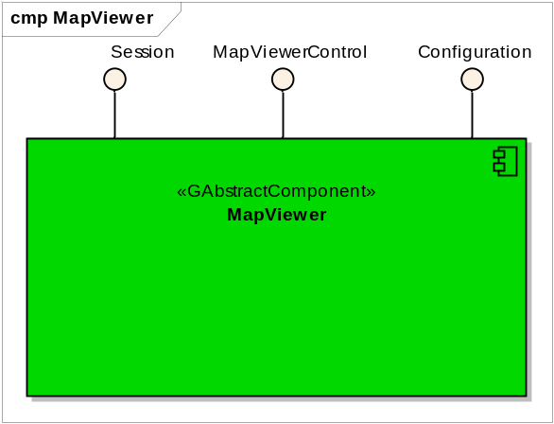

Interaction with other Components

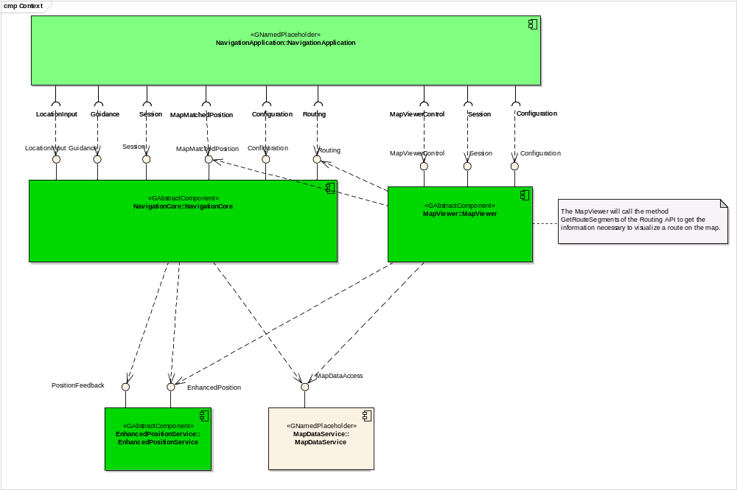

API

D-Bus
The MapViewer interfaces are D-Bus interfaces. They are defined using the D-Bus introspection data format, which is nothing but an IDL expressed in XML format.

For more information about the D-Bus data types please refer to the following website:
http://dbus.freedesktop.org/doc/dbus-specification.html#message-protocol-signatures

For more information about the D-Bus introspection data format, please refer to the following website:
http://dbus.freedesktop.org/doc/dbus-specification.html#introspection-format

Git Repository
The MapViewer interfaces can be found in the GENIVI Git repository at:
https://git.genivi.org/git/gitweb.cgi?p=navigation;a=tree;f=MapViewer/api

Naming Convention

Element | Description | Example
Interface File | genivi.<component name in lowercase character>.<interface name in lowercase characters> | genivi.navigationcore.mapviewercontrol.xml
Methods/Signal/Properties | Camel case naming convention.  First letter uppercase | CreateMapViewInstance
Arguments | Camel case naming convention.  First letter lowercase | scaleID

Data Types Convention
D-bus types code are used. Please refer to the following webpage for more information:
http://dbus.freedesktop.org/doc/dbus-specification.html

Element | D-Bus Data Type Code | Example
Enumerators | q (uint16)
Handles | y (uint8)
Maps | a{qv} | Dictionary of tuples (key, value)  The key is expressed as an enumerator

Errors

Error Type | Description | Example | Error Documentation | Note
User Error | Error caused by user actions | The user tries to start route guidance, although guidance is already running | Application specific error string documented in the XML file | Can occur in final product
Hardware Error | Error related to hardware/database related problems | No map data | Application specific error string documented in the XML file | Can occur in final product
Protocol Error | Error caused by wrong sequence of commands | Wrong sequence of commands to enter destination | Standard D-Bus error string | Should not occur in final product
Bus Error | D-Bus communication error | Bus busy | Standard D-Bus error string | Can occur in final product
Programming Error | Programming Error | Invalid parameters | Standard D-Bus error string and debug messages | Should not occur in production code

Only application-specific errors are documented directly in the interfaces (XML files). For all other errors, standard D-Bus strings are used. These kinds of strings are not documented in the interfaces. It is implicitly assumed that every method may return a standard D-Bus error string.

Sequence Diagrams

navigation application browses map

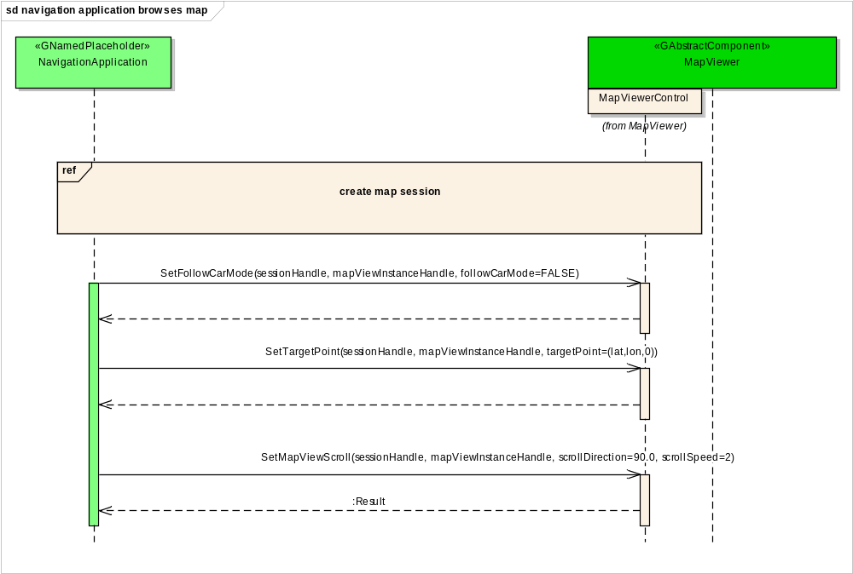

navigation application creates map session

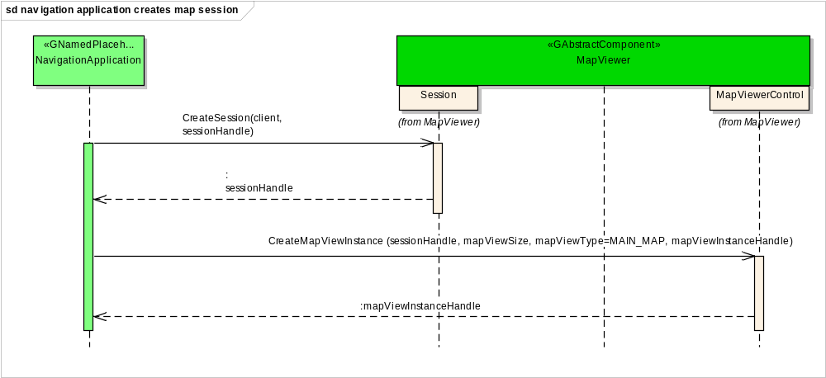

navigation application sets center

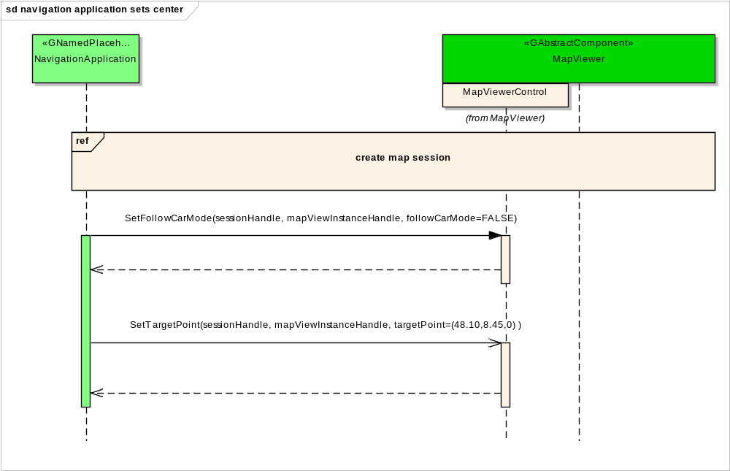

navigation application sets map zoom by delta

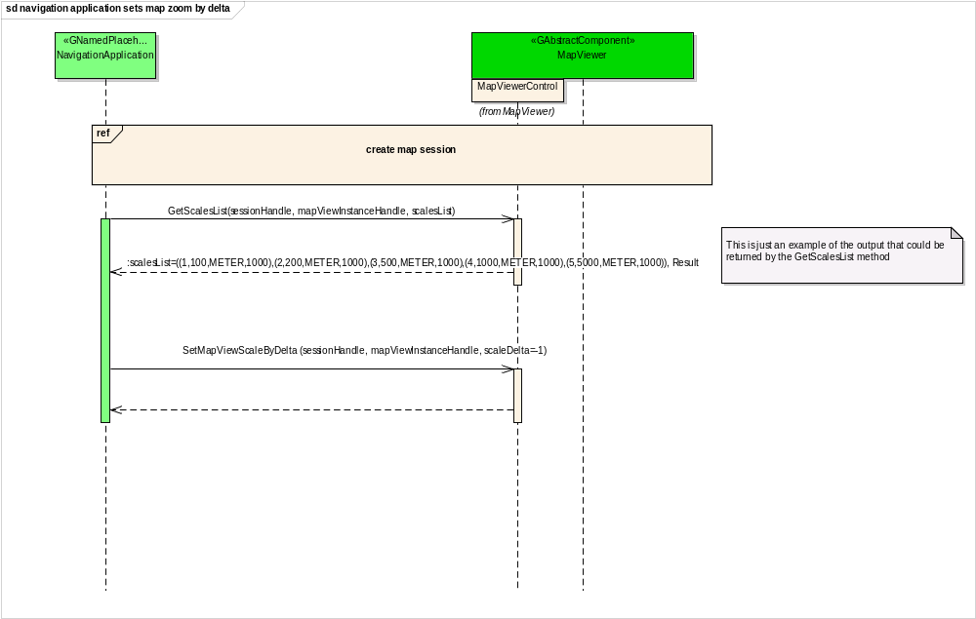

navigation application shows route

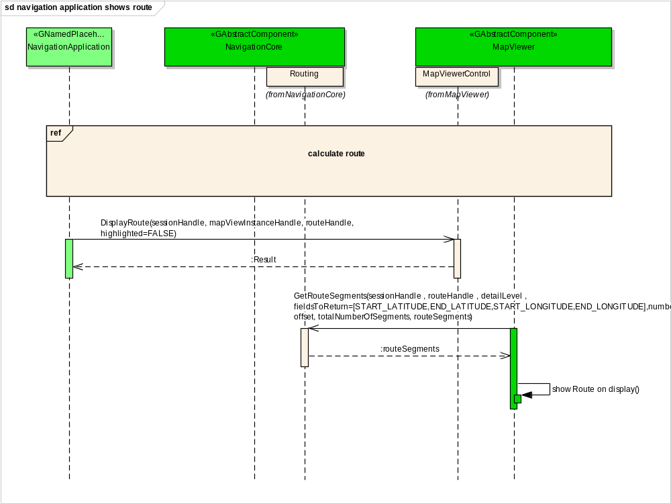

Interfaces

