

GENIVI NavigationCore API

Release 3.0.2
Status: Approved

30 June 2014

Accepted for release by:
This document has been accepted for the GENIVI Gemini Release by the Expert Group Location Based Services (EG-LBS)

Abstract:
This document describes the API of the NavigationCore Abstract Component.
Keywords:
NavigationAPIs, NavigationCore.

SPDX-License-Identifier: CC-BY-SA-4.0

Copyright (C) 2014, BMW Car IT GmbH, Continental Automotive GmbH, Elektrobit Automotive GmbH, Neusoft Technology Solutions GmbH, PCA Peugeot Citroën, TomTom International B.V., XS Embedded GmbH

This work is licensed under a Creative Commons Attribution-ShareAlike 4.0 International License

To view a copy of this license, visit http://creativecommons.org/licenses/by-sa/4.0/
or send a letter to Creative Commons, 444 Castro Street, Suite 900, Mountain View, California, 94041, USA.

Table of contents

1 Change History 4
2 Introduction 5
3 Terminology 6
4 Requirements 7
5 Architecture 8
5.1 Interfaces 8
5.2 Interaction with other Components 9
6 API 10
6.1 D-Bus 10
6.2 Git Repository 10
6.3 Naming Conventions 10
6.4 Data Types Convention 11
6.5 Errors 12
6.6 Sessions 13
6.7 Sequence Diagrams 15
6.7.1 navigation application creates route 15
6.7.2 navigation application starts route calculation 16
6.7.3 navigation application gets list of segments 17
6.7.4 navigation application enters destination 18
6.7.5 two clients try to change route preferences of the same route 19
6.7.6 navigation application sets route preferences 20
6.7.7 navigation application sets starting point 21
6.7.8 navigation application sets transportation means 22
6.7.9 navigation application changes waypoints order 23
6.7.10 navigation application enables voice guidance 24
6.7.11 navigation application starts a simulation 25
6.7.12 navigation application starts guidance 26
6.7.13 navigation application stops guidance 27
6.7.14 HMI requests voice instruction 28
6.7.15 navigation application creates location input session 29
6.7.16 navigation application enters location 30
6.7.17 navigation application enters location using speller 31
6.7.18 navigation application enters full address 32
6.8 Interfaces 33

Change History

Version | Date | Author | Change
0.1 | 27 Feb 2012 | Marco Residori (XS Embedded) | Document Created.
0.2 | 19 Mar 2012 | Marco Residori (XS Embedded) | Updated sequence diagrams.  Updated Interfaces chapter.
0.3 | 21 Mar 2012 | Marco Residori (XS Embedded) | Updated Interfaces chapter.
1.0 | 22 Mar 2012 | Marco Residori (XS Embedded) | System Architecture Team (SAT) approval.
2.0 (beta) | 07 Jun 2013 | Marco Residori (XS Embedded) | Updated API description. API Version 2.0.
2.0 | 17 Jun 2013 | Marco Residori (XS Embedded) | Updated API description.  API fixes: GT-2691, GT-2689, GT-2651.  API Version 2.0 (gemini-final tag)
3.0.0 | 21 Jan 2014 | Marco Residori (XS Embedded) | Updated API description.  API Version 3.0.0
3.0.1 | 22 May 2014 | Marco Residori (XS Embedded) | Updated copyright notes.
3.0.2 | 30 June 2014 | Marco Residori (XS Embedded) | Updated contributors list.

Introduction
This document describes the NavigationCore API.

Terminology

Term | Description
Link-ID | Identifier of a route segment in a database

Requirements
- Ease of Development

- Extensibility

- Multi-client Behavior

- Simplicity

Architecture

Interfaces

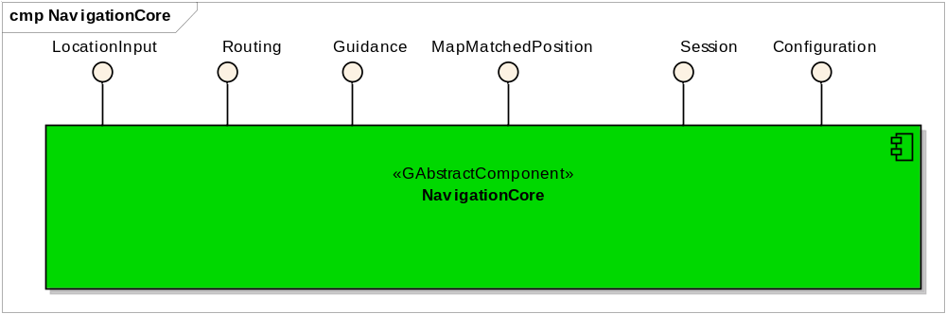

Interaction with other Components

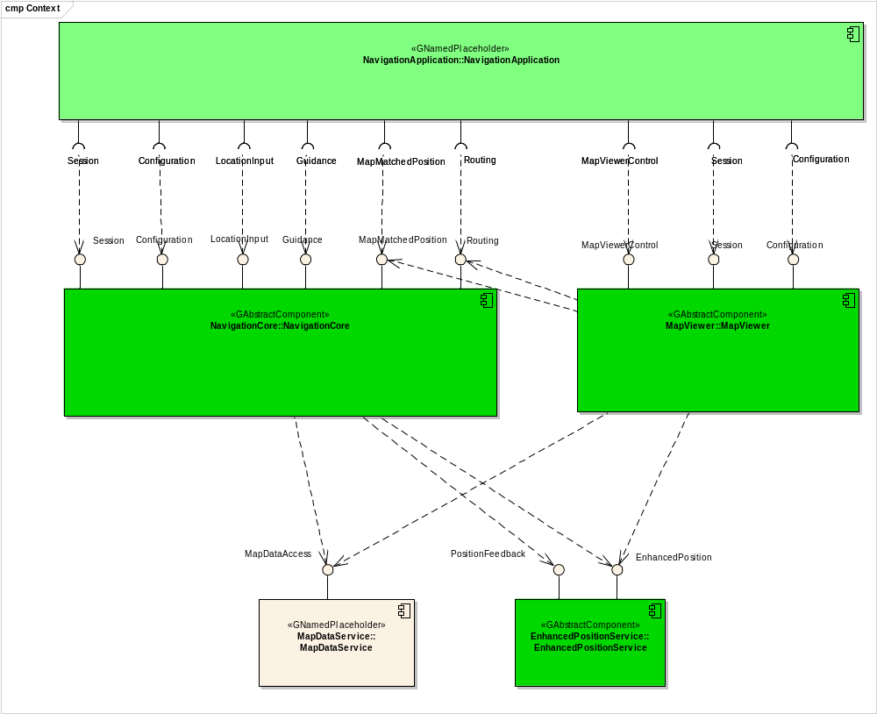

API

D-Bus
The NavigationCore interfaces are D-Bus interfaces. They are defined using the D-Bus introspection data format, which is nothing but an IDL expressed in XML format.

For more information about the D-Bus data types please refer to the following website:
http://dbus.freedesktop.org/doc/dbus-specification.html#message-protocol-signatures

For more information about the D-Bus introspection data format, please refer to the following website:
http://dbus.freedesktop.org/doc/dbus-specification.html#introspection-format

Git Repository
The NavigationCore interfaces can be found in the GENIVI Git repository at:
https://git.genivi.org/git/gitweb.cgi?p=navigation;a=tree;f=NavigationCore/api

Naming Conventions

Element | Description | Example
Interface File | genivi.<component name in lowercase character>.<interface name in lowercase characters> | genivi.navigationcore.routing.xml
Methods/Signal/Properties | Camel case naming convention  First letter uppercase | CalculateRoute
Arguments | Camel case naming convention  First letter lowercase | routeHandle

Data Types Convention
D-bus types code are used. Please refer to the following webpage for more information:
http://dbus.freedesktop.org/doc/dbus-specification.html

Element | D-Bus Data Type Code | Example
Enumerators | q (uint16)
Handles | y (uint8)
Maps | a{qv} | Dictionary of tuples (key, value)  The key is expressed as an enumerator

Errors

Error Type | Description | Example | Error Documentation | Note
User Error | Error caused by user actions | The user tries to start route guidance, although guidance is already running | Application specific error string documented in the XML file | Can occur in final product
Hardware Error | Error related to hardware/database related problems | No map data | Application specific error string documented in the XML file | Can occur in final product
Protocol Error | Error caused by wrong sequence of commands | Wrong sequence of commands to enter destination | Standard D-Bus error string | Should not occur in final product
Bus Error | D-Bus communication error | Bus busy | Standard D-Bus error string | Can occur in final product
Programming Error | Programming Error | Invalid parameters | Standard D-Bus error string and debug messages | Should not occur in production code

Only application-specific errors are documented directly in the interfaces (XML files). For all other errors, standard D-Bus strings are used. These kinds of strings are not documented in the interfaces. It is implicitly assumed that every method may return a standard D-Bus error string.

Sessions
A session-id identifies a requester. In a multi-client context only the requester that created an instance may be allowed to execute operations on that instance.
Other requesters may operate on the same handle (e.g. route handle, location input handle) with limited rights. For example, only the creator of a route handle can start/stop a route calculation on that handle. Other clients may simply be allowed to retrieve the total distance to the destination.
The following diagram shows an example of how session handles can be used:
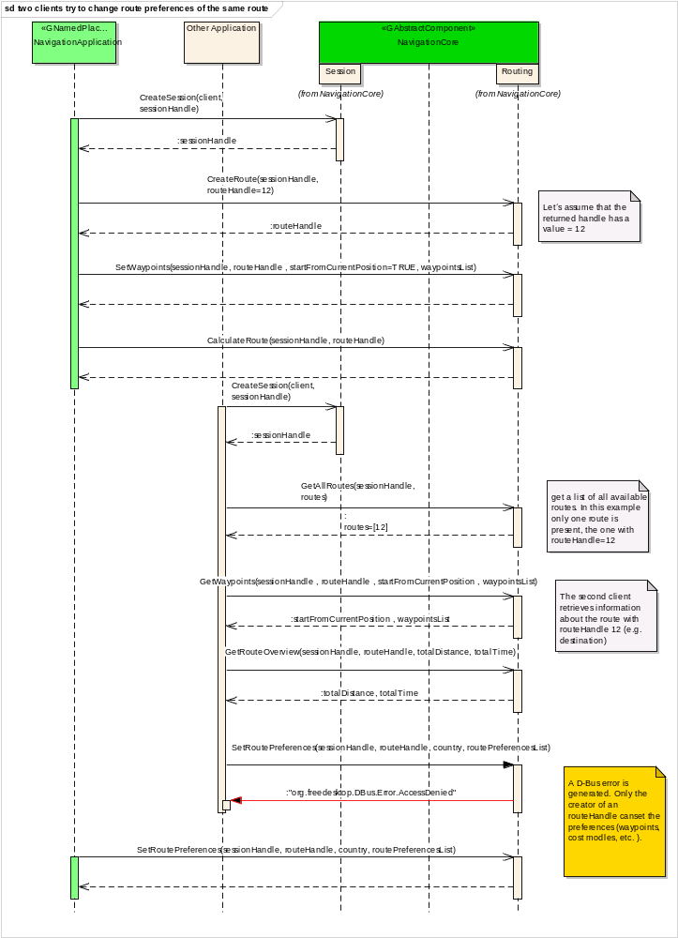

Sequence Diagrams

navigation application creates route

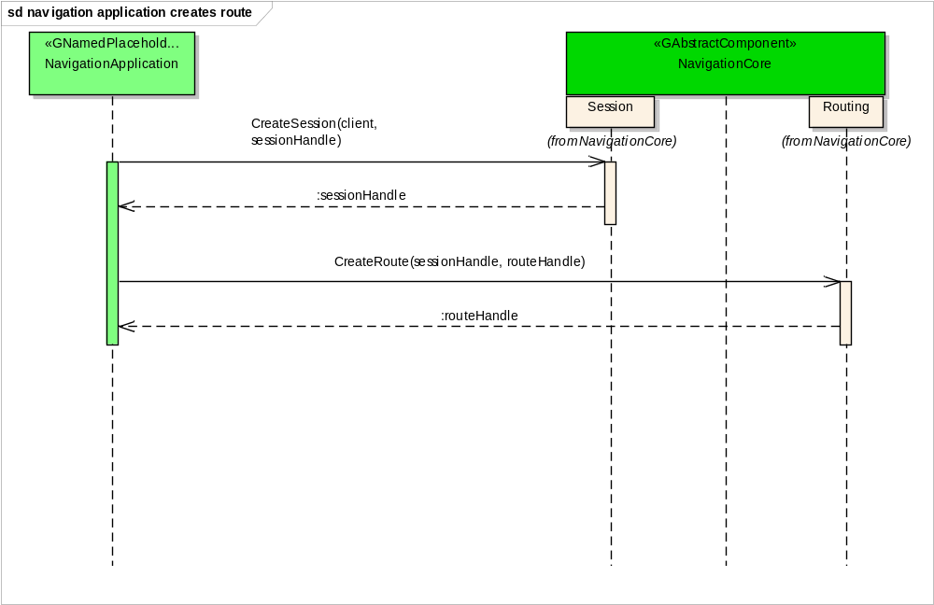

navigation application starts route calculation
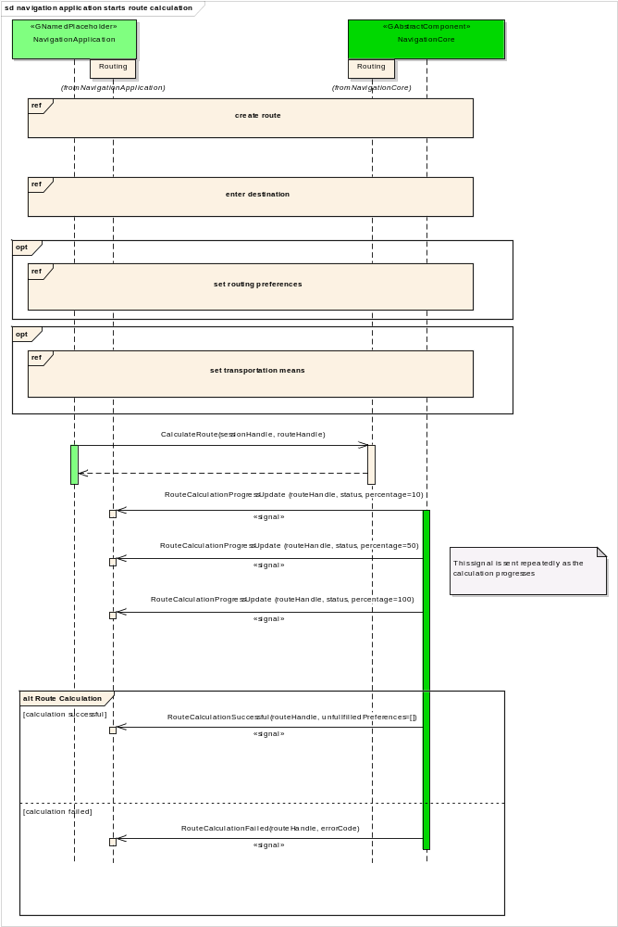

navigation application gets list of segments

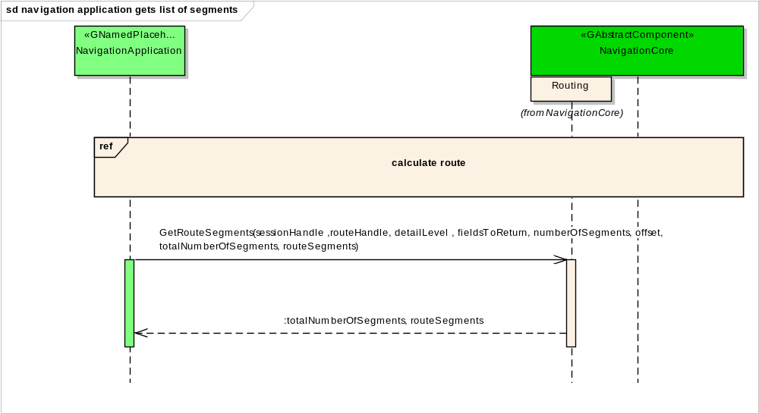

navigation application enters destination

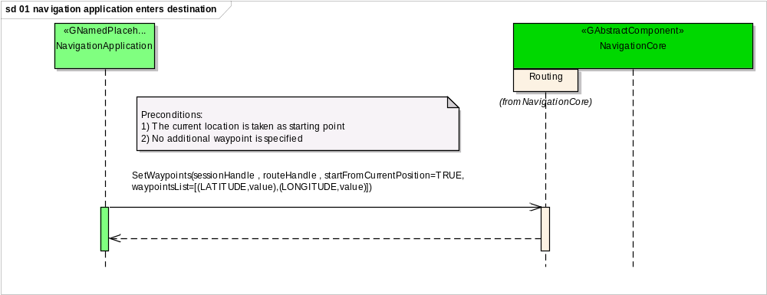

two clients try to change route preferences of the same route

navigation application sets route preferences

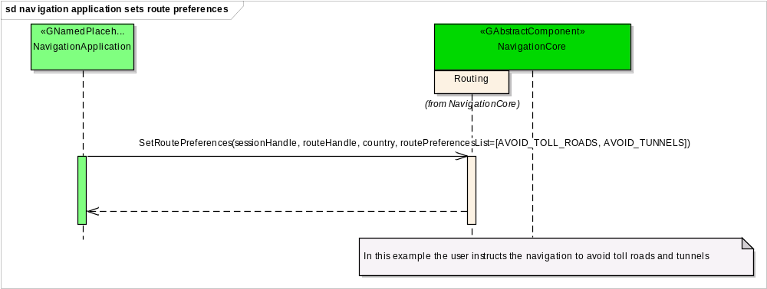

navigation application sets starting point

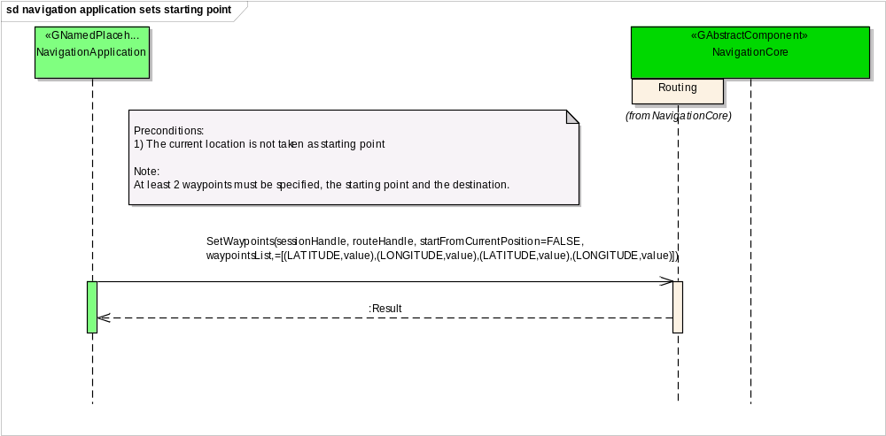

navigation application sets transportation means

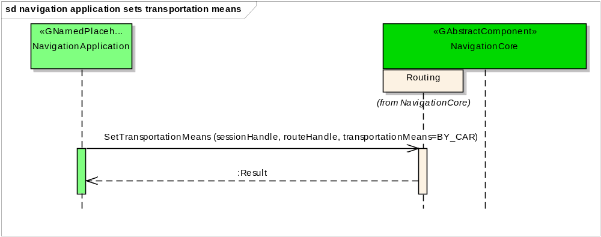

navigation application changes waypoints order

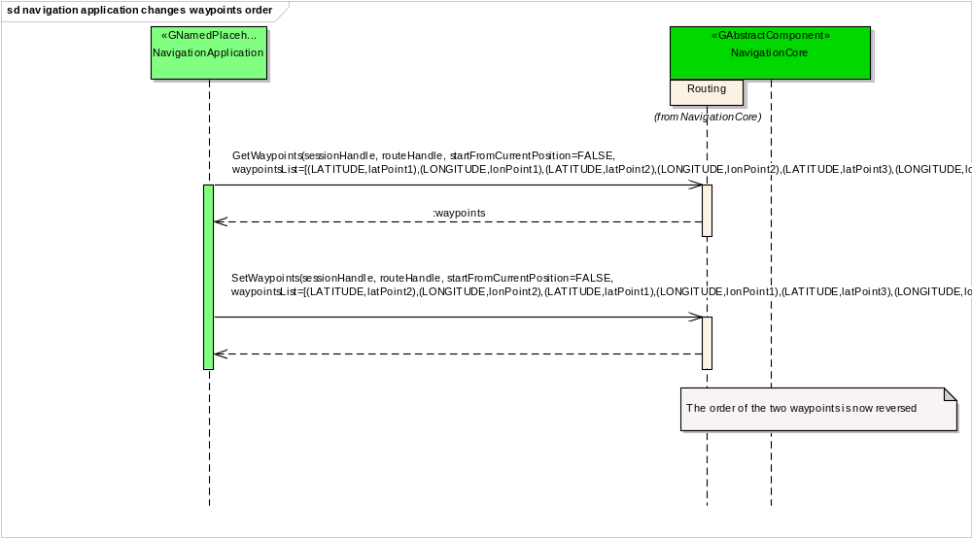

navigation application enables voice guidance

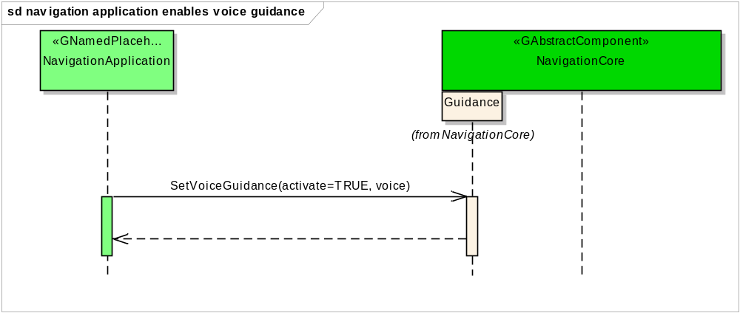

navigation application starts a simulation

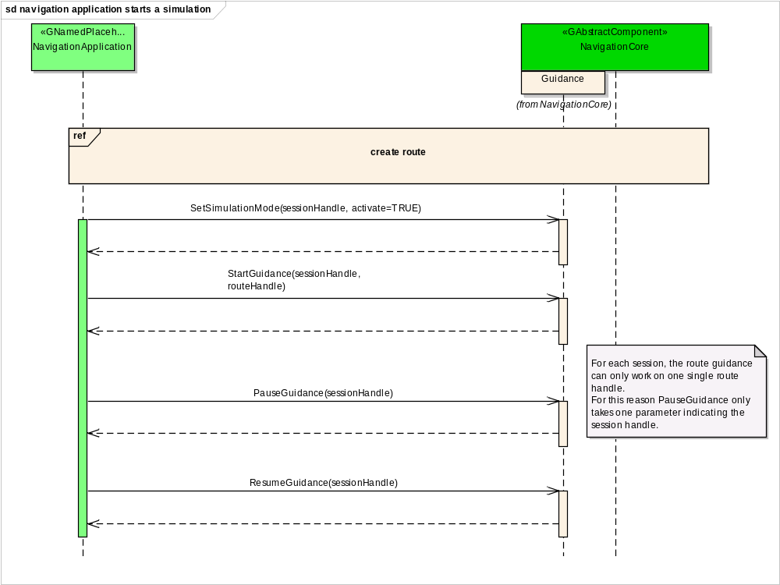

navigation application starts guidance

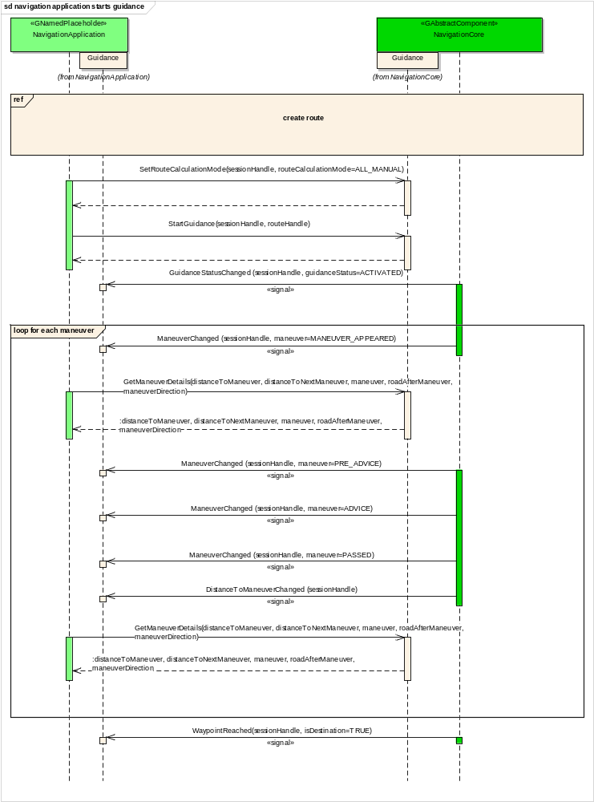

navigation application stops guidance

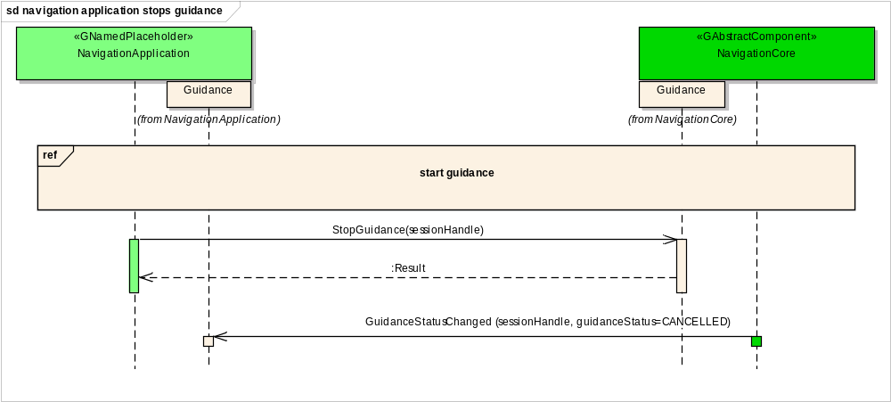

HMI requests voice instruction

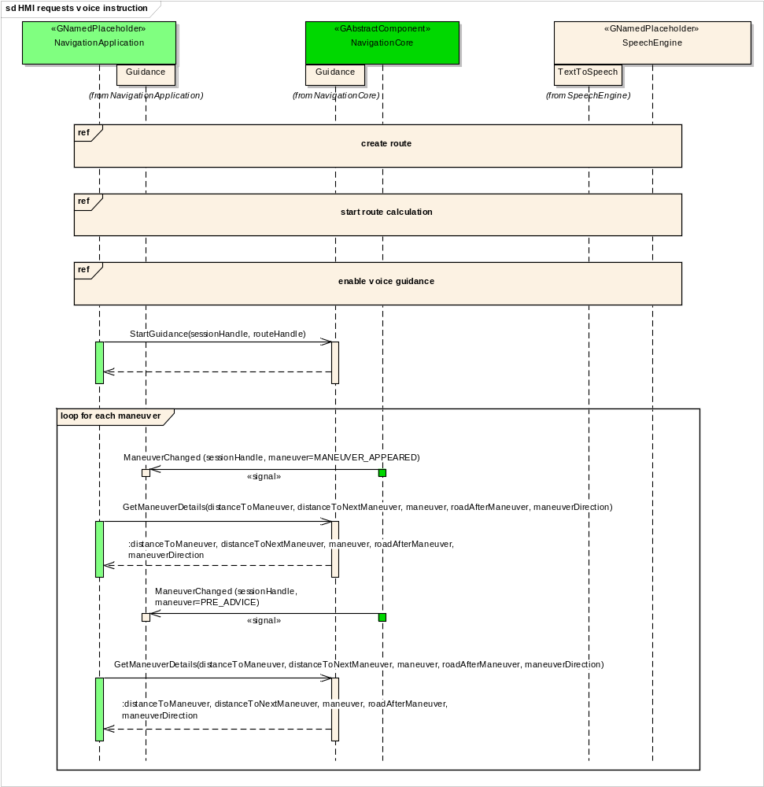

navigation application creates location input session

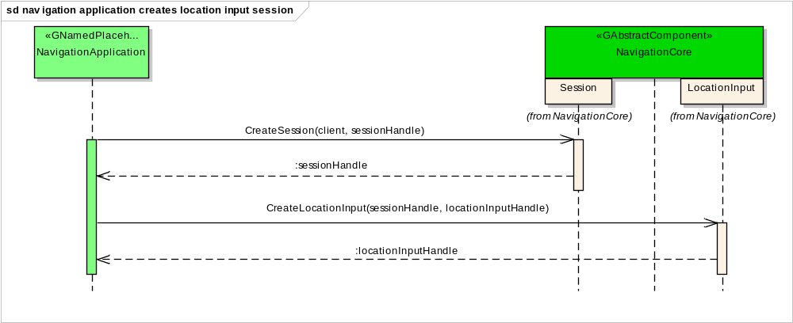

navigation application enters location

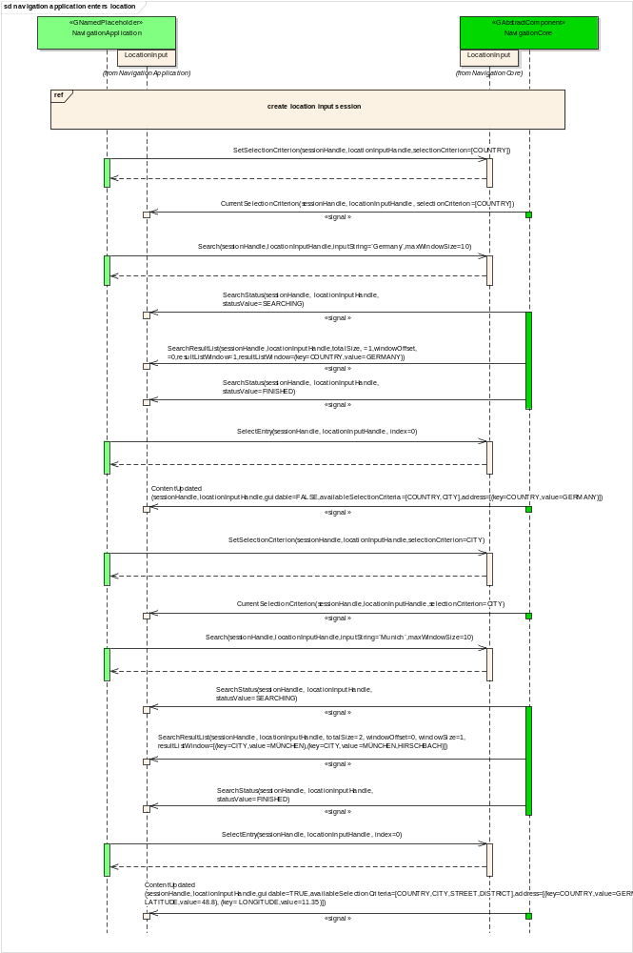

navigation application enters location using speller

navigation application enters full address

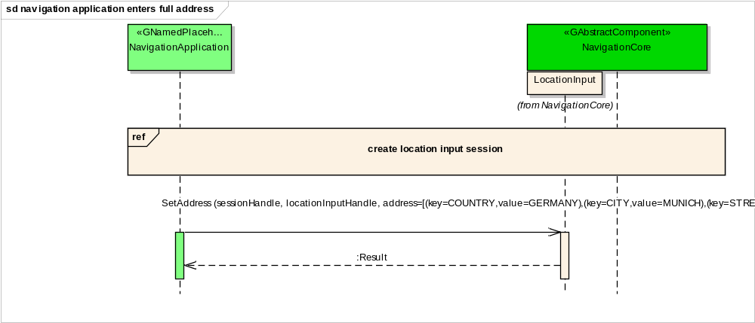

Interfaces

