QUICK HEALTH ANALZER



January 31 2024

-By Abhay Swarnkar

**TABLE OF CONTENT**

**S.NO DESCRIPTION PAGE NO**

**1. CHAPTER 1 INTRODUCTION 1**

## 2. CHAPTER 2 PROBLEM DEFINATION & 2 PROPOSED MODEL

2.1 Problem Definition 2

2.2 Objective 2

2.3 Proposed Model 3

## 3. CHAPTER 3 METHDOLOGY 9

3.1 Data Collection and Sources 9

3.2 Description of Diseases Datasets 9

3.3 Jupyter Notebook code on Diseases 10

3.4 System Requirements 12

3.5 Fronted 12

3.6 Backend 12

3.7 Api (Application Programming Interface) 13

3.9 User Interface 18

3.9 Result 21

**4. CHAPTER 4 BUSINESS MODEL**

**5. CHAPTER 5 FINANCIAL MODELLING (EQUATION)**

**WITH MACHINE LEARNING**

CONCULSION 22 FUTURE SCOPE 23

REFERENCE 24

**LIST OF FIGURES**

**FIG NO. FIGURE NAME PAGE NO**

Fig 2.1 Proposed Model 4

Fig 3.1 Backend startup 17

Fig 3.2 Fronted/src/Diabetes.jsx 17

Fig 3.3 Fronted/src/HeartDiseases.jsx 17

Fig 3.4 Fronted/src/NeruologicalDiseases.jsx 17

Fig 3.5 UI/Home Page 18

Fig 3.6 UI/Heart Diseases Home page 18

Fig 3.7 UI/Neurological 19

Diseases (Parkinson)

Fig 3.8 About Section 19

Fig 3.9 Diseases Input Section 20

Fig 3.10 Output Show 21

Fig 3.11 Subscription Business Model 26

**CHAPTER 1**

**INTRODUCTION**

## 1.0 INTRODUCTION: -

Early illness identification is an important worldwide public health goal. Using machine learning (ML) approaches to assess consumer diagnostic data has emerged as a game-changing approach to early-stage illness identification. This paradigm focuses on three specific diseases: heart disease, diabetes, and Parkinson's disease. Machine learning algorithms, particularly classification models, play an important role in this process. These models are trained on various datasets containing diagnostic information from people. The input characteristics might comprise a variety of health indicators, genetic markers, lifestyle variables, and other pertinent data. Machine learning algorithms learn to discover patterns and develop connections with the early stages of heart disease, diabetes, and Parkinson's disease by analyzing these complex datasets. The importance of early detection cannot be emphasized. Machine learning methods, particularly classification models, are critical for tackling the Quick Health Analyzer Problem. These algorithms are trained on a variety of datasets, including genetic information, lifestyle factors, and health markers. Machine learning algorithms can detect small patterns and correlations in these complicated datasets, which may foretell the beginning of illness. Recognizing these early-stage indications is critical for creating prediction models that can warn healthcare workers to possible concerns. Ethical issues, data privacy, and model interpretability become critical when deploying these technologies in real-world healthcare settings. In short, using machine learning into early illness detection efforts represents a paradigm change in healthcare. We want to transform diagnostic capabilities, empower healthcare practitioners, and, eventually, improve the quality of life for people throughout the world by using the power of powerful algorithms.

* 1. **Feasibility:**

This Project can be developed and deployed within a year as SaaS (Software as a Service) for anyone to use.

* 1. **Viability:**

As the Health Sector Industry grows in India and the world, there will always be small business existing which can use this service to improvise on their sales and data warehousing techniques. So, it is viable to survive in the long-term future as well but improvements are necessary as new technology emerge.

* 1. **Monetization:**

This Service is directly monetizable as it can be directly released as a service on completion which can be used by business.

**CHAPTER 2**

**PROBLEM DEFINATION AND PROPOSED MODEL**

## 2.1 PROBLEM DEFINITION: -

At its foundation, the Quick Health Analyzer Problem is motivated by the understanding that standard healthcare practices, which frequently respond to symptoms as they emerge, have limits. Waiting for symptoms to appear might delay therapy beginning, lowering the effectiveness of therapies. The idea is to use modern technologies, notably machine learning, to filter through massive datasets containing a variety of health-related factors and indicators.

Machine learning methods, particularly classification models, are critical for tackling the Quick Health Analyzer Problem. These algorithms are trained on a variety of datasets, including genetic information, lifestyle factors, and health markers. Machine learning algorithms can detect small patterns and correlations in these complicated datasets, which may foretell the beginning of illness. Recognizing these early-stage indications is critical for creating prediction models that can warn healthcare workers to possible concerns. However, the Quick Health Analyzer Problem is not without problems. Implementing machine learning-based diagnostic systems necessitates a multidisciplinary approach. Collaboration among healthcare specialists, data scientists, and technology experts is critical for navigating the intricacies of healthcare data and ensuring the ethical use of new technologies. Data privacy, model interpretability, and the ethical concerns of deploying predictive technology in healthcare settings all require careful study.

## 2.2 OBJECTIVE: -

The value of early detection cannot be emphasized. For illnesses such as heart disease, diabetes, and Parkinson's, early detection enables therapies that can slow or reverse disease development. Tailored treatment strategies can be implemented, thereby reducing problems and increasing overall patient outcomes. Furthermore, early detection improves the efficiency of healthcare systems by decreasing the demand on resources that would otherwise be used to manage advanced-stage disorders. Machine learning methods, particularly classification models, are critical for tackling the Quick Health Analyzer Problem. These algorithms are trained on a variety of datasets, including genetic information, lifestyle factors, and health markers. Machine learning algorithms can detect small patterns and correlations in these complicated datasets, which may foretell the beginning of illness. Recognizing these early-stage indications is critical for creating prediction models that can warn healthcare workers to possible concerns.

We are Work on Only Three Type of Diseases.

1. Heart Disease
2. Diabetes Disease
3. Parkinson’s (Neurological Disease)

**2.2.1 Heart disease:**

Heart disease, encompassing a range of conditions affecting the heart and blood vessels, stands as a formidable health challenge worldwide. It is imperative to delve into a comprehensive understanding of this complex ailment, considering its prevalence, risk factors, diagnostic methods, and the role of cutting-edge technologies, particularly machine learning, in its early detection and management.

**Prevalence and Impact:**

Heart disease, often used interchangeably with cardiovascular disease, remains a leading cause of morbidity and mortality globally. According to the World Health Organization (WHO), an estimated 17.9 million lives are claimed each year due to cardiovascular diseases, accounting for approximately 31% of all global deaths. The impact is not only measured in lives lost but also in the substantial economic burden it places on healthcare systems.

**Risk Factors:**

Understanding the risk factors associated with heart disease is paramount for both prevention and timely intervention. These factors can be broadly categorized into modifiable and nonmodifiable. Non-modifiable risk factors include age, gender, and genetics, while modifiable factors encompass lifestyle choices like diet, physical activity, smoking, and excessive alcohol consumption. The interplay of these factors underscores the complexity of heart disease.

**Diagnostic Approaches:**

Accurate diagnosis forms the bedrock of effective heart disease management. Traditional diagnostic methods include electrocardiograms (ECG or EKG), echocardiograms, and stress tests. These techniques provide valuable insights into the heart's function and structure. Advanced imaging modalities such as cardiac MRI and CT angiography offer detailed anatomical information. Biomarkers like troponin and B-type natriuretic peptide (BNP) aid in detecting cardiac damage and heart failure, respectively.

**Role of Machine Learning in Early Detection:**

The integration of machine learning (ML) into healthcare, particularly for early disease detection, has emerged as a transformative approach. ML algorithms, fueled by vast datasets, excel in identifying subtle patterns indicative of pre-symptomatic stages. In the context of heart disease, these algorithms analyze diverse data points, including patient demographics, lifestyle factors, and medical history, to predict the likelihood of developing cardiovascular conditions. Early detection facilitated by ML not only enhances prognosis but also enables tailored intervention strategies.

**Challenges in Implementation:**

While ML holds immense promise, its integration into healthcare is not without challenges. Ethical considerations, data privacy concerns, and the need for transparent and interpretable models are critical aspects. Ensuring that the benefits of ML are accessible across diverse demographic groups while minimizing biases is an ongoing endeavor.

**2.2.2 Diabetes Disease:**

Diabetes, a chronic metabolic disorder characterized by elevated blood sugar levels, has emerged as a pervasive health challenge globally. This comprehensive exploration aims to shed light on the multifaceted nature of diabetes, encompassing its prevalence, risk factors, diagnostic approaches, and the evolving role of innovative technologies, particularly machine learning, in early detection and management.

**Prevalence and Impact:**

Diabetes has reached epidemic proportions, affecting millions of lives and posing a significant burden on healthcare systems. According to the International Diabetes Federation (IDF), approximately 537 million adults were living with diabetes in 2021, with projections indicating a rise to 643 million by 2030. The impact of diabetes extends beyond its immediate health implications, contributing to complications such as cardiovascular disease, kidney failure, and vision impairment.

**Risk Factors:**

Understanding the risk factors associated with diabetes is crucial for effective prevention and management. While genetics and family history play a role, lifestyle factors take center stage. Sedentary lifestyles, unhealthy dietary patterns, obesity, and age are key contributors. The intricate interplay between genetic predisposition and environmental factors underscores the complexity of diabetes.

**Diagnostic Approaches:**

Accurate and timely diagnosis forms the linchpin of diabetes management. Traditional diagnostic methods involve measuring fasting blood sugar levels, oral glucose tolerance tests, and glycated hemoglobin (HbA1c) tests. These tests provide insights into the body's ability to regulate glucose. Continuous glucose monitoring (CGM) systems offer real-time data, enhancing the precision of diabetes management.

**Role of Machine Learning in Early Detection:**

The integration of machine learning (ML) into diabetes care has ushered in a new era of early detection and personalized intervention. ML algorithms analyze diverse datasets, including patient demographics, lifestyle factors, and genetic markers, to identify patterns indicative of pre-diabetic states. This proactive approach allows for early intervention, lifestyle modifications, and personalized treatment plans tailored to individual needs.

**Challenges in Implementation:**

While ML holds promise in revolutionizing diabetes care, its implementation is not without challenges. Ethical considerations, data privacy, and the need for transparent and interpretable models are paramount. Ensuring accessibility and fairness in ML-driven diabetes solutions across diverse populations is an ongoing pursuit.

**2.2.3 Parkinson’s (Neurological Disease):**

Parkinson's disease, a neurodegenerative disorder that primarily affects movement, has long been a subject of intensive research and medical scrutiny. This in-depth exploration aims to unravel the multifaceted nature of Parkinson's, delving into its clinical features, underlying mechanisms, diagnostic challenges, and the transformative role of machine learning in early detection and management. **Clinical Features and Impact:**

Parkinson's disease manifests through a spectrum of clinical features, with motor symptoms like tremors, bradykinesia, and rigidity being hallmark indicators. Non-motor symptoms, including cognitive impairment, mood disorders, and autonomic dysfunction, contribute to the disease's pervasive impact on the quality of life. As a progressive condition, Parkinson's poses not only physical challenges but also places a substantial emotional and socioeconomic burden on individuals and their families.

**Underlying Mechanisms and Pathophysiology:**

The pathophysiology of Parkinson's is complex and involves the degeneration of dopaminergic neurons in the substantia nigra region of the brain. This leads to the disruption of neurotransmitter balance, particularly dopamine, crucial for regulating movement. Accumulation of alpha-synuclein protein in the form of Lewy bodies further characterizes the disease. While these mechanisms provide insights, the exact etiology remains elusive, emphasizing the need for continued research.

**Diagnostic Challenges:**

Diagnosing Parkinson's disease poses significant challenges, particularly in its early stages. Clinical assessments, neuroimaging, and response to dopaminergic medications contribute to the diagnostic process. However, misdiagnosis and delayed identification are not uncommon, hindering timely intervention. The elusive nature of pre-symptomatic stages underscores the imperative for innovative diagnostic approaches. **Role of Machine Learning in Early Detection:**

The advent of machine learning (ML) has brought a paradigm shift in Parkinson's disease detection. ML algorithms analyse extensive datasets, including clinical assessments, genetic markers, and even voice and gait patterns, to identify subtle patterns indicative of preclinical Parkinson's. These data-driven approaches hold promise for early and accurate detection, enabling interventions that may modify the course of the disease.

## 2.3 PROPOSED MODEL

Machine learning methods, particularly classification models, are critical for tackling the Quick Health Analyzer Problem. These algorithms are trained on a variety of datasets, including genetic information, lifestyle factors, and health markers. Machine learning algorithms can detect small patterns and correlations in these complicated datasets, which may foretell the beginning of illness. Recognizing these early-stage indications is critical for creating prediction models that can warn healthcare workers to possible concerns. Developing a suggested model for early illness detection entails combining several components, including data gathering, feature selection, model building, and ethical concerns. The following is an outline of a potential paradigm for early illness detection.

**2.3.1 Data Collection:**

**2.3.1.1 Diverse Dataset**: Gather a comprehensive dataset that includes a range of health indicators, genetic markers, and lifestyle variables relevant to the targeted diseases (e.g., heart disease, diabetes, Parkinson's).

**2.3.1.2 Quality Assurance:** Ensure data quality by addressing issues such as missing values, outliers, and inconsistencies.

**2.3.1.3 Ethical Data Usage:** Prioritize patient privacy and obtain explicit consent for data usage.

**2.3.2 Feature Selection: -**

**2.3.2.1 Identification of Relevant Features:** Employ feature selection techniques to identify the most informative variables contributing to disease prediction.

**2.3.3 Model Development:**

**2.3.3.1 Machine Learning Algorithms**: Select appropriate machine learning algorithms based on the nature of the data and the specific characteristics of the diseases.

**2.3.3.2 Training and Validation:** Split the dataset into training and validation sets to train the model and assess its performance.

**2.3.3.3 Ensemble Methods**: Explore ensemble methods to combine predictions from multiple models, enhancing overall accuracy.

**2.3.4 Validation and Evaluation:**

**2.3.4.1 Cross-Validation:** Implement cross-validation techniques to robustly evaluate the model's performance.

**2.3.4.2 External Validation:** Validate the model on external datasets to assess its generalizability.

**2.3.6 Deployment:**

**2.5.6.1 User-Friendly Interface:** Design an intuitive interface for healthcare practitioners to input data and interpret model outputs.

**2.5.6.2 Integration with Healthcare Systems:** Ensure seamless integration with existing healthcare systems for easy adoption.

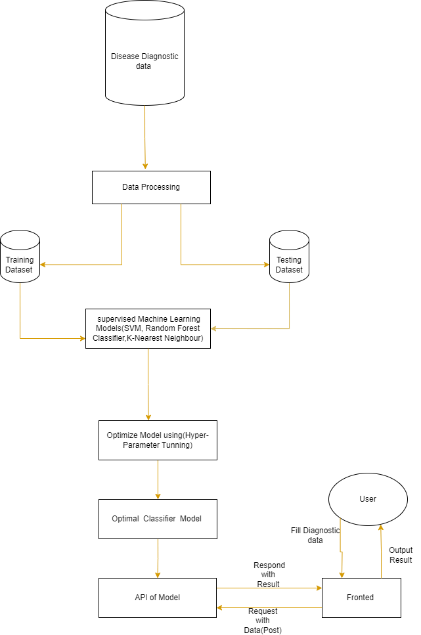

**Fig 2.1. Proposed Model**

**CHAPTER 3 METHDOLOGY**

**3.1 Data Collection And Sources :**

We use datasets for building models from Kaggle, UCI-datasets. Where link are there

**3.1.1 Heart Diseases:**

* [**https://www.kaggle.com/datasets/johnsmith88/heart-disease-dataset**](https://www.kaggle.com/datasets/johnsmith88/heart-disease-dataset)
* [**https://archive.ics.uci.edu/dataset/45/heart+disease**](https://archive.ics.uci.edu/dataset/45/heart+disease)

**3.1.2 Diabetes Disease:**

* [**binariks.com**](https://binariks.com/blog/ai-machine-learning-for-early-disease-detection/)[**)https://www.kaggle.com/datasets/uciml/pima-indians-diabetesdatabase**](https://www.kaggle.com/datasets/uciml/pima-indians-diabetes-database)

**3.1.3 Parkinson’s Diseases:**

* [**https://www.kaggle.com/datasets/naveenkumar20bps1137/parkinsons-diseasedetection/data**](https://www.kaggle.com/datasets/naveenkumar20bps1137/parkinsons-disease-detection/data)

**3.2 Description Of Diseases Datasets:**

1. **Heart Diseases:**

|  |  |  |  |  |  |  |
| --- | --- | --- | --- | --- | --- | --- |
| **Variable**  **Name** | **Role** | **Type** | **Demographic** | **Description** | **Units** | **Missing**  **Values** |
| age | Feature | Integer | Age | Age of Patient | years | no |
| sex | Feature | Categorical | Sex | Sex (male:1,Female:0) |  | no |
| cp | Feature | Categorical |  |  |  | no |
| trestbps | Feature | Integer |  | resting blood pressure (on admission to the hospital) | mm  Hg | no |
| chol | Feature | Integer |  | serum cholestoral | mg/dl | no |
| fbs | Feature | Categorical |  | fasting blood sugar > 120 mg/dl |  | no |
| restecg | Feature | Categorical |  |  |  | no |
| thalach | Feature | Integer |  | maximum heart rate achieved |  | no |
| **Variable**  **Name** | **Role** | **Type** | **Demographic** | **Description** | **Units** | **Missing**  **Values** |
| exang | Feature | Categorical |  | exercise induced angina |  | no |
| oldpeak | Feature | Integer |  | ST depression induced by exercise relative to rest |  | no |

**Table 3.1 Data Dictionary of Heart Diseases**

1. **Diabetes Diseases:**

|  |  |  |  |  |  |  |
| --- | --- | --- | --- | --- | --- | --- |
| **Variable Name** | **Role** | **Type** | **Demographic** | **Description** | **Units** | **Missing**  **Values** |
| Pregnancies | Feature | Integer | No of  Pregnancies |  | years | no |
| Glucose | Feature | Integer | Glucose | Sex  (male:1,Female:0) |  | no |
| Blood Pressure | Feature | Integer |  | resting blood pressure (on admission to the hospital) | mm  Hg | no |
| SkinThickness | Feature | Integer |  |  |  | no |
| DiabetesPedigreeFunction | Feature | Numeric |  | s | mg/dl | no |
| Insulin | Feature | Numeric |  | fasting blood sugar > 120 mg/dl |  | no |
| BMI | Feature | Integer |  |  |  | no |
| Age | Feature | Integer | Age |  | years | no |
| Status | Feature | Integer |  | Result (Yes =1,no  0) |  | no |

**Table 3.2 Data Dictionary Diabetes 3 Parkinson’s Diseases** name - ASCII subject name and recording number

MDVP:Fo(Hz) - Average vocal fundamental frequency

MDVP:Fhi(Hz) - Maximum vocal fundamental frequency

MDVP:Flo(Hz) - Minimum vocal fundamental frequency

Five measures of variation in Frequency

MDVP:Jitter(%) - Percentage of cycle-to-cycle variability of the period duration MDVP:Jitter(Abs) - Absolute value of cycle-to-cycle variability of the period duration

MDVP:RAP - Relative measure of the pitch disturbance

MDVP:PPQ - Pitch perturbation quotient

Jitter:DDP - Average absolute difference of differences between jitter cycles

Six measures of variation in amplitude

MDVP:Shimmer - Variations in the voice amplitdue

MDVP:Shimmer(dB) - Variations in the voice amplitdue in dB

Shimmer:APQ3 - Three point amplitude perturbation quotient measured against the average of the three amplitude

Shimmer:APQ5 - Five point amplitude perturbation quotient measured against the average of the three amplitude

MDVP:APQ - Amplitude perturbation quotient from MDVP

Shimmer:DDA - Average absolute difference between the amplitudes of consecutive periods

Two measures of ratio of noise to tonal components in the voice

NHR - Noise-to-harmonics Ratio and HNR - Harmonics-to-noise Ratio status - Health status of the subject (one) - Parkinson's, (zero) - healthy

Two nonlinear dynamical complexity measures

RPDE - Recurrence period density entropy

D2 - correlation dimension

DFA - Signal fractal scaling exponent

Three nonlinear measures of fundamental frequency variation spread1 - discrete probability distribution of occurrence of relative semitone variations spread2 - Three nonlinear measures of fundamental frequency variation

PPE - Entropy of the discrete probability distribution of occurrence of relative semitone variations

**3.3 Jupyter Notebook**

**For Heart Disease: https://github.com/GENRATECODE/Machine_Learning_Project/blob/main/Project_1/Project_classifcation_HeartDIsease_Project.ipynb**

|  |
| --- |
|  |
|  |
|  |
|  |
|  |
|  |

## 3.4 SYSTEM REQUIREMENTS

**3.3.1 Operating System**

### • Windows 7 or Later

**3.3.2 Hardware Requirement**

* **CPU i3-6gen/Dual Core**
* **Ram 4/8Gb**
* **Storage 128GB min**

## 3.5 FRONTED

**Language :**

* HTML
* CSS
* JavaScript
* ReactJS

**Platform:**

* VS code
* Git
* GitHub

## 3.6 BACKEND

**Language:**

* Python

**Library:**

* FastAPI
* Pandas
* NumPy
* Scikit-learn
* Matplotlib
* Pickle
* Json

**Platform:**

* Anaconda
* Jupyter Notebook
* Git
* VS code

**3.7 API(APPLICATION PROGRAMMING INTERFACE):**

Unicorn is an ASGI( Asynchronous Server Gateway Interface) Server that’s used to serve Python web applications, Particularly Those built using asynchronous frameworks like Fast API and Starlite. ASGI is designed to handle asynchronous web applications. Which can perform multiple tasks concurrently, making them highly efficient for handling many simultaneous connections.

Run code : uvicorn Backend.Heatlh:app –host 0.0.0.0 –port 10000

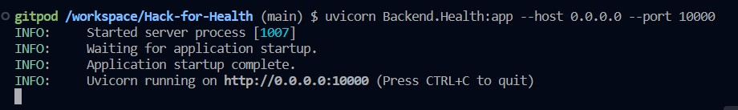

# Fig 3.1 Backend startup

Link: [http://0.0.0.0:10000](http://0.0.0.0:10000/) in Fronted Where Post request Generate

And past on this place ‘POST’

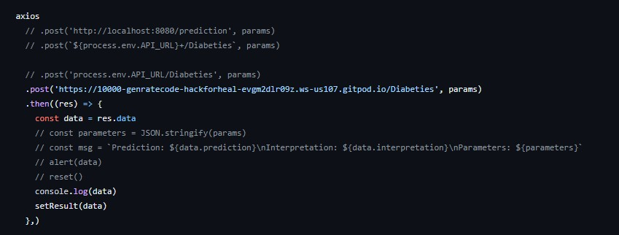

# Fig 3.2 Fronted/src/Diabetes.jsx

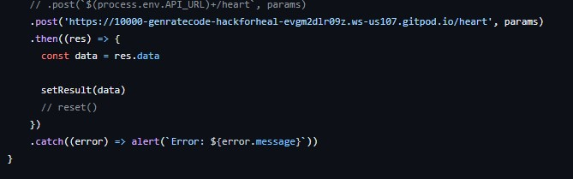

# Fig 3.3 Fronted/src/HeartDiseases.jsx

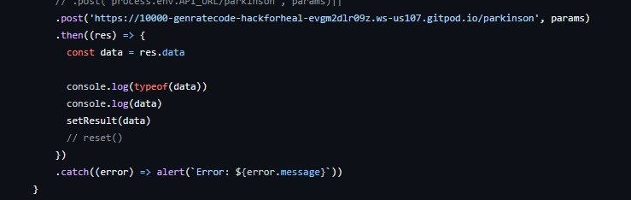

# Fig 3.4 Fronted/src/NeruologicalDiseases.jsx

## 3.8 USER INTERFACE



# Fig 3.5 UI/Home Page



# Fig 3.6 UI/Heart Diseases Home page

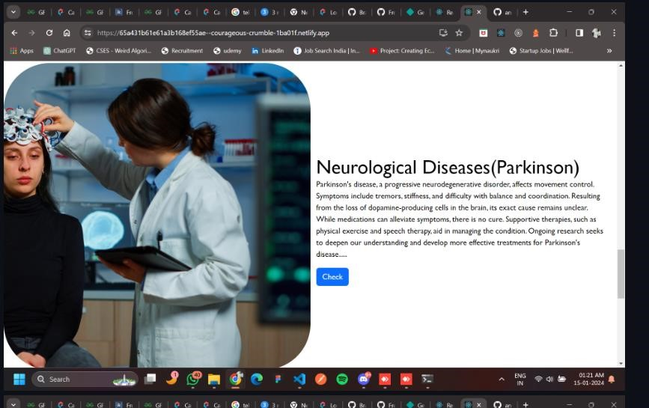

# Fig 3.7 UI/Neurological Diseases(Parkinson)

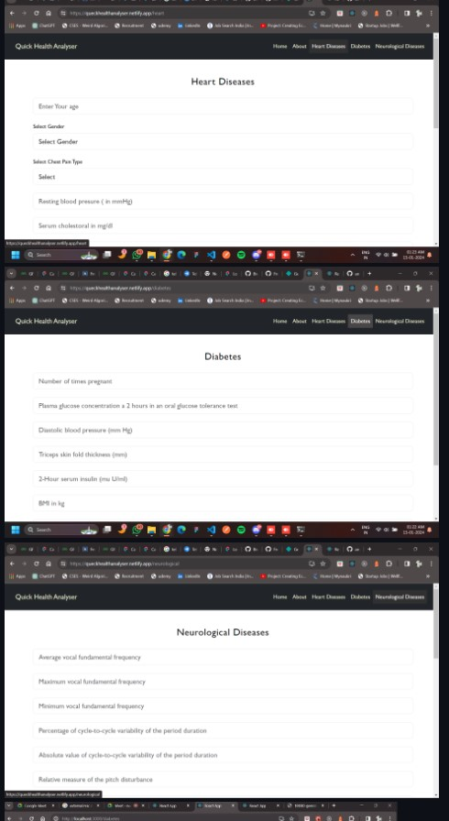Fig 3.9 Diseases Input Section

## 3.8 RESULT

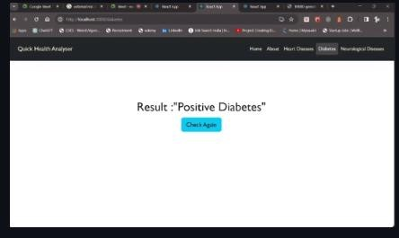

# Fig 3.10 Output Show

**CHAPTER 4 BUSINESS MODEL**

**4.1 BUSINESS MODEL:**

* A business model is a company's core strategy for profitably doing business.
* Models generally include information like products or services the business plans to sell, target markets, and any anticipated expenses.
* There are dozens of types of business models including retailers, manufacturers, fee-for-service, or freemium providers.
* The two levers of a business model are pricing and costs.
* When evaluating a business model as an investor, consider whether the product being offer matches a true need in the market.

## 4.2 TYPES OF BUSINESS MODELS

There are as many types of business models as there are types of business. For instance, direct sales, [franchising](https://www.investopedia.com/terms/f/franchise.asp), advertising-based, and [brick-and-mortar](https://www.investopedia.com/terms/b/brickandmortar.asp) stores are all examples of traditional business models. There are hybrid models as well, such as businesses that combine internet retail with brick-and-mortar stores or with sporting organizations like the [NBA](https://www.investopedia.com/articles/investing/070715/nbas-business-model.asp).

* Retailer
* Manufacturer
* Fee-of-service
* Subscription
* Freemium
* Bundling
* Marketplace
* Affiliate
* Razor Blade
* Frachise
* Pay-As-You-Go
* Brokerage

**4.3 BUSINESS MODELLING**

For the service, it is beneficial to use a Subscriptions Business Model, Where initially some Diseases will be provided for free to engage customer retention and increase our customer count. Later it will be charging a subscription fee to use the Service further for their business, In the Subscription business model, customers pay a fixed amount of money Based on the price of a feature to get access to products or services provided by the company. The major problem is user conversion, how to convert the users into paid users

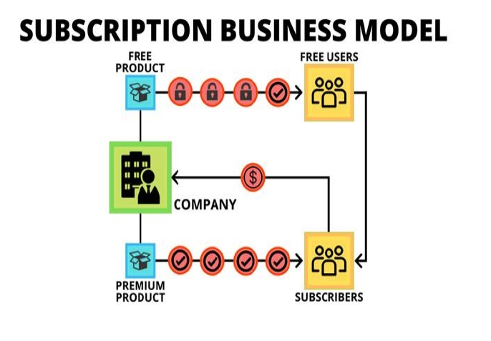

3.11 Subscription Business Model

**CHAPTER 5**

**FINANCIAL MODELLING (EQUATION) WITH MACHINE LEARNING**

It was forecast that the global healthcare AI/ML market would be worth almost 188 billion U.S. Dollars by 2030. Increasing at a compound annual growth rate of 37 percent from 2022 to 2030.

Let’s assume that the duration of developing the ml Model take about 1 to 4 weeks and the cost for producing the model is the cost members the team salary. Let’s there be two members of team, one is ML engineers and another Full stack web developer. Let the salary of the ML engineers be ‘ml’ and the full stack web developer be ‘fs’. And other charges as

Hosting ‘host’, Operational Cost “Op”

Total cost => C= 2*ml+fs+Op+host

Note: ignore other cost as Data Cost, Security, Maintenance and Support

The profit or financial equation will look like this

Y=5000*x(t)-C

Here X(t) is a function that represents the growth of the customer base and y is the profit.

**CONCLUSION**

The integration of machine learning into early illness detection epitomizes a paradigm shift in healthcare. It seeks to revolutionize diagnostic capabilities, empower healthcare practitioners, and ultimately elevate the quality of life on a global scale. As we navigate this transformative journey, a commitment to ethical practices and collaborative endeavors will be instrumental in realizing the full potential of machine learning in healthcare. using machine learning into early illness detection efforts represents a paradigm change in healthcare. We want to transform diagnostic capabilities, empower healthcare practitioners, and, eventually, improve the quality of life for people throughout the world by using the power of powerful algorithms. In the context of machine learning applications for the Early Disease Detection Problem, notable achievements underscore the potential of these technologies. Achieving an 87% accuracy rate for heart diseases, 81% for diabetes, and an impressive 97% for Parkinson's demonstrates the efficacy of these models in realworld scenarios. Market basket analysis is being used

**FUTURE SCOPE**

* Integration of Advanced Technologies
* Expanding the Disease Portfolio
* Implementation of Telemedicine and Digital Health Platforms
* Add Prevacation and prevent method according diseases
* Patient Empowerment and Educations
* Innovative treatment Modalities:
* Integration of Image Technologies
* Blockchain for Data Security:

**REFERENCE**

* [**AI/ML Algorithms for Early Disease Detection and Diagnosis**](https://binariks.com/blog/ai-machine-learning-for-early-disease-detection/)
* [**(binariks.com**](https://binariks.com/blog/ai-machine-learning-for-early-disease-detection/)[**)https://www.kaggle.com/datasets/uciml/pima-indians-diabetesdatabase**](https://www.kaggle.com/datasets/uciml/pima-indians-diabetes-database)
* [**https://www.kaggle.com/datasets/naveenkumar20bps1137/parkinsons-diseasedetection/data**](https://www.kaggle.com/datasets/naveenkumar20bps1137/parkinsons-disease-detection/data)
* [**https://www.kaggle.com/datasets/johnsmith88/heart-disease-dataset**](https://www.kaggle.com/datasets/johnsmith88/heart-disease-dataset)
* [**https://archive.ics.uci.edu/dataset/45/heart+disease**](https://archive.ics.uci.edu/dataset/45/heart+disease)
* [What is a Business Model with Types and Examples (investopedia.com)](https://www.investopedia.com/terms/b/businessmodel.asp#:~:text=For%20instance%2C%20direct%20sales%2C%20franchising,sporting%20organizations%20like%20the%20NBA)
* [GENRATECODE/Hack-for-Health (github.com)](https://github.com/GENRATECODE/Hack-for-Health)