**INTRODUCTION**

In Today deregulated electricity markets, electricity prices fluctuate due to competition among power suppliers. Profit maximization has become a major motivation in electric markets. The imbalance between supply and demand results in volatile electricity prices. In a regulated market, load forecasting was the main focus of the electric power industry. Subsequently, the more complex electricity price forecasting (EPF) has become more important in the deregulated electric power industry. Hourly electricity price forecasting (EPF) for the next month gives pivotal information to power producers and consumers to build their own particular methodologies for utility augmentation and to enhance precise techniques to maximize their profit. EPF depends on input variables, such as available historical price and load data, system operating conditions, weather conditions, and temperature values, fuel prices, time indices (including hours, weekdays, and seasons), demand, bidding strategies, operating reserves, imports, temperature effects, predicted power shortfalls, and generation outages. composite multilayer neural network topologies, including hybrid parallel and hybrid cascade topologies, are applied to enhance the hourly EPF for the next month in Australian electricity markets. The hourly temperature, hourly electricity load, hourly natural gas data, and other hourly historical data have been considered in forecasting. The simulation results obtained have shown that hybrid parallel topology is more accurate and less in computational time.

**Literature Survey**

**1. Problem Statement**

We tend to design an the interconnections of neural networks with different connection topologies to improve the overall forecasting performance accuracy.Neural networks are be connected in many configurations, like cascade or serial topology, parallel topology, cascade parallel topology in cascade and in parallel, parallel–cascade topology in cascade and in parallel, hybrid parallel topology and short-term hourly EPF is found out using the historical hourly data for the year 2004 as a training set.We have inter-connected three separate nets in a cascade topology and a parallel topology to acquire the best performance based on simulation results.

**2. Objectives**

The Objective is to demonstrate a new computational approach to applying composite back-propagation multilayer neural networks to forecast hourly electricity price for the next month based on different factors and to improve accuracy. The intent is to study the behavior of diverse composite topologies to compare the best performance indices evaluated by the mean absolute percentage error and mean square error. The performance of different topologies is compared to identify the best connection architecture. The data used in the forecasting are hourly historical data of the temperature, electricity load, and natural gas price from the Australian electricity markets.

**PROPOSED METHOD**

**Tools And Technologies:**

* TensorFlow
* Keras
* Numpy
* Pandas
* Sklearn

**Base Model:**

* We have used Artificial Neural Network for the prediction of the prices. There are different models which are there:
  + Cascade Topology
  + Parallel Topology
  + Cascade-Parallel-in-Cascade Topology
  + Cascade-Parallel-in-Parallel Topology
  + Parallel-Cascade-in-Cascade Topology

Date - Date in MM/DD/YYYY format

Hour - Hour Ending

DA_DEMAND - Day-ahead demand consists of fixed and price sensitive demand bids plus Decrement bids and increment offers. NEPOOL = sum of zones plus the hub.

DA_LMP - Non-PTF demand = [non-dispatchable + unmetered + station service] as determined by metering

DA_EC - Day-Ahead energy component

DA_MLC - Real-Time Marginal Loss Component

RT_LMP - Real-Time Location Marginal Price

RT_EC - Real-Time Energy Component

SYSLOAD - NEPOOL system load = [generation - pumping load + net interchange] as determined by metering

RegCP -Regulation Clearing Price

Cascade Topology

The cascade topology are interconnected in feedforward connection where the output of the first network is used as input for the second network. The neural network design is divided into stages, i.e., the training stage and the simulation stage. Each network is trained to optimize its inputs with respect to the target values. As a result, Net 1 will be trained using x input value and to target value, while Net 2 will be trained with the output of Net 1, y1, as an input to it with respect to t target value, so connecting neural networks in cascade topology and finding the best cascade sequence.

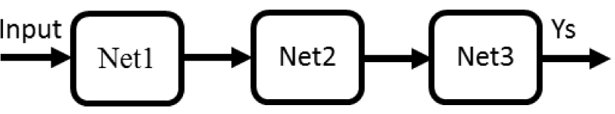

Parallel Topology

In the parallel topology one starts using the same input applied to all networks and then the output of all the networks is aggregated into to a single output neuron. Different weights are assigned to each network output where the best performing network is assigned higher weight. In connecting neural networks in parallel, there is no difference in connection sequence and the final output is improved compared with the output of each network resulting from the averaging mechanism. Enhanced results can be obtained by assigning a higher weight to the network with best performance and lower or even zero weight for the weak network.

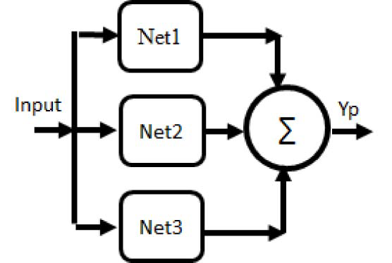

Fig 2 : Parallel Topology

Parallel–cascade-in-cascade Topology

In Parallel-Cascade-In-Cascade Topology, one starts using the same input applied to all networks and then the output of all the networks is aggregated into to a single output neuron.After which that output is feed into Cascade topology where output of the first network is used as input for the second network.

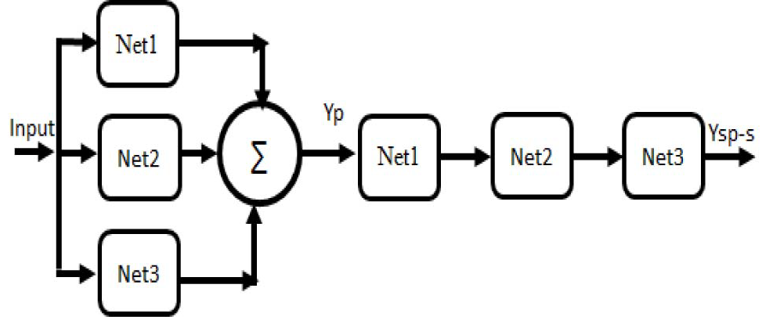

Fig 3. Parallel–cascade-in-cascade Topology

Cascade–parallel-in-cascade Topology

In Cascade-parallel-in-cascade topology, networks are interconnected in feedforward connection where the output of the first network is used as input for the second network.Then the final output of the this is feed into a parallel system where one starts using the same input applied to all networks and then the output of all the networks is aggregated into to a single output neuron.

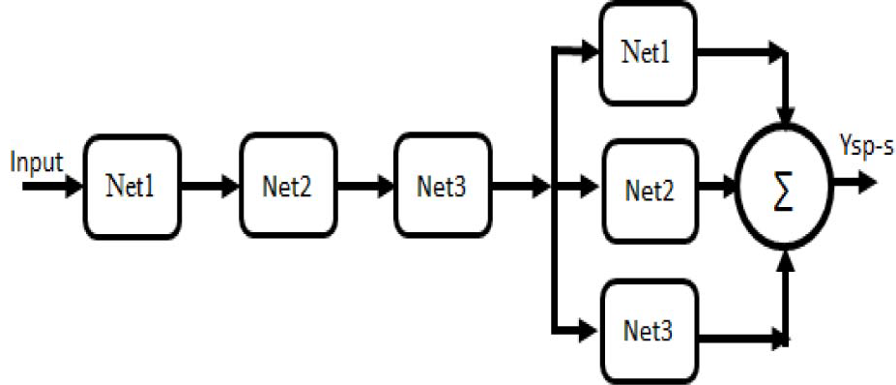

Fig 4. Cascade–parallel-in-cascade Topology

Cascade–parallel-in-parallel Topology

In Cascade–parallel-in-parallel topology, there is cascade topology and parallel topology of network and both are connected in parallel. So, a single input is feed into both parallel and cascade one and then final output is the combined one.

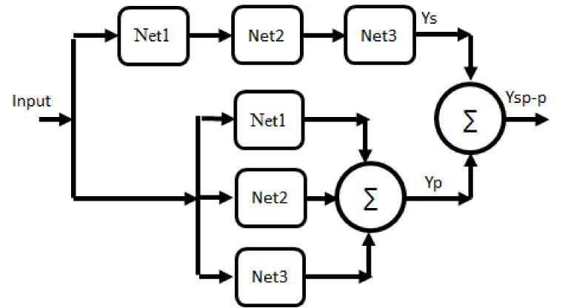

Fig 5. Cascade–parallel-in-parallel Topology

**Results and Analysis**

**Conclusion and Future work**

A new computational approach to applying composite backpropagation multilayer neural networks to forecast hourly electricity price for the next month based on hourly important factors, such as previous hourly load, hourly weather, loss and consumptions conditions for electricity load forecasting. We interconnected three separate nets in a cascade topology and a parallel topology to acquire the best performance based on simulation results.

A comparison of the cascade and parallel alone topology results in the performance superior to that of the parallel topology. A comparison of the cascade–parallel-in-cascade topology with the cascade–parallel-in-parallel topology reveals that starting the topology by a cascade connection and ending with a cascade connection results in the performance superior to that of starting the topology by a parallel connection and ending with a parallel connection. Therefore, the cascade–parallel-in-cascade topology is superior to that of the cascade–parallel in parallel.From a comparison of the performance of the cascade–parallel in parallel with that of parallel–cascade in parallel, we concluded that starting the topology with parallel connection yields superior performance to that starting with the cascade connection. Likewise, we found that there is no difference in accuracy between a parallel–cascade-in-cascade connection and parallel–cascade in-parallel connection.

From the analysis of the performance of each topology, it is concluded that the parallel topology, which averages the output errors, improves the performance of the systems. Onthe other hand, the cascade topology accumulates the error from each training stage, which mostly improves the overall performance in the systems with high data distribution.

References

[1] N. Amjady and A. Daraeepour, “Mixed price and load forecasting of electricity markets by a new iterative prediction method,” Electr. Power Syst. Res., vol. 79, no. 9, pp. 1329–1336, 2009.

[2] A. Karsaz, H. R. Mashhadi, and M. M. Mirsalehi, “Market clearing price and load forecasting using cooperative co-evolutionary approach,” Int. J. Elect. Power Energy Syst., vol. 32, no. 5, pp. 408–415, 2010.

[3] R. Weron, “Electricity price forecasting: A review of the state-of-theart with a look into the future,” Int. J. Forecasting, vol. 30, no. 4,pp. 1030–1081, 2014.

[4] J. P. S. Catalao, S. J. P. S. Mariano, V. M. F. Mendes, and L. A. F. M. Ferreira, “An artificial neural network approach for shortterm electricity prices forecasting,” presented at the Int. Conf. Intell. Syst. Appl. Power Syst., Nov. 2007, pp. 1–6.

[5] V. Iyer, C. C. Fung, and T. Gedeon, “A fuzzy-neural approach to electricity load and spot-price forecasting in a deregulated electricity

market,” Presented at the Conf. Convergent Technol. Asia-Pacific Region (TENCON), Oct. 2003, pp. 1479–1482.

[6] K. B. Sahay and M. M. Tripathi, “Day ahead hourly load and price forecast in ISO New England market using ANN,” in Proc. Annu. IEEE India Conf. (INDICON), Dec. 2013, pp. 1–6.

[7] G. Li, C.-C. Liu, J. Lawarree, M. Gallanti, and A. Venturini, “Stateof- the-art of electricity price forecasting,” presented at the Int. Symp. CIGRE/IEEE PES, Oct. 2005, pp. 110–119.

[8] A. Karsaz, H. R. Mashhadi, and R. Eshraghnia, “Cooperative coevolutionary approach to electricity load and price forecasting in deregulated electricity markets,” presented at the IEEE Power India Conf.,2006.