### Indian Pines Dataset

The Indian Pines dataset was acquired by the NASA Airborne Visible/Infrared Imaging Spectrometer (AVIRIS) sensor over the Indian Pines agricultural site in northwestern Indiana in June 1992, at 20-m spatial resolution and 10-nm spectral resolution over the range of 400-2500 nm. Twenty noisy and water absorption bands (104–108, 150–163, and 220) were removed resulting in a 200-band image. Ground reference data were comprised of 10,366 labeled samples assigned to 16 classes: *Corn-no till*, *Corn-min till*, *Corn*, *Soybeans-no till, Soybeans-min till, Soybeans-clean till, Alfalfa, Grass/Pasture*, *Grass/Trees*, *Grass/Pasture-mowed*, *Hay-windrowed*, *Oats*, *Wheat*, *Woods, Building-Grass-Trees-Drives*, and *Stone-Steel towers*. The crop-tillage related classes relate to the management practices used for tilling in a particular field. For example, *Soybeans-no till* refers to a field in which soybeans are planted, but no tillage was performed after the last harvest, thereby leaving a significant quantity of crop residue. *Soybeans-min* till refers to tillage which breaks up the soil, reducing the quantity of remaining residue, while *Soybeans-clean till* refers to fields that are fully ploughed after the previous harvest, leaving essentially no residue. *Corn-tillage* related classes are defined similarly. True-color composite and relative ground reference maps are shown in Fig. 1, while the details related to the number of labeled samples is listed in Table 1.

200 attributes,0-1 , 16 labels, 145*145 high dimension picture. principal component analysis. dimension reductive.

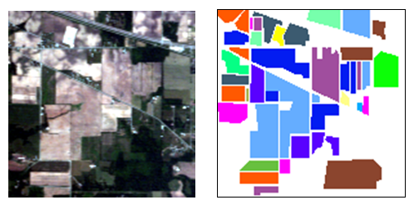

1. (b)

Fig. 1 Indian Pines dataset (a) True-color composite image; (b) Ground reference map

Table 1 Number of labeled samples for Indian Pines dataset

|  |  |  |
| --- | --- | --- |
|  | Class name | # labeled samples |
|  | C1: Corn-no till | 1434 |
|  | C2: Corn-min till | 834 |
|  | C3: Corn | 234 |
|  | C4: Soybeans-no till | 968 |
|  | C5: Soybeans-min till | 2468 |
|  | C6: Soybeans-clean till | 614 |
|  | C7: Alfalfa | 54 |
|  | C8: Grass/Pasture | 497 |
|  | C9: Grass/Trees | 747 |
|  | C10: Grass/Pasture-mowed | 26 |
|  | C11: Hay-windrowed | 489 |
|  | C12: Oats | 20 |
|  | C13: Wheat | 212 |
|  | C14: Woods | 1294 |
|  | C15: Building-Grass-Trees-Drive | 380 |
|  | C16: Stone-Steel towers | 95 |
|  | Total | 10366 |