Data: Indian Pines – 145x145 = 21025 pixels, 200 bands, 17 classes

After removing class 0 (unclassified data): 10249 pixels, 16 classes

Autoencoder: one hidden layer, units per layer: [200, 100, 200]

Classifier: logistic regression, 2000 epochs

Without class balancing

**Results**

Cost function:

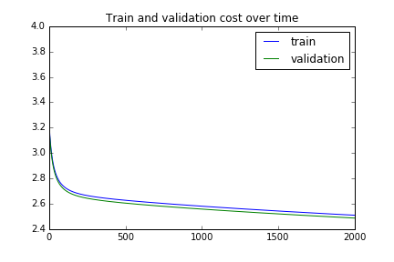

Confusion matrix for training set looks like this:

TRAIN: Accuracy : 0.472759798341

VALIDATION: Accuracy : 0.468292682927

TRAIN : Confusion matrix

Predicted 1 5 7 10 13 All

Acctual

0 3 7 16 0 0 26

1 248 3 0 596 0 847

2 48 1 0 454 0 503

3 71 26 0 69 0 166

4 5 78 0 14 193 290

5 0 369 0 2 66 437

6 2 1 0 16 0 19

7 105 47 104 22 0 278

8 0 12 0 0 0 12

9 0 3 0 585 0 588

10 29 18 0 1458 0 1505

11 35 2 0 301 0 338

12 0 125 0 1 0 126

13 0 4 0 0 728 732

14 3 106 0 10 108 227

15 10 0 0 45 0 55

All 559 802 120 3573 1095 6149

VALIDATION : Confusion matrix

Predicted 1 5 7 10 13 All

Acctual

0 0 2 6 0 0 8

1 82 2 0 208 0 292

2 15 0 0 164 0 179

3 15 5 0 16 0 36

4 1 29 0 6 55 91

5 0 125 0 1 28 154

6 0 0 0 2 0 2

7 38 25 25 9 0 97

8 0 5 0 0 0 5

9 0 1 0 184 0 185

10 7 2 0 469 0 478

11 16 0 0 109 0 125

12 0 45 0 0 0 45

13 0 1 0 0 259 260

14 0 31 0 3 41 75

15 2 0 0 16 0 18

All 176 273 31 1187 383 2050

Added class balancing to the cost function.

,

- number of pixels in class ,  
 - total number of pixels $percent_{i}$ 
 – percentage share of $i$-th class $weight_{i}$ 
 – weight coefficient of $i$-th class for cost function, which is inverse proportional to percentage and gives larger weights to smaller classes. $n_classes$ 
 – number of different classes in dataset

Cost function:

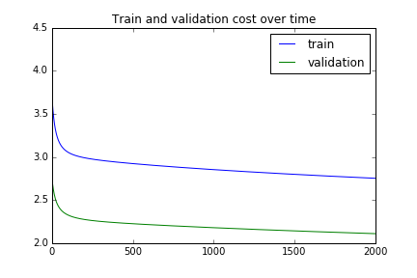

2000 epochs - normalized weighted classes in cost function

TRAIN: Accuracy : 0.501707594731

VALIDATION: Accuracy : 0.499024390244

TRAIN : Confusion matrix

Predicted 1 5 7 9 10 13 15 All

Acctual

0 0 0 33 0 1 0 0 34

1 241 2 1 0 618 1 0 863

2 44 0 1 0 465 0 0 510

3 67 7 1 0 68 0 0 143

4 2 12 74 0 18 194 0 300

5 0 347 11 0 15 71 0 444

6 0 0 6 0 13 0 0 19

7 3 0 266 0 8 0 0 277

8 0 9 0 0 0 0 0 9

9 0 1 1 0 557 0 0 559

10 20 10 4 0 1422 0 0 1456

11 37 0 1 0 299 0 0 337

12 0 125 1 0 1 0 0 127

13 0 1 0 0 0 773 0 774

14 3 107 14 0 10 105 0 239

15 5 0 0 1 16 0 36 58

All 422 621 414 1 3511 1144 36 6149

VALIDATION : Confusion matrix

Predicted 1 5 7 10 13 15 All

Acctual

0 0 0 3 0 0 0 3

1 71 0 1 227 0 0 299

2 16 0 0 142 0 0 158

3 12 3 1 23 0 0 39

4 2 2 13 5 59 0 81

5 0 119 7 7 24 0 157

6 0 0 0 5 0 0 5

7 0 0 92 0 0 0 92

8 0 8 0 0 0 0 8

9 0 0 0 203 0 0 203

10 10 0 4 504 0 0 518

11 10 0 0 110 0 0 120

12 0 43 0 0 0 0 43

13 0 5 0 0 228 0 233

14 0 32 1 1 42 0 76

15 4 0 0 2 0 9 15

All 125 212 122 1229 353 9 2050