Word distribution:

**Each document contains how many words?**

-Mean: 69.2187

-Max: 978

-Min:3

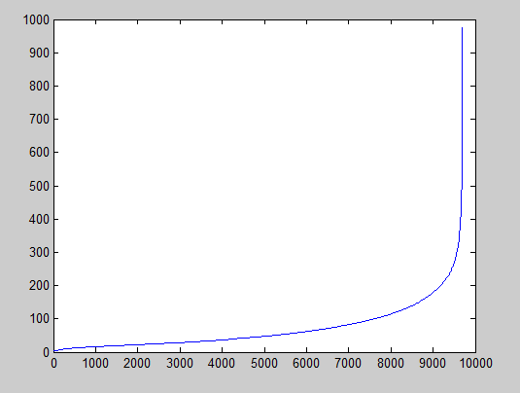

**Each word appear in how many documents?**

**-Mean：1.9376**

**-Medium**

**-Max： 9188**

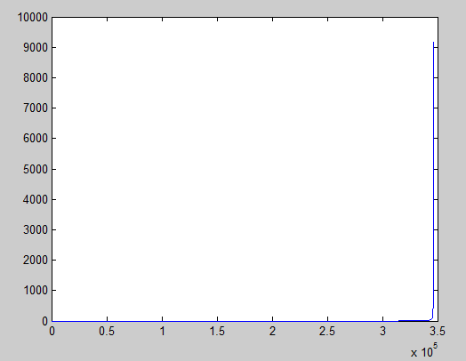

**Label Distribution**

**Each label in how many instances?**

**-mean: 25.6320**

**-max: 113**

**-min: 4**

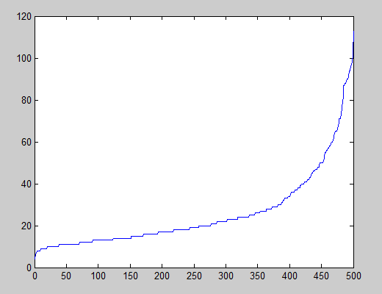

**Each document has how many labels?**

**-mean:** **1.3221**

**-max: 7**

**-median: 1**

**-min: 1**

