Global Canopy Atlas pipeline
Fabian Fischer et al.
2025-04-30
Table of Contents

1 List of accronyms
- GCA: Global Canopy Atlas
- DTM: Digital Terrain Model
- DSM: Digital Surface Model
- CHM: Canopy Height Model
- ALS: Aerial Lidar Scanning
- CRS: Coordinate Reference System
- UTM: Universal Transverse Mercator
- TIN: Triangle Irregular Network
- MAAP: Multi-Mission Algorithm and Analysis Platform
- ESA: European Space Agency

2 Package description
The GCA pipeline is a tool used for the generation of Digital Terrain Model (DTM) and Canopy Height Model (CHM) from Aerial LiDAR Scanning (ALS) data.
The package source code can be found at: https://github.com/fischer-fjd/GCA/tree/GCA_open_source

3 General workflow
- Diagram
The following diagram represents the pipeline workflow.
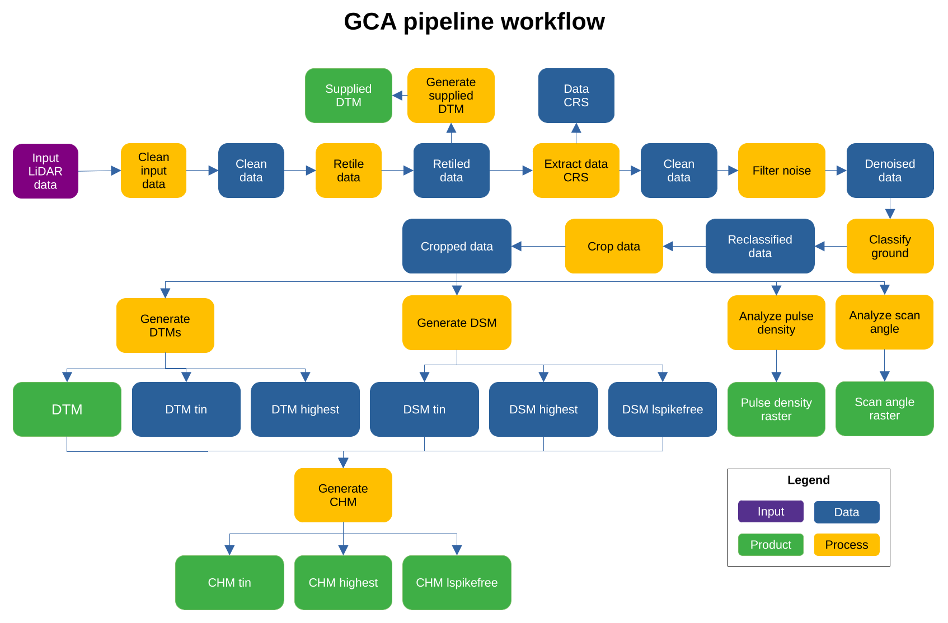
Diagram of the GCA pipeline workflow
In this figure, the blue items represent data being produced by a process of the pipeline that will serve as input for the next step, the orange items represent the processing steps of the pipeline and the green items represent the final output products of the pipeline.
A detailed description of the pipeline’s workflow is given in the following section.
- Description
- The pipeline main processing steps are:
  - Clean input data: perform an initial clean of the data
  - Retile .las/.laz files to the specified tile size
  - Generate output from untreated point cloud (as .tif files for point classification and corresponding DTM via ‘lasgrid’ and ‘las2dem’ functions, upon information availability)
  - Read CRS and then delete pointcloud user information
  - Remove duplicate (xyz) points
  - Remove noise points
  - Classify (or reclassifiy) ground points
  - Crop canopy heights above a user-defined ‘maximum height’ (via ‘lasheight’ function); that ‘maximum height’ is used as a very coarse point cloud filter, assuming that trees never reach such height (e.g., 125 m here)
  - Get pulse density and scan angle (as .tif files)
  - Create DTMs
  - Create DSMs
  - Create normalized point clouds
  - Estimate laser penetration
  - Create CHMs
  - Compute canopy summary statistics from point clouds
  - Produce a final synthesis files and a set of three INFO files that document the output products

4 Input data
The pipeline takes two items as input data: the set of input pointcloud files and a metadata file with information about the acquisiton data. Both are expalined in detail in the following sections.
- Aquisition pointcloud files
The input pointcloud data is provided in the form of a folder containing a set of pointcloud files, in format LAS (.las) or its compressed equivalent LAZ (.laz). Normally each pointcloud file corresponds to a tile of the scanned landscape. All tiles must have the same Coordinate Reference System (CRS).
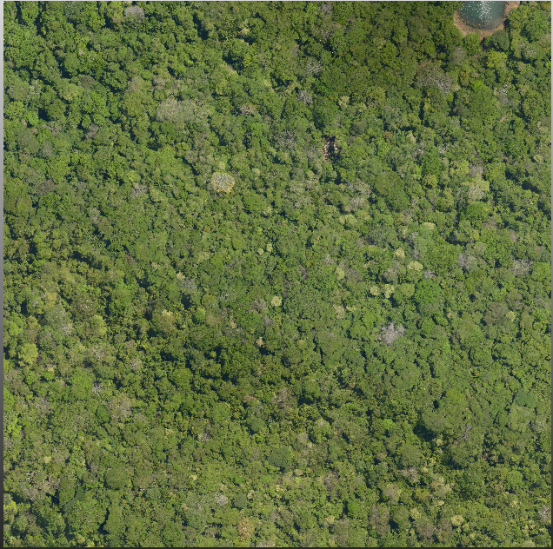
Top view of an example ALS data tile (RGB used just for visualization)
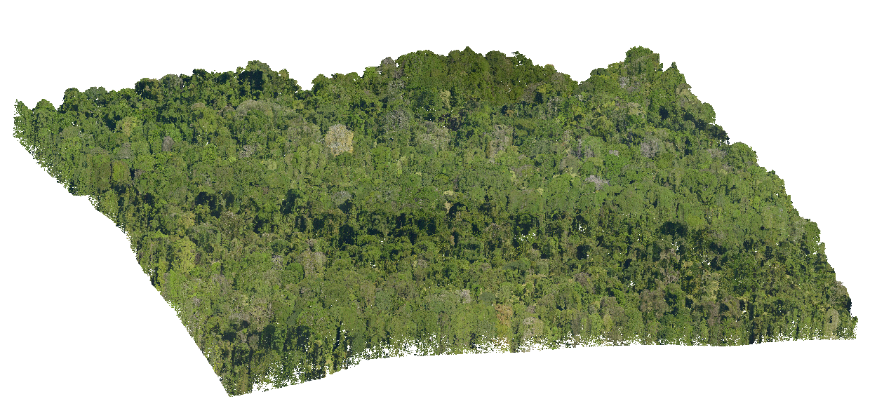
Side view of an example ALS data tile (RGB used just for visualization)
- Aquisition metadata file
- A metadata file should be provided with the data in the same folder. This file shall contain:
  - General information
    - Site name
    - Acquisition date
    - Covered area
    - Pulse density
    - Point density
    - Laser type
    - Wavelength
    - Beam divergence
    - Vehicle
    - Operator
  - Point cloud data
    - Data format
    - Tile number
    - Tile size
  - Acquisition parameters
    - Swath angle
    - Pulse Repetition Rate (PRR)
    - Ground footprint size of pulse
    - Flight height
    - Acquisition mode
    - Note(s)
  - ROI bounding box
    - Coordinate Reference System (CRS)
    - xmin
    - xmax
    - ymin
    - ymax

5 Parameters
The pipeline has a set of parameters that can control how the processing of the input data is performed. The following table lists the most important ones:
Name | Description | Default
name_job | Overall job name, used for processing stats | “gca”
type_file | Type of the files to be processed, needs to be exact (las, laz) | “las”
dir_dataset | Folder that contains data sets | “”
dir_processed | Folder where processed data sets should be saved | “”
path_lastools | Folder to most recent lastools installation | “”
tmpdir_processing | Folder where processing occurs (files will be overwritten) | “”
resolution | Resolution of raster products (in m) | 1.0
n_cores | Number of cores for processing | 1
size_tile | Retiling size | 500
size_buffer | Tile buffer size | 50
force.utm | Force reprojection of coordinate reference system into UTM (and meter) coordinates | True
force.recompute | Force reprocessing. Only unprocessed data subsets will be reprocessed | False

6 Usage
The GCA pipeline is a complete application that takes files as an input and will produce a set of different files as the product output. Therefore, the user must only satisfy the following steps in order to use the pipeline:
- Place the input data in the desired input folder
- Complete and verify the input data metadata
- Fill the desired values for each parameter
- Run the main file: ALS_processing_v.x.x.x.R (where x.x.x is the desired version of the pipeline)
Then, the pipeline will process the data and generate the output products, which will be placed at the directory defined by the “dir_processed” parameter.
Note that currently, the pipeline requires a recent distribution of the LiDAR processing software LAStools (https://rapidlasso.de/product-overview/) as well as a valid license. Efforts are underway to developing and incorporating counterparts to all the LAStools-based functions that would eventually rely on functions from the lidR (https://cran.r-project.org/web/packages/lidR/index.html) and lasR (https://r-lidar.github.io/lasR/) R packages, before benchmarking output scripts (e.g., in terms of speed) and products.
The general setting of the pipeline involves three folders: “01_raw”, “02_ancillary” and “03_processed”. The “01_raw” folder contains the input data (raw data plus metadata file) that is necessary for data processing. This file will be used to update information that can not be directly extracted from the scan, among which key information is data citation/website/contact + coordinate reference system (EPSG code) + temporal acquisition range (minimum and maximum date). The “02_ancillary” folder contains the pipeline scripts. There are at least two of them, named e.g. “ALS_processing_helperfunctions_v.x.x.x.R” and “ALS_processing_v.x.x.x.R”, with the latter hosting the different user-defined parameters to be used for data processing). The third folder, “03_processed”, contains the processed products mentioned above, as well as several “INFO” files produced at the end of processing.

7 Output products
This section describes the output products generated by the pipeline. An example of each product is given for an ALS data set acquired for the Barro Colorado Island reserve (Panama).
- Digital Terrain Model (DTM)
- Several versions of the DTM are generated by the pipeline:
  - dtm_supplied
  - DTM generated using the original ground classification provided by the acquisition data
  - dtm_highest
  - DTM generated using the ground classification generated by the pipeline, and using only the highest ground points.
  - dtm_asdef
  - Computed from default ground classification and Delaunay-triangulation. Useful as baseline and for comparisons across datasets.
  - dtm_lasfine
  - Refined DTM, created with more sensitive parameters. Useful in conjunction with the lasdef product to assess robustness of ground modelling.
  - dtm
  - The default terrain model used by the processing pipeline. Based on the default ground classification, but refined to improve accuracy in steep areas.
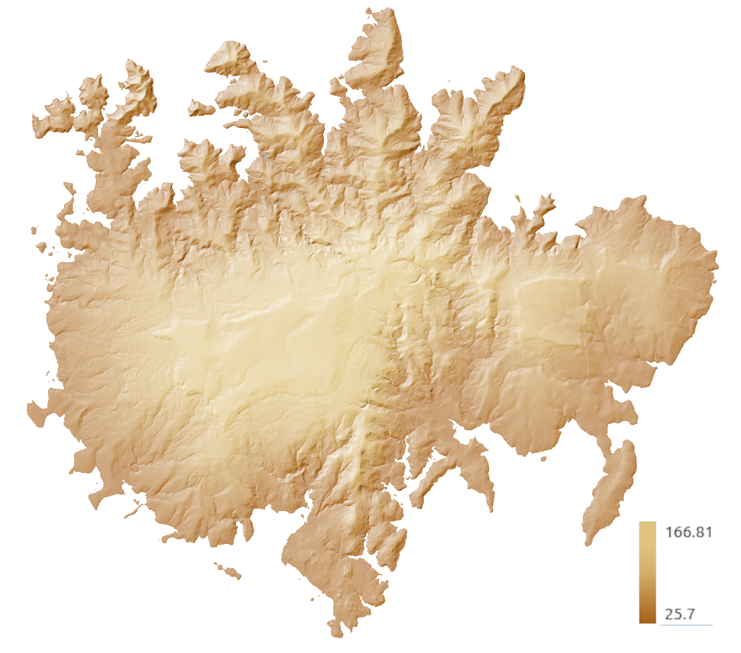
Example output: DTM (dtm version) for the BCI dataset [m]
- Canopy Height Model (CHM)
- Several versions of the CHM are generated by the pipeline:
  - chm_highest
  - CHM generated by creating a TIN over the highest returns of the pointcloud.
  - chm_tin
  - CHM generated by creating a TIN over the first returns of the pointcloud.
  - chm_lspikefree
  - CHM generated with the lspike free algorithm, a more sophisticated version based on the TIN approach that focuses on removing possible spikes in the CHM.
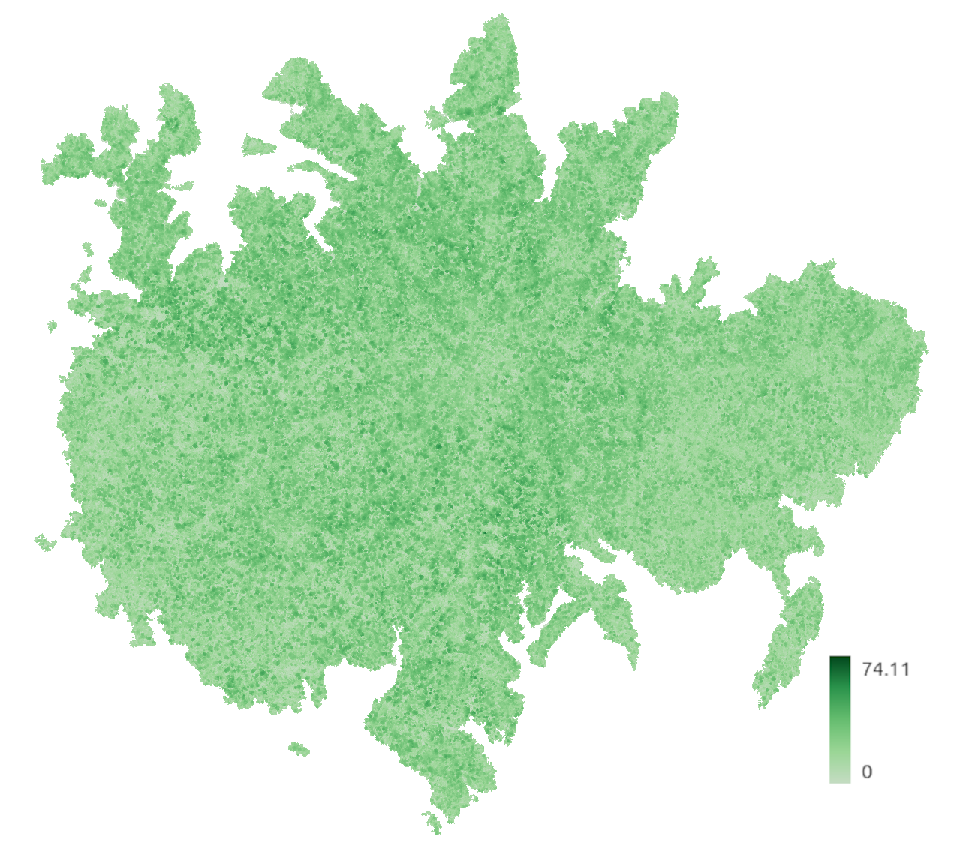
Example output: CHM (lspikefree) for the BCI dataset [m]
- Pulse density raster
A raster generated over the ROI that shows the number of pulses per square meter. This pulse density is important to have an idea of the data coverage of the studied region, which is a main data quality metric.
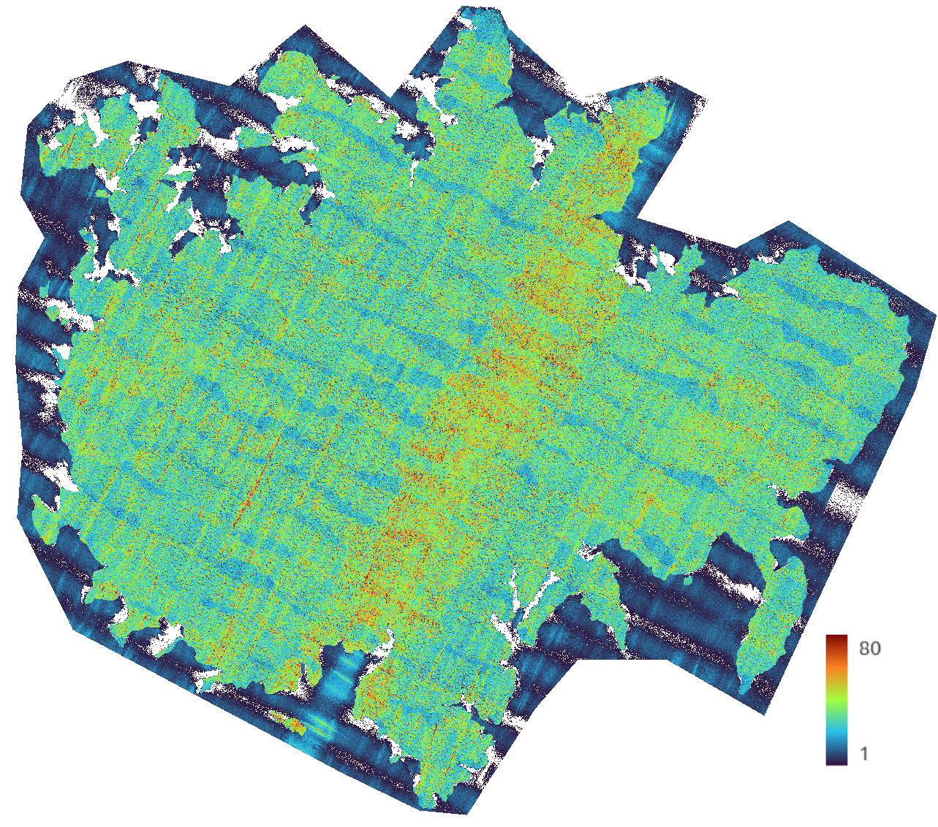
Pulse density raster for the BCI dataset [pulses/m2]
- Scan angle raster
A raster generated over the ROI that shows the maximum beam angle per square meter. The scan angle is directly related to the intensity of the laser return and the laser penetration, which is of great importance for the study of forest canopies.
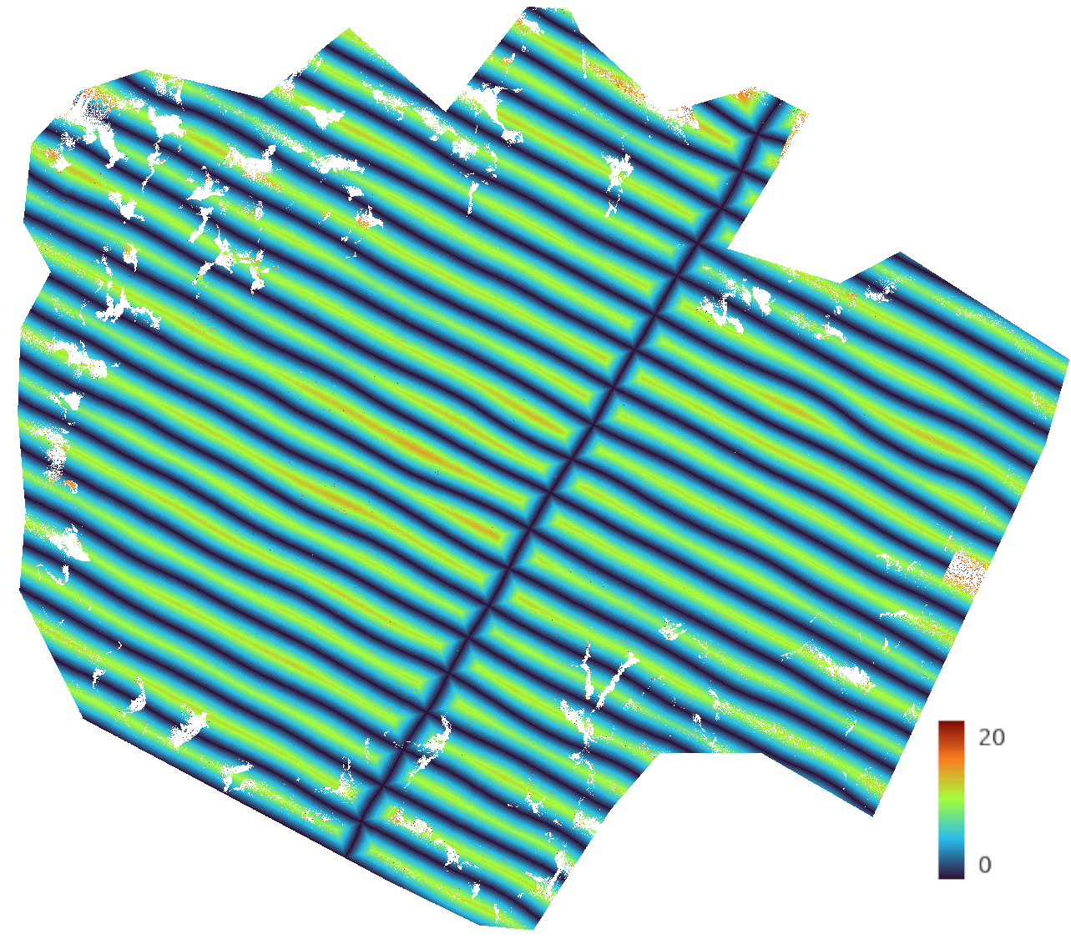
Scan angle raster for the BCI dataset [degrees]

