Case Study 08

Maris Grundy

October 26, 2021

library(tidyverse)  
library(knitr)  
library(kableExtra)  
  
URL<- "https://gml.noaa.gov/webdata/ccgg/trends/co2/co2_annmean_mlo.txt"  
Data<- read_table(URL, skip=57, col_names=c("year", "mean", "unc"))

ggplot(data=Data, aes(x=year, y=mean))+  
 geom_line()

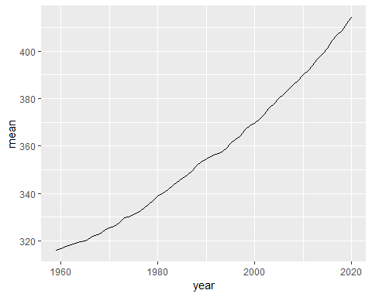

top5 <- Data %>%  
 arrange(desc(mean))%>%  
 top_n(mean, n=5)  
  
knitr::kable(top5)

year

mean

unc

2020

414.24

0.12

2019

411.66

0.12

2018

408.72

0.12

2017

406.76

0.12

2016

404.41

0.12