Case Study 08

Sunny Yueh

August 1, 2020

library(tidyverse)  
library(knitr)  
  
URL<-"ftp://aftp.cmdl.noaa.gov/products/trends/co2/co2_annmean_mlo.txt"  
Data<-read_table(URL,skip=56)

##   
## ── Column specification ───────────────────────────────────────────────────────────────────────────────────────────  
## cols(  
## `#` = col_logical(),  
## year = col_double(),  
## mean = col_double(),  
## unc = col_double()  
## )

Data<-Data[,-1]

ggplot(data=Data,aes(x=year,y=mean))+  
 geom_line()

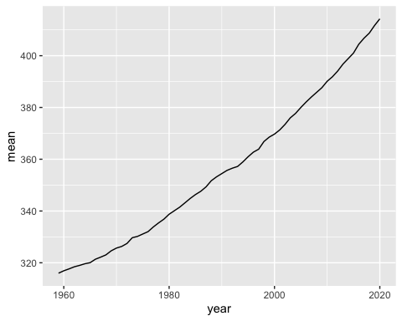

top5<-Data %>%  
 arrange(desc(mean))%>%  
 top_n(mean,n=5)  
  
knitr::kable(top5)

|  |  |  |
| --- | --- | --- |
| year | mean | unc |
| 2020 | 414.24 | 0.12 |
| 2019 | 411.66 | 0.12 |
| 2018 | 408.72 | 0.12 |
| 2017 | 406.76 | 0.12 |
| 2016 | 404.41 | 0.12 |