Case Study 08

Alex Gould

October 26, 2021

library(tidyverse)  
  
URL <- "https://gml.noaa.gov/webdata/ccgg/trends/co2/co2_annmean_mlo.txt"  
Data <- read_table(URL, skip = 57, col_names =c("year", "mean", "unc"))

##   
## ── Column specification ────────────────────────────────────────────────────────  
## cols(  
## year = col_double(),  
## mean = col_double(),  
## unc = col_double()  
## )

ggplot(data=Data, mapping=aes(x=year, y=mean))+  
 geom_line(color= "green")

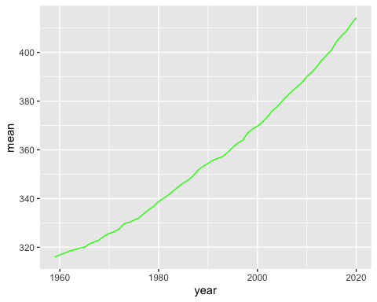

Top5 <- Data %>%  
 arrange(desc(mean)) %>%  
 top_n(mean, n=5)  
  
knitr::kable(Top5)

|  |  |  |
| --- | --- | --- |
| year | mean | unc |
| 2020 | 414.24 | 0.12 |
| 2019 | 411.66 | 0.12 |
| 2018 | 408.72 | 0.12 |
| 2017 | 406.76 | 0.12 |
| 2016 | 404.41 | 0.12 |

#run rmarkdown::render("week_08/case_study_08.Rmd", output_format = "all") below