Case Study 08: One Script, Many Products

Qingqing Chen

26 October, 2021

## Load data

url <- "ftp://aftp.cmdl.noaa.gov/products/trends/co2/co2_annmean_mlo.txt"  
df <- read.table(url, col.names = c("year", "mean", "unc"))

## Visualize

#Use ggplot to plot a time series of CO2 levels through time  
min_year <- df$year %>% min()  
max_year <- df$year %>% max()  
df %>%   
 mutate(sd = sd(mean)) %>%   
 as_tibble() %>%   
 ggplot(., aes(x = year, y = mean)) +  
 geom_line(color = "black", lwd = 0.7) +  
 # geom_errorbar(aes(ymin = mean-sd, ymax = mean+sd),  
 # width = 0.4) +  
 geom_point(size = 1.5, color = "red") +  
 scale_x_continuous(breaks = seq(min_year, max_year, 5)) +  
 theme_bw() +  
 labs(x = "Year", y = "Mean", title= "Trends in Atmospheric Carbon Dioxide")

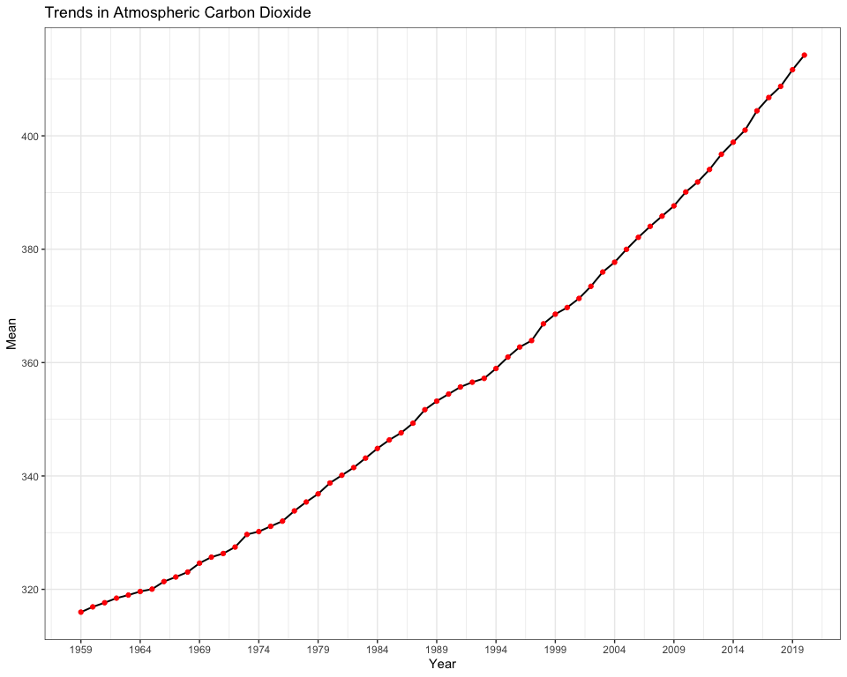

## Creat table

### Method 1

# statistical summary  
summ <- df %>%   
 slice(-1) %>%   
 mutate(Years = case_when(  
 year %in% seq(1960, 1969) ~ "1960 - 1969",   
 year %in% seq(1970, 1979) ~ "1970 - 1979",   
 year %in% seq(1980, 1989) ~ "1980 - 1989",   
 year %in% seq(1990, 1999) ~ "1990 - 1999",   
 year %in% seq(2000, 2009) ~ "2000 - 2009",   
 year %in% seq(2010, 2019) ~ "2010 - 2019",   
 year %in% seq(2020, 2029) ~ "2020 - "  
 )) %>%   
 group_by(Years) %>%   
 dplyr::summarise(Mean = mean(mean),   
 S.D. = sd(mean),   
 Min = min(mean),   
 Max = max(mean))

# suitable for github doc output  
knitr::kable(summ)

# suitable for html output   
kbl(summ,  
 caption = "Mean Mauna Loa CO2 every decade",   
 format = "html", table.attr = "style='width:40%;'") %>%  
 kableExtra::kable_styling(bootstrap_options = "striped",  
 position = "float_right") %>%   
 as_image(width = 10, file = "table.png")

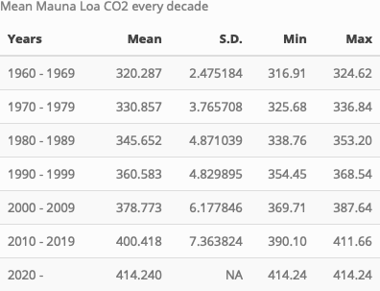

### Method 2

# suitable for html output  
DT::datatable(summ,   
 caption = 'Mean Mauna Loa CO2 every decade',   
 rownames = F,  
 filter = 'top')

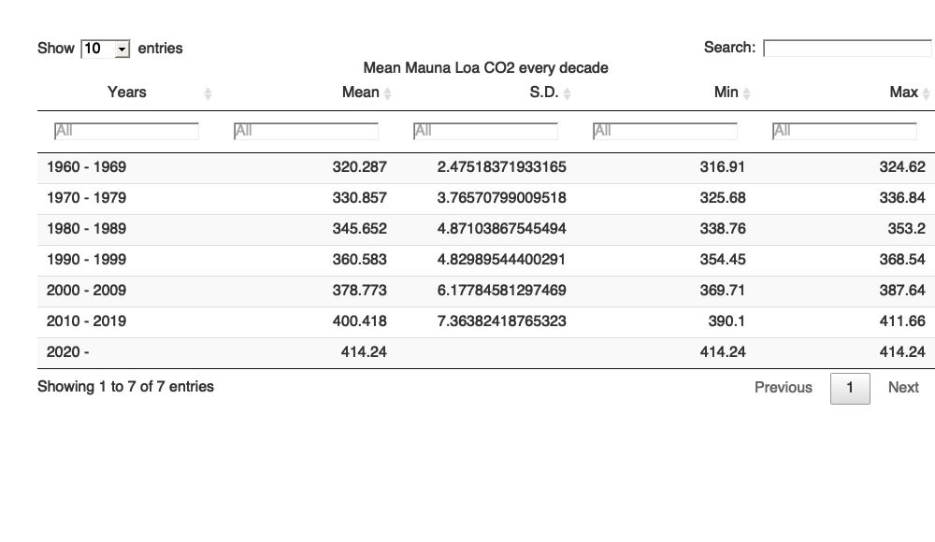

## Render output files

rmarkdown::render("week_08/case_study_08.Rmd",output_format = "all")