Case Study 08

Hui Gao

October 25, 2021

## Load libraries

library(tidyverse)  
library(knitr)  
library(kableExtra)

## Read data

data <- read_table("ftp://aftp.cmdl.noaa.gov/products/trends/co2/co2_annmean_mlo.txt",   
 skip = 57,   
 col_names = c("year", "mean", "unc"))

## Plot

ggplot(data, aes(year, mean)) +  
 geom_line(color = 'red') +  
 # geom_ribbon(aes(ymin=mean-unc, ymax=mean+unc), color = "grey", alpha = .1) +  
 theme_bw()

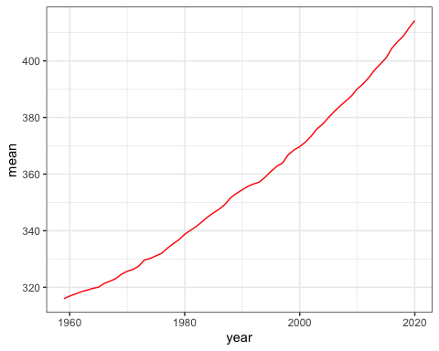

data %>%   
 kable() %>%   
 as_image(width = 10,file = "table.png")

