Case Study 08

Zhenqi Zhou

October 26, 2021

## Annual Mean Carbon Dioxide Concentrations 1959-Present

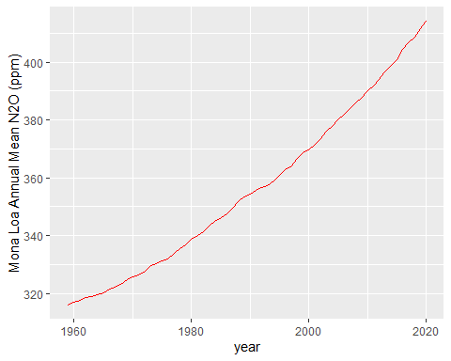

## Top Five Annual Mean Carbon Dioxide Concentrations at Mona Loa

