Case Study 08

Your Name

August 1, 2020

#Load Packages  
library(tidyverse)  
library(dplyr)  
library(kableExtra)  
  
#Read data in  
URL<- ("https://gml.noaa.gov/webdata/ccgg/trends/co2/co2_annmean_mlo.txt")  
Data <- read_table(URL, skip=57, col_names= c("year", "mean", "unc"))

##   
## -- Column specification ------------------------------------------------------------  
## cols(  
## year = col_double(),  
## mean = col_double(),  
## unc = col_double()  
## )

#Plot it  
ggplot(data=Data,mapping=aes(x=year, y=mean))+  
geom_line(color="red", size=2)+  
xlab("Year")+  
ylab("Manual Loa Annual Mean CO_2(ppm)")

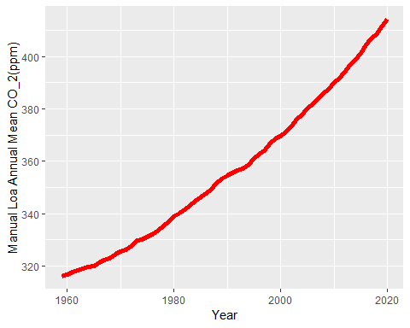

#Top 5 Mean Table  
Top5 <- Data%>%  
arrange(desc(mean))%>%  
top_n(mean, n=5)  
  
#Print Top5  
Top5

## # A tibble: 5 x 3  
## year mean unc  
## <dbl> <dbl> <dbl>  
## 1 2020 414. 0.12  
## 2 2019 412. 0.12  
## 3 2018 409. 0.12  
## 4 2017 407. 0.12  
## 5 2016 404. 0.12

#Knit  
knitr::kable(Top5)

year

mean

unc

2020

414.24

0.12

2019

411.66

0.12

2018

408.72

0.12

2017

406.76

0.12

2016

404.41

0.12