Case Study 08: One Script, Many Products

Wei Liu

October 26, 2021

## Annual Mean Nitrous Oxide Concentrations 2001 - 2020

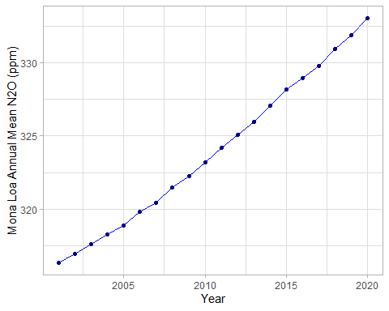

## Top Five Annual Mean Nitrous Oxide Concentrations at Mona Loa

