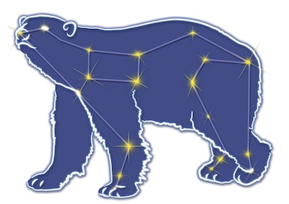
Great Bear Petroleum Operating LLC
A New Direction for the Last Frontier
601 W. 5th Ave., Suite 505, Anchorage, AK 99501
Phone: (907) 868-8070, Fax: (907) 868-3887

June 22, 2011

Ms. Cathy Foerster, Chair
Alaska Oil and Gas Conservation Commission
601 West 5th Ave., Suite 505
Anchorage, Alaska 99501

RE: Weekly Report of Operations
Great Bear Petroleum: Alcor #1 (PTD # 212-057)

Dear: Ms. Foerster,
This is a report of Great Bear Petroleum’s well operations on the Alcor #1 for the period June 16 through June 21, 2012, inclusive.

June 16, 2012 0’ MW (N/A) Vis (N/A) Incl (N/A)
Rack and tally DP and HWDP. Make all of it up in stands and rack back in derrick to pre-load rig. Prepare to cut conductor.

June 17, 2012 0’ MW (N/A) Vis (N/A) Incl (N/A)
Cut off conductor, install 4” outlets. Install landing ring and adapter on conductor and test seals to 500 psi. Measure and cut riser sleeve and install on adapter sleeve. NU 21-1/4” diverter tee and diverter. Install knife valve on diverter tee, assemble and secure diverter line. Install riser from diverter to rig floor.

June 18, 2012 0’ MW 10.0 ppg Vis 300 sec Incl N/A
Function test diverter, PVT sensors and gas alarms. Make dummy run to wellhead with 9-5/8” casing hanger on landing joint and stand back. Perform full test of diverter system, sensors and alarms with AOGCC witness (Jeff Jones). MU BHA #1 and stand back. Rack, tally and drift 9-5/8” casing.

June 19, 2012 800’ MW 10.0 ppg Vis 300 sec Incl 0.46˚
Rack, tally and drift 9-5/8” casing. RIH w/ drlg assy, tag btm at 97’. Drill 12-1/4” hole 97’ to 250’. POH, MU add’l BHA, RIH. Drill 250’ to 800’.

June 20, 2012 1,920’ MW 10.1 ppg Vis 280 sec Incl 0.65˚
Drill 12-1/4” hole 800’ to 1,920’.

June 21, 2012 2,510’ MW 10.2 ppg Vis 150 sec Incl 0.50˚
Drill 12-1/4” hole 1,920’ to 2,510’. CBU twice and POH to BHA to wipe hole for running casing. RIH to TD, CBU twice, spot new mud on bottom and POH.

If you have any questions or require additional information, please contact me at 264-6114 or 250-3113.

Sincerely,

For GREAT BEAR PETROLEUM OPERATING LLC

Bill Penrose

Drilling Manager
SolstenXP Inc.

cc: Clark Clement – Great Bear

