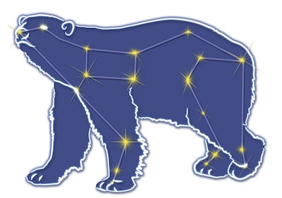
Great Bear Petroleum Operating LLC
A New Direction for the Last Frontier
601 W. 5th Ave., Suite 505, Anchorage, AK 99501
Phone: (907) 868-8070, Fax: (907) 868-3887

August 13, 2011

Ms. Cathy Foerster, Chair
Alaska Oil and Gas Conservation Commission
601 West 5th Ave., Suite 505
Anchorage, Alaska 99501

RE: Weekly Report of Operations
Great Bear Petroleum: Alcor #1 (PTD # 212-057)

Dear: Ms. Foerster,
This is the final report of Great Bear Petroleum’s well operations on the Alcor #1 for the period August 10 through August 12, 2012, inclusive.

August 10, 2012 10,812’ MW 9.8 ppg Vis 28 sec Incl 1.20˚
Finish CBU, RU to cement. Prime and pressure test lines. Pump 125 bbls 10.6 ppg mud + 3 bbls water + 40 bbls weighted spacer + 57.3 bbls Class G cement. Drop plug and chase w/ 10 bbls water + 26 bbls 9.8 ppg brine + 30 bbls water + 50 bbls 9.8 ppg brine. Bump plug, check floats – OK. Drop setting ball. Pressure up to rupture disk, disk ruptured. Perform pull test to 60K lbs – OK. Release from liner hanger and break off cement head. PU 28’ and displace well to 9.8 ppg brine. Pressure test liner hanger to 3,000 psi – OK. POH laying down DP. LD HWDP and liner running tool. RIH w/ DP f/ derrick and POH laying down same.

August 11, 2012 10,812’ MW 9.8 ppg Vis 28 sec Incl 1.20˚
Finish LD DP. Flush stack. Pressure test csg/shoe/lnr to 3,000 psi – OK. Set frac sleeve w/ BPV profile in WH. Install BPV and ND BOPE. Install tbg head adapter and two ea 7-1/16”, 10K master valves. Clean pits.

August 12, 2012 10,812’ MW 9.8 ppg Vis 28 sec Incl 1.20˚
Complete installation of master valves. Clean pits, change liners in #1 mud pump. Test tree to 8,000 psi. Reinstall BPV. Complete rig cleaning and prep for rig move. Release rig from Alcor #1 at 1200 hrs, 08-12-12. FINAL REPORT.

If you have any questions or require additional information, please contact me at 264-6114 or 250-3113.

Sincerely,

For GREAT BEAR PETROLEUM OPERATING LLC

Bill Penrose

Drilling Manager
SolstenXP Inc.

cc: Clark Clement – Great Bear

