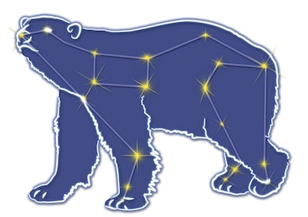
Great Bear Petroleum Operating LLC
A New Direction for the Last Frontier
601 W. 5th Ave., Suite 505, Anchorage, AK 99501
Phone: (907) 868-8070, Fax: (907) 868-3887

July 13, 2011

Ms. Cathy Foerster, Chair
Alaska Oil and Gas Conservation Commission
601 West 5th Ave., Suite 505
Anchorage, Alaska 99501

RE: Weekly Report of Operations
Great Bear Petroleum: Alcor #1 (PTD # 212-057)

Dear: Ms. Foerster,
This is a report of Great Bear Petroleum’s well operations on the Alcor #1 for the period July 6 through July 12, 2012, inclusive.

July 6, 2012 7,100’ MW 9.4 ppg Vis 84 sec Incl 0.45˚
C&C hole while lowering mud weight to 9.4 ppg. Wash and ream 5,908’ to 6,434’. Drill 8-1/2” hole 6,434’ to 7,100’

July 7, 2012 8,014’ MW 9.4 ppg Vis 80 sec Incl 0.88˚
Drill 7,100’ to 7,440’. Make wiper trip to 6,482’. Hole in good condition. Drill 7,440’ to 8,014’.

July 8, 2012 8,250’ MW 9.4 ppg Vis 85 sec Incl 1.07˚
Drill 8,014’ to 8,250’. C&C hole and make wiper trip to 2,463’ in prep for logging and running casing. LD excess 5” drill pipe in derrick. RIH to 5,800’.

July 9, 2012 8,320’ MW 9.5 ppg Vis 85 sec Incl 2.03˚
RIH from 5,800’ to 8,250’. Drill & slide 8,250’ to 8,320’ and CBU to ensure bit in a good shale for 7” casing shoe. POH L/D 5” DP. Break down BHA.

July 10, 2012 8,320’ MW 9.5 ppg Vis 115 sec Incl 2.22˚
Cont L/D BHA. RU for WL logging. Make logging Run #1: Quad-Combo/Dipole Sonic/Compensated Spectral Gamma Ray. Make logging Run #2: Oil Mud Micro-Imager/6-Arm Caliper. RD WL. Change upper BOP rams to 7”.

July 11, 2012 8,320’ MW 9.5 ppg Vis 115 sec Incl 2.22˚
Test 7” rams to 250/5,000 psi (took 3 attempts). RU casing running tools. Run 7”, 29#, P-110, BTC csg to 5,700’.

July 12, 2012 8,320’ MW 9.5 ppg Vis 100 sec Incl 2.22˚
Finish running 7” csg and land out in WH. Shoe at 8,311’. Circulate w/ very few returns. RU to pump cement. Test lines to 3,000 psi. Pump 5 bbls water, 20 bbls chemical spacer, 10 bbls water. Drop btm plug and pump 119 bbls 12.5 ppg lead slurry and 32 bbls 15.8 ppg tail slurry. Drop top plug, switch to rig pumps and displace w/ mud. Very few returns during pumping. Bump plug on schedule, check floats – OK. RD cementers, change rams and DP handling tools to 4”.

If you have any questions or require additional information, please contact me at 264-6114 or 250-3113.

Sincerely,

For GREAT BEAR PETROLEUM OPERATING LLC

Bill Penrose

Drilling Manager
SolstenXP Inc.

cc: Clark Clement – Great Bear

