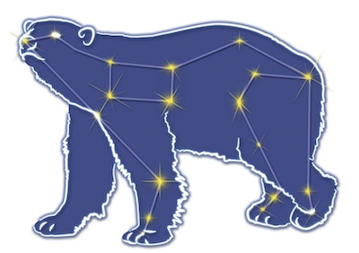
Great Bear Petroleum Operating LLC
A New Direction for the Last Frontier
601 W. 5th Ave., Suite 505, Anchorage, AK 99501
Phone: (907) 868-8070, Fax: (907) 868-3887

August 10, 2011

Ms. Cathy Foerster, Chair
Alaska Oil and Gas Conservation Commission
601 West 5th Ave., Suite 505
Anchorage, Alaska 99501

RE: Weekly Report of Operations
Great Bear Petroleum: Alcor #1 (PTD # 212-057)

Dear: Ms. Foerster,
This is a report of Great Bear Petroleum’s well operations on the Alcor #1 for the period August 3 through August 9, 2012, inclusive.

August 3, 2012 10,662’ MW 10.7 ppg Vis 45 sec Incl 1.20˚
L/D 30’ Core Assy #3 – 26’ recovered. M/U 60’ Core Assy #4 and RIH to 10,474’. Displace 11.2 ppg trip mud to 10.7 ppg drilling mud. Wash fill from 10,474’ to 10,602’. Cut Core #4 from 10,602’ to 10,662’. Break off core w/ 20K lbs overpull. Displace 10.7 ppg drilling mud w/ 11.2 ppg tripping mud.

August 4, 2012 10,662’ MW 11.2 ppg Vis 55 sec Incl 1.20˚
Finish displacing to 11.2 ppg tripping mud. POH w/ Core #4. L/D coring assy – recovered 57’. Commence weekly BOP test.

August 5, 2012 10,662’ MW 11.2 ppg Vis 51 sec Incl 1.20˚
Finish BOP test (test witness waived by AOGCC’s Chuck Scheve). M/U drilling BHA and RIH. Tag fill at 10,628’. Displace 11.2 ppg tripping mud with 10.7 ppg drilling mud.

August 6, 2012 10,812’ MW 11.2 ppg Vis 55 sec Incl 1.20˚
Finish displacing 11.2 ppg tripping mud with 10.7 ppg drilling mud. Work pumps in attempt to get LWD signal – NG. Drill from 10,662’ to 10,812’ TD. Displace 10.7 ppg drilling mud with 11.2 ppg tripping mud and POH.

August 7, 2012 10,812’ MW 11.2 ppg Vis 56 sec Incl 1.20˚
Download LWD tools – no data stored in memory. MU quad-combo LWD BHA and RIH. Tag fill at 10,792’, wash to TD at 10,812’ and commence MAD passing upward with LWD tools.

August 8, 2012 10,812’ MW 11.2 ppg Vis 53 sec Incl 1.20˚
Continue MAD pass upward to casing shoe at 8,311’. POH, LD BHA, download LWD. Rig up to run 4-1/2” liner.

August 9, 2012 10,812’ MW 11.2 ppg Vis 52 sec Incl 1.20˚
RU to run 4-1/2” liner. MU 2,741’ of 4-1/2”, 13.5 lb, P-110, Hydril 521 liner w/ HES Versaflex liner hanger and RIH on DP. Tag fill at 10,753’, would not wash down. CBU.

If you have any questions or require additional information, please contact me at 264-6114 or 250-3113.

Sincerely,

For GREAT BEAR PETROLEUM OPERATING LLC

Bill Penrose

Drilling Manager
SolstenXP Inc.

cc: Clark Clement – Great Bear

