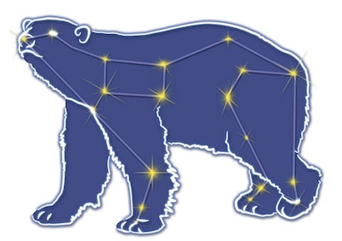
Great Bear Petroleum Operating LLC
A New Direction for the Last Frontier
601 W. 5th Ave., Suite 505, Anchorage, AK 99501
Phone: (907) 868-8070, Fax: (907) 868-3887

June 29, 2011

Ms. Cathy Foerster, Chair
Alaska Oil and Gas Conservation Commission
601 West 5th Ave., Suite 505
Anchorage, Alaska 99501

RE: Weekly Report of Operations
Great Bear Petroleum: Alcor #1 (PTD # 212-057)

Dear: Ms. Foerster,
This is a report of Great Bear Petroleum’s well operations on the Alcor #1 for the period June 22 through June 28, 2012, inclusive.

June 22, 2012 2,510’ MW 10.2 ppg Vis 170 sec Incl 0.50˚
POH, set back BHA. Run 9-5/8” casing. Stuck at 1,861’, work free. Continue running casing to 2,120’

June 23, 2012 2,510’ MW 10.4 ppg Vis 60 sec Incl 0.50˚
Continue running casing, washing down. Hole very tight below 2,000’. Land casing, MU and RIH w/ inner cmtg string and FC stab-in assy. Pump 440 bbls 11.1 ppg permafrost lead cement. Observe cmt returns at surface, switch to 15.8 ppg Class G tail cement and pump 50.5 bbls. Displace w/ mud and bump plug. Unsting f/ FC, CBU and POH.

June 24, 2012 2,510’ MW 10.4 ppg Vis 52 sec Incl 0.50˚
LD BHA. ND diverter system, NU wellhead components, NU BOPE.

June 25, 2012 2,510’ MW 10.4 ppg Vis 50 sec Incl 0.50˚
NU BOPE and function test.

June 26, 2012 2,510’ MW 10.4 ppg Vis 50 sec Incl 0.50˚
Test BOPE w/ AOGCC witness (Chuck Scheve). MU 8-1/2” BHA. RIH, shallow test MWD/LWD tools. RIH, tag FC at 2,406’. Change pits over to MOBM.

June 27, 2012 3,410’ MW 10.2 ppg Vis 76 sec Incl 0.18˚
Pressure test csg to 3,000 psi for 30 min. Displace spud mud in csg w/ MOBM. Drill shoe track, rat hole and 20’ of new fm to 2,541’. Perform LOT, yielded 13.9 ppg EMW. Drill to 3,410’. Started losing partial returns at 3,220’, commenced adding LCM to mud.

June 28, 2012 3,989’ MW 9.7 ppg Vis 78 sec Incl 0.65˚
Drill 8-1/2” hole 3,410’ to 3,586’. Mud returns about half of mud pumped. Pump LCM pill and circulate. Losses the same. Pump second LCM pill. Losses the same. Cut mud weight from 10.2 ppg to 9.7 ppg. Drill 3,586’ to 3,798, losses down to 4-8 bph. Hole giving back some mud on connections. Drill 3,798’ to 3,989’.

If you have any questions or require additional information, please contact me at 264-6114 or 250-3113.

Sincerely,

For GREAT BEAR PETROLEUM OPERATING LLC

Bill Penrose

Drilling Manager
SolstenXP Inc.

cc: Clark Clement – Great Bear

