**Proposed Setup for ISSM-ShelficeRemeshing test**

In the remeshing github branch

(<https://github.com/dngoldberg/MITgcm/tree/branch_remeshing)>

there is a verification experiment detailed in

verification/shelfice_remeshing/. The input folder gives various parameters for the experiment, e.g. the dimensions of the lat-lon grid are in /shelfice_remeshing/input/data. The ocean modelling setup is fairly standard. There is no sea ice, and OBCS is used to force conditions at the northern boundary. The southern boundary is no-flow for the ocean, and the east-west boundaries are periodic.

The ice shelf setup is detailed in verification/shelfice_remeshing/code/STREAMICE_OPTIONS.h and verification/shelfice_remeshing/input, but almost all users of MITgcm will be unfamiliar with these files!!! Adherence to the setup exactly is not so important as the broad strokes, given here.

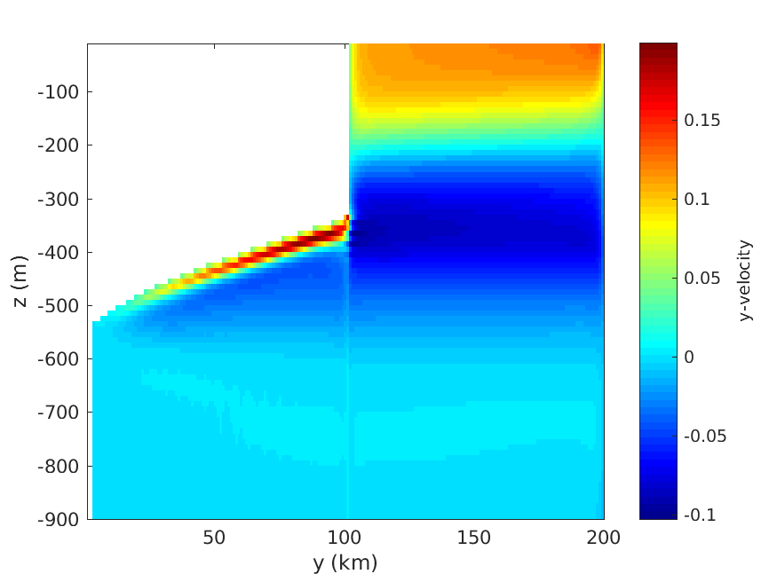Briefly:

* Uniform bathymetry of -900m
* Specified volume flux of ice at the southern boundary
* Ice model is effectively 1D (east-west periodic)
* There is a fixed calving boundary about the north-south mid point. Again, not so important as the fact that there is a reasonable amount of open ocean.
* The grid (the ice grid, but for me ice and ocean grid are one and the same) is actually 3 grid cells wide – the streamice solver is not coded for a 1-cell wide domain, unfortunately! But both ice and ocean are transversely periodic and there is effectively no dependence on the transverse direction.

Figure 1: Horizontal ocean velocity in 2D simulation below 1D ice shelf (uncolored portion)

* I have implemented “buttressing” through the Dupont & Alley, 2005 parameterisation. But even if ISSM does not do this, I do not think this is important. We do not need buttressing for this test. Simply a 1D floating ice shelf, unconfined, beginning in a steady state, will do. Furthermore I am completely agnostic about the ice stiffness parameter.

**Further thoughts about ISSM-MITgcm Coupling**

A “skeleton” coupling strategy already exists. Having looked it over, I would like to potentially refine this. The fundamental principles to respect seem to be:

1. The time-average of the melt rate calculated by the ocean, and experienced by the ice shelf, should be the same.
2. Efforts should be made to ensure that discontinuities in ice mass seen by the ocean are as seldom and small as possible.*

* An important point to make is the following: the ocean does not see ice shelf draft; it sees ice shelf **mass per unit area** (sometimes input through the field ShelficePloadAnomaly, but input as mass directly). SHELFICE setups where only the draft is specified, actually are specifying mass implicitly. They are specifying the exact mass required such that the ice shelf base will be at a given draft.

These criteria should influence what fields are passed from which model – in effect, what is “owned” by each model. Current thinking is that ISSM “owns” ice thickness/draft/mass and any changes thereof; and that MITgcm “owns” melt rates. I am OK with this.

When last we talked a strategy was beginning to take shape – based on the fact that ice thickness change (ice thickness *tendency*) is determined by both melt rates, SMB and mass divergence. The latter two do not rely on the ocean model. So one could write for ISSM:

$${\left(\frac{dh}{dt}\right)}_{dyn}= SMB-∇∙(uh)$$

$$\left(\frac{dh}{dt}\right) = {\left(\frac{dh}{dt}\right)}_{dyn}-m$$

where h is thickness, u is ice velocity, and *m* is melt rate, averaged over a time step. ${\left(\frac{dh}{dt}\right)}_{dyn}$ can be evaluated at the start of a simulation, without knowing melt rate. Moreover, MITgcm can impose a constant mass change rate to the ice draft. Therefore a viable coupling scheme could be

Coupled time step *n*

1. ISSM takes forward time step (from time tn to tn+1) without melt rate
2. Dynamic tendency (dhdtdyn) is calculated
3. Initial ice shelf draft, and dynamic tendency, passed to MITgcm through mpi
4. Ocean integrates from from time tn to tn+1, allowing changes to ice shelf mass and therefore to the free surface (which is also the ice draft).

Note that at the end of step 4, ice mass in the ocean model (*mass*MITgcm) is not the same as the field read in at time tn at the beginning of step 4 (which we will call *mass*ISSM)

1. Ocean melt rate averaged from time tn to tn+1, and passed to ISSM via mpi
2. ISSM *again* takes forward time step from time tn to tn+1, *with* melt rate. Ice thickness at time tn+1 is finally established. (If time step is explicit, additional velocity solve is not necessary.

Coupled time step *n+1*

1. ISSM takes forward time step (from time tn+1 to tn+1) without melt rate …

…

Potential drawback: it is *vital* that, at the start of sub-step 4 in coupling time step n+1, when the ocean model receives ice thickness from ISSM at time tn+1, that the resultant mass (massISSM at time tn+1) be equal to massMITgcm at the end of sub-step 4 in coupling time step n. If not – Tsunamis!!! **Any thoughts on ways to ensure this?**

Other than that – I think the scheme is plausible, unless I have misunderstood things quite badly!