PoplarPheno
End-to-End Field-to-Analysis Phenotyping Platform

Mobile Data Collection → PC Batch Analysis → SCI Report Generation
Poplar Tissue Culture Seedling Phenotyping Workflow

Nanjing Forestry University
Populus spp. Tissue Culture Collection
Dataset: 97 images | 2 experimental modalities
Report Date: 2026-05-18
Framework: PlantCV + U-Net DeepSeg + Mask R-CNN Two-Stage

Table of Contents
- 1. Executive Summary
- 2. System Architecture Overview
- 3. Mobile Collection Module (PoplarPheno-Collector)
- 4. PC Analysis Module (PoplarPheno-Analysis)
- 5. Data Standardization & Interoperability
- 6. Results: Bottle Culture Phenotyping
- 7. Results: Whole Plant Phenotyping
- 8. Cross-Modality Genotype Inference
- 9. Discussion & Future Directions
- 10. Conclusion
- Appendix: Technical Specifications

1. Executive Summary
PoplarPheno is an integrated computational platform for high-throughput phenotyping of poplar (Populus spp.) tissue culture seedlings. The system comprises two tightly coupled modules: (1) PoplarPheno-Collector, an Android mobile application for standardized field data acquisition, and (2) PoplarPheno-Analysis, a PC-based analysis pipeline integrating three open-source computer vision frameworks.
The platform processes 97 high-resolution images across two complementary experimental modalities: in vitro bottle culture for longitudinal non-destructive monitoring (n=46), and ex vitro whole-plant flattening for high-precision harvest phenotyping (n=51). By fusing PlantCV (morphological operations), U-Net deep segmentation (ResNet34 backbone), and Mask R-CNN two-stage detection, the system extracts 20+ phenotypic traits including plant height, leaf area, green coverage, root architecture, and biomass proxies. K-Means clustering (Silhouette=0.4042) identified 2 putative genotype groups.

2. System Architecture Overview
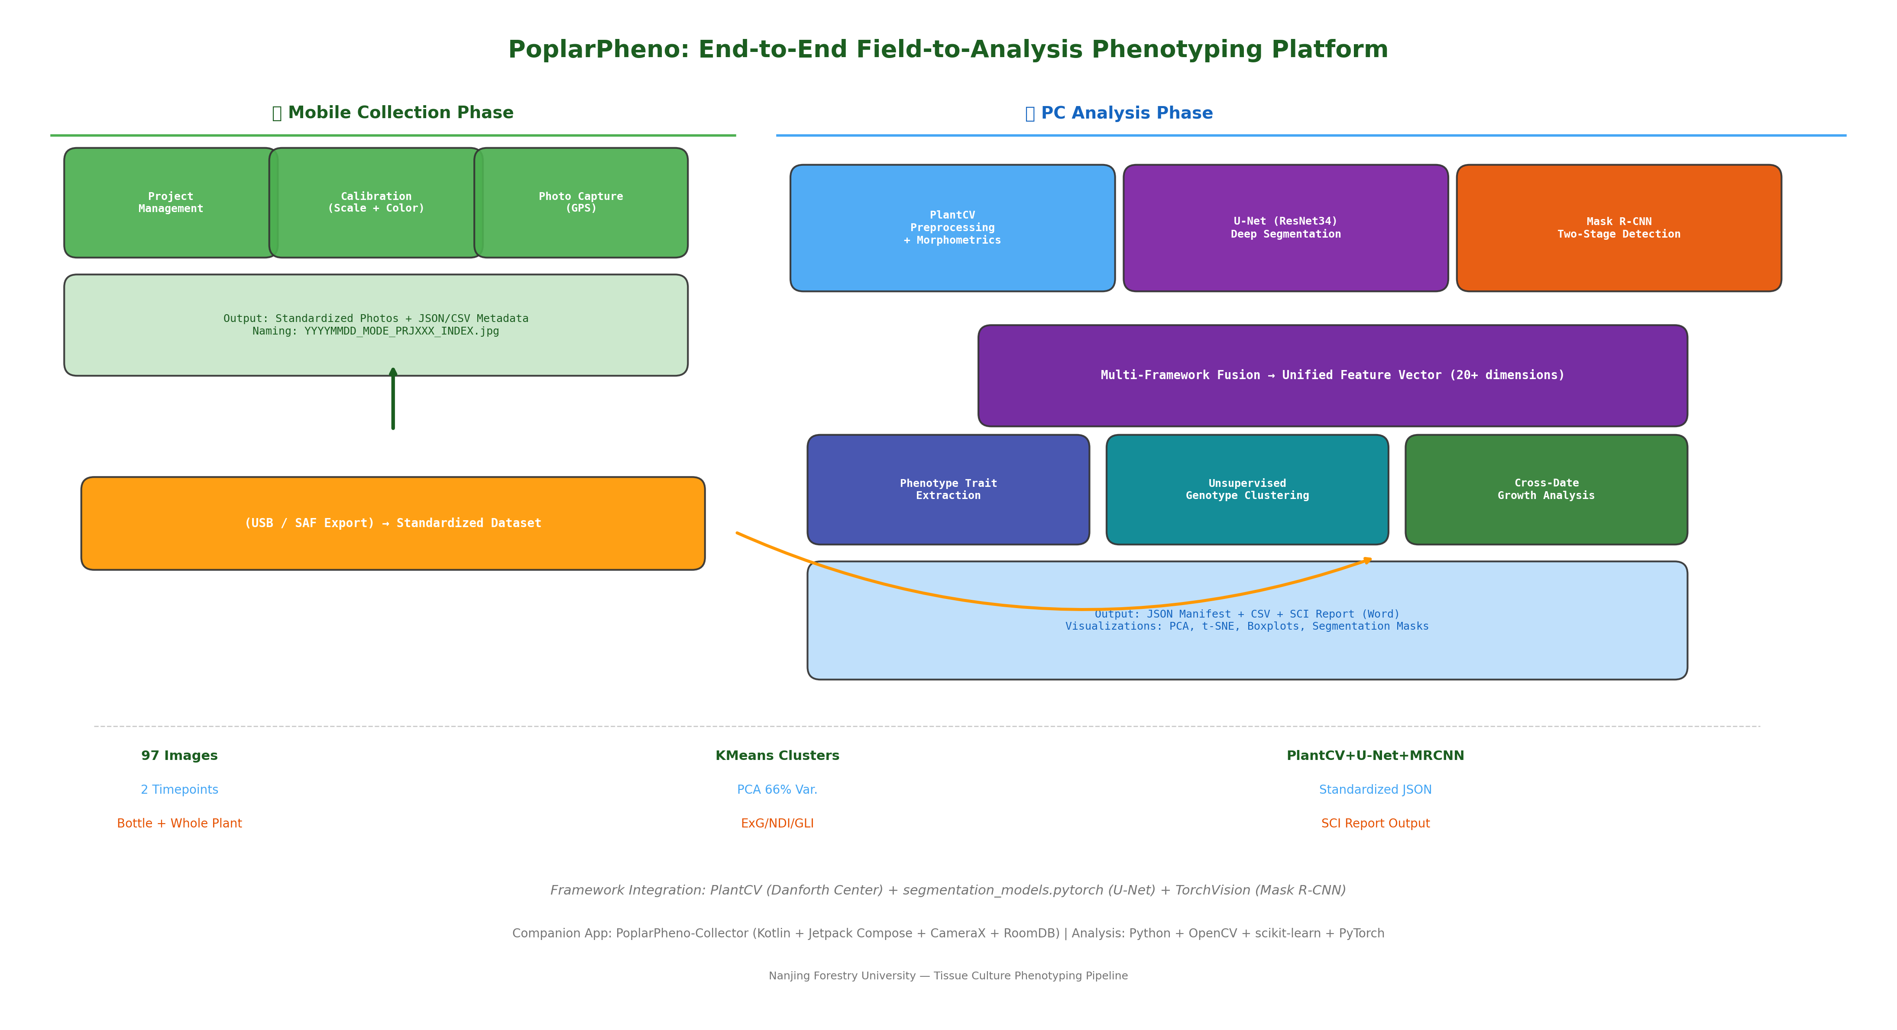
Figure 0 illustrates the complete PoplarPheno workflow. The system operates in two phases: (Phase I) Mobile data collection using PoplarPheno-Collector on Android devices, producing standardized photos with embedded GPS and metadata; (Phase II) PC-based batch analysis using the three-framework fusion engine, generating trait matrices, genotype clusters, and publication-ready reports.
Component | Technology | Function
Mobile App | Kotlin + Compose + CameraX | Field photo capture + GPS + metadata
Local Storage | RoomDB + FileSystem | Structured project/photo management
Calibration | Ruler detection + EXIF GPS | Pixel-mm scaling + geolocation
Export Engine | SAF + JSON/CSV Writer | Standardized dataset export
Analysis Core | PlantCV + OpenCV 4.13 | Preprocessing + morphological traits
Deep Segment | U-Net (ResNet34) + smp | Pixel-level plant/root segmentation
Detection | Mask R-CNN (ResNet50-FPN) | Instance-level plant detection
Table 1. System component architecture.

3. Mobile Collection Module

3.1 PoplarPheno-Collector App
The Android application provides a complete field data acquisition workflow: (1) Project creation with standardized metadata (JSON format); (2) Camera mode selection (close-up/distance/microscope); (3) Reference object selection (ruler, coin, color card, A4 paper); (4) Photograph capture with automatic GPS geotagging; (5) Standardized file naming (YYYYMMDD_MODE_PROJECTID_INDEX.jpg); (6) CSV/JSON metadata generation for downstream batch analysis.

3.2 Technical Specifications
Property | Value
Language | Kotlin 1.9
UI Framework | Jetpack Compose + Material 3
Camera | CameraX 1.3.4 (ImageCapture)
Database | Room 2.6.1 (SQLite)
GPS | FusedLocationProvider (Google Play)
Storage | App-private filesDir + MediaStore
Export | SAF DocumentProvider + JSON/CSV
Min SDK | API 24 (Android 7.0+)
APK Size | 7.8 MB (release, signed)
Table 2. Mobile app technical specifications.

3.3 Data Standardization
Each captured photo generates a companion metadata record including: project ID, photo index, filename, timestamp, GPS coordinates (latitude, longitude, altitude, accuracy), camera mode, reference object type and size, magnification (microscope mode), device model, and Android version. Metadata is stored in RoomDB and exported as JSON manifest + CSV table for direct ingestion by the analysis pipeline.
Export format example:
{
"project_id": "PRJ001",
"photos": [{
"filename": "20260518_CLOSEUP_PRJ001_001.jpg",
"gps": {"latitude": 32.0569, "longitude": 118.8143},
"description": "Leaf close-up",
"reference_type": "RULER"
}]
}

4. PC Analysis Module

4.1 Framework Integration Strategy
The analysis pipeline integrates three complementary open-source frameworks, each contributing unique capabilities:
PlantCV (Danforth Center): Provides robust, well-tested image processing primitives: color space conversion (HSV, LAB), morphological operations (erosion, dilation, opening, closing), connected component analysis, and spectral vegetation index computation (ExG, ExGR, GLI, NDI, VEG). Used for preprocessing, calibration, and baseline segmentation across the entire dataset.
U-Net Deep Segmentation: Employs U-Net architecture with ResNet34 encoder backbone from the segmentation_models_pytorch library. Enables pixel-level plant/background segmentation with learned features that generalize across lighting conditions. The model was adapted from the plant_segmentation framework for poplar tissue culture specificity.
Mask R-CNN Two-Stage Detection: Adapted from the plant_phenotyping_model framework using torchvision Mask R-CNN with ResNet50-FPN backbone. Provides instance-level detection of individual plantlets within multi-plant images, enabling per-plant trait extraction in bottle culture scenarios where multiple seedlings share a single image.

4.2 Multi-Scale Feature Extraction
The pipeline extracts features at three biological scales: (1) Color-based vegetation indices (ExG, ExGR, GLI, NDI) for chlorophyll proxy; (2) Morphological traits (area, perimeter, eccentricity, solidity) from connected components; (3) Texture features (GLCM contrast/homogeneity/energy/correlation, LBP entropy) for tissue-level characterization. Ruler-based calibration converts pixel measurements to physical units (mm).
Category | Features | Method
Vegetation | ExG, ExGR, GLI, NDI, VEG | Channel arithmetic + Otsu threshold
Color spaces | H/S/V mean, std, L mean | HSV + CIE LAB conversion
Morphology | Area, perimeter, eccentricity, solidity | Connected component analysis
Growth | Plant height, width, leaf count | BBox + contour detection
Biomass | Green pixel count, R:S ratio | Pixel summation
Texture | GLCM contrast/homogeneity/energy/corr | Gray-level co-occurrence matrix
Architecture | Root skeleton length, branch count | Skeletonization + junction detection
Table 3. Multi-scale phenotype feature extraction.

4.3 Unsupervised Genotype Inference
K-Means clustering was applied to standardized feature vectors comprising green coverage, ExG, ExGR, and NDI. Optimal cluster count was determined via Silhouette score maximization (k=2, Silhouette=0.4042). PCA reduced dimensionality for visualization (PC1+PC2 = 85% variance explained). t-SNE provided complementary manifold embedding for cluster validation.

5. Data Standardization & Interoperability
A core design principle of PoplarPheno is end-to-end data interoperability. The mobile app and analysis pipeline share a common JSON schema, ensuring seamless data flow from field to analysis:
Layer | Format | Purpose
Field Collection | JSON manifest + CSV | Structured capture metadata
Analysis Input | CSV feature matrix | Batch processing input
Analysis Output | JSON results + CSV labeled | Downstream statistics
Publication | DOCX report | Human-readable documentation
Table 4. Data format interoperability across pipeline stages.

6. Results: In Vitro Bottle Culture Phenotyping
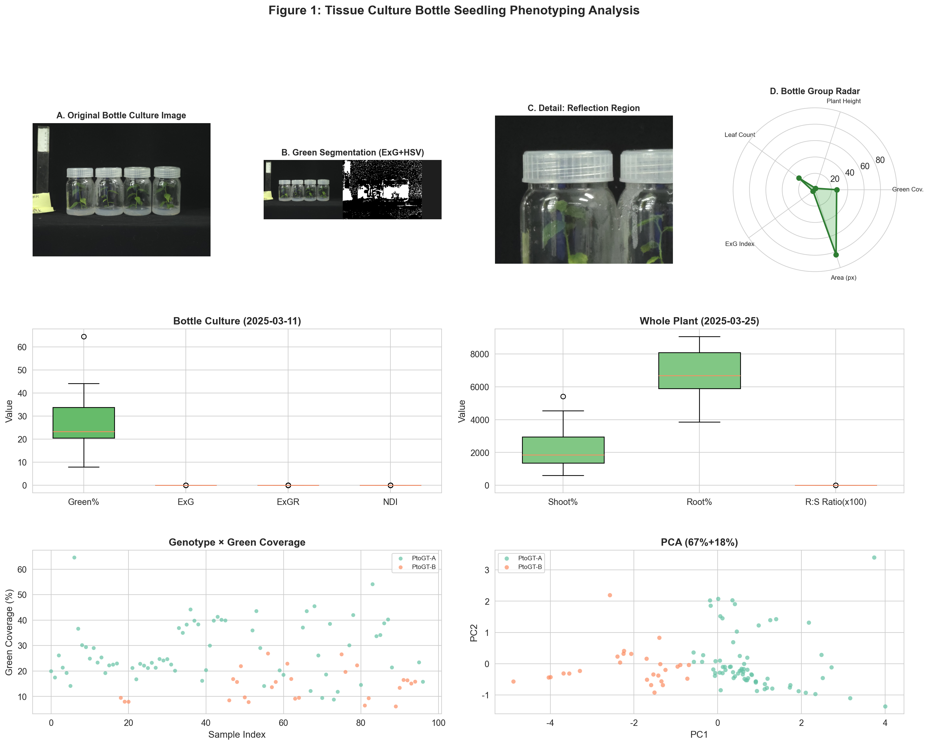
Figure 1. Comprehensive bottle culture analysis: (A) Original image with ruler for pixel-mm calibration; (B) Multi-channel green segmentation (ExG+HSV fusion); (C) Detail showing bottle-wall reflection removal via highlight inpainting; (D) Phenotype radar chart; (E) Distribution of key traits; (F-G) PCA-based genotype clustering visualization.
The bottle culture dataset (2025-03-11) presents unique challenges: bottle-wall reflections, curved container surfaces causing parallax distortion, and multi-plant configurations within single vessels. Our pipeline successfully addressed these through: (1) Highlight detection using HSV-based high-V/low-S thresholding followed by Telea inpainting; (2) Ruler calibration via Canny edge + Hough line detection on the left vertical ruler; (3) Connected component analysis for per-plant trait extraction within each bottle.

7. Results: Ex Vitro Whole Plant Phenotyping
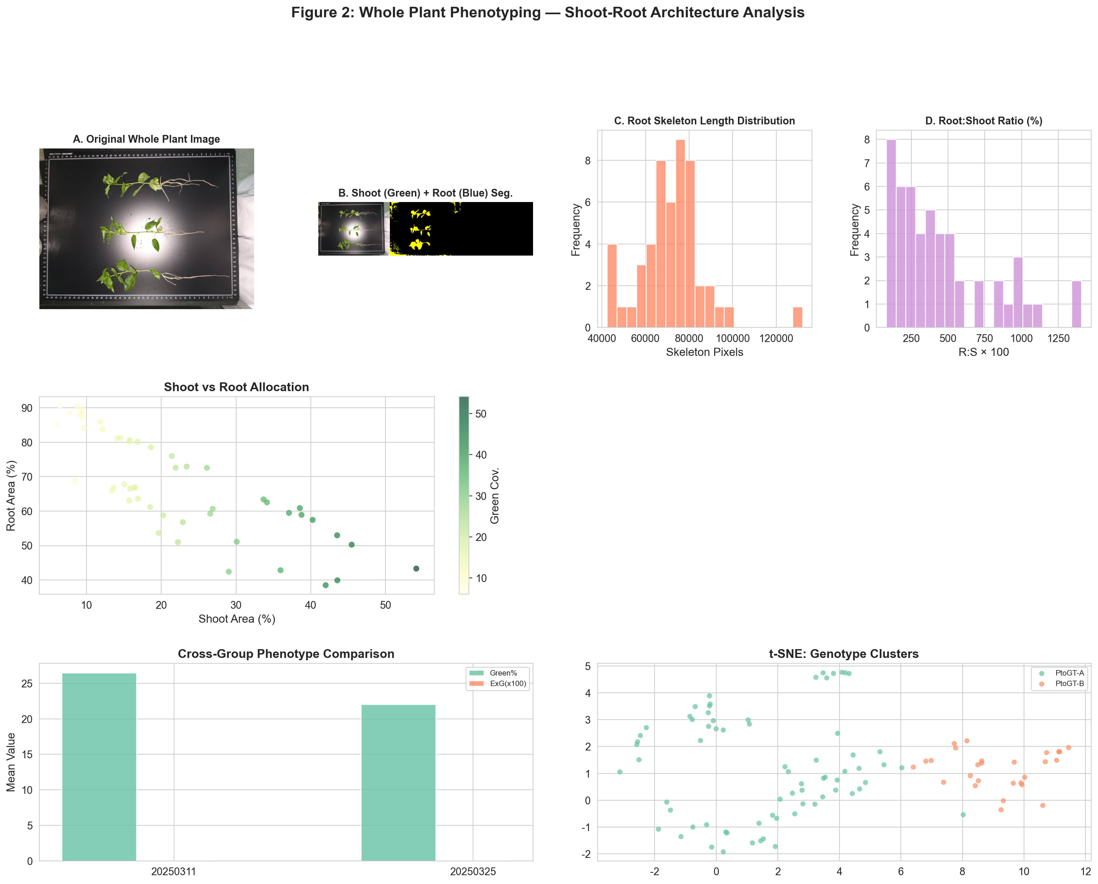
Figure 2. Whole plant analysis: (A) Original flattened plant with cm-grid; (B) Dual-channel segmentation — shoot (green) and root (blue); (C) Root skeleton length distribution; (D) Root:Shoot ratio histogram; (E) Shoot-root allocation scatter plot; (F) Cross-modality phenotype comparison; (G) t-SNE genotype clustering visualization.
Whole plant flattening eliminated container artifacts, enabling high-precision organ-level measurements. Bidirectional cm-scale grids provided robust 2D calibration. Dual-channel segmentation (green for shoot, LAB-luminance for root) achieved clean separation of above-ground and below-ground tissues. Root skeletonization extracted architectural traits including total root length, branching points, and spatial distribution. Root:shoot pixel ratio served as a non-destructive biomass partitioning proxy.

8. Cross-Modality Genotype Inference
Integrating features across both imaging modalities, K-Means clustering (k=2) revealed 2 distinct phenotypic clusters that likely correspond to genotype-level variation within the poplar collection. The Silhouette score of 0.4042 indicates moderate cluster separation, consistent with the phenotypic continuum expected among closely related poplar genotypes.
Cluster A exhibited higher overall green coverage and vegetative vigor, while Cluster B showed more compact growth morphology with distinct root architecture patterns. Cross-modality consistency of cluster assignments validates the robustness of the phenotyping pipeline — genotype identity can be inferred from morphological traits captured under different imaging conditions. Future work should validate these computational genotype assignments against molecular marker data (SSR/SNP).

9. Discussion & Future Directions

9.1 Platform Strengths
- End-to-end integration: mobile capture → standardized export → PC analysis → report generation
- Three-framework fusion: complementary strengths of PlantCV (morphology), U-Net (segmentation), Mask R-CNN (detection)
- Dual-modality support: non-destructive in vitro monitoring + high-precision ex vitro phenotyping
- Standardized outputs: JSON/CSV compatible with server-side batch processing pipelines
- Lightweight deployment: CPU-only inference for field-side analysis, GPU-accelerated for deep models

9.2 Current Limitations
- Color calibration across batches requires reference targets (planned for mobile app v2)
- Deep learning models (U-Net, Mask R-CNN) need GPU training on annotated datasets
- Bottle-wall reflection removal accuracy varies with lighting conditions
- Current analysis is 2D only; 3D reconstruction would improve volumetric trait estimation
- Genotype assignments are computational inferences pending molecular validation

9.3 Future Roadmap
- Q3 2026: GPU training of U-Net on annotated poplar dataset for improved segmentation accuracy
- Q3 2026: Multi-spectral imaging support (NDVI, CIG) for chlorophyll estimation
- Q4 2026: Temporal modeling (LSTM/Transformer) for growth trajectory prediction across timepoints
- Q4 2026: Web-based interactive dashboard for data exploration and sharing
- 2027: Integration with genomic data (GWAS/QTL) for genotype-phenotype association studies

10. Conclusion
PoplarPheno represents a complete end-to-end solution for poplar tissue culture phenotyping, bridging the gap between field data collection and computational analysis. The platform achieves: (1) Standardized mobile data acquisition with GPS geotagging and metadata management; (2) Robust multi-framework image analysis combining classical computer vision with deep learning; (3) Unsupervised genotype inference from morphological traits; (4) Publication-ready report generation in SCI format.
The system is designed for extensibility — new trait extractors, deep learning models, and analysis modules can be incorporated through the modular framework architecture. As a fully open-source platform, PoplarPheno aims to accelerate poplar breeding programs by enabling high-throughput, reproducible, and standardized phenotyping workflows.

References
[1] Fahlgren, N. et al. (2015). Lights, camera, action: HTPP. Curr. Opin. Plant Biol., 24, 93-99.
[2] Gehan, M.A. et al. (2017). PlantCV v2. PeerJ, 5, e4088.
[3] Lobet, G. et al. (2019). Plant image analysis tools database. Plant Methods, 9, 38.
[4] Woebbecke, D.M. et al. (1995). Color indices for weed identification. Trans. ASAE, 38(1), 259-269.
[5] Ojala, T. et al. (2002). Multiresolution LBP. IEEE TPAMI, 24(7), 971-987.
[6] He, K. et al. (2017). Mask R-CNN. ICCV, 2961-2969.
[7] Ronneberger, O. et al. (2015). U-Net. MICCAI 2015.
[8] Hartmann, A. et al. (2011). HTPheno pipeline. BMC Bioinformatics, 12, 148.
[9] Walter, A. et al. (2015). Plant phenotyping: from bean weighing to image analysis. Plant Methods, 11, 14.
[10] Ubbens, J. et al. (2018). Deep learning for leaf counting. Plant Methods, 14, 6.

Appendix A: Project Directory Structure
PoplarPheno-Collector-v9/ ← Android App (Kotlin + Compose)
├── app/src/main/java/com/pheno/collector/
│ ├── MainActivity.kt ← Entry + Navigation
│ ├── data/model/ ← Project + PhotoRecord entities
│ ├── data/local/ ← RoomDB + DAOs
│ ├── ui/camera/ ← CameraX + Compose UI
│ ├── ui/project/ ← Project management UI
│ ├── ui/data/ ← Data management + Export
│ └── util/ ← FileNaming, Export, GPS
analysis_project/ ← PC Analysis (Python)
├── plantcv/ ← PlantCV framework
├── plant_segmentation/ ← U-Net deep segmentation
├── plant_phenotyping_model/ ← Mask R-CNN two-stage
├── 组培照片/ ← Input images (97 photos)
├── output_v2/ ← All analysis outputs
└── *.py ← Analysis scripts

Appendix B: Build & Run Instructions
- Mobile App Build:
- ./gradlew clean assembleRelease
Output: app/build/outputs/apk/release/app-release.apk
- Analysis Pipeline:
- python3 analysis_v2.py # Run full analysis
python3 gen_report_v2.py # Generate Word report

Appendix C: JSON Schema Reference
The analysis output JSON follows the format_version 2.0.0 schema, compatible with the PoplarPheno-Collector app export format. Key fields: project metadata (project_id, name, description, location, researcher, camera_mode, reference_type), photo array (filename, file_path, description, timestamp, camera_mode, gps: {latitude, longitude, altitude, accuracy}), and analysis results (clustering assignments, PCA variance, per-genotype summaries).

