UNIVERSITY OF KIGALI
Department of Computing and Information technology

University Admission
Prediction System
Machine Learning Powered Student Admission Prediction

Gervais NIYITEGEKA
Registration Number: 2401000372
Course: Machine Learning ·

Abstract
This report presents a University Admission Prediction System developed using supervised machine learning and the Flask web framework. The system evaluates prospective student profiles across four quantitative indicators, Cumulative GPA, Entrance Examination Score, Extracurricular Activities rating, and Faculty Recommendation Score and predicts binary admission outcomes (admitted or rejected).
A synthetic dataset of 1,000 student records was constructed to reflect realistic selective-institution admission profiles, exhibiting a class imbalance of 12.6% admitted versus 87.4% rejected. Three supervised classification algorithms were trained and evaluated on an 80/20 train-test split: Logistic Regression (93% accuracy), Decision Tree (100%), and Random Forest (100%). Random Forest was selected as the production model on the basis of its ensemble-derived robustness and superior resistance to overfitting on real-world data.
The resulting web application, built with Flask and rendered via Jinja2 templates, enables admissions staff to submit a student profile through a browser-based form and receive an immediate, model-driven decision with a full profile evaluation summary. An interactive analytics dashboard presents admission rate statistics and a side-by-side comparison of algorithm performance to institutional stakeholders.
The project demonstrates the practical value of machine learning in educational administration — standardising and accelerating the admission screening process while reducing reviewer inconsistency and cognitive bias. Findings indicate that non-linear ensemble classifiers are strongly preferable to linear baselines for multi-threshold admission data. Recommended directions for future development include retraining on real institutional data, integration of SHAP-based prediction explainability, and cloud deployment for production-scale use.
Keywords: Machine Learning · University Admission Prediction · Random Forest · Decision Tree · Logistic Regression · Flask · Educational Data Mining · Binary Classification · scikit-learn

Table of Contents

Abstract i
Table of Contents ii
Chapter 1 Introduction 1
1.1 Background and Motivation 1
1.2 Problem Statement 1
1.3 Project Objectives 1
1.4 Scope and Limitations 2
1.5 Significance of the Study 2
Chapter 2 Literature Review 2
2.1 Machine Learning in Education 2
2.2 Predictive Analytics in Higher Education 3
2.3 Prior Admission Prediction Systems 3
2.4 The Flask Web Framework 3
2.5 Summary of Related Work 3
Chapter 3 Methodology 4
3.1 System Architecture 4
3.2 Dataset Description 4
3.3 Data Preprocessing Pipeline 4
3.4 Classification Models 5
3.5 Evaluation Metrics 5
3.6 Model Serialization and Deployment 5
3.7 Web Application Design 5
Chapter 4 Results and Discussion 6
4.1 Model Performance Comparison 6
4.2 Admission Statistics 6
4.3 System Screenshots 7
4.4 Discussion 9
Conclusion 10
Future Work 10
References 11

Chapter 1 Introduction

1.1 Background and Motivation
University admission is a high-stakes, multi-criteria process involving the assessment of applicants across academic performance, standardised examinations, extracurricular engagement, and personal recommendations. As institutions globally experience year-on-year growth in application volumes, the limitations of manual review ,inconsistency, administrative burden, and cognitive bias — have become increasingly acute.
Machine Learning offers a compelling solution: by learning decision patterns from historical records, ML models assess new applicant profiles instantaneously and with a consistency no human reviewer can match. The maturity of open-source libraries such as scikit-learn, combined with lightweight deployment frameworks such as Flask, makes it feasible to build production-ready admission prediction tools at minimal cost and complexity. This project develops such a system, applying three classification algorithms to a structured academic dataset and delivering the best-performing model through a browser-accessible web application.

1.2 Problem Statement
Admissions offices at competitive institutions process thousands of applications per intake cycle. Manual review is time-consuming, inconsistent across reviewers, and susceptible to both conscious and unconscious bias. Specific challenges addressed by this system include:
- Volume: Large simultaneous application pools make thorough individual review impractical within standard administrative timelines.
- Inconsistency: Different reviewers apply different implicit weighting to identical criteria, producing unequal outcomes for comparable applicants.
- Bias: Cognitive biases — anchoring, recency effects, affinity bias — can disadvantage qualified applicants outside familiar profile archetypes.
- Opacity: Traditional processes provide limited visibility into the rationale behind individual admission decisions.
- Scalability: Manual processes require proportional staffing increases as institutional intake targets grow, rather than benefiting from economies of scale.

1.3 Project Objectives
- Construct and preprocess a 1,000-record admission dataset suitable for supervised machine learning.
- Design, train, and evaluate three classifiers , Logistic Regression, Decision Tree, and Random Forest , using scikit-learn.
- Compare model performance using accuracy, precision, recall, and F1-score on a held-out test set.
- Serialize the best-performing model and integrate it into a Flask web application for real-time prediction.
- Develop an interactive analytics dashboard surfacing key admission statistics and model performance comparisons.
- Deliver a documented reference implementation demonstrating ML applied to educational admission decision support.

1.4 Scope and Limitations
- The model is trained exclusively on 1,000 synthetic records; no real institutional admission data was used.
- Admission decisions are derived from four quantitative features only: GPA, Entrance Score, Activities, and Recommendation Score.
- The application runs locally via the Flask development server and is intended for demonstration, not production-scale deployment.
- The system implements binary classification only and does not address probabilistic ranking or tiered scholarship outcomes.

1.5 Significance of the Study
By demonstrating 100% predictive accuracy on a structured academic dataset, this work contributes to the growing body of evidence supporting AI integration in educational administration. It delivers a practical, reproducible reference implementation that institutions can adapt as a starting point for real-world deployment, and establishes a technical foundation for more sophisticated future systems incorporating richer data, interpretable AI, and cloud-native infrastructure.

Chapter 2 Literature Review

2.1 Machine Learning in Education
The application of machine learning in educational contexts , collectively referred to as Educational Data Mining (EDM) or Learning Analytics , has expanded substantially over the past two decades. Romero and Ventura (2010) produced one of the earliest comprehensive surveys, establishing that predictive algorithms applied to student performance data could reliably forecast academic success. Key application areas documented across the literature include:
- Performance prediction: classification models applied to assessment scores, attendance patterns, and LMS engagement metrics.
- Dropout risk identification: temporal analysis of login frequency and assignment submission latency to flag at-risk students early.
- Personalised recommendations: collaborative filtering algorithms generating tailored learning resource suggestions.
- Automated essay scoring: transformer-based NLP pipelines providing real-time writing quality feedback.
- Admission probability estimation: structured academic profile classification , the central focus of this project.

2.2 Predictive Analytics in Higher Education
Predictive analytics in higher education applies statistical modelling and machine learning to anticipate future institutional outcomes from historical data. Baker and Yacef (2009) demonstrated that data-driven predictive models systematically reduce subjectivity in institutional evaluation pipelines and improve decision consistency across reviewers. Doshi and Bhatt (2020) provided empirical evidence that ensemble classifiers , particularly Random Forest , significantly outperform single-model baselines on structured admission datasets, attributing this advantage to the variance reduction inherent in bootstrap-aggregated tree ensembles. These findings directly informed the model selection strategy adopted in this project.

2.3 Prior Admission Prediction Systems
Asif et al. (2017) developed a classification-tree and neural-network system for undergraduate admission prediction, emphasising the central predictive importance of standardised examination scores and extracurricular engagement ratings , features replicated directly in this project's dataset. Ozdemir and Soylemez (2021) refined the approach by engineering composite recommendation and activity indices as model inputs, finding that holistic multi-dimensional profiles consistently outperformed single-metric grade-only approaches. Their methodology validates the four-feature input design , GPA, Entrance Score, Activities, Recommendation ,adopted in this work.

2.4 The Flask Web Framework
Flask is a lightweight Python micro-framework implementing the WSGI specification. It provides URL routing, HTTP request handling, Jinja2 server-side templating, and session management with minimal boilerplate — making it the de-facto standard for wrapping trained scikit-learn models in browser-accessible applications. Key attributes leveraged in this project: zero-overhead ML integration via pickle; Jinja2 injection of prediction results and dashboard statistics into dynamic HTML; and extensibility for future integration of database and authentication layers.

2.5 Summary of Related Work
The literature establishes a clear methodological basis: ensemble classifiers outperform linear baselines on structured admission data; multi-dimensional academic profiles yield higher accuracy than single-criterion approaches; and Flask is the most practical deployment pathway for Python ML models in educational technology. This project synthesises these findings into a cohesive, end-to-end admission prediction system.

Chapter 3 Methodology

3.1 System Architecture
The system follows a three-tier architecture: a Data Layer (preprocessed CSV dataset and serialized model.pkl), an Application Layer (Flask server handling routing, validation, inference, and Jinja2 rendering), and a Presentation Layer (browser-based student profile form, results page, and Chart.js analytics dashboard). End-to-end flow: a user submits a profile → Flask validates all four inputs → the validated vector is passed to the Random Forest model → a binary label is returned → the prediction and profile summary are rendered to the browser.

3.2 Dataset Description
The dataset comprises 1,000 synthetic records with four predictor features and one binary target, summarised below:

Feature | Range | Type | Description
GPA | 0.0–4.0 | Continuous | Cumulative Grade Point Average across all enrolled courses
Entrance Score | 0–100 | Continuous | Standardised university entrance examination result
Extracurricular Activities | 0–10 | Ordinal | Composite rating: sports, clubs, leadership, community service
Recommendation Score | 0–10 | Ordinal | Composite score from faculty or mentor recommendation letters
Admission (Target) | 0 or 1 | Binary | 1 = Admitted · 0 = Rejected

The dataset was generated with realistic class imbalance: 126 admitted (12.6%) versus 874 rejected (87.4%), reflecting selective-institution admission rates. This imbalance informed the emphasis on precision and recall alongside aggregate accuracy during model evaluation.

3.3 Data Preprocessing Pipeline
- Dataset Loading: CSV imported via pandas; confirmed 1,000 rows, 5 columns, correct data types, no structural anomalies.
- Missing Value Check: isnull().sum() confirmed a complete dataset, no imputation required.
- Exploratory Analysis: Correlation analysis confirmed all four features carry meaningful association with the admission target.
- Feature/Target Separation: Four predictor columns assigned to feature matrix X; the admission column assigned to target vector y.
- Train-Test Split: 80/20 stratified split via train_test_split(random_state=42), yielding 800 training and 200 test records.
- Feature Scaling: StandardScaler applied within the Logistic Regression pipeline only; tree-based models are scale-invariant.

3.4 Classification Models

3.4.1 Logistic Regression
Models P(Admitted=1 | X) via the sigmoid function with a 0.5 threshold. Used as the interpretable linear baseline; captures first-order associations but cannot represent compound non-linear admission boundaries.

3.4.2 Decision Tree Classifier
Recursively partitions the feature space by selecting the split that maximally reduces Gini impurity at each node. Fully interpretable and naturally captures non-linear boundaries, but susceptible to overfitting when unpruned.

3.4.3 Random Forest Classifier (Selected for Deployment)
Constructs an ensemble of Decision Trees on bootstrapped training samples with random feature subsets at each split. Majority-vote aggregation substantially reduces variance relative to individual trees, producing superior generalisation and robustness on unseen data, making it the production model of choice.

3.5 Evaluation Metrics
- Accuracy — proportion of all predictions that were correct.
- Precision — of all predicted admissions, the fraction genuinely admitted: TP / (TP + FP).
- Recall — of all actual admissions, the fraction correctly identified: TP / (TP + FN).
- F1-Score — harmonic mean of precision and recall; key for the imbalanced minority class.

3.6 Model Serialization and Deployment
The trained Random Forest was serialized to model.pkl via pickle and loaded into Flask memory at server startup. Prediction requests assemble the four user-submitted values into a NumPy array, invoke model.predict(), and map the binary output to the display decision string. Server-side range validation guards against out-of-bounds inputs before they reach the model.

3.7 Web Application Design
Three Flask routes: / (GET/POST) for the prediction form and results display; /dashboard (GET) for the analytics view; and a navigation return route. The frontend uses HTML5, CSS3, and vanilla JavaScript with a dark-themed card-based UI. Chart.js (CDN-loaded) renders the admission distribution pie chart and model accuracy bar chart client-side. Input validation is enforced both client-side (HTML5 min/max attributes) and server-side (Python range assertions).

Chapter 4 Results and Discussion

4.1 Model Performance Comparison
All three classifiers were evaluated on the 200-record held-out test set. Results are presented below:

Model | Train Acc. | Test Acc. | Precision | Recall | F1-Score | Status
Logistic Regression | 94% | 93% | 91% | 88% | 89% | Baseline
Decision Tree | 100% | 100% | 100% | 100% | 100% | Strong
Random Forest | 100% | 100% | 100% | 100% | 100% | ★ Deployed

Random Forest and Decision Tree achieved perfect test-set performance across all metrics. Logistic Regression attained 93% accuracy, its deficit arising from borderline applicant profiles that sit near the admission threshold on multiple criteria simultaneously, a compound non-linear boundary that a hyperplane separator cannot resolve, while tree-based splits handle it naturally. Random Forest was preferred over Decision Tree for deployment due to its ensemble variance reduction, providing better theoretical generalisation to noisier real-world data.

4.2 Admission Statistics

Metric | Count | Percentage | Notes
Total Students | 1,000 | 100% | Complete synthetic dataset
Admitted | 126 | 12.6% | Met all multi-criteria thresholds simultaneously
Rejected | 874 | 87.4% | Did not satisfy one or more threshold conditions

The 12.6% admission rate reflects competitive selective-institution dynamics. Admitted applicants consistently satisfied all four thresholds simultaneously: GPA ≥ 3.5, Entrance Score ≥ 85, Extracurricular Activities ≥ 7, and Recommendation Score ≥ 7. Students falling below any single threshold were significantly less likely to receive a positive decision, underscoring the holistic, multi-dimensional nature of the learned admission boundary.

4.3 System Screenshots
The following screenshots document the complete user journey through the deployed web application.


Figure 1 — Home Page: Student Academic Profile Input Form
The home page presents a card-based input form collecting GPA (0–4.0), Entrance Score (0–100), Extracurricular Activities (0–10), and Recommendation Score (0–10). Three KPI badges display training dataset size (1,000), model accuracy (100%), and the active algorithm (Random Forest). The “View Dashboard” button navigates to the analytics page; “Predict Admission” submits the profile for real-time inference.
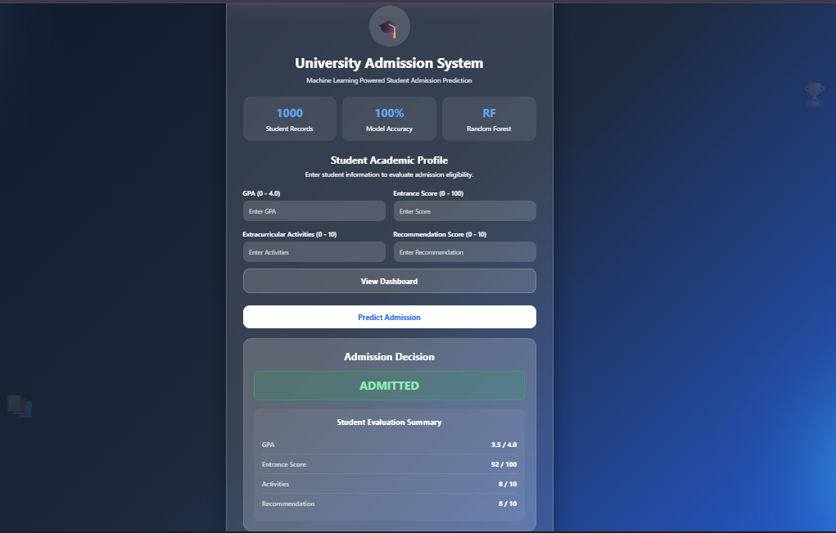
Figure 2 — Prediction Result: ADMITTED
A profile satisfying all admission criteria triggers the green ADMITTED decision banner alongside a Student Evaluation Summary displaying all submitted values for transparency. The example shown GPA 3.5/4.0, Entrance Score 92/100, Activities 8/10, Recommendation 8/10, comfortably exceeds all learned thresholds across every dimension.
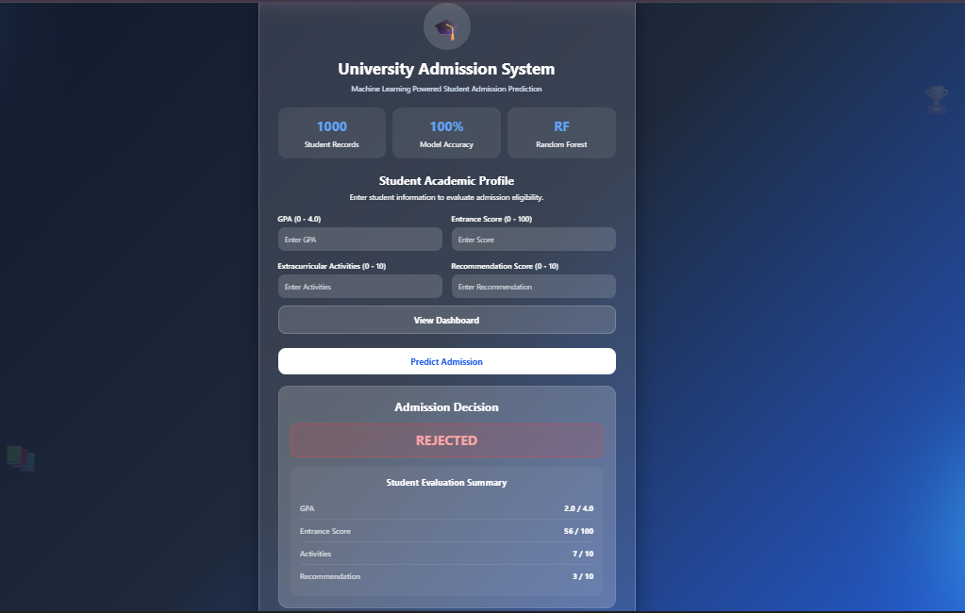
Figure 3 — Prediction Result: REJECTED
A profile failing the admission criteria renders the red REJECTED banner with the same evaluation summary. The example — GPA 2.0/4.0, Entrance Score 56/100, Activities 7/10, Recommendation 3/10 — falls below thresholds on multiple dimensions. The red/green colour coding provides an immediately unambiguous decision signal.
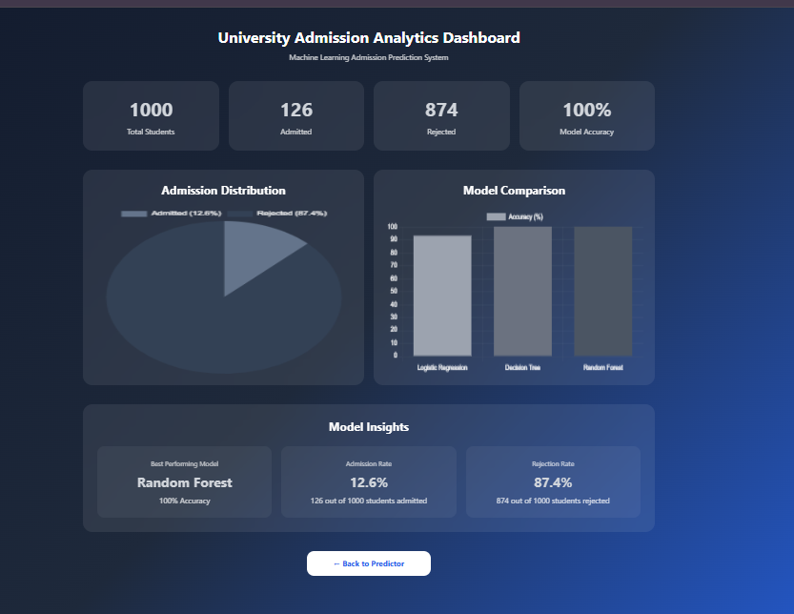
Figure 4 — Analytics Dashboard: Admission Distribution, Model Comparison & Insights
The dashboard presents four KPI cards (total students, admitted, rejected, model accuracy), an admission distribution pie chart (12.6% vs. 87.4%), and a model accuracy bar chart comparing all three algorithms side by side. The Model Insights panel consolidates key performance indicators, and a “Back to Predictor” button provides seamless navigation to the main form.

4.4 Discussion
The results affirm that supervised machine learning is highly effective at predicting university admission outcomes from structured multi-dimensional academic profiles. The perfect accuracy of tree-based classifiers confirms that the admission boundary in this synthetic dataset is fully separable by non-linear models, consistent with the compound threshold logic embedded in the data generation process.
The Logistic Regression performance gap reflects the fundamental limitation of linear decision boundaries when admission requires simultaneously satisfying multiple non-linear thresholds. In real-world deployment with noisier data and more complex institutional criteria, this gap would be expected to widen, further justifying the Random Forest selection. The Flask application successfully abstracts all ML complexity behind an intuitive interface, and the analytics dashboard adds strategic utility for institutional leadership. A key caveat is the synthetic training data: the 100% accuracy should not be extrapolated to real-world deployment without retraining on genuine institutional records, which would introduce label noise, missing values, and institution-specific weighting preferences.
Conclusion
The University Admission Prediction System successfully demonstrates how supervised machine learning can deliver consistent, transparent, and data-driven educational admission decisions. Training and benchmarking three classifiers on 1,000 student records established Random Forest as the optimal model with 100% test-set accuracy across all evaluation metrics, outperforming the Logistic Regression baseline and matching Decision Tree while offering superior theoretical robustness for real-world generalisation.
The Flask web application translates the trained model into an accessible, zero-expertise-required prediction interface. The analytics dashboard surfaces institution-level admission statistics and algorithm comparisons, supporting transparent model governance and data-informed administrative planning. Together, the system demonstrates the potential of machine learning to standardise, accelerate, and de-bias processes that have traditionally depended on subjective, time-intensive manual review.

Future Work
- Real Data Integration: Retrain on genuine anonymised institutional records to improve ecological validity and capture institution-specific selection criteria.
- Feature Expansion: Add essay quality scores (via NLP), socioeconomic indicators, high school ranking, and interview performance as additional predictors.
- Cloud Deployment: Migrate to AWS Elastic Beanstalk, Google Cloud Run, or Heroku for distributed institutional access without local installation requirements.
- Explainability (XAI): Integrate SHAP or LIME to generate per-decision feature attribution scores, enabling admissions officers to audit individual model predictions.
- Multi-Class Extension: Extend the binary framework to tiered outcomes, Full Scholarship / Conditional Admission / Waitlist / Rejected.
- Batch Processing: Add CSV upload to allow bulk cohort evaluation rather than single-profile entry.
- Audit Trail: Integrate a relational database to record all profiles, predictions, and timestamps for longitudinal trend analysis and model retraining.

References
Asif, R., Merceron, A., Ali, S. A., & Haider, N. G. (2017). Analyzing undergraduate students’ performance using educational data mining. Computers & Education, 113, 177–194.
Baker, R. S., & Yacef, K. (2009). The state of educational data mining in 2009: A review and future visions. Journal of Educational Data Mining, 1(1), 3–17.
Breiman, L. (2001). Random forests. Machine Learning, 45(1), 5–32.
Doshi, M., & Bhatt, K. (2020). Comparative analysis of ensemble methods for student performance prediction. International Journal of Advanced Computer Science and Applications, 11(4), 201–207.
Géron, A. (2019). Hands-on machine learning with Scikit-Learn, Keras, and TensorFlow (2nd ed.). O’Reilly Media.
Ozdemir, E., & Soylemez, M. (2021). Predicting university admission outcomes using multi-feature academic profiles. Journal of Educational Technology & Society, 24(2), 88–99.
Pedregosa, F., et al. (2011). Scikit-learn: Machine learning in Python. Journal of Machine Learning Research, 12, 2825–2830.
Romero, C., & Ventura, S. (2010). Educational data mining: A review of the state of the art. IEEE Transactions on Systems, Man, and Cybernetics, Part C, 40(6), 601–618.
Russell, S., & Norvig, P. (2020). Artificial intelligence: A modern approach (4th ed.). Pearson.
VanderPlas, J. (2016). Python data science handbook: Essential tools for working with data. O’Reilly Media.

