Project 5 - Library Management App (User, Book, Author, Loan)
Name: Gervais Niyitegeka
Reg No: 2401000372
Date: 27 September 2026
These are screenshots taken from the app running on a physical Android device, with a short note under each one explaining what it shows.
1. Sign Up screen
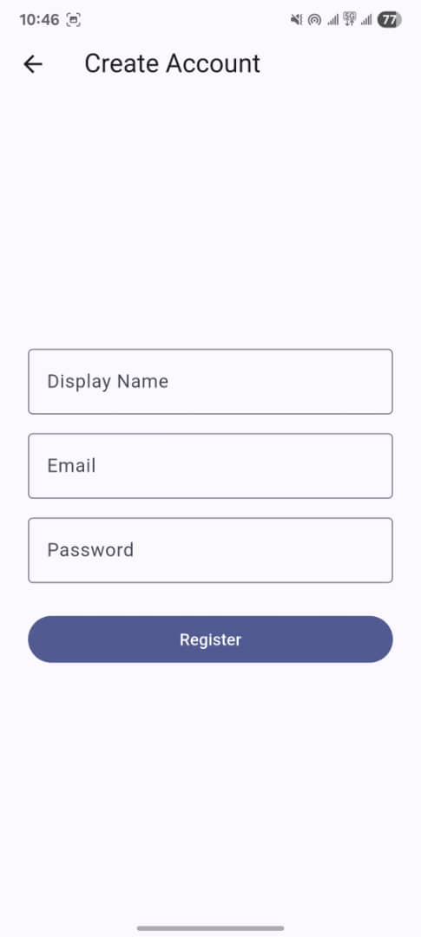
This is the Create Account screen. A new user types a display name, email and password and taps Register. This is done through Firebase Authentication (FR-1).
2. Account created message
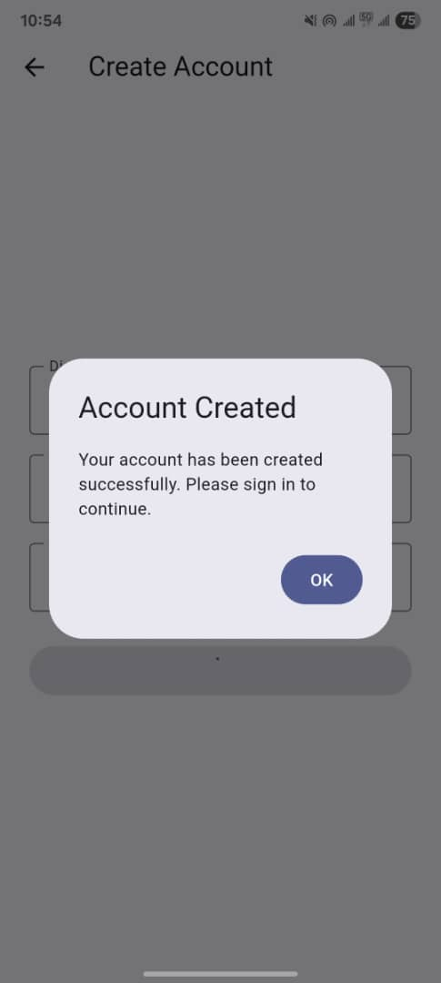
After registering, this popup shows to confirm the account was created and tells the user to go sign in.
3. Sign In screen
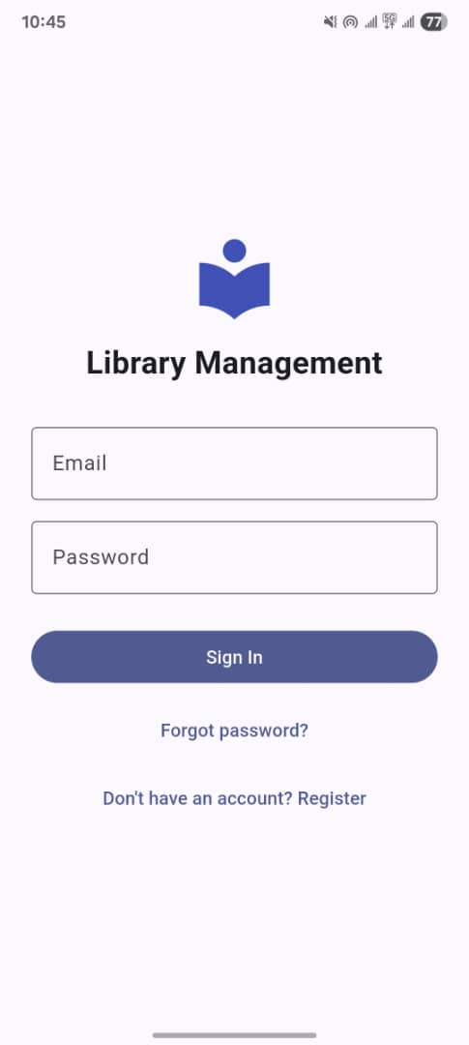
This is the sign in screen for the app. A user logs in with email and password (FR-2). If they are not signed in, this is the screen they always land on first (the auth gate).
4. Library screen / home feed
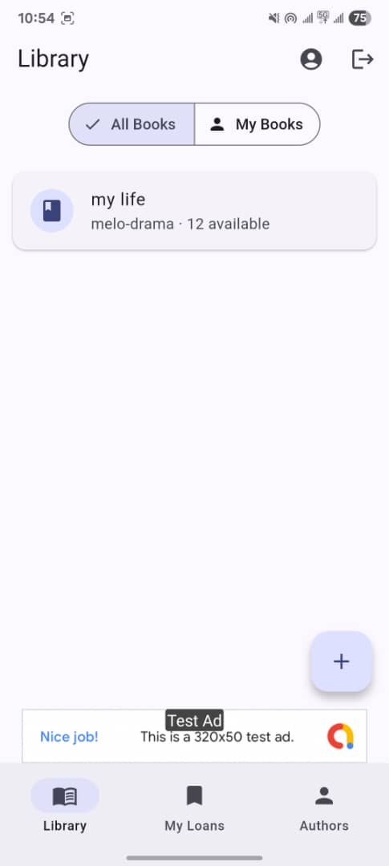
This is the home screen after logging in. It lists the books that are in Firestore, and you can switch between All Books and My Books. The banner ad also shows at the bottom of this screen.
5. Add Book screen
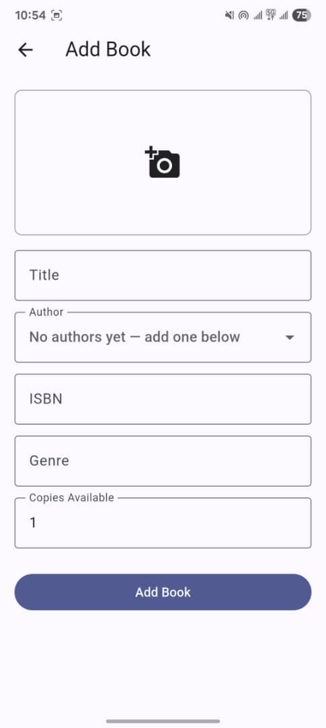
This form is used to add a new Book. It has a cover photo, title, author, ISBN, genre and copies available, so more than 5 fields like the assignment asked for. The photo gets uploaded to Cloud Storage when the book is saved.
6. Book details screen
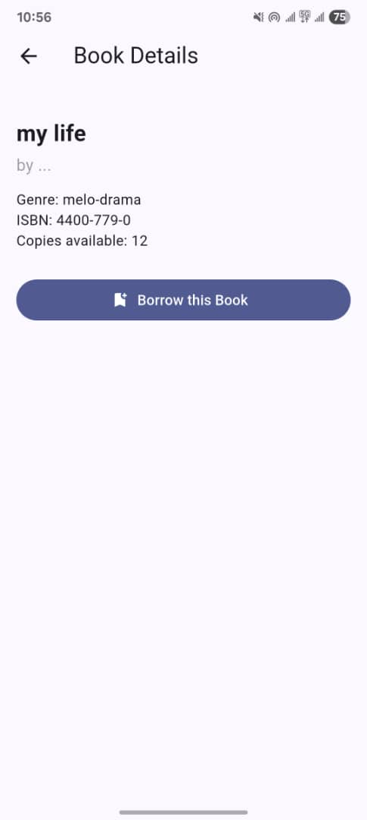
Tapping a book from the list opens this details page, showing the genre, ISBN and how many copies are available. The Borrow this Book button creates a Loan record connecting this book to the logged in user.
7. Add Author screen
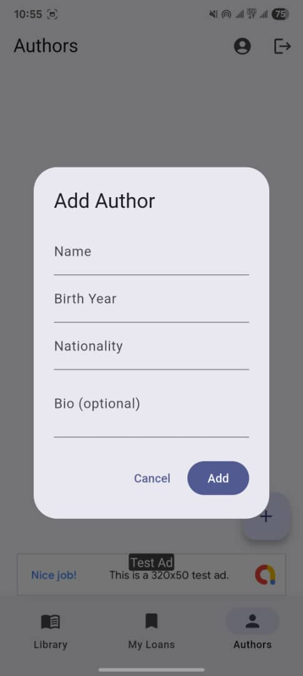
This is the form used to add an Author, which is the entity that books reference but the user does not own. You can also see the banner ad in the background of this screen.
8. My Loans screen
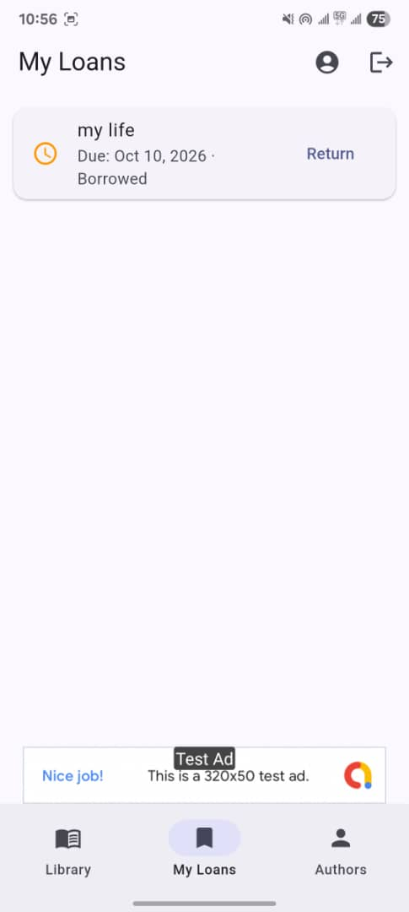
This screen lists the books the current user has borrowed, with the due date and a Return button. This is the Loan entity, since each loan record links a user and a book together.
9. Edit profile screen
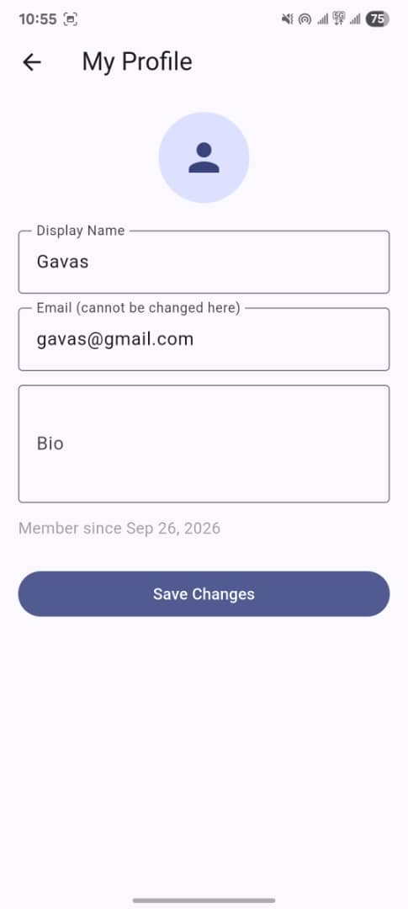
This is where a user can update their own profile - display name and bio (email cannot be changed here since it's tied to the Firebase account). This is the update part of CRUD for the User entity.
10. Interstitial ad

This is the full screen ad (test ad shown here) that pops up after an action is completed, like borrowing or returning a book. If this ad fails to load, it is skipped and the rest of the app still works normally.
11. Delete confirmation
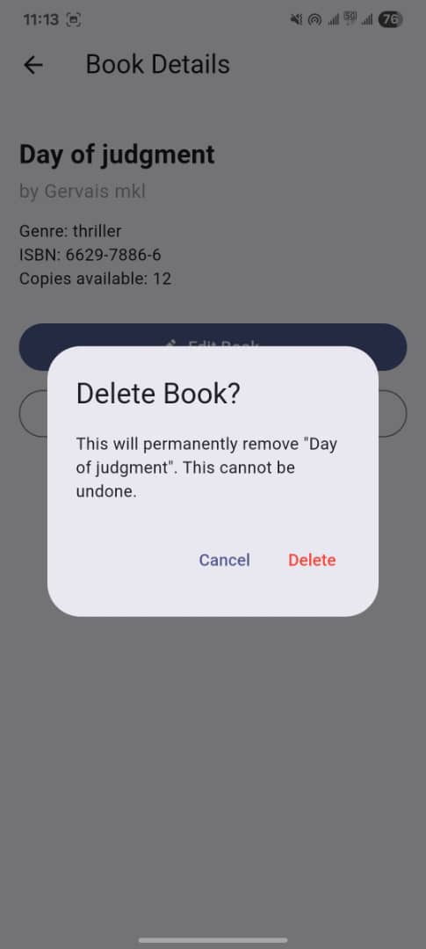
This dialog appears when a book's owner taps Delete Book, warning that the action is permanent before it happens. This is the delete part of CRUD for the Book entity.
12. Book details screen (owner view)
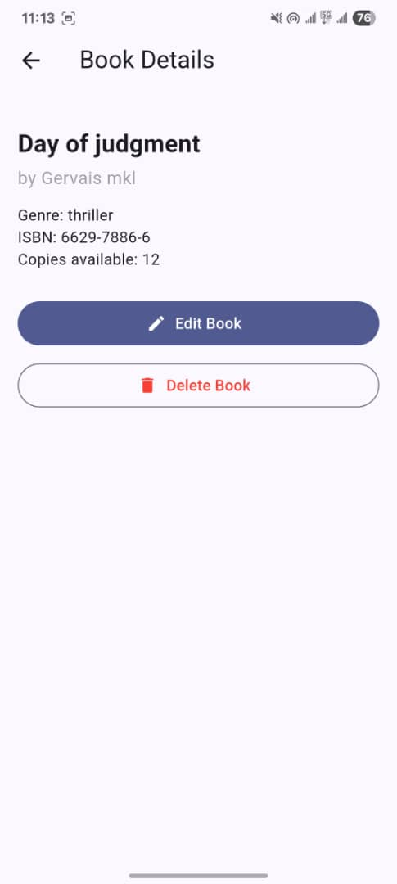
This is the same book details screen, but seen by the book's own owner - the Edit Book and Delete Book buttons only appear here, since only the owner is allowed to change or remove their own book.
13. My Loans screen (multiple loans)
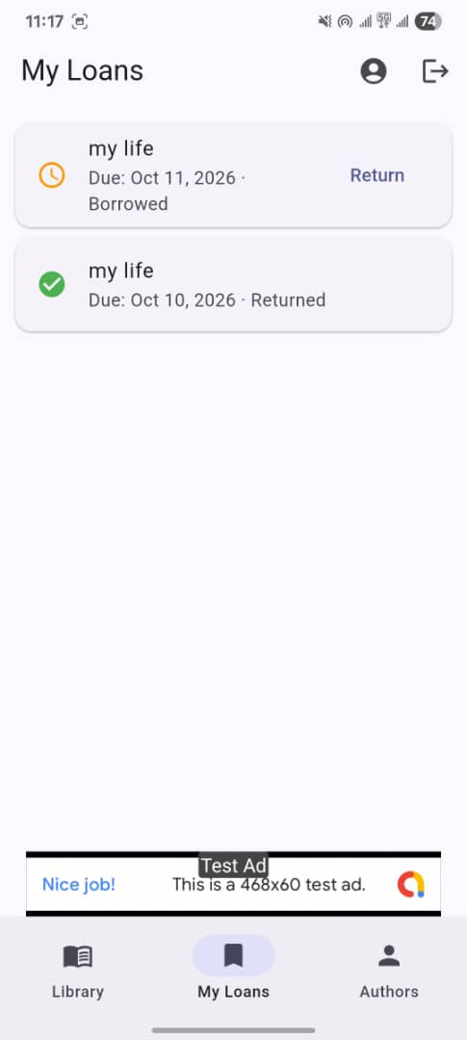
This shows two separate loan records for the same book title - one currently borrowed and one already returned - showing that a book can be loaned out, returned, and loaned out again.
14. Authors screen (delete action)
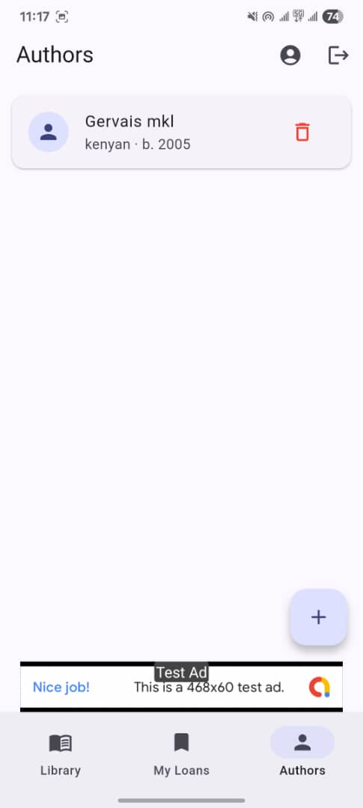
This shows an existing author with its delete option visible, confirming that authors support full CRUD (create, read, update, delete), not just adding new ones.

