BRIDGESTONE TYRE
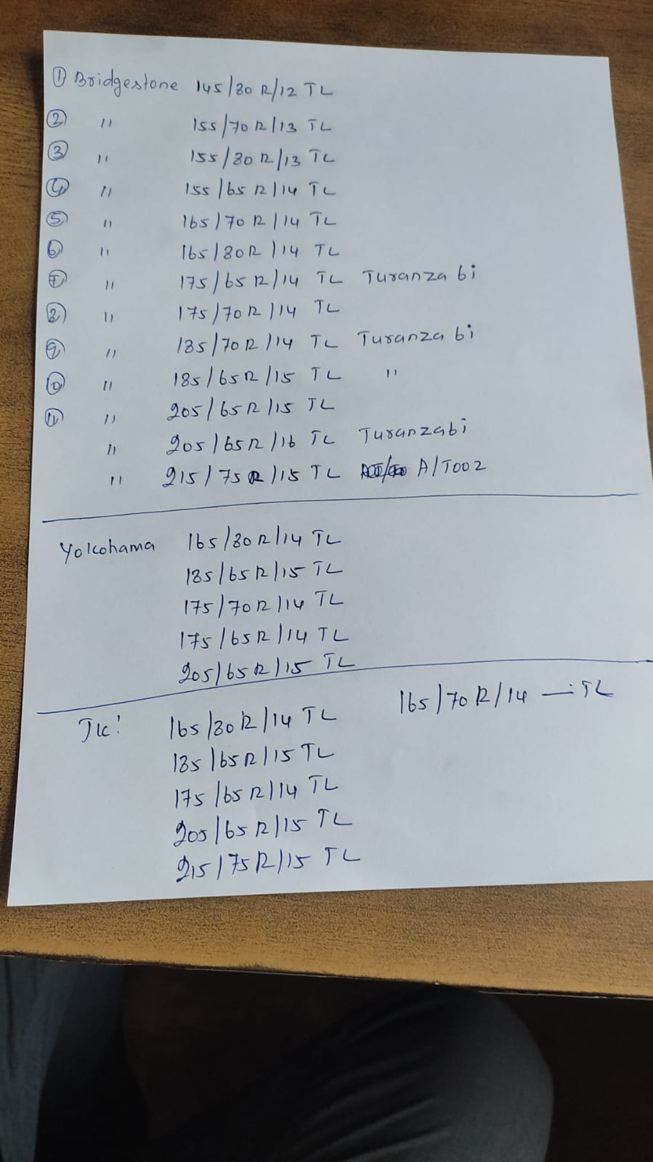
YOKOHAMA TYRE
JK TYRE

MICHELIN TYRE
