**1.Describe Numpy, Pandas and Matplotlib.**

**NumPy** is a powerful Python library primarily used for numerical computations. It provides efficient multi-dimensional arrays and a vast collection of mathematical functions to operate on these arrays.

**Key features and benefits of NumPy:**

* **Efficient Arrays:** NumPy arrays are optimized for numerical operations, offering significant performance advantages compared to Python's built-in lists.
* **Broadcasting:** NumPy supports broadcasting, which allows for element-wise operations between arrays of different shapes.
* **Mathematical Functions:** NumPy provides a comprehensive set of mathematical functions, including trigonometric, logarithmic, exponential, and statistical functions.
* **Linear Algebra:** NumPy includes efficient implementations of linear algebra operations like matrix multiplication, inversion, and decomposition.
* **Random Number Generation:** NumPy offers tools for generating random numbers from various distributions.
* **Integration with Other Libraries:** NumPy integrates well with other scientific computing libraries like SciPy, Matplotlib, and Pandas.

**Common use cases of NumPy:**

* **Data Analysis and Manipulation:** NumPy is widely used for tasks like data cleaning, preprocessing, and exploration.
* **Machine Learning:** It serves as a fundamental building block for many machine learning algorithms, providing efficient data structures and numerical operations.
* **Scientific Computing:** NumPy is essential for various scientific simulations, modeling, and analysis.
* **Image Processing:** NumPy can be used to represent and manipulate images as multi-dimensional arrays.

In summary, NumPy is a versatile and efficient library that empowers Python programmers to perform numerical computations effectively. Its capabilities make it an indispensable tool for a wide range of applications

**Pandas** is a powerful Python library designed for data analysis and manipulation. It provides high-performance data structures and data analysis tools that make working with structured and tabular data efficient and intuitive.

**Key features and benefits of Pandas:**

* **Data Structures:** Pandas introduces two primary data structures:
  + **Series:** A one-dimensional labeled array capable of holding any data type.
  + **DataFrame:** A two-dimensional labeled data structure with rows and columns, similar to a spreadsheet.
* **Data Manipulation:** Pandas offers a rich set of functions for data cleaning, transformation, and analysis, including:
  + **Selection and Indexing:** Easily select and access specific data elements.
  + **Filtering:** Filter data based on conditions.
  + **Grouping and Aggregation:** Group data by categories and apply aggregate functions (e.g., mean, sum, count).
  + **Joining and Merging:** Combine data from multiple DataFrames.
  + **Reshaping:** Pivot, stack, unstack, and reshape data for different analysis perspectives.
* **Missing Data Handling:** Pandas provides tools to handle missing values, including imputation and removal.
* **Time Series Analysis:** Pandas excels at working with time series data, offering functions for date and time manipulation, frequency conversion, and time-based operations.
* **Integration with Other Libraries:** Pandas seamlessly integrates with other popular data science libraries like NumPy, Matplotlib, and Seaborn, enabling comprehensive data analysis workflows.

**Common use cases of Pandas:**

* **Data Cleaning and Preprocessing:** Cleaning and preparing data for analysis.
* **Exploratory Data Analysis (EDA):** Summarizing and understanding data characteristics.
* **Statistical Analysis:** Performing statistical calculations and tests.
* **Data Visualization:** Creating informative plots and visualizations.
* **Machine Learning:** Preparing and processing data for machine learning models.
* **Financial Analysis:** Analyzing financial data, such as stock prices and market trends.

In summary, Pandas is a versatile and powerful library that simplifies data analysis tasks in Python. Its efficient data structures and comprehensive set of functions make it an essential tool for data scientists, analysts, and researchers working with structured data.

**Matplotlib** is a popular Python library for creating static, animated, and interactive visualizations. It offers a wide range of plotting types, customizable styles, and tools for data visualization.

**Key features and benefits of Matplotlib:**

* **Versatile Plotting:** Matplotlib supports various plot types, including line plots, scatter plots, histograms, bar charts, pie charts, and 3D plots.
* **Customization:** You can customize every aspect of your plots, from colors, labels, and titles to fonts, markers, and gridlines.
* **Integration:** Matplotlib integrates well with other scientific Python libraries like NumPy and Pandas, making it easy to visualize data from different sources.
* **Interactive Plots:** Create interactive plots with zooming, panning, and tooltips using the matplotlib.pyplot interface or the mplcursors library.
* **Publication-Quality Graphics:** Generate high-quality figures suitable for presentations, publications, and reports.

**Common use cases of Matplotlib:**

* **Data Visualization:** Exploring and understanding data through visual representations.
* **Scientific Research:** Presenting research findings and results.
* **Engineering and Analysis:** Analyzing data from experiments and simulations.
* **Business Intelligence:** Creating dashboards and reports for decision-making.

**Examples of Matplotlib plots:**

* **Line plot:** Visualizing trends and relationships between variables.
* **Scatter plot:** Showing the distribution of data points in two dimensions.
* **Histogram:** Understanding the distribution of a single variable.
* **Bar chart:** Comparing categories or groups.
* **Pie chart:** Representing proportions of a whole.
* **3D plot:** Visualizing data in three dimensions.

By leveraging Matplotlib's capabilities, you can effectively visualize your data and gain valuable insights.

**2. Write a program to display weather information by using matplot.**

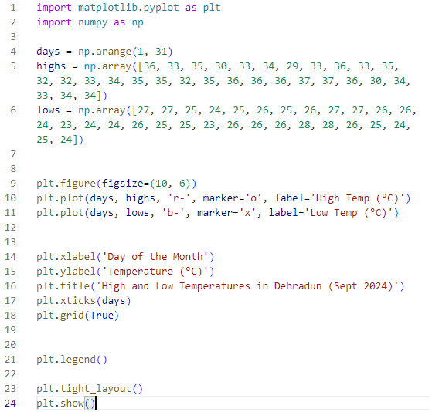

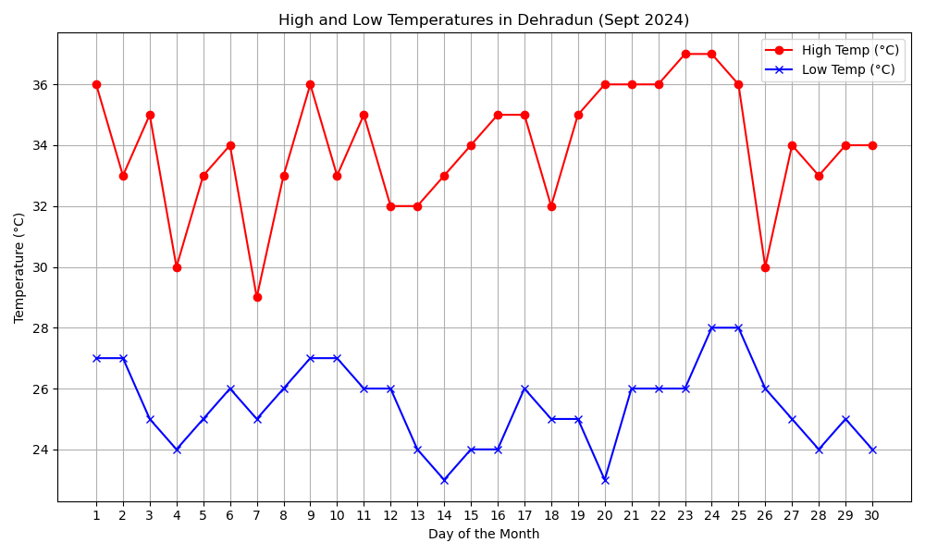

**3. Display Histograms on blood sugar level.**

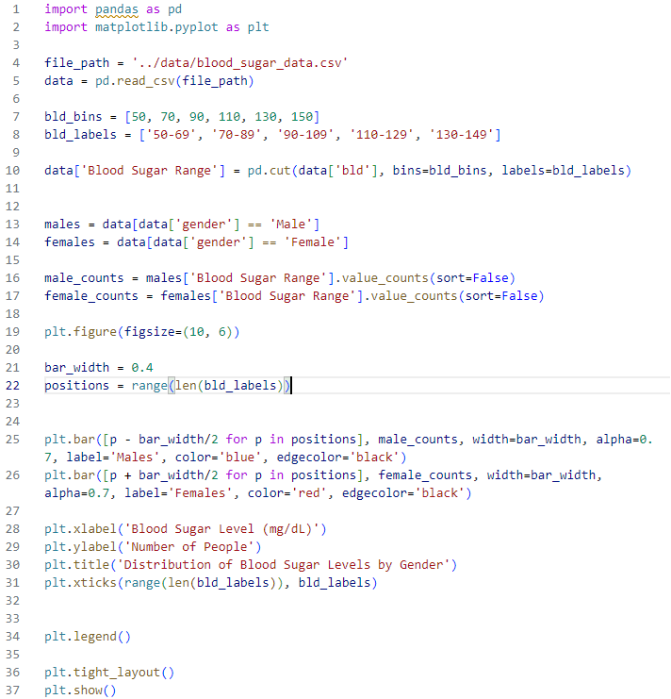

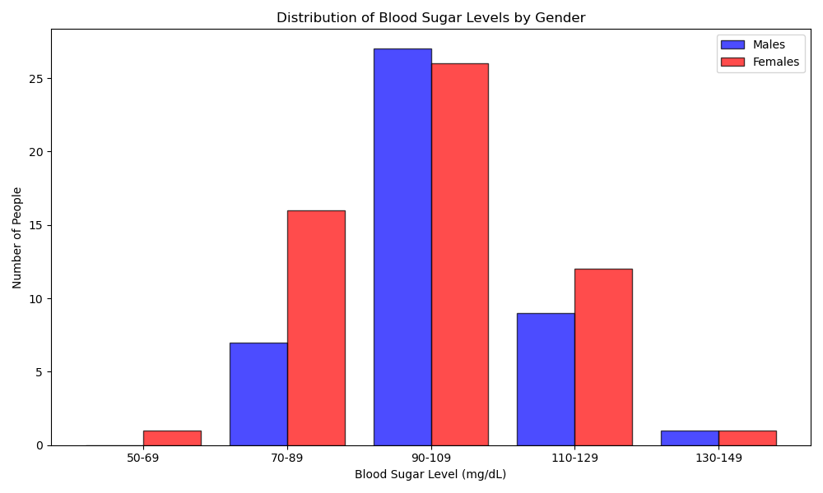

**4. Perform linear regression on home price dataset.**

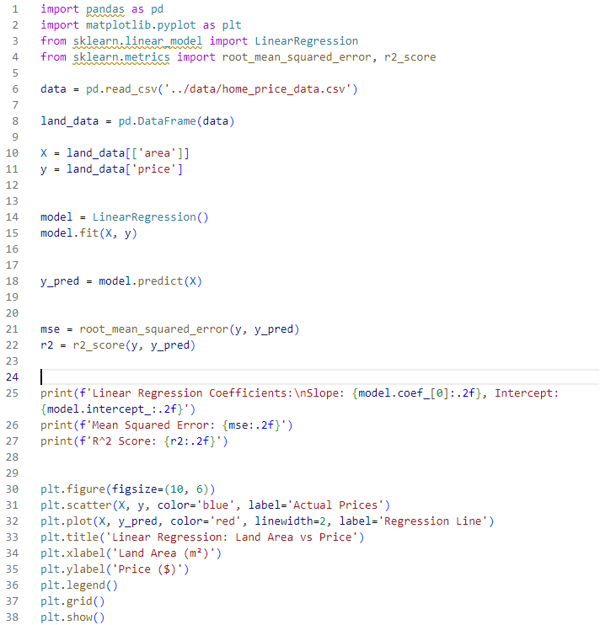

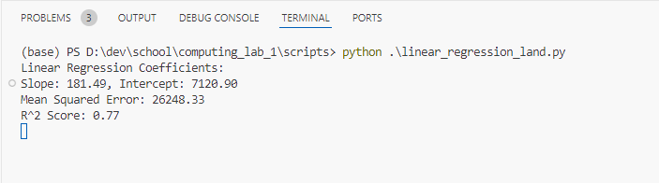

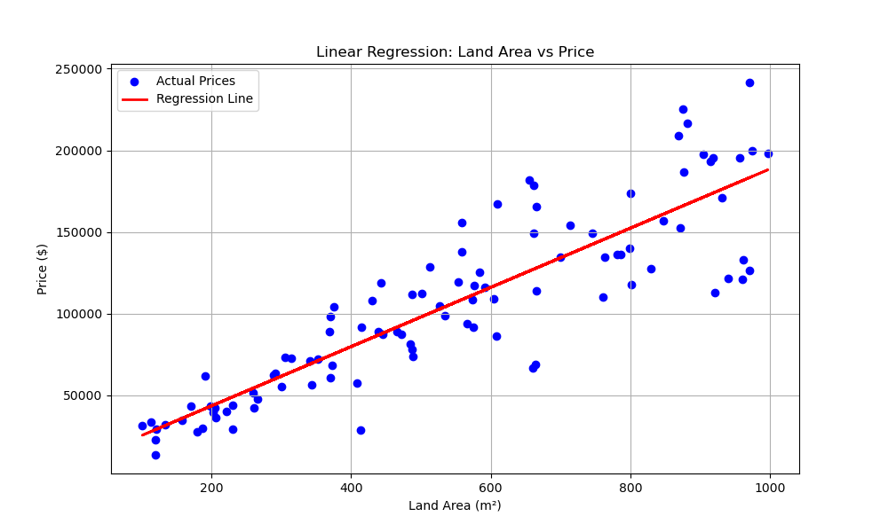

**5.Perform logistic regression on Life Insurance dataset**

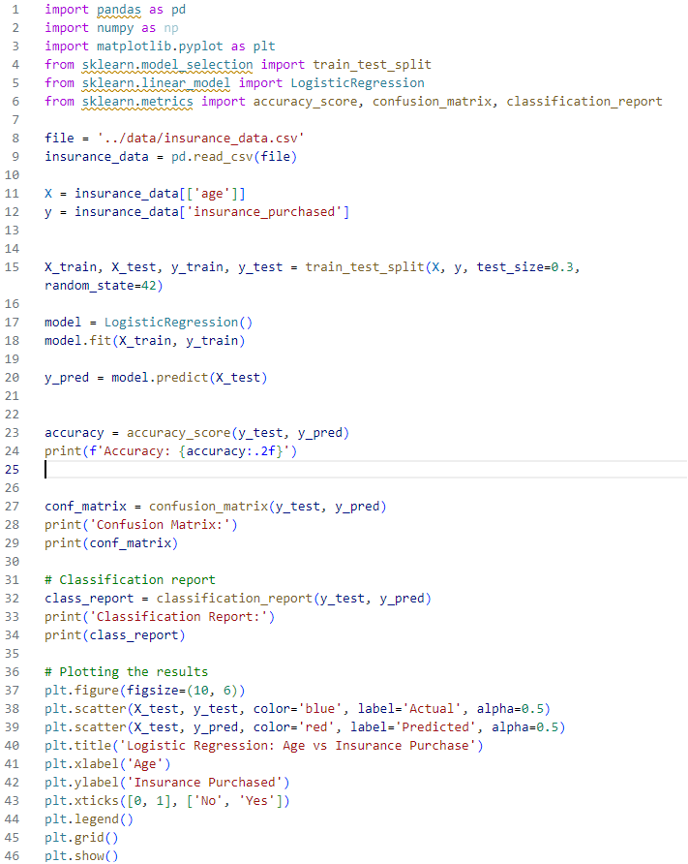

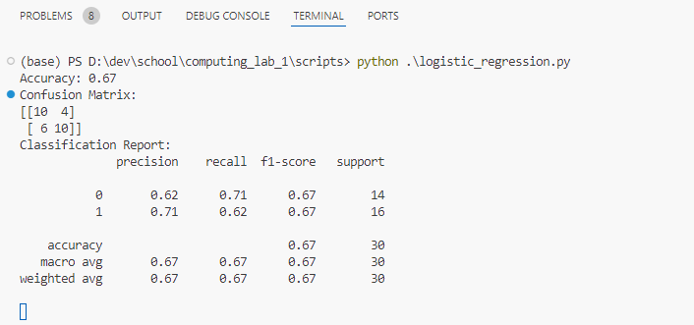

All the supporting resources & source codes are available on this [github repo](https://github.com/GEU-M-tech/computing_lab)

