**Clients**

**Dr. Hammonds-Odie**

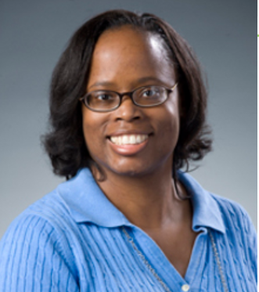

Dr.Hammonds-Odie is an associate Professor of Biology. As a teacher and researcher, she wants undergraduate students to discover the joys and challenges of basic science research. She believes student learning should include improving basic social and communication skills. She has taken great pride in listening to students present their own research in a competent and professional manner.

**Dr.Pollacia**

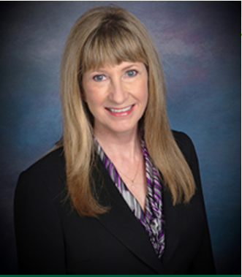

Dr. Lissa Pollacia is a professor of information technology and assistant dean of the School of Science and Technology. She holds a master's degree in both mathematics and computer science, and a Ph.D. in computer science. She has many years of teaching experience, has served as principal investigator for numerous research grants, and published many journal articles and papers. She is the national coordinator for AITP’s Database Design contest at the National Collegiate Conference (NCC).