**SUPPLEMENTARY INFORMATION**

A Skin-Attachable, Stretchable Integrated System Based on Liquid GaInSn for Wireless Human Motion Monitoring with Multi-Site Sensing Capabilities

Yu Ra Jeong†, Jeonghyun Kim†, Zhaoqian Xie†, Yeguang Xue, Sang Min Won, Geumbee Lee, Sang Woo Jin, Soo Yeong Hong, Xue Feng, Yonggang Huang, John A. Rogers*, Jeong Sook Ha*

Y. R. Jeong, S. Y. Hong, Prof. J. S. Ha

Department of Chemical and Biological Engineering, Korea University, Seoul 02453, Republic of Korea

e-mail: jeongsha@korea.ac.kr

J. Kim

Department of Electronics Convergence Engineering, Kwangwoon University, Seoul, Republic of Korea

J. Kim, S. M. Won, Prof. J. A. Rogers

Department of Materials Science and Engineering, Frederick Seitz Materials Research Laboratory, University of Illinois at Urbana-Champaign, Urbana, IL 61801, USA

Z. Xie, Prof. X. Feng

AML, Department of Engineering Mechanics, Center for Mechanics and Materials, Tsinghua University, Beijing 100084, China. Department of Civil and Environmental Engineering, Northwestern University, Evanston, IL 60208, USA

G. Lee, S. W. Jin, Prof. J. S. Ha

KU-KIST Graduate School of Converging Science and Technology, Korea University,

Seoul 02841, Republic of Korea

Z. Xie, Y. Xue, Prof. Y. Huang

Department of Civil and Environmental Engineering, Mechanical Engineering, and Materials Science and Engineering, Northwestern University, Evanston, IL 60208, USA

Prof. Y. Huang

Department of Civil and Environmental Engineering, Mechanical Engineering, Materials Science and Engineering, Center for Engineering and Health, and Skin Disease Research Center, Northwestern University, Evanston, IL 60208, USA

Prof. J. A. Rogers

Departments of Materials Science and Engineering, Biomedical Engineering, Chemistry, Mechanical Engineering, Electrical Engineering and Computer Science, and Neurological Surgery; Center for Bio-Integrated Electronics; Simpson Querrey Institute for Nano/biotechnology; Northwestern University, Evanston, IL 60208, USA.   
e-mail: jrogers@northwestern.edu

*Corresponding-Author: Prof. J. S. Ha, e-mail: jeongsha@korea.ac.kr, Prof. John A. Rogers, e-mail: jrogers@northwestern.edu

**Supplementary Note S1: Experimental procedure**

*Fabrication of the liquid metal patterns on PDMS substrate:* A glass substrate was cut into a rectangle of size 75 mm × 50 mm, followed by rinsing with acetone and isopropyl alcohol. Poly(methyl methacrylate) (PMMA, Microchem) was spin-coated (2000 rpm, 30 s) and baked at 180 °C to avoid adhesion between the glass substrate and PDMS. PDMS (Sylgard 184, Dow Corning Corp; mixed at a 10:1 ratio of base to curing agent by weight) was spin-coated on the substrate and partially cured at 75 °C for 7 min and 30 s. The Cr and Au thin film is deposited on the partially cured PDMS substrates rather than on the completely cured PDMS to avoid generation of crack by thermal residual stress. Deposition of the metal film by sputtering or e-beam evaporation may crack the film surface because of the residual strain generated during the film formation process.[1],[2] Therefore, in this study, the Cr/Au film layer was deposited on a partially cured PDMS substrate. The optical images of the PDMS/Cr/Au surface are presented in **Figure S1**.

A 10-nm-thick Cr layer was deposited before depositing the 100-nm-thick Au film (2.1 Å s-1) using magnetron sputtering (AJA Orion 3 sputter system, Massachusetts, USA) on the partially cured PDMS substrates at a rate of 1.0 Å s-1 to enhance the adhesion between the metal film and PDMS. As-deposited PDMS substrates were placed in an oven at 70 °C for 20 min to make them in a fully cured state. Solid metal patterns were fabricated using photolithography (AZ 5214 photoresist, spin-coating at 3000 rpm for 30 s, baking at 110 °C for 1 min 30 s, UV irradiance for 140 mJ cm−2, development for ≈28 s with developer AZ 917 MIF) and wet etching process. Liquid metal droplet (GaInSn, Rotometals) with a native oxide layer was cast on the Au patterns, followed by casting few microliters of 10 wt% NaOH droplet, and the reduced liquid metal was selectively coated on the Au surface after spreading the reduced GaInSn out on the PDMS substrate. Rinsing and drying were performed using DI water and an oven at 70 °C, respectively.Optical images of the liquid metal pattern are shown in **Figure S2**.

*Fabrication of the liquid metal NFC device*: A ceramic capacitor (213 pF, Murata Electronics North America), a resistor (2.37 kΩ, Vishay Dale), and an NFC chip (SL13A ams AG) were mounted on the liquid metal pattern using an optical microscope, and electrically connected. PDMS (0.2 g, 10:1 ratio of base to the curing agent by weight) was cast on the substrates and degassed, followed by curing in an oven at 70 °C for 40 min.

*Characterizing the strain sensor*: The electrical resistance was measured with a digital multimeter (DMM, USB-4065, National Instruments, USA) after inserting a copper wire into the GaInSn microchannel. Mechanical testing of the sensor was performed with a customized uniaxial stretcher. For the dynamic pressure measurements, a force sensor (Mark-10 Series 7) was fixed onto a uniaxial motion controller (SM4-0806-3S), which pressed the sensor in a normal direction to the substrate.

*Wireless measurements of various strain*: To monitor various human motion, the devices were mounted on the skin after integrating a layer of a thin adhesive (acrylic adhesive, Scapa Healthcare) on the back of the device. The adhesive has biocompatibilities and conformal interfaces with low modulus.[3] For single device measurement, a NFC reader (AMS Inc.) was used for data capture at a distance of 5 mm. For the multi-device monitoring, a custom-built wireless set-up was introduced. The communication distance could be extended by applying high power with a large-sized antenna (ID ISC.ANT800/600-DA, FEIG Electronics) for power transfer and data acquisition. Since the wireless obtained data from the custom-built wireless system exhibit code signals with arbitrary units, a calibration graph showing the relationship between two different measurements was shown in **Figure S18.**

*Electromagnetic Characterization*: Electromagnetic properties were measured with an impedance analyzer (4291A RF impedance/material analyzer, Hewlett Packard) over a frequency range of 5–20 MHz. Measurements involved placement of the device at the center of the primary coil at a vertical distance of ~2 mm.

*Measurement of the Young’s moduli of the NFC device*: The modulus of the liquid metal NFC device was measured under uniaxial tensile loading with a dynamic mechanical analyzer (DMA) (TA Instruments, Q 800).

**Supplementary Note S2: Finite element analysis**

Three-dimensional (3D) finite element analysis (FEA) was used to simulate the uniaxial tension and pressuring of the strain sensor, NFC coil and the system, respectively. Eight-node 3D solid elements were used for PDMS microfluidic system and the skin, and element and mesh convergence were ensured. The material properties are: elastic modulus 3 MPa and the Poisson’s ratio 0.49 for the PDMS encapsulation layer; elastic modulus 0.13 MPa and Poisson’s ratio 0.49 for skin; elastic modulus 0.125 MPa and Poisson’s ratio 0.49 for Ecoflex; elastic modulus 1.63 MPa and Poisson’s ratio 0.49 for the mixture of PDMS and Ecoflex at a ratio of 5:5; and the resistor, tuning capacitor and NFC chip are modeled as rigid.

**Supplementary Note S3: Electromagnetic simulations**

The finite element analysis was adopted in the electromagnetic simulations to calculate the resistance, inductance, Q factor and resonant frequency of the liquid-metal NFC device. The simulations were performed using the commercial software ANSYS HFSS, in which tetrahedron elements were used in the solution with adaptive meshing convergence. The default adaptive convergence condition, together with a spherical surface (700 mm in radius) as the radiation boundary, ensured computational accuracy. The configurations of the liquid-metal sensor and NFC coil were first exported from the mechanics simulations performed using the commercial software ABAQUS, then imported to software ANSYS HFSS. The complex port impedance *Z* was directly obtained from the electromagnetic simulations. The resistance (*R*), inductance (*L*) and Q factor (*Q*), were then derived by using the expressions, *R* = Re{*Z*}, *L* = Im{*Z*}/2*πf*, and *Q* =|Im{*Z*}/Re{*Z*}|, where Re{*Z*}, Im{*Z*} and *f* represent the real and imaginary parts of the *Z* and the resonant frequency, respectively. The material parameters include the relative permittivity (*εr*), relative permeability (*μr*) and conductivity (*σ*) of the GaInSn and PDMS, i.e., *εr_GaInSn* = 1, *μr_**GaInSn* = 1 and *σGaInSn* = 3.46 x 106 S/m; and *εr_PDMS* = 2.55, *μr_PDMS* = 1 and *σPDMS* = 2.5×10-14 S/m.

**Supplementary Note S4: Monitoring of finger motion**

To obtain quantitative analysis of the finger motion, same measurements that were done in Figure 5f were carried out using copper wire connections, which is shown in **Figure S19**. The changes in the resistance are smaller than expected as indicated in Figure 3c. In **Figure S20**, we compared actual strain exerted on the skin by finger movements and the response of the strain sensor in normalized resistance after copper wire connections. The actual strain was obtained by measuring the change in the length between two fixed points around the carpometacarpal joint of index finger while doing the flexion movements with specific bending degree. The reduced signal is attributed to the difference in the Young’s modulus between the skin (1–2 kPa) and PDMS encapsulating elastomer (3 MPa), since the strain generated on the skin is not fully transferred to the relatively hard substrate, that is PDMS substrates.[4]

**References**

[1] O. Graudejus, P. Görrn, S. Wagner, *ACS Appl. Mater. Interfaces* **2010**, *2*, 1927.

[2] R. Seghir, S. Arscott, *Sci. Rep.* **2015**, *5*, 14787.

[3] J. Kim, G. A. Salvatore, H. Araki, A. M. Chiarelli, Z. Xie, A. Banks, X. Sheng, Y. Liu, J. W. Lee, K.-I. Jang, S. Y. Heo, K. Cho, H. Luo, B. Zimmerman, J. Kim, L. Yan, X. Feng, S. Xu, M. Fabiani, G. Gratton, Y. Huang, U. Paik, J. A. Rogers, *Sci. Adv.* **2016**, *2*.

[4] Y. R. Jeong, H. Park, S. W. Jin, S. Y. Hong, S.-S. Lee, J. S. Ha, *Adv. Func. Mater.* **2015**, *25*, 4228.

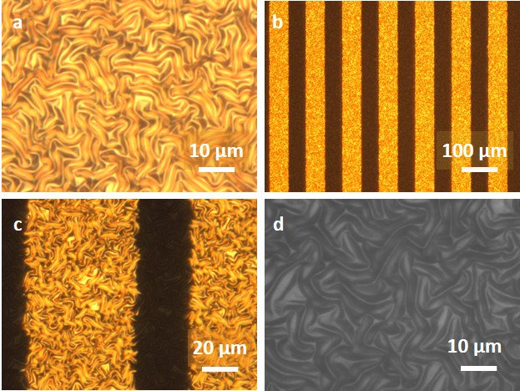

**Figure S1.** Cr/Au film deposited on partially cured PDMS surface.(a) Wavy pattern of the PDMS/Au surface. (b) Patterned image (after wet etching). (c) Edge at the pattern. (d) Surface of PDMS after wet etching.

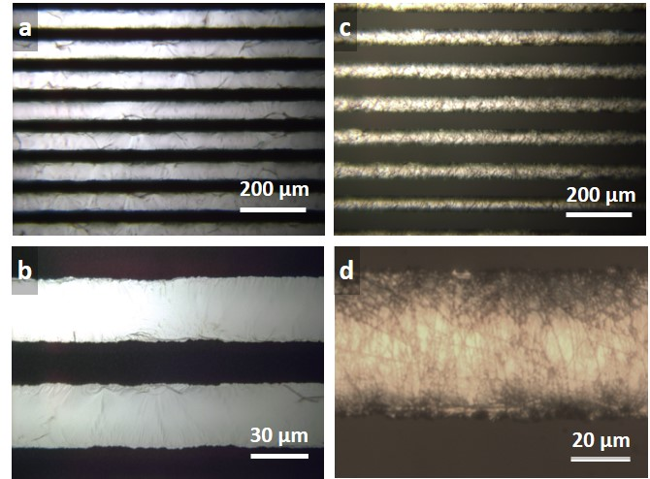

**Figure S2.** Optical images of the liquid metal pattern. (a) An optical image of the liquid metal pattern before encapsulation (70 μm width). (b) Magnified view of (a). (c) An optical image of the liquid-metal pattern after encapsulation (50 μm width). (d) Magnified view of (c).

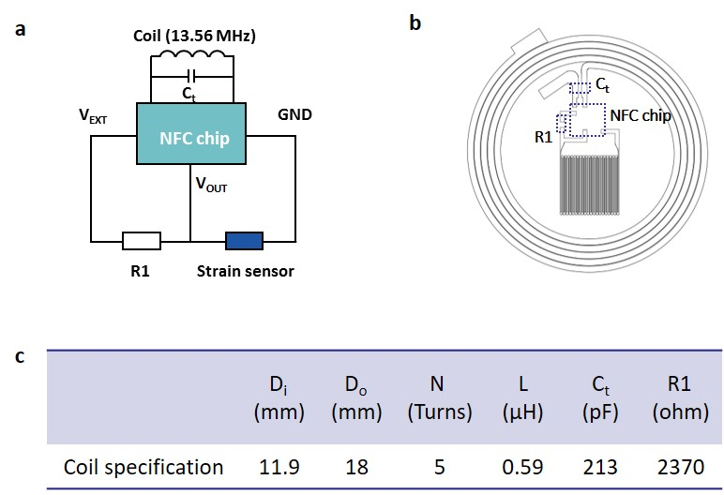

**Figure S3.** Circuit designs and specification of the inductive coil. (a) Circuit diagram of the NFC device. (b) Design of the coil and device. (c) Table showing the specification of the liquid metal coil. Di, Do, N, L, Ct, and R1 are the inner diameter, outer diameter, the number of turns of the coil, tuning capacitance, and resistance of the commercial SMD, respectively.

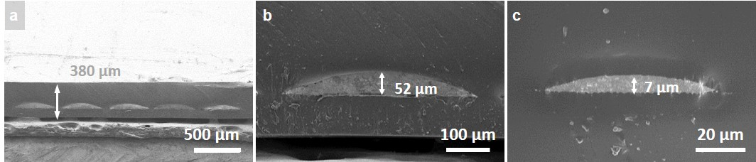

**Figure S4.** Cross-sectional SEM images of the liquid metal microchannel (a) Cross-sectional SEM image of the liquid metal coil embedded in a PDMS matrix. (b) Magnified cross-sectional image of the liquid metal coil. (c) Cross-sectional SEM image of the strain sensor.

**

**Figure S5.** (a) Successive images of liquid metal patterning process via selective wetting of reduced GaInSn using NaOH. (b) Screen printing of GaInSn without NaOH treatment.

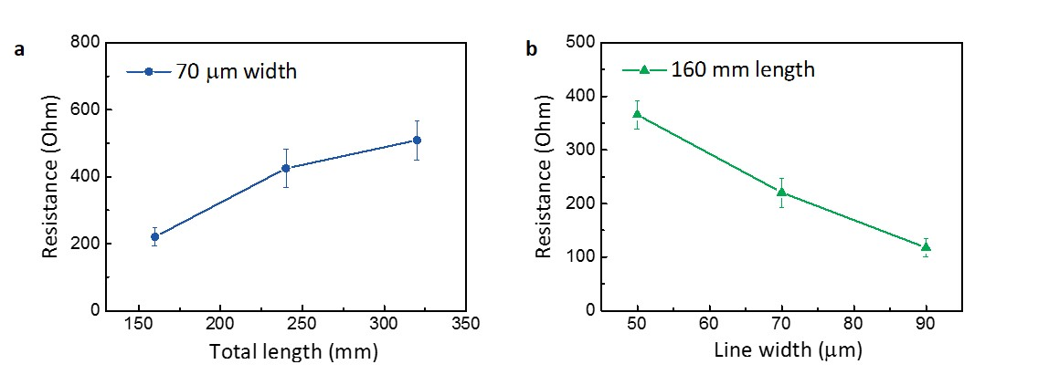

**Figure S6.** Initial resistance of the patterned liquid metal strain sensors. (a) Initial resistance values of the strain sensors for various lengths with the same line width (70 μm). (b) Initial resistance values of the strain sensors for various lengths with the same total length (160 mm) (error bars represent standard deviations).



**Figure S7.** Simulated images of the uniaxial stretching deformation of the three liquid-metal sensors with line widths 50μm, 70μm and 90μm, respectively. Three liquid-metal sensors always deform uniformly during 30% stretching.

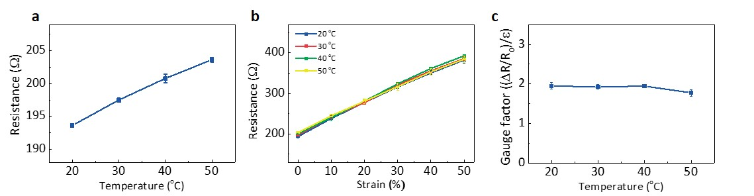

**Figure S8.** Temperature dependence of the strain sensor. (a) Resistance change of the liquid metal strain sensor with temperature. (b) Resistivity variation as a function of the applied uniaxial strain at various temperatures. (c) Variation of the gauge factor associated with the changes in temperatures. (Error bars represent standard deviations).

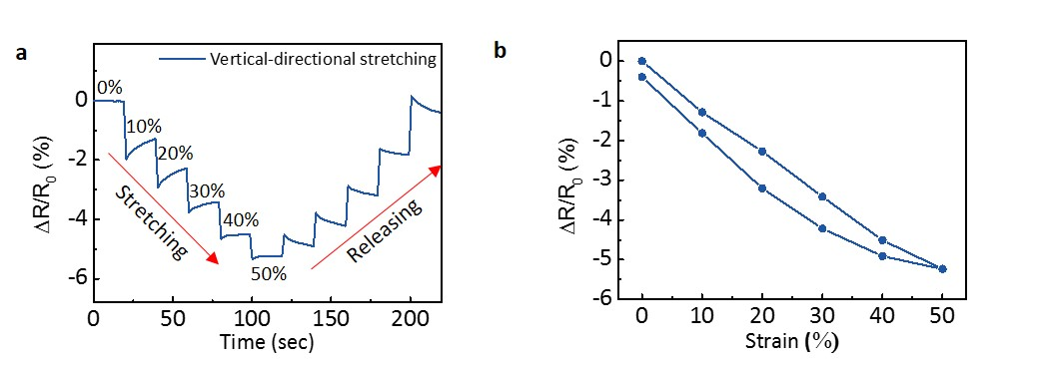

**Figure S9.** Strain loading on the strain sensors in the vertical direction.(a) Time-resistance curve of the strain sensor that was gradually stretched by 50% in a direction vertical to the sensor electrode. (b) Normalized resistance of the strain sensor according to the strain loading.

**Supplementary Note S5: Pressure measurement setups**

The applied pressure was measured by fixing the force gauge (Mark-10) to the z-axis motion controller while the sensor was placed on a glass slide. In the case of the support platform, it is made of a heavy stone of at least 15 kg or more, in order not to be affected by vibrations of the surrounding environment while measuring. (The total weight of the setup shown in **Figure S10 (b)** is 20 kg.) Since the sensor was stuck on the glass slide, it did not slide or move during the measurement. Also, the force actuator was calibrated before measurements, and it had a negligible measurement error of 0.03 % in both (pull/push) directions. The calibration results are shown in **Figure S10 (c)**.

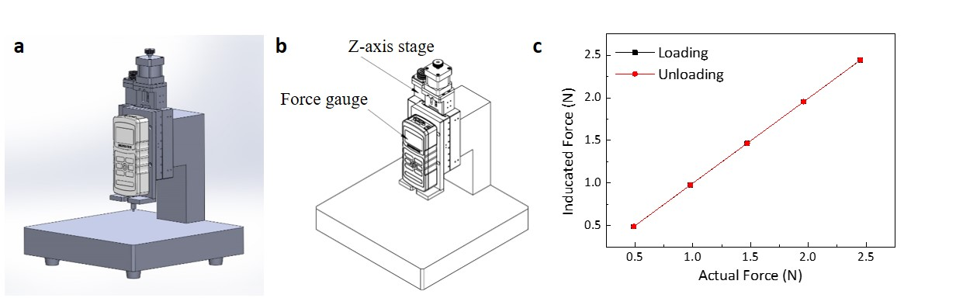

**Figure S10.** (a, b) Schematics of the pressure measuring system (c) Calibration results of the force actuator.



**Figure S11.** Dependence of the modulus dependence on the sensitivity to compressive strain. The liquid metal sensor was encapsulated with polymers of different modulus; PDMS (Young’s modulus, E ~3 MPa), a mixture of PDMS and Ecoflex at a ratio of 5:5 (E ~1.63 MPa), and Ecoflex (E ~125 kPa). (Error bars represent standard deviations).

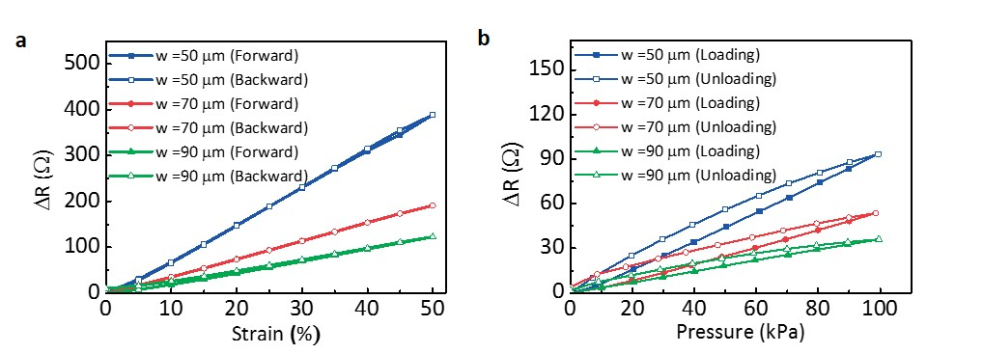

**Figure S12.** Hysteresis curves for three different widths of the strain sensor corresponding to (a) tensile strain loading and (b) normal pressure loading**.**

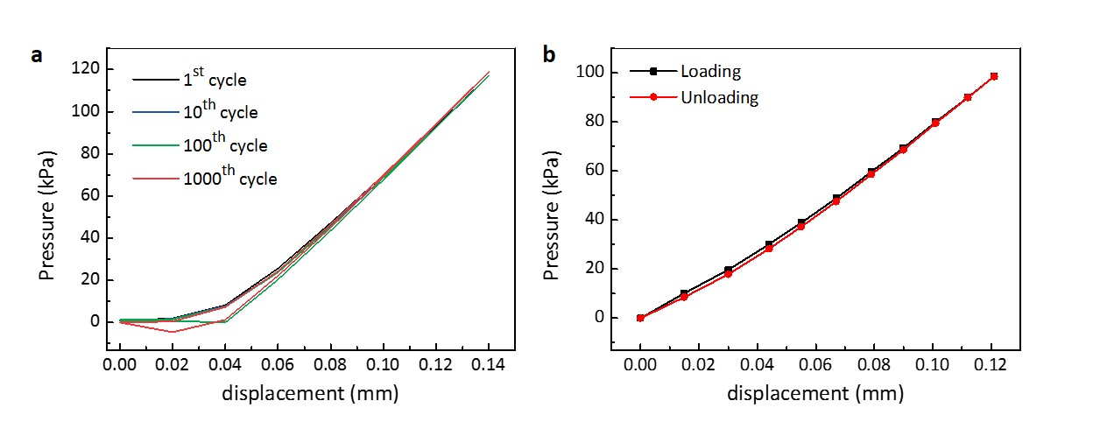

**Figure S13.** Stress-strain curves of (a) bare PDMS and (b) a liquid metal-filled PDMS (as fabricated sensor). The “displacement” shown in x-axis indicates the displacement of the load gauge that pressed the PDMS.



**Figure S14.** Stress-strain curve for the liquid-metal NFC device including NFC chip and other surface mounted components (resistor and capacitors). The corresponding Young’s modulus of the device is 3.8 MPa.

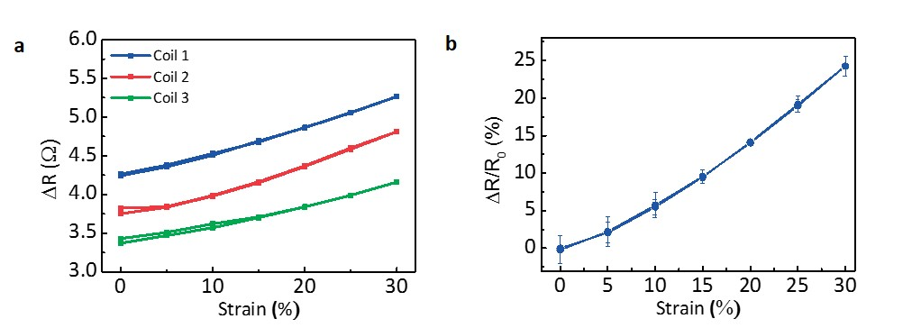

**Figure S15.** (a) Measured resistance variation for three different coils. (b) Normalized change in the resistance (error bars represent standard deviations).



**Figure S16.** Stress-strain curve for the liquid-metal NFC device including NFC chip and other surface mounted components (resistor and capacitors). The corresponding Young’s modulus of the device is 3.8 MPa.

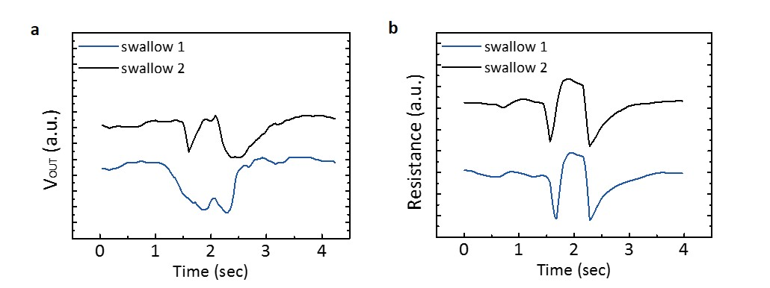

**Figure S17.** Real-time monitoring of muscle motion during swallowing via (a) NFC wireless data transmission and (b) wired data acquisition.

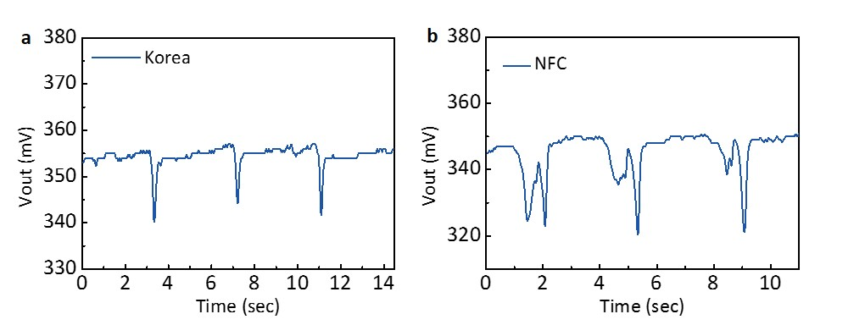

**Figure S18.** Monitoring of muscle motion during speech when saying (a) “Korea,” and (b) “NFC.”



**Figure S19.** Calibration curve for the multi-device monitoring system. The external readers used in two different NFC measurements have different units in output signal, therefore a calibration curve to reveal a relationship between two output signals are shown. The output signal shown in Figure 5f was calibrated using the equation noted in the inset.

**Figure S20.** Real time monitoring of four finger movements using copper wire connections.



**Figure S21.** Calibration curve for the flexion of the finger. The actual strain was calculated by measuring the distance between two fixed points around a carpometacarpal joint of an index finger. As the flexion degree increased, the strain on the joint increased as well. The normalized variation of the resistance of the strain sensor corresponds to each flexion degree is also presented.