Viability-Aware Entry Decisions at Dynamic Narrow-Road Bottlenecks
A reproducible temporal-window pilot study | Synthetic decision-level evaluation | Not yet an automotive closed-loop validation

Abstract
When a temporary gap opens on a constrained road, an autonomous vehicle must determine whether entering the bottleneck will leave a feasible continuation or an available nonblocking refuge. Existing work has already addressed fail-safe stopping, narrow-road meeting gaps, occlusion-aware planning, and uncertainty-aware reachable corridors. This study therefore examines a narrower hypothesis: joint admission decisions based on future conflict windows, intermediate refuge availability, and bounded forecast inflation can reduce unsuccessful commitments in a stylized mixed-traffic bottleneck. We introduce STV-ED, an entry-time and refuge-use scheduler using predicted temporal occupation intervals. A fully reproducible synthetic benchmark includes two conflict regions and a temporarily occupied intermediate refuge. Across 1,000 paired scenarios with Gaussian event-time prediction errors of standard deviation 1.0 s, exposure to realized conflict or unavailable refuge windows decreases from 22.6% for a joint nominal scheduler to 6.1% with a 1.25 s temporal envelope (paired risk difference: −16.5 percentage points; 95% paired bootstrap interval: −19.0 to −14.1 points). Mean planned completion time increases from 13.51 s to 15.27 s. These findings support feasibility of the decision logic only in the stipulated temporal abstraction; no vehicle collisions, physical safety guarantees, rural data calibration, or closed-loop vehicle trajectories are inferred.
Keywords: autonomous driving; narrow roads; mixed traffic; entry decisions; safety refuge; uncertain occupancy; reproducible simulation

1. Introduction
Autonomous vehicles operating on narrow road segments face discrete commitment decisions. A momentary opening at the entrance can be misleading when a pedestrian, cyclist, oncoming vehicle, or temporary roadside obstruction changes the downstream free space before the ego vehicle clears the segment. A vehicle that has already entered may then require an unexpected stop in a location that blocks oncoming movement or lacks adequate geometric clearance. Decision-making and motion planning are therefore coupled, even when the immediate goal is only to enter or wait.
This problem is not unstudied. Fail-safe motion planning retains a recoverable emergency maneuver under predicted occupancy [2]. Narrow-road scene modeling identifies meeting gaps and decides where to wait [10]. Occlusion-aware control with terminal stopping constraints [9], risk-predictive narrow-road planning [11], and reachable-corridor planning under uncertainty [12] further limit novelty claims based solely on braking, forecasting, or stop-point selection. The present work does not claim to invent any of those ingredients.
Our question is deliberately smaller: in an idealized two-bottleneck corridor with an intermediate refuge that can itself become occupied, can an entry scheduler that jointly checks conflict time windows and refuge availability avoid commitments that a nominal-window scheduler accepts? The synthetic pilot is intended to falsify or support this narrow feasibility hypothesis before investing in vehicle-dynamics modeling and motion-planning integration.
Contributions of this pilot are: (i) an explicit time-expanded entry/refuge feasibility formulation for a changing bottleneck; (ii) a reproducible implementation with temporal uncertainty envelopes and ablations separating robust forecasting from refuge feasibility; and (iii) paired synthetic experiments reporting both conflict exposure and planned completion-time cost. These are research-development results, not a demonstrated state-of-the-art contribution.

2. Related Work and Evidence Boundary
General planning and control methods for urban autonomous vehicles are surveyed by Paden et al. [1]. Magdici and Althoff [2] compute a fail-safe trajectory capable of bringing the vehicle to a stop, making it inappropriate to present backup stopping as new. Hubmann et al. [4] and Zhang et al. [7] use POMDP-based behavior planning for occluded traffic participants and address overconservative behavior and deadlock. Yu et al. [5] use reachability for occlusion risk assessment.
For narrow road operation, Jeong [6] integrates motion prediction with a drivable corridor. Zhang et al. [10] formulate meeting-gap selection and feasible vehicle trajectories for roads obstructed by stationary and moving vehicles; the online source is an arXiv preprint, and its peer-reviewed status is not assumed here. Fujinami and Raksincharoensak [11] explicitly use risk-predictive safe speeds in limited-visibility narrow roads. Recent work by Chen et al. [12] embeds uncertainty-aware reachable sets in a spatiotemporal corridor. Firoozi et al. [9] further show that a terminal stopping constraint can support feasibility under occlusion in robot navigation.
Accordingly, the research gap is conditional rather than established: although the retrieved papers cover the major ingredients, the present pilot tests their combination specifically as an entrance admission condition when an intermediate holding place has stochastic temporal availability. An exhaustive novelty claim would require full-text, method-level comparison and reproduction of strong published baselines, which has not yet been done.

3. Problem Formulation

3.1 Temporal road resources
Consider a longitudinal corridor consisting of a staging area B0, an optional intermediate pull-off B1, and an exit B2. A localized conflict zone G1 occurs in the first segment; G2 occurs in the second. This arrangement abstracts a narrow shared passage with pedestrian/bicycle crossing windows and a stopping place that may be occupied by a temporary delivery or commercial activity. It does not constitute a two-dimensional road geometry.
Let O1, O2, and OB denote the realized time intervals in which G1, G2, and B1 are unavailable, respectively. The planner observes predicted intervals Ô1, Ô2, and ÔB. Each segment has fixed travel time T = 6 s, corresponding to a segment length of 18 m and an assumed speed of 3 m/s. The ego vehicle occupies a conflict zone between 2.2 and 3.8 s after departure from the respective segment. These offsets approximate a vehicle footprint and clearance margin; steering and acceleration are not simulated.
Cᵢ(t) = [t + 2.2, t + 3.8], i ∈ {1, 2}. (1)
A direct traversal departs B0 at t0 and passes G2 with second-stage departure t1 = t0 + T. Alternatively, the ego vehicle can arrive at B1 at t0 + T, remain there until t1 ≥ t0 + T, and then continue. Such a staged plan is feasible only if B1 remains unoccupied throughout the hold.
H(t₀,t₁) = [t₀ + T − ε, t₁ + ε], ε = 0.2 s. (2)

3.2 Uncertain occupation intervals
A nominal event forecast supplies one interval [â, b̂] per predicted occupation event. We inflate it to [â − δ, b̂ + δ] with temporal padding δ. The inflated union for resource r is Ôr(δ). This construction is a simple uncertainty envelope, not a learned predictor or distributionally robust estimator. In the synthetic experiments, predicted event existence and duration are assumed correct; the start and end times are shifted by the same Gaussian timing error.
Ôᵣ(δ) = ⋃ₖ [âᵣₖ − δ, b̂ᵣₖ + δ]. (3)

3.3 Entry and stop admissibility
A direct plan is admissible when both planned gate crossings are disjoint from inflated conflict occupancy. A staged plan is admissible when both gate crossings are free and the entire refuge-use interval is disjoint from inflated refuge occupancy. The scheduler searches t0 on a 0.5 s grid up to 50 s and t1 on a 0.5 s grid allowing at most 30 s holding in B1. Among admissible direct and staged plans, it selects the earliest planned exit time. The planner may instead remain outside the corridor until the future schedule admits a plan.
minimize tfinish = t₁ + T (4)
subject to C₁(t₀) ∩ Ô₁(δ) = ∅, C₂(t₁) ∩ Ô₂(δ) = ∅; (5)
if staged: H(t₀,t₁) ∩ ÔB(δ) = ∅, t₁ ≥ t₀ + T. (6)
The time-expanded search operationalizes the distinction between “the entrance is now free” and “a scheduled traversal has a feasible continuation or holding option.” The result is an entry/refuge schedule, not a continuous vehicle trajectory.

4. Proposed STV-ED Scheduler

4.1 Procedure
1. Receive forecast occupation windows of conflict resources G1/G2 and refuge B1.
2. Expand every window on its time axis using a user-selected δ (1.25 s in the main experiment).
3. Enumerate candidate entry times t0 in 0.5 s increments; reject candidates whose first crossing conflicts with G1.
4. For each surviving entry, test immediate through-passage of G2 and possible staged departure times t1.
5. Reject staged choices whenever B1 becomes unavailable at any point during the predicted stop interval.
6. Choose the feasible choice with earliest planned exit; otherwise continue waiting outside the constrained segment.

4.2 Conditional non-overlap property
For the simplified interval model, the following conditional statement holds. If realized occupation is contained in the padded forecast for every resource actually used, i.e., Or ⊆ Ôr(δ), then a plan satisfying Eqs. (5)–(6) has no realized resource-window overlap. This follows directly from disjointness with a superset. However, Gaussian forecast errors are unbounded, event occurrence is assumed known, and travel durations are idealized, so this statement is not a formal safety guarantee for an autonomous vehicle.

5. Reproducible Synthetic Experiment

5.1 Environment and forecast generator
The experiment uses only synthetic, randomly generated occupation schedules. These distributions were selected to create frequent temporary conflicts and should not be interpreted as measurements from any town or rural road. Two potential events are sampled independently for each resource; an event is present with the probability below, has a uniform start time, and lasts for a uniformly sampled duration.
Resource | Start windows (s) | Event probability | Duration (s)
Gate G1 | U(1,13); U(17,33) | 0.82 each | U(2,5.5)
Gate G2 | U(5,22); U(24,42) | 0.82 each | U(2,5.5)
Refuge B1 | U(4,23); U(25,38) | 0.65 each | U(2,7)

For each predicted event, an independent offset e ~ N(0, σ²) is added to both endpoints, keeping the duration unchanged. We evaluate σ ∈ {0.4, 1.0, 1.6} s. The main temporal envelope uses δ = 1.25 s. The same realized scene and noisy forecast are supplied to every prediction-based policy within an episode. Each σ has 1,000 episodes generated from NumPy random seed 20261102. The script and its input parameters are supplied as companion material.

5.2 Internal baselines and ablations
Policy | Available information / rule
Reactive | Checks current first-gate occupancy only; proceeds without future schedule evaluation.
Local prediction | Forecasts G1; may plan to use B1 without checking whether B1 is available.
Joint nominal | Searches G1, G2 and B1 together, but uses δ = 0.
Robust without refuge | Uses δ = 1.25 s for gate conflicts but removes B1 availability checking.
STV-ED joint robust | Uses δ = 1.25 s for both gates and the intermediate refuge.

These are independently implemented baselines and ablations, not implementations or performance replications of SM-NR, OA-MPC, or any cited method. The evaluation deliberately isolates two modeling choices: temporal uncertainty padding and refuge occupancy constraints.

5.3 Outcomes and statistics
A resource conflict exposure occurs if a scheduled gate crossing overlaps its realized occupied interval, or if planned refuge residence overlaps realized refuge occupation. This is a schedule-level failure event; no vehicle collision, emergency braking, collision avoidance, or continuous controller response is simulated. We report exposure rate, nominally conflict-free schedule completion rate (one minus exposure), and mean planned finish time across all scenarios. Wilson 95% intervals describe the exposure proportion. For paired comparisons, the risk-difference interval is estimated by 5,000 episode-level bootstrap resamples.

6. Results

6.1 Main ablation comparison
σ (s) | Reactive | Local | Joint nominal | Robust / no refuge | STV-ED
0.4 | 39.2% | 18.2% | 14.4% | 9.6% | 0.0%
1.0 | 36.4% | 24.8% | 22.6% | 13.3% | 6.1%
1.6 | 36.5% | 32.1% | 30.3% | 23.5% | 16.8%

Each cell reports conflict exposure, not collision rate. At σ = 1.0 s, 95% Wilson intervals are 20.1–25.3% (joint nominal), 11.3–15.5% (robust / no refuge), and 4.8–7.8% (STV-ED). All three methods receive the same predicted event windows for each episode.
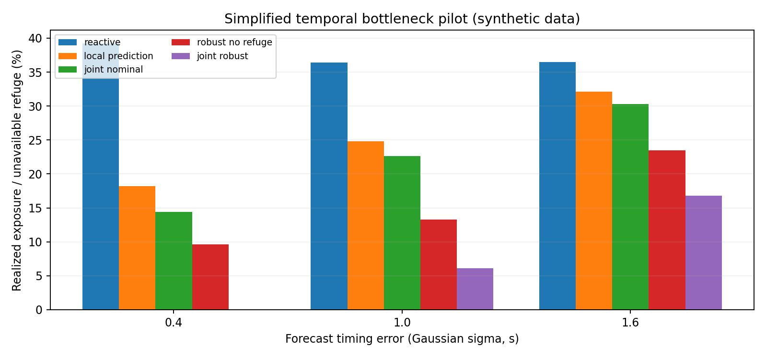
Figure 1. Exposure to realized synthetic occupation windows. Lower values are better; these are not physical collision rates.
At σ = 1.0 s, nominal joint scheduling has 22.6% exposure and an average planned finish time of 13.51 s. STV-ED with δ = 1.25 s reduces exposure to 6.1%, while average planned completion time increases to 15.27 s. The paired difference is −16.5 percentage points (95% bootstrap interval: −19.0 to −14.1 points). The robust planner without refuge checking exhibits 13.3% exposure, indicating that the refuge-availability constraint matters in this particular generator. At σ = 1.6 s, exposure for STV-ED rises to 16.8%: prediction error still creates substantial failure risk.

6.2 Temporal uncertainty sensitivity
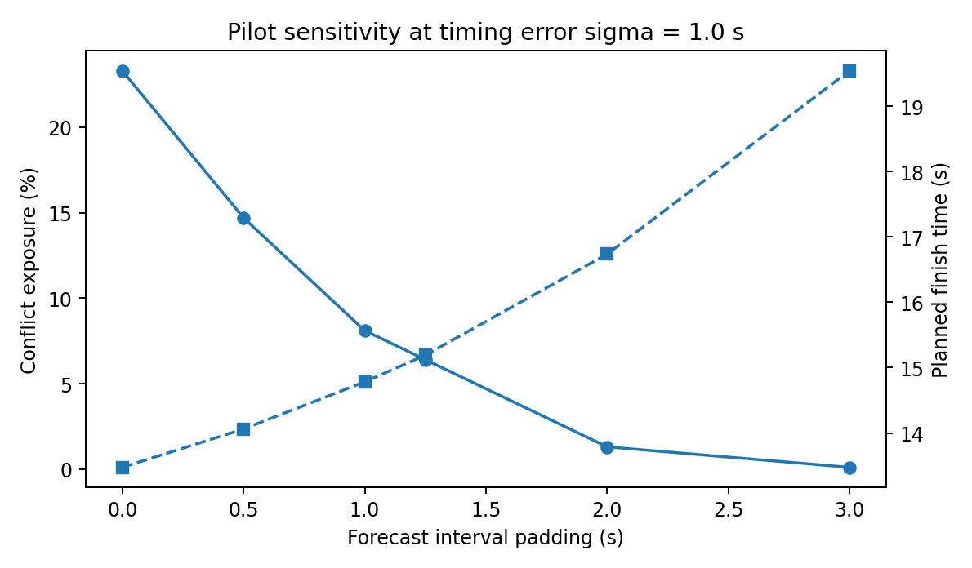
Figure 2. The tradeoff between temporal padding and planned finish time (separate 1,000-scene sensitivity set, σ = 1.0 s).
In the independent 1,000-scene padding sweep (σ = 1.0 s), exposure declines from 23.3% at δ = 0 to 6.4% at δ = 1.25 s and 1.3% at δ = 2.0 s. Mean planned finish time increases from 13.47 s to 15.19 s and 16.74 s, respectively. Hence, reducing exposure in the chosen synthetic distribution comes with a measurable throughput cost. The padding parameter is not statistically calibrated to real prediction errors.

7. Discussion, Limitations, and Next Validation
The main result is a restricted feasibility demonstration: when entrance decisions rely on future resource occupancy and an intermediate holding place with time-dependent availability, additional admission constraints reduce temporal conflicts in an abstract simulator. This result is consistent with the general motivation of fail-safe motion planning [2], narrow-road meeting-gap analysis [10], and uncertainty-aware reachable planning [12], rather than evidence that the method supersedes them.
- Travel time is fixed and motion is longitudinal only. No bicycle model, vehicle length footprint collision check, braking dynamics, actuator limits, road curvature, or controller is implemented.
- The planner receives correct future event existence and durations, with only Gaussian timing shifts. Real occlusions, unseen participants, missed detections, false detections, and multimodal intentions are excluded.
- Decisions are scheduled open-loop in this test. Mid-segment replanning, emergency maneuvers, pedestrian responses, and true closed-loop interactions are not included.
- The random time-window distributions are hand-selected; no empirical township traffic study was used for calibration or external validity testing.
- The baseline algorithms are internal heuristics/ablations. Strong methods cited in the literature were not reimplemented; no superiority claim over peer-reviewed state-of-the-art planners is justified.
- Stopping in a refuge is represented only by temporal availability. Real geometric accessibility, vehicle width, steering radii, legal right-of-way, and whether stopping is acceptable are not assessed.
For a submission-quality study, the next phase must replace segment travel-time abstraction with a vehicle-kinematic model and dynamic obstacle occupancy, integrate a recoverable trajectory or stop-set constraint into an actual planner, implement closed-loop replanning, and evaluate against at least a nominal planner, a predictive collision-aware planner, and an appropriate published safe planning baseline. CommonRoad [3] can provide standardized dynamics and scenarios; CARLA [13] may serve as a later perception/interaction check. Realistic or measured mixed-traffic event frequencies are also needed. The research title should be revised to include trajectory planning only after that component is actually implemented.

8. Conclusion
This pilot constructed and executed a reproducible temporal-window model of entrance admission at a two-conflict narrow-road bottleneck with a dynamically occupied intermediate refuge. In the selected synthetic episodes, forecast padding and refuge-use feasibility checks reduce preselected schedule conflicts at the cost of later planned exits. The work validates neither collision avoidance nor full vehicle motion planning, and its novelty against published fail-safe and narrow-road methods remains to be established. These limitations define the necessary work before any EI conference submission.

References
[1] Paden, B., Cap, M., Yong, S. Z., Yershov, D., and Frazzoli, E. (2016). A Survey of Motion Planning and Control Techniques for Self-Driving Urban Vehicles. IEEE Transactions on Intelligent Vehicles, 1(1), 33–55. https://doi.org/10.1109/TIV.2016.2578706
[2] Magdici, S., and Althoff, M. (2016). Fail-safe motion planning of autonomous vehicles. 2016 IEEE International Conference on Intelligent Transportation Systems, 452–458. https://doi.org/10.1109/ITSC.2016.7795594
[3] Althoff, M., Koschi, M., and Manzinger, S. (2017). CommonRoad: Composable benchmarks for motion planning on roads. 2017 IEEE Intelligent Vehicles Symposium, 719–726. https://doi.org/10.1109/IVS.2017.7995802
[4] Hubmann, C., Quetschlich, N., Schulz, J., Bernhard, J., Althoff, D., and Stiller, C. (2019). A POMDP Maneuver Planner for Occlusions in Urban Scenarios. 2019 IEEE Intelligent Vehicles Symposium, 2172–2179. https://doi.org/10.1109/IVS.2019.8814179
[5] Yu, M.-Y., Vasudevan, R., and Johnson-Roberson, M. (2020). Risk Assessment and Planning with Bidirectional Reachability for Autonomous Driving. 2020 IEEE International Conference on Robotics and Automation. https://doi.org/10.1109/ICRA40945.2020.9197491
[6] Jeong, Y. (2021). Self-Adaptive Motion Prediction-Based Proactive Motion Planning for Autonomous Driving in Urban Environments. IEEE Access, 9, 105612–105626. https://doi.org/10.1109/ACCESS.2021.3100590
[7] Zhang, C., Steinhauser, F., Hinz, G., and Knoll, A. (2021). Improved Occlusion Scenario Coverage with a POMDP-based Behavior Planner for Autonomous Urban Driving. 2021 IEEE International Intelligent Transportation Systems Conference, 593–600. https://doi.org/10.1109/ITSC48978.2021.9564424
[8] Gangadhar, S., Wang, Z., Poku, K., Yamada, N., Honda, K., Nakahira, Y., Okuda, H., and Suzuki, T. (2023). An occlusion- and interaction-aware safe control strategy for autonomous vehicles. IFAC-PapersOnLine, 56(2), 7926–7933. https://doi.org/10.1016/j.ifacol.2023.10.315
[9] Firoozi, R., Mir, A., Camps, G. S., and Schwager, M. (2025). OA-MPC: Occlusion-Aware MPC for Guaranteed Safe Robot Navigation With Unseen Dynamic Obstacles. IEEE Transactions on Control Systems Technology, 33(3), 940–951. https://doi.org/10.1109/TCST.2024.3520462
[10] Zhang, Q., Guang, J., Cao, Z., and Liu, J. (2024). Scene Modeling of Autonomous Vehicles Avoiding Stationary and Moving Vehicles on Narrow Roads. arXiv preprint arXiv:2412.13305. https://arxiv.org/abs/2412.13305
[11] Fujinami, Y., and Raksincharoensak, P. (2026). Risk-predictive trajectory and speed planning method for safe autonomous driving on urban narrow roads. Mechanical Engineering Journal, 13(2), 25-00380. https://doi.org/10.1299/mej.25-00380
[12] Chen, K., Zhao, C., Ji, Y., and Du, Y. (2026). SURE-plan: A spatio-temporal uncertainty-aware reachable set embedding framework for safe and efficient motion planning of autonomous vehicles. Transportation Research Part C, 190, 105800. https://doi.org/10.1016/j.trc.2026.105800
[13] Dosovitskiy, A., Ros, G., Codevilla, F., Lopez, A., and Koltun, V. (2017). CARLA: An Open Urban Driving Simulator. Proceedings of the 1st Conference on Robot Learning, PMLR 78, 1–16. https://proceedings.mlr.press/v78/dosovitskiy17a.html

