Curriculum Vitae: Priv. Doz. Dr. Peter G. Thirolf

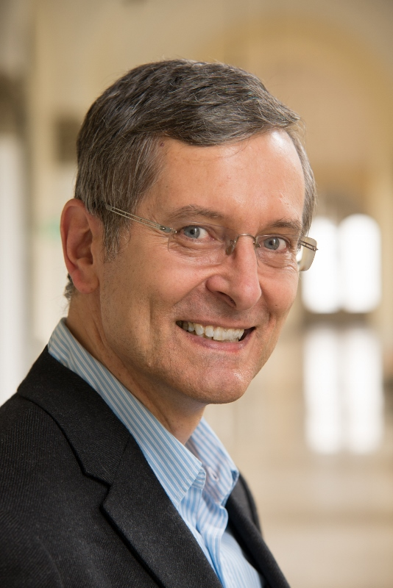

FOTO
(bitte im Anhang beifügen)

Ludwig-Maximilians-Universität München
Fakultät für Physik
Chair of Experimental Physics - Medical Physics
Am Coulombwall 1
85748 Garching
Web: http://www.med.physik.uni-muenchen.de

Phone: ++(0)89-28914064
Fax: ++(0)89-28914072
E-mail: Peter.Thirolf@physik.uni-muenchen.de

Date and place of birth: 08.08.1960 (Frankfurt/Main, Germany)
Gender: Male
Nationality: German

EDUCATION

1987: Diploma in Physics, Ruprecht-Karls-University (RKU) Heidelberg
1992: PhD in Physics, University of Heidelberg
2004: Habilitation, Ludwig-Maximilians-University (LMU) München

ACADEMIC CAREER

1992-1994: Scientific employee, Max-Planck-Institute (MPI) for Nuclear Physics,
Heidelberg
1995-1996: Research Associate at National Superconducting Cyclotron Laboratory,
Michigan State University, East Lansing, MI, USA
1996-2004: Scientific Assistant, LMU München
2002: Appointment as ‘Akademischer Rat’ at LMU Munich
since 2004: ‘Privatdozent’ (Lecturer), LMU München
2006: Promotion to ‘Akademischer Oberrat’ at LMU Munich

PROFESSIONAL ACTIVITIES

2003-2005: Coordinator of the multi-national EU-funded research network 'IonCatcher'
since 2004: Project leader in the DFG-funded Transregional Collaborative Research Center
TR18 ‘Relativistic Laser-Plasma Dynamics’
2006-2009: Coordinator of the multi-national EU-funded research network 'SAFERIB'
2006-2010: Member of the Steering Committee of the EU-Project ‘EURISOL-Design
Study
since 2006: Principal Investigator and project leader in the DFG Cluster of Excellence
'Origin and Structure of the Universe’
since 2006: Project leader in the DFG Cluster of Excellence ‘Munich-Centre for
Advanced Photonics (MAP)’
2006-2009: Research Area Coordinator: 'Fundamental Physics and Nuclear Transitions'
in the DFG Cluster of Excellence MAP
2010-2011: Deputy Research Area Coordinator: 'Fundamental Physics and Nuclear
Transitions' (substituting Prof. T.W. Hänsch)
2006-2011: Board Member of the DFG Cluster of Excellence MAP
since 2010: Member of the Collaboration Committee of the DESIR facility at SPIRAL-2
(Caen/France)
2010-2012: Member of the Executive Board of the EU funded Research Infrastructure:
ELI-Nuclear Physics (Bucharest, Romania)
since 2012: Council Member of the NUSTAR collaboration at FAIR (Darmstadt/Germany)
since 2012: Member of the ‘Expert Committee Experiments (ECE)’ at the International
FAIR facility (Darmstadt)
since 2012: Deputy project leader of the Centre for Advanced Laser Applications (CALA)
in Garching
2014-2016: Member of the Scientific Council of the Institut Laue-Langevin (ILL,
Grenoble/France)
since 2015: Member of the PHELIX high-intensity laser program committee at GSI
since 2016: Coordinator of the H2020 Networking Activity NA5-MediNet within ENSAR2
since 2016: Chairman of the PHELIX high-intensity laser program committee at GSI
since 2016: Member of the Scientific Advisory Committee of the ELBE – Center for High
Power Radiation Sources (Helmholtz-Zentrum Dresden-Rossendorf)

PEER REVIEWING ACTIVITIES:

Regularly active as referee for: Physical Review Letters, Physical Review C, Physics
Letters B, Physics in Medicine and Biology, Medical Physics, Nuclear Instruments and
Methods A/B, European Physical Journal A, Journal of Instrumentation, IEEE
Transactions on Nuclear Science

SUPERVISIONS:

9 PhD theses, 7 diploma theses, 8 MSc theses, 11 BSc theses, 6 Postdoctoral Fellows ,
currently ongoing: 3 PhD thesis projects, 2 MSc thesis projects, 1 BSc thesis project

MAIN PROJECTS:

Currently 5 running third-party funded projects as PI or project leader

FELLOWSHIPS

1980 – 1987: Fellow of the ‘Studienstiftung des Deutschen Volkes’

AWARDS

2017: GSI/FAIR GENCO membership award

RESEARCH INTERESTS

Instrumentation for medical physics applications, structure of exotic nuclei, nuclear mass spectrometry, laser ion acceleration, fundamental physics

10 MOST IMPORTANT PUBLICATIONS:

1. P.G. Thirolf and D. Habs, Spectroscopy in the Second and Third Minimum of Actinide
Nuclei, Prog. Part. Nucl. Phys. 49 (2002) 325-402.
2. P.G. Thirolf, B.V. Pritychenko, B.A. Brown, P.D. Cottle, M. Chromik, T. Glasmacher, G.
Hackman, R.W. Ibbotson, K.W. Kemper, T. Otsuka, L.A. Riley, H. Scheit, Spectroscopy of
the 2⁺₁ state in ²²O and shell structure near the neutron drip line, Phys. Lett. B 485 (2000)
16.
3. M. Csatlos, A. Krasznahorkay, P.G. Thirolf, D. Habs, Y. Eisermann, T. Faestermann, G.
Graw, J. Gulyas, M.N. Harakeh, R. Hertenberger, M. Hunyadi, H.J. Maier, Z. Mate, O.
Schaile, H.-F. Wirth, Resonant tunneling through the triple-humped fission barrier of ²³⁶U,
Phys. Lett. B 615 (2005) 175.
4. W. Schwerdtfeger, P.G. Thirolf, K. Wimmer, D. Habs, H. Mach, T.R. Rodriguez, V.
Bildstein, J.L. Egido, L.M. Fraile, R. Gernhäuser, K. Heyde, P. Hoff, H. Hübel, U. Köster,
T. Kröll, R. Krücken, R. Lutter, T. Morgan, P. Ring, Shape coexistence near the neutron
number N= 20: First identification of the E0 decay from the deformed 0⁺₂ state in ³⁰Mg,
Phys. Rev. Lett. 103, 012501 (2009).
5. M. Block, D. Ackermann, K. Blaum, C. Droese, M. Dworschak, S. Eliseev, T.
Fleckenstein, E. Haettner, F. Herfurth, F. P. Heßberger, S. Hofmann, J. Ketelaer, J. Ketter,
H.-J. Kluge, G. Marx, M. Mazzocco, Yu. N. Novikov, W. R. Plaß, A. Popeko, S. Rahaman,
D. Rodríguez, C. Scheidenberger, L. Schweikhard, P. G. Thirolf, G. K. Vorobyev, and C.
Weber, First direct mass measurements of trans-uranium elements - Bridge to the
superheavy island of nuclear stability, Nature 463 (2010) 785.
6. E. Minaya Ramirez, D. Ackermann, K. Blaum, M. Block, C. Droese, Ch.E. Düllmann, M.
Dworschak, M. Eibach, S. Eliseev, E. Haettner, F. Herfurth, F.P. Heßberger, S. Hofmann,
J. Ketelaer, G. Marx, M. Mazzocco, D. Nesterenko, Yu. Novikov, W.R. Plaß, D.
Rodriguez, C. Scheidenberger, L. Schweikhard, P.G. Thirolf and C. Weber, Direct
mapping of shell-effects in the heaviest elements, Science 337, 1207 (2012).
7. L. v.d. Wense, B. Seiferle, M. Laatiaoui, H.J. Maier, J.B. Neumayr, H.-F. Wirth, C. Mokry,
J. Runke, K. Eberhardt, C.E. Düllmann, N. Trautmann, P.G. Thirolf, Direct detection of the
Thorium-229 nuclear clock transition, Nature 533, 47-51 (2016).
8. B. Seiferle, L. v.d. Wense, P.G. Thirolf, Lifetime measurement of the ²²⁹Th nuclear isomer,
Phys. Rev. Lett. 118, 042501 (2017).
9. L. v.d. Wense, A. Palffy, B. Seiferle, S. Stellmer, J. Weitenberg, P.G. Thirolf, Novel
method for ^{229m}Th energy measurement, Phys. Rev. Lett. 119, 132503 (2017).
10. J. Thielking, M.V. Okhapkin, P. Glowacki, D.M. Meier, L. v.d. Wense, B. Seiferle, C.E.
Düllmann, P.G. Thirolf, E. Peik, Laser spectroscopic characterization of the nuclear clock
isomer ^{229m}Th, Nature 556, 321-325 (2018).

June 2018: 273 publications, h-index: 36 (from: Web of Knowledge)

