pragma solidity >=0.4.22 <0.6.0;

contract Voting {

bytes32[]candidates = new bytes32[](5);

mapping (bytes32 => uint) candidatesVotingCount;

constructor(bytes32[] memory _candidates)public{

for(uint i = 0; i<_candidates.length; i++){

candidates[i] = _candidates[i];

}

}

function votingToPerson(bytes32 person)public {

assert(isValidToPerson(person));

candidatesVotingCount[person] += 1;

}

function votingTotalToPerson(bytes32 person)public view returns (uint) {

assert(isValidToPerson(person));

return candidatesVotingCount[person];

}

function isValidToPerson(bytes32 person)public view returns (bool) {

for(uint i = 0; i<candidates.length; i++){

if(candidates[i]==person){

return true;

}

}

return false;

}

}

//["zhh","mayun","zhangbozhi","Liudehua","lwl"]

# 1.web3安装问题

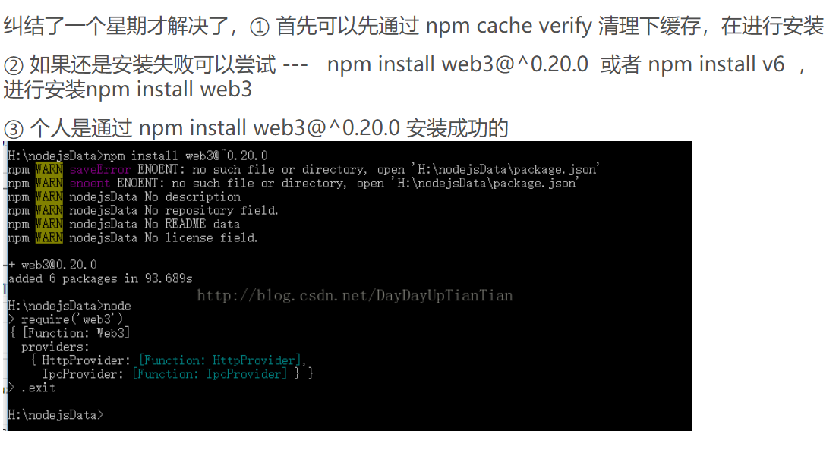

# 2.区块链数据不刷新和event事件

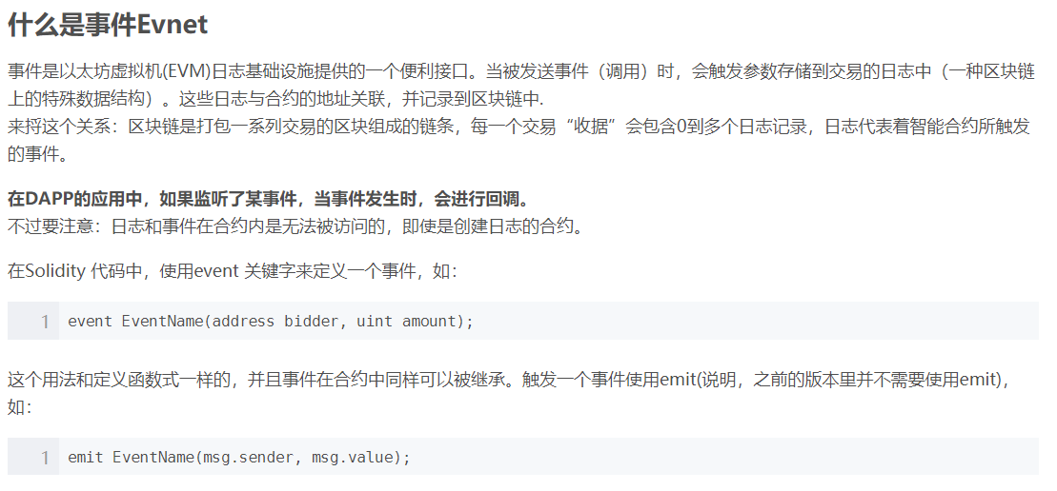

# 安装metamask

1. 下载metamask

<https://github.com/MetaMask/metamask-extension/releases>

2.解压下载的文件，并在谷歌浏览器中选择“加载已解压的扩展程序”。

# 3.在ropsten中获取测试一台币网址

<https://faucet.ropsten.be/>