**Pteam: An Online Gaming Shop**

**User Manual**

2024

**TABLE OF CONTENTS**

1. Introduction to Pteam: An Online Gaming Shop 3

1.1. Brief Overview of the Pteam Application 3

1.2. Purpose of the Installation Manual 3

2. System Requirements 4

2.1. Hardware Prerequisites 4

2.2. Software Prerequisites 4

3. Installation Manual 4

3.1. MacOS JDK installation 4

3.2. MacOS Maven installation 7

3.3. MacOS Visual Studio Code installation 8

3.4. MacOS MySQL installation 10

3.4. Setting environment in VS Code for the project 11

4. User Manual 12

# 1. Introduction to Pteam: An Online Gaming Shop

## 1.1. Brief Overview of the Pteam Application

Welcome to Pteam, an exciting online store designed to change how you buy and manage your video games. Pteam is built using Java Spring Boot and stores data securely with MySQL, ensuring a smooth and reliable experience. This application employs object-oriented programming principles, making it both sophisticated and user-friendly, perfect for gamers of all kinds.

Pteam offers a variety of features to make your shopping experience enjoyable:

* **User Accounts:** Start by creating an account, which gives you access to a personalized profile. After logging in, you can add credit cards for purchasing games, view your personal information, manage payment methods, and check your purchase history. You can also update your password in the profile section to keep your account secure.
* **Diverse Game Store:** The main attraction of Pteam is its diverse store, featuring 30 games from different genres and price ranges. To help you find what you want quickly, you can sort games by price and filter them by genre and price range. Once you pick the games you want, you can add them to your cart for easy checkout.
* **Secure Checkout:** The checkout process is simple and secure. You’ll be taken to a payment page where you can choose an active credit card, enter your billing information, and confirm the transaction with your CVV code. You’ll also need to agree to Pteam’s terms and conditions.
* **Personal Game Library:** Once the purchase is successful, the games will be added to your personal game library, where you can launch them directly from Pteam.

Pteam not only provides a fun and engaging shopping experience but also gives you full control over your game purchases and account information. With a detailed installation and user manual, Pteam is easy to set up and use, making it an ideal choice for gamers looking for a reliable and feature-packed online gaming store.

## 1.2. Purpose of the Installation Manual

The Installation Manual is designed to provide step-by-step instructions for MacOS to set up the Pteam application. It includes detailed information on system requirements, hardware and software prerequisites, and any necessary dependencies. The manual also addresses potential installation issues and troubleshooting steps, ensuring a smooth and hassle-free installation process.

Specifically, the Installation Manual includes:

* Setting up Java Spring Boot for MacOS.
* Installing Maven on MacOS.
* Installing VS Code and setting it up for the project.
* Installing MySQL for MacOS.

# 2. System Requirements

## 2.1. Hardware Prerequisites

* Personal computer or laptop;
* Keyboard, mouse, monitor;
* Internet connection.

## 2.2. Software Prerequisites

* Operating System: MacOS Sonoma 14.4 or higher;
* Java Development Kit (JDK) 22;
* Apache Maven 3.9.6 or higher;
* MySQL 8.3.0 or higher;
* IDE: Visual Studio Code (VS Code) with required extensions.

# 3. Installation Manual

## 3.1. MacOS JDK installation

JDK can be installed from Oracle official website. Link to the download: <https://www.oracle.com/java/technologies/downloads/>

Figure 1. JDK installation variants for MacOS.

As you can see, there are 2 different versions to choose from *(Figure 1).* How do you choose a correct one? ARM64 is version for Mac with Apple M1/M2/M3 chips, where x64 version is for Mac with Intel chip.

Figure 2. MacOS chip version.

Look for the "Processor" information *(Figure 2).* MacOS chip version can be checked by clicking Apple logo in the left top corner -> About This Mac -> Processor. In the example figure you can see that this MacOS has Intel chip. It means that for following MacBook you need to download x64 JDK version but not ARM64.

Figure 3. DMG file content.

After choosing correct version, download x64 DMG Installer *(Figure 1).* After downloading, you will get DMG file where you need to double-click on installation package – “JDK 22.0.1.pkg” *(Figure 3).*

Figure 4. JDK installation menu.

Figure 5. JDK installation location.

Figure 6. JDK successful installation.

After opening JDK 22.0.1.pkg file, installation menu for JDK will open *(Figure 4).* You can choose directory for installation, but I suggest using the default one *(Figure 5).* After successful download, you can close installation menu *(Figure 6)*.

Figure 7. How to open Terminal.

To set JAVA_HOME path, you first need to check Java version that you have installed. To check, you need to open Terminal. By pressing “Command + Space”, a search bar will be open where you need to type “terminal” *(Figure 7)*.

Figure 8. Java_home version.

After opening terminal, you need to type following command to check Java home version: “/usr/libexec/java_home -V” *(Figure 8)*. In the following example, you need to choose the latest version, which is 22.0.1.

Figure 9. configuration file creation for Zsh shell.

Figure 10. Java home path set.

To set the Java Home path, you need to create a configuration file for the Zsh shell if it doesn’t already exist. To create the .zshrc file, type the following command: “touch .zshrc”. This command will create the configuration file for Zsh. To check if it was created, type “ls -al” and find the .zshrc file in the list *(Figure 9).* To open it, type the command “open .zshrc”. Then, paste the following commands with the correct Java version *(Figure 10).* To save this path, you can either reopen the terminal or type the command “source .zshrc”.

## 3.2. MacOS Maven installation

For dependencies support in Java project, you need to download Maven. It can be downloaded from [https://maven.apache.org/download.cgi.](https://maven.apache.org/download.cgi)

Figure 11. Maven folder installation.

Figure 12. Set Maven path.

Figure 13. Maven Home Location.

After downloading the following archive *(Figure 11)*, maven folder will be downloaded. In my example, I will place this folder to /Users/andreyh/apache-maven-3.9.6.

To set path for Maven, you need to open bash profile. It can be open via “vim ~/.bash_profile” in terminal. After opening bash profile, you need to press ‘i’ to change to insert mode and paste 2 following commands *(Figure 12).* Hit ESC and then :wq to come out from this bash profile and then ENTER. Now you need to save bash profile by typing “source ~/.bash_profile” and check Maven location by “echo $MVN_HOME” *(Figure 13)*.

## 3.3. MacOS Visual Studio Code installation

To download VS Code to launch the project, you can use the following link:

<https://code.visualstudio.com/download>

Figure 14. VS Code OS selection.

Figure 15. Downloaded Application.

On the official download website of VS Code, you need to select the MacOS version *(Figure 14).* After downloading the archive, you will find the VS Code application in the Downloads folder, which you can instantly launch *(Figure 15).*

Figure 16. Extension Marketplace.

Figure 17. Java Extension Pack.

Figure 18. Spring Boot Extension Pack.

After successfully installing VS Code, you need to install two extensions to launch the project. To download them, open the Extension Marketplace *(Figure 16)* and download the “Extension Pack for Java” *(Figure 17)* and the “Spring Boot Extension Pack” *(Figure 18).*

## 3.4. MacOS MySQL installation

MySQL will be used as a database for storing data for the project. It can be downloaded from <https://dev.mysql.com/downloads/mysql/>

Figure 19. MySQL version selection.

Figure 20. Password setting.

In our case, you select “x86, 64-bit” because of the Intel chip *(Figure 19).* After downloading the archive, the installation menu will open. Follow the installation steps, and then a configuration window will appear where you need to set a password for your database *(Figure 20).* You should remember that password because it will be used for connecting the DB to the project. After that, MySQL will be successfully installed.

## 3.4. Setting environment in VS Code for the project

Figure 21. Clone Repository.

After you have downloaded everything needed for the project, you need to clone the repository from GitHub. Open Explorer, select "Clone Repository," and paste the link to the GitHub repository: <https://github.com/GGHF1/pteam>*(Figure 21).*

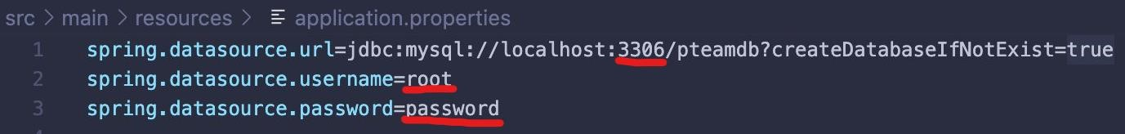

Figure 22. Setting DB connection.

Figure 23. MySQL port.

After opening the repository, the project will be saved to the selected folder. To connect this project to MySQL DB, open “application.properties” located in “\pteam\src\main\resources\”. Now, fill in the port, which can be found in the MySQL application *(Figure 23)*, and set the username and password that were created after downloading MySQL *(Figure 22).* You have now installed everything needed to launch the project!

Figure 24. Project launch button.

Now press launch button to launch the project *(Figure 24)*. After that, open browser and type in search bar: [http://localhost:8080/.](http://localhost:8080/) If everything was installed correctly, the web application will be opened!

# 4. User Manual

Figure 25. Welcome page

Welcome to the Pteam web application. After launching the project, this page will be loaded *(Figure 25).* Here, you will find news about the latest game added to the store and general information about the store. The welcome page features three buttons: Login, Register, and Store.

If you prefer to explore available games in the store without registering, click the “Store” button.

Figure 26. Store page

Figure 27. Game’s description modal box.

Figure 28. Sorted games from High to Low.

Figure 29. Filtered by genre “Horror”.

Figure 30. Filtered by price – from 50 to 70.

Figure 31. Website is asking to log in after pressing “Add to cart”.

Here is store page *(Figure 26).* Due to you are still not registered, all you can do is check game’s info *(Figure 27),* sort games by price *(Figure 28)*, filter by genre *(Figure 29),* filter by price *(Figure 30).* Meaning, you have access to common fucntions but if you try to press “Add to Cart” button, the website will require you to log in first *(Figure 31).* That’s why you need to press register button to register your new account!

Figure 32. Register form.

Figure 33. Incorrect input for registration.

Here is register form page *(Figure 32).* Here you should fill all forms with corresponding information. All input should be valid or “Register” button will remain disabled! *(Figure 33)*

Figure 34. Incorrect credentials.

After successful registration, you must log in to your account. If you have forgotten your password and cannot log in, click “Restore password” *(Figure 34).*

Figure 35. Restore password page.

Here, you need to fill out the required forms to verify that the account is yours. After completing this step, the password will be successfully changed *(Figure 35).*

Figure 36. Main page.

After successfully logging in, you will be directed to the main page *(Figure 36).* It may look like the welcome page, but the buttons have changed. Now, you will find:

* **Profile -** Displays account information and functions associated with your account.
* **Store -** Access the store page with all available games and access to the cart.
* **Game Library -** Stores all purchased games in your personal game library.
* **Logout -** Logs you out of your account.

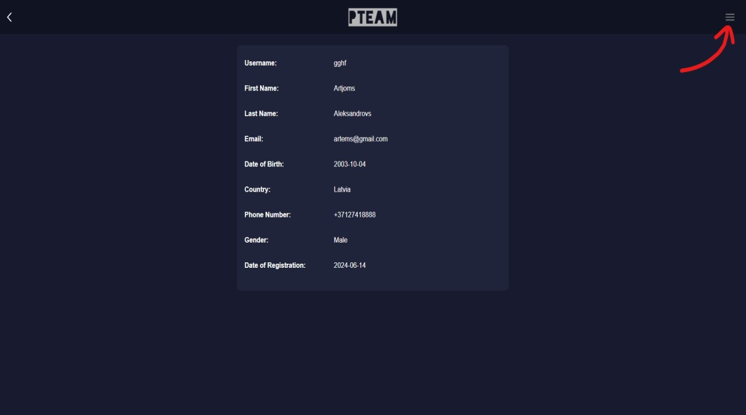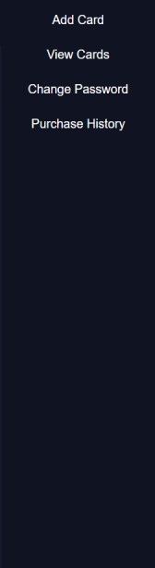

Figure 37. Profile page with drawer.

Here is your profile page where your account’s information is available *(Figure 37).* Additionally, in the top right corner, there is a drawer button. Clicking on it reveals four buttons:

* **Add card -** Fill out all required forms to add a credit card for purchasing games.
* **View cards -** Displays all added cards, including their service type and status.
* **Change password -** Allows you to change your password to a new one.
* **Purchase history -** Shows detailed information about all purchases you have made.

Let’s add a new credit card so you can make purchases!

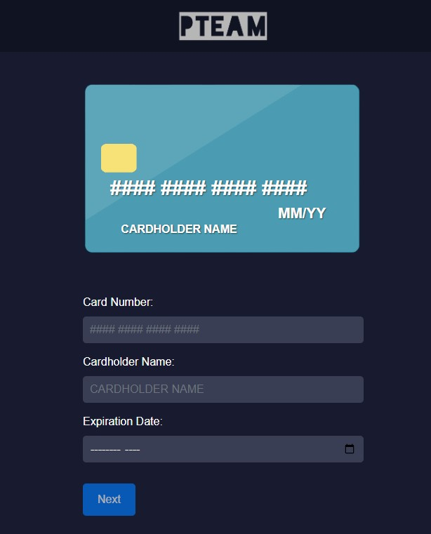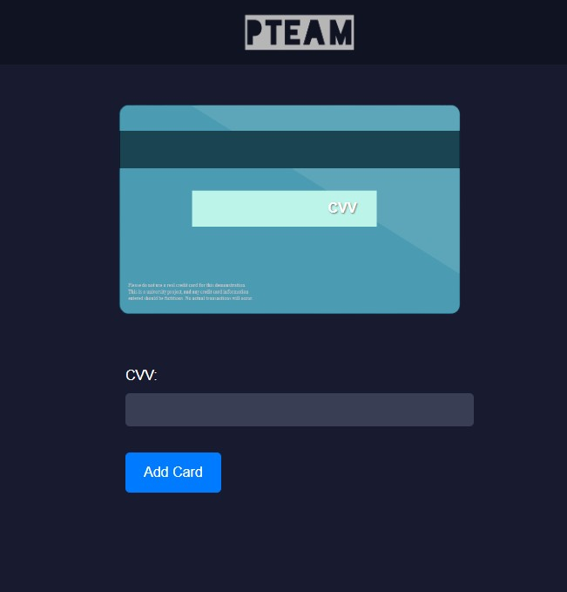

Figure 38. Step 1 and 2 of adding a card.

Figure 39. View added cards.

Here is the page for adding a card, divided into 2 steps *(Figure 38).* First, enter the card number, cardholder name, and expiration date. If the input is valid, the card will flip over, and you will need to enter the CVV code. If everything is entered correctly, the card will be added to your account. You can view it by clicking “View cards” in the profile page *(Figure 39).*

Figure 40. Adding games to the cart.

Now that you have added a card, you can choose any games you want to purchase. After clicking “Add to cart”, the game will be added to the cart, and the number next to the cart icon will display how many games are currently in the cart *(Figure 40).*

Figure 41. Cart’s content.

After clicking on cart icon, the cart will show on modal box all added games. You can either remove specific game from the cart or go to checkout page *(Figure 41).*

Figure 42. Order details.

If you have clicked on the “Checkout” button, you will be directed to the order details page. From this point, you have 20 minutes to complete your purchase or your current order will be deleted. You can proceed to payment or cancel the order *(Figure 42).*

Figure 43. Payment page. If you click on the “Proceed to payment” button, you will be directed to the payment page. Here, you need to select your active card (expired cards won’t be shown) and enter the necessary billing information. To confirm the payment, you must enter the CVV code and agree to the website's terms and conditions *(Figure 43).*

Figure 44. Game library.

Figure 45. Purchase history.

If your payment was successful, your new games will be added to your personal game library. *(Figure 44)* Additionally, as mentioned earlier, the details of each purchase will be added to your purchase history. *(Figure 45)*

Figure 46. Log out.

If you want to log out of your account, all you need to do is press “Logout” button in main page. After clicking it, your session will be terminated and you will have to log in once again to access your account *(Figure 46).*