**Problem introduction**

Using the monthly sales data (in millions of dollars) of a manufacturing company over last eight years to predict sales data each month in 2022, and find the best Exponential Smoothing model to predict.

**Problem 1**

Use first two years of data to estimate initial (time 0) Level (L0), Trend (T0), and

the additive seasonal factors for each month of the year.

L0 = 101.311595

T0 = 1.5863627

Additive seasonal factors:



**Problem 2**

Using smoothing constants α=0.2, β=0.1, and γ=0.1 apply additive trend-seasonal model to your data and compute Mean % Error, Mean Absolute % Error, RMSE (Root Mean Square Error), and other indicators. Discuss what information these indicators provide. Use your model to forecast next 12 months.

**<1> Additive trend-seasonal model**

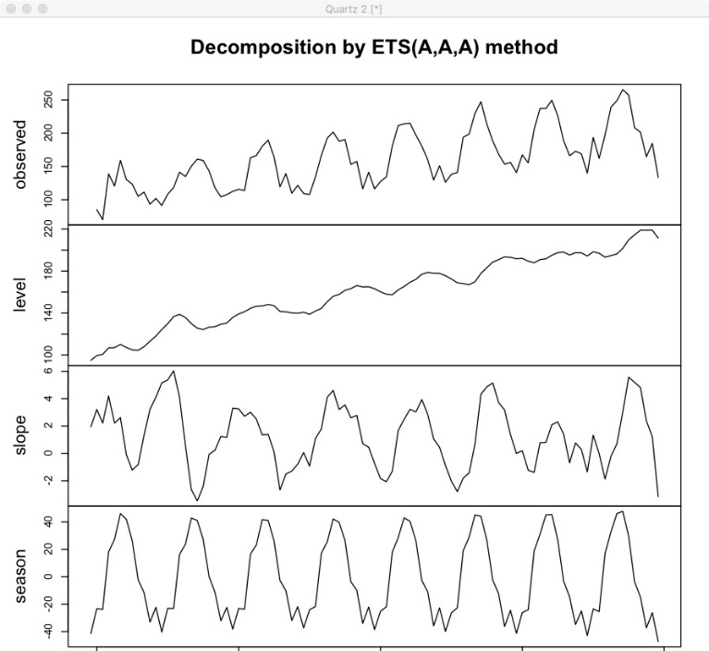

Level component = Lt

Slope = Tt

Season = St

**<2>Time series**

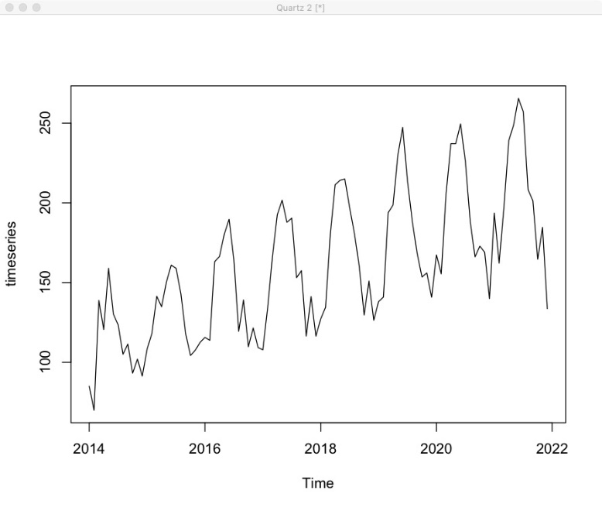

The sales data observed between 2014 and 2022 in the manufacturing company, is shown in this picture.

**<3> The Indicators of additive trend-seasonal model**



**<4>What are Mean % Error, Mean Absolute % Error and RMSE?**

MPE: The **mean percentage error (MPE)** is the computed average of percentage errors by which forecasts of a model differ from actual Sales value of the quantity being forecast, which shows our forecast on average is off 0.8857627%.

MAPE: Mean Absolute Percentage Error (MAPE) is the mean of all absolute percentage errors between the predicted sales and actual sales values, which shows our forecast on average is off 8.203792%.

MASE: It is the mean absolute error of the forecast sales values, divided by the mean absolute error of the in-sample one-step naive forecast, which is equal to 0.7922201.

RMSE: It is difference between prediction sales and truth sales each month, which is related to the best model we will choose.

**<5> Forecast of Sales data in 2022 for additive trend-seasonal model**

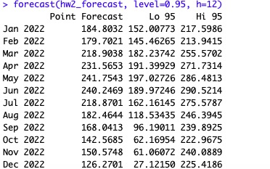

**Problem 3**

Repeat Problem (1) and problem (2) for a multiplicative trend-seasonal model. Compare this model to the additive trend-seasonal model obtained in problem (2). Use your model to forecast next 12 months.

**<1> estimate initial (time 0) Level (L0), Trend (T0), and the multiplicative seasonal factors**

L0 = 101.311595

T0 = 1.5863627

multiplicative seasonal factors



**<2> multiplicative trend-seasonal model**

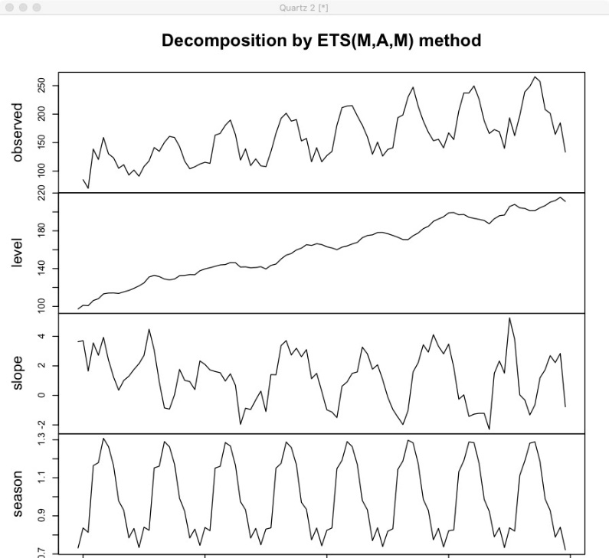

Level component = Lt

Slope = Tt

Season = St

**<3> The Indicators of multiplicative trend-seasonal model**



**<4> What are Mean % Error, Mean Absolute % Error and RMSE?**

MPE: The **mean percentage error (MPE)** is the computed average of percentage errors by which forecasts of a model differ from actual Sales value of the quantity being forecast, which shows our forecast on average is off 0.8662507%.

MAPE: Mean Absolute Percentage Error (MAPE) is the mean of all absolute percentage errors between the predicted sales and actual sales values, which shows our forecast on average is off 6.530475%.

MASE: It is the mean absolute error of the forecast sales values, divided by the mean absolute error of the in-sample one-step naive forecast, which is equal to 0.64777.

RMSE: It is difference between prediction sales and truth sales each month, which is related to the best model we will choose.

**<5> Forecast of Sales data in 2022 for multiplicative trend-seasonal model**

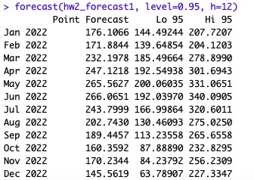

**<6> Compare multiplicative trend-seasonal model to the additive trend-seasonal model**

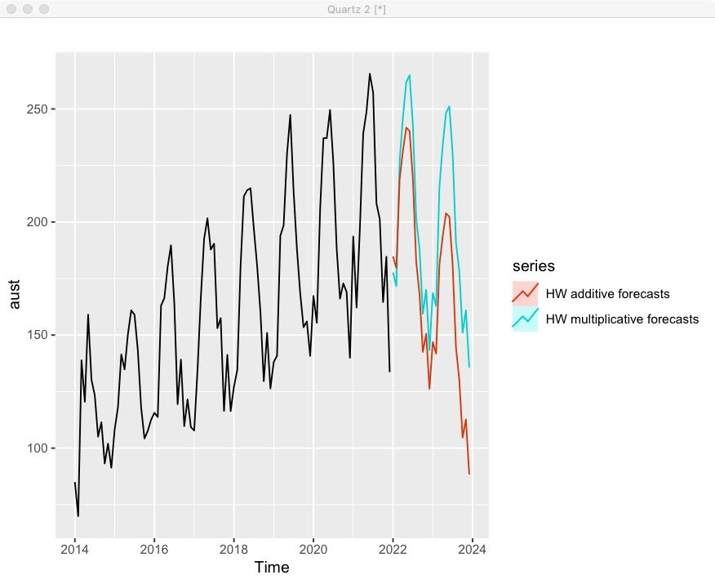

**Problem 4**

Use R to find the best additive trend-seasonal model as well as best multiplicative trend-seasonal model (restrict all smoothing constants to be between 0.1 and 0.5). Compare accuracy measures (RMSE, etc.) of these models to one obtained in part (b) and part (c). What is your forecast for next 12 months based on this model?

**<1> The best additive trend-seasonal model**

α=0.4999, β=0.1001, and γ=0.1008

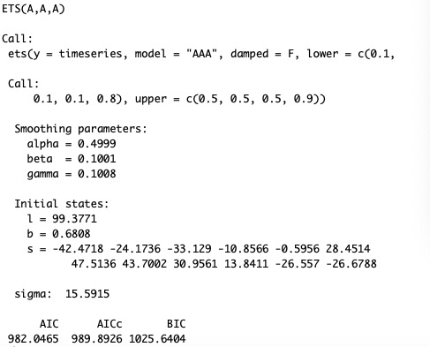

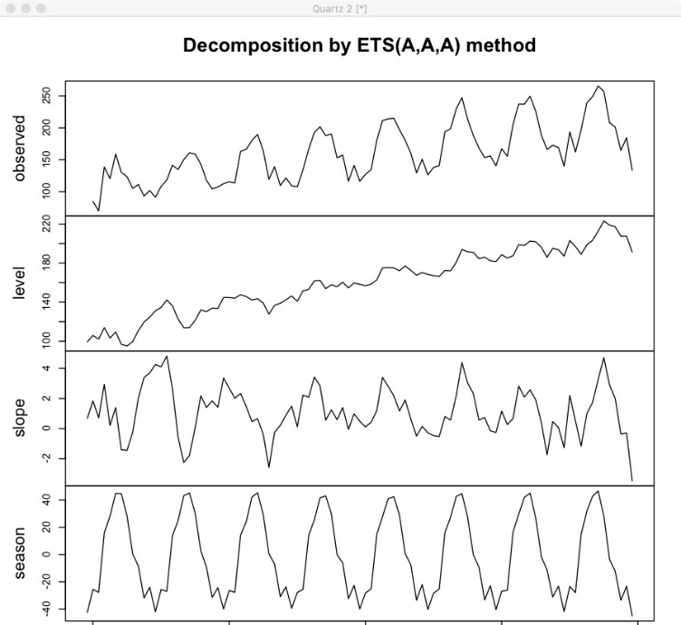

Level component = Lt

Slope = Tt

Season = St

RMSE = 14.23307



Forecast of Sales data in 2022 with best additive trend-seasonal model

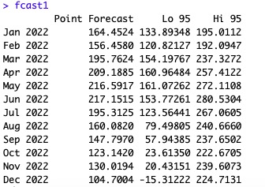

**<2> The best multiplicative trend-seasonal model**

α=0.1571, β=0.1, and γ=0.1

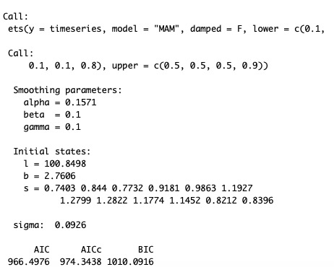

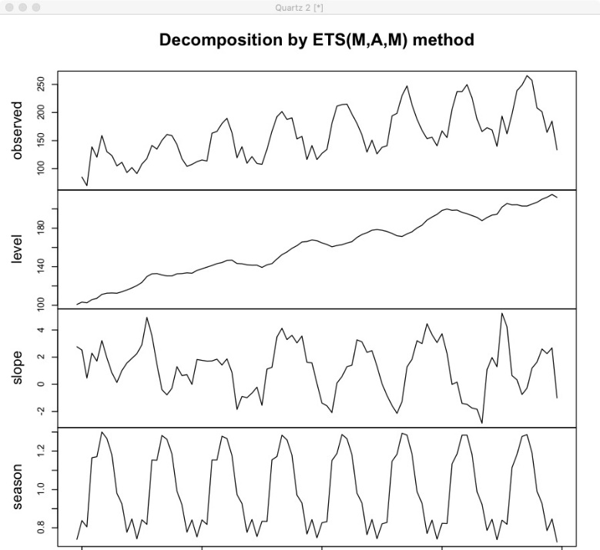

Level component = Lt

Slope = Tt

Season = St

RMSE = 13.21017



Forecast of Sales data in 2022 with best multiplicative trend-seasonal model

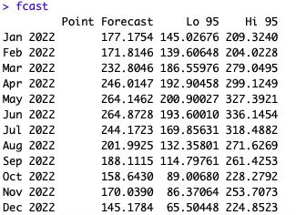

**<3> Compare the best additive trend-seasonal model and best multiplicative trend-seasonal model in Time Series**

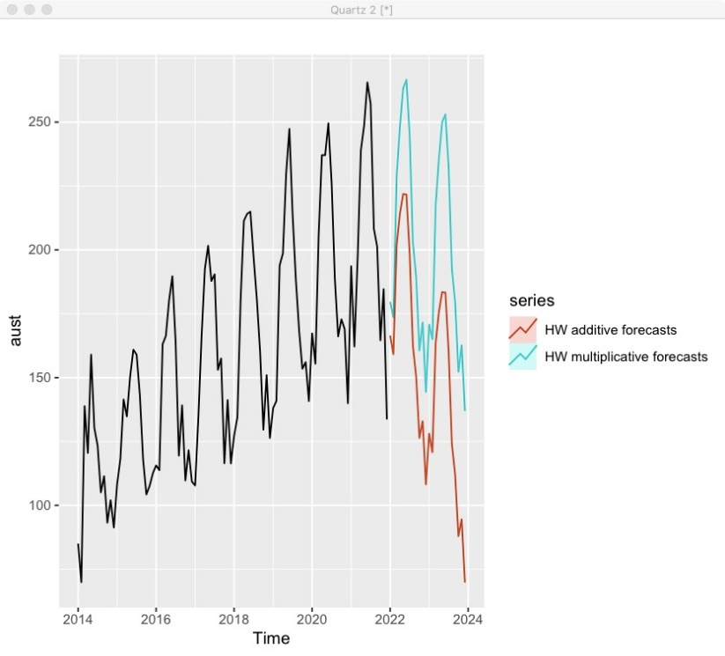

**<4> Find the best model**

According to the lowest RMSE (13.21017), MPE and MAPE, we choose the multiplicative trend-seasonal model with α=0.1571, β=0.1, and γ=0.1 as the best model to predict the Sales.

**Summary**

The forecasts generated by the method with the additive seasonality display larger and increasing seasonal variation as the level of the forecasts increases compared to the forecasts generated by the method with multiplicative seasonality. The multiplicative seasonal component sums to approximately m = 12, The smoothing parameters and initial estimates for the components have been estimated by minimizing RMSE. With the additive method, the seasonal component is expressed in absolute terms in the scale of the observed series, and in the level equation the series is seasonally adjusted by subtracting the seasonal component. Within each year, the seasonal component will add up to approximately zero. With the multiplicative method, the seasonal component is expressed in relative terms (percentages), and the series is seasonally adjusted by dividing through by the seasonal component. Within each year, the seasonal component will sum up to approximately m. We apply Holt-Winters' method with both additive and multiplicative seasonality to forecast monthly sales in a manufacturing company.