Lab 2

Employee Payroll GUI

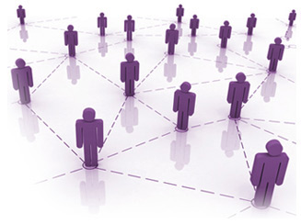

|  |
| --- |
| Chris McFee Tuan Nguyen Daniel Mallon Michael Tighe Stanislav Leskow |