Software Architecture and Design Specification
Project: Event Management System
Version: 1.3
Authors: Dharoor Shiva Sai Varun, Chirag Basanth Bellav , Gandhar Sameer Gokhale , Harshith J
Date: 04-10-2026
Status: Draft

Revision History
Version | Date | Author | Change Summary
1.0 | 02-10-2026 | Dharoor Shiva Sai Varun | Initial draft — Sections 1-2 (Introduction, Document Overview)
1.1 | 02-10-2026 | Chirag Basanth Bellavi | Section 3 (Architecture): component diagram, pattern, tech stack
1.2 | 03-10-2026 | Gandhar Sameer Gokhal | Section 3.9 (Security Architecture) and Section 4 (Design): sequence diagrams, API design
1.3 | 4-10-2026 | Harshith J | Section 4.4-4.6, Section 5 (Appendices), final consolidation and review

Approvals
Role | Name | Signature/Date
Project Supervisor / Instructor

1. Introduction

1.1 Purpose
This document specifies the software architecture and design of the Event Management System (EMS): a web platform through which Organizers create and manage events and Attendees discover, register for, and pay for them.

1.2 Scope
Covers the system's major services — authentication, event management, registration/waitlisting, payments, notifications, QR check-in, and reporting — their component structure, interactions, chosen architecture pattern, security architecture, API design, and key design decisions. Excludes third-party payment gateway and email/SMS provider internals, which are consumed as external services.

1.3 Audience
Developers, QA engineers, the project supervisor/instructor, and future maintainers of the system.

1.4 Definitions
EMS (Event Management System), RBAC (Role-Based Access Control), REST (Representational State Transfer), JWT (JSON Web Token), QR (Quick Response code), TLS (Transport Layer Security), RTM (Requirements Traceability Matrix).

2. Document Overview

2.1 How to use this document
Section 3 describes the system architecture: components, chosen pattern, technology stack, risks, traceability to requirements, and security architecture. Section 4 describes the detailed design: sequence diagrams, API design, error handling, and UX notes. Section 5 contains supporting appendices.

2.2 Related Documents
- Software Requirements Specification (SRS) — Event Management System, v1.3
- Software Test Plan (STP) — Event Management System
- Requirements Traceability Matrix (Appendix C of the SRS)

3. Architecture

3.1 Goals & Constraints
Goals: secure handling of user and payment data; reliable registration with no overbooking; a responsive experience for both Organizers and Attendees; maintainable, modular codebase. Constraints: must integrate with a third-party payment gateway; must not store raw card data; development timeline bound by the academic term schedule.

3.2 Stakeholders & Concerns
- Attendees: ease of use, trustworthy payments, timely notifications.
- Organizers: accurate capacity tracking, clear dashboards, low setup effort.
- Project Supervisor/Instructor: traceability, adherence to IEEE documentation standards.
- Developers: modularity, testability, clear API contracts.

3.3 Component (UML) Diagram
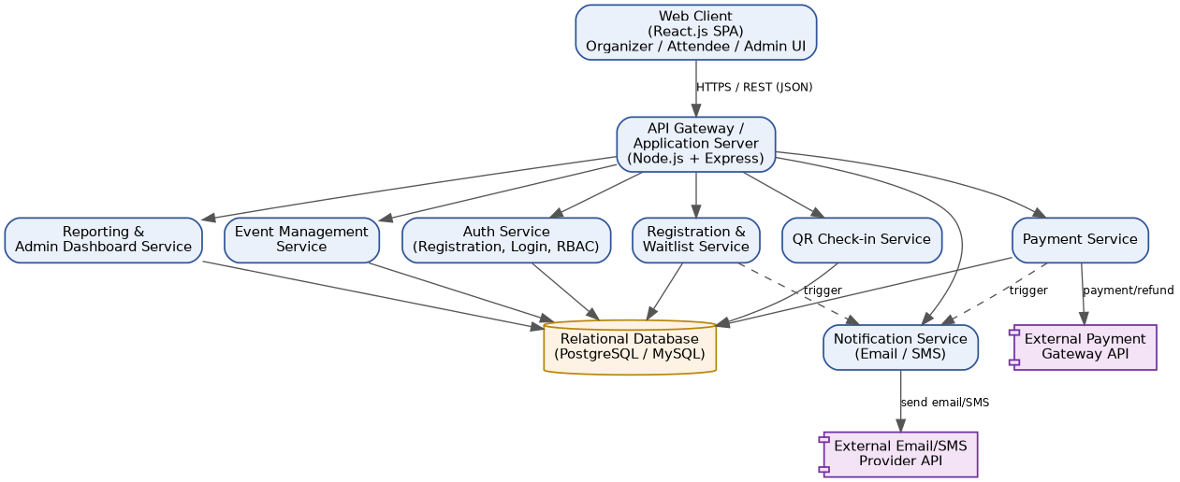
Figure 1 — Component diagram of the Event Management System.

3.4 Component Descriptions
Component | Responsibility
Web Client (React.js SPA) | Renders Organizer, Attendee, and Admin interfaces; calls the backend REST API over HTTPS.
API Gateway / Application Server (Node.js + Express) | Single entry point for all client requests; handles routing, request validation, and delegates to the domain services below.
Auth Service | Handles registration, login, password hashing, session/JWT issuance, and role-based access control (RBAC).
Event Management Service | Handles event creation, editing, publishing, and cancellation by Organizers.
Registration & Waitlist Service | Manages attendee registrations, capacity checks, and automatic waitlisting.
Payment Service | Initiates and confirms payments through the external payment gateway and issues refunds.
Notification Service | Sends confirmation, reminder, and change-notification emails/SMS via an external provider.
QR Check-in Service | Generates per-registration QR codes and validates scans at the event to mark attendance.
Reporting & Admin Dashboard Service | Aggregates registration, revenue, and attendance data for Organizer and Admin dashboards.
Relational Database (PostgreSQL/MySQL) | Persistent storage for users, events, registrations, payments, and notification logs.

3.5 Chosen Architecture Pattern and Rationale
A layered, service-oriented architecture is chosen: a single-page React.js front end communicates with a Node.js/Express API server, which delegates to focused domain services (Auth, Event Management, Registration, Payment, Notification, Check-in, Reporting), all backed by one relational database. This keeps each concern independently testable and replaceable without the operational overhead of full microservices (separate deployments, inter-service networking, distributed transactions), which was considered and rejected as unnecessary at the project's current scale. As a project built in JavaScript (React.js + Node.js) or alternatively Python (Django), the same layered separation applies regardless of final language choice — Django's app-per-domain structure maps directly onto the same service boundaries.

3.6 Technology Stack & Data Stores
- Front end: React.js (single-page application), responsive CSS.
- Back end (Option A): Node.js + Express, REST API, JWT-based authentication.
- Back end (Option B): Python + Django, Django REST Framework, token/session authentication.
- Database: PostgreSQL or MySQL (relational, transactional integrity for registration/payment records).
- External services: third-party payment gateway (e.g., Razorpay/Stripe-style API); email/SMS provider (e.g., SendGrid/Twilio-style API).
- Transport security: TLS/HTTPS for all client-server and server-to-gateway communication.

3.7 Risks & Mitigations
- Risk: Registration race condition causing overbooking → Mitigation: database-level transactional capacity checks (row locking) in the Registration Service.
- Risk: Payment gateway downtime → Mitigation: asynchronous payment status polling/webhooks with retry, and clear 'pending' states shown to the user.
- Risk: Notification provider rate limits during a reminder burst → Mitigation: queue-based dispatch with backoff instead of synchronous sends.

3.8 Traceability to Requirements
The table below maps groups of SRS functional requirements (REQ-1 through REQ-28) to the architecture component responsible for satisfying them; see the SRS Appendix C for the full per-requirement traceability matrix.
Requirement (SRS) | Description | Architecture Component
REQ-1 to REQ-4 | User registration, email verification, login, RBAC | Auth Service
REQ-5 to REQ-8 | Event creation, draft/publish, edit/cancel, capacity validation | Event Management Service
REQ-9, REQ-10 | Event listing and search/filtering | Event Management Service, Web Client
REQ-11 to REQ-14 | Registration, waitlisting, capacity decrement, cancellation | Registration & Waitlist Service
REQ-15 to REQ-17 | Payment gateway integration, payment confirmation, refunds | Payment Service
REQ-18 to REQ-20 | Confirmation email, reminder notification, change notification | Notification Service
REQ-21 to REQ-23 | QR generation, check-in validation, duplicate-scan rejection | QR Check-in Service
REQ-24 to REQ-26 | Organizer dashboard, Admin dashboard, CSV export | Reporting & Admin Dashboard Service
REQ-27, REQ-28 | Post-event feedback submission and aggregation | Event Management Service, Database

3.9 Security Architecture

Security Objectives
- Protect attendee and organizer personal data (names, emails, payment status) from unauthorized access or disclosure.
- Ensure only authenticated, authorized users can create, modify, or cancel events and registrations (no privilege escalation).

Security Requirements
- All passwords shall be stored using a salted hashing algorithm (e.g., bcrypt); plaintext passwords shall never be persisted or logged.
- All client-server and server-to-gateway traffic shall use TLS 1.2 or higher.
- Raw payment card data shall never be stored on EMS servers; all card handling shall occur through the payment gateway's PCI-DSS-compliant flow.
- Every API endpoint shall enforce role-based access control (RBAC) server-side, independent of UI-level restrictions.

Threat Modeling (STRIDE)
- Spoofing → mitigated by JWT/session-based authentication and email verification at sign-up.
- Tampering → mitigated by server-side validation of all event/registration state transitions; capacity checks never trust client input.
- Information Disclosure → mitigated by TLS in transit, hashed passwords at rest, and no raw payment data stored.
- Denial of Service → mitigated by rate limiting on authentication and registration endpoints.
- Elevation of Privilege → mitigated by RBAC enforced at the API layer for Organizer- and Administrator-only actions.

4. Design

4.1 Design Overview
The EMS is designed around the services introduced in Section 3, each exposing a narrow REST interface to the API server. Cross-service workflows — such as registering for a paid event, or checking in an attendee — are coordinated by the API server calling the relevant services in sequence, as shown in the two flows below.

4.2 UML Sequence Diagrams
Two representative flows are shown: (1) an attendee registering for and paying for an event, and (2) an organizer checking in an attendee via QR code at the event.
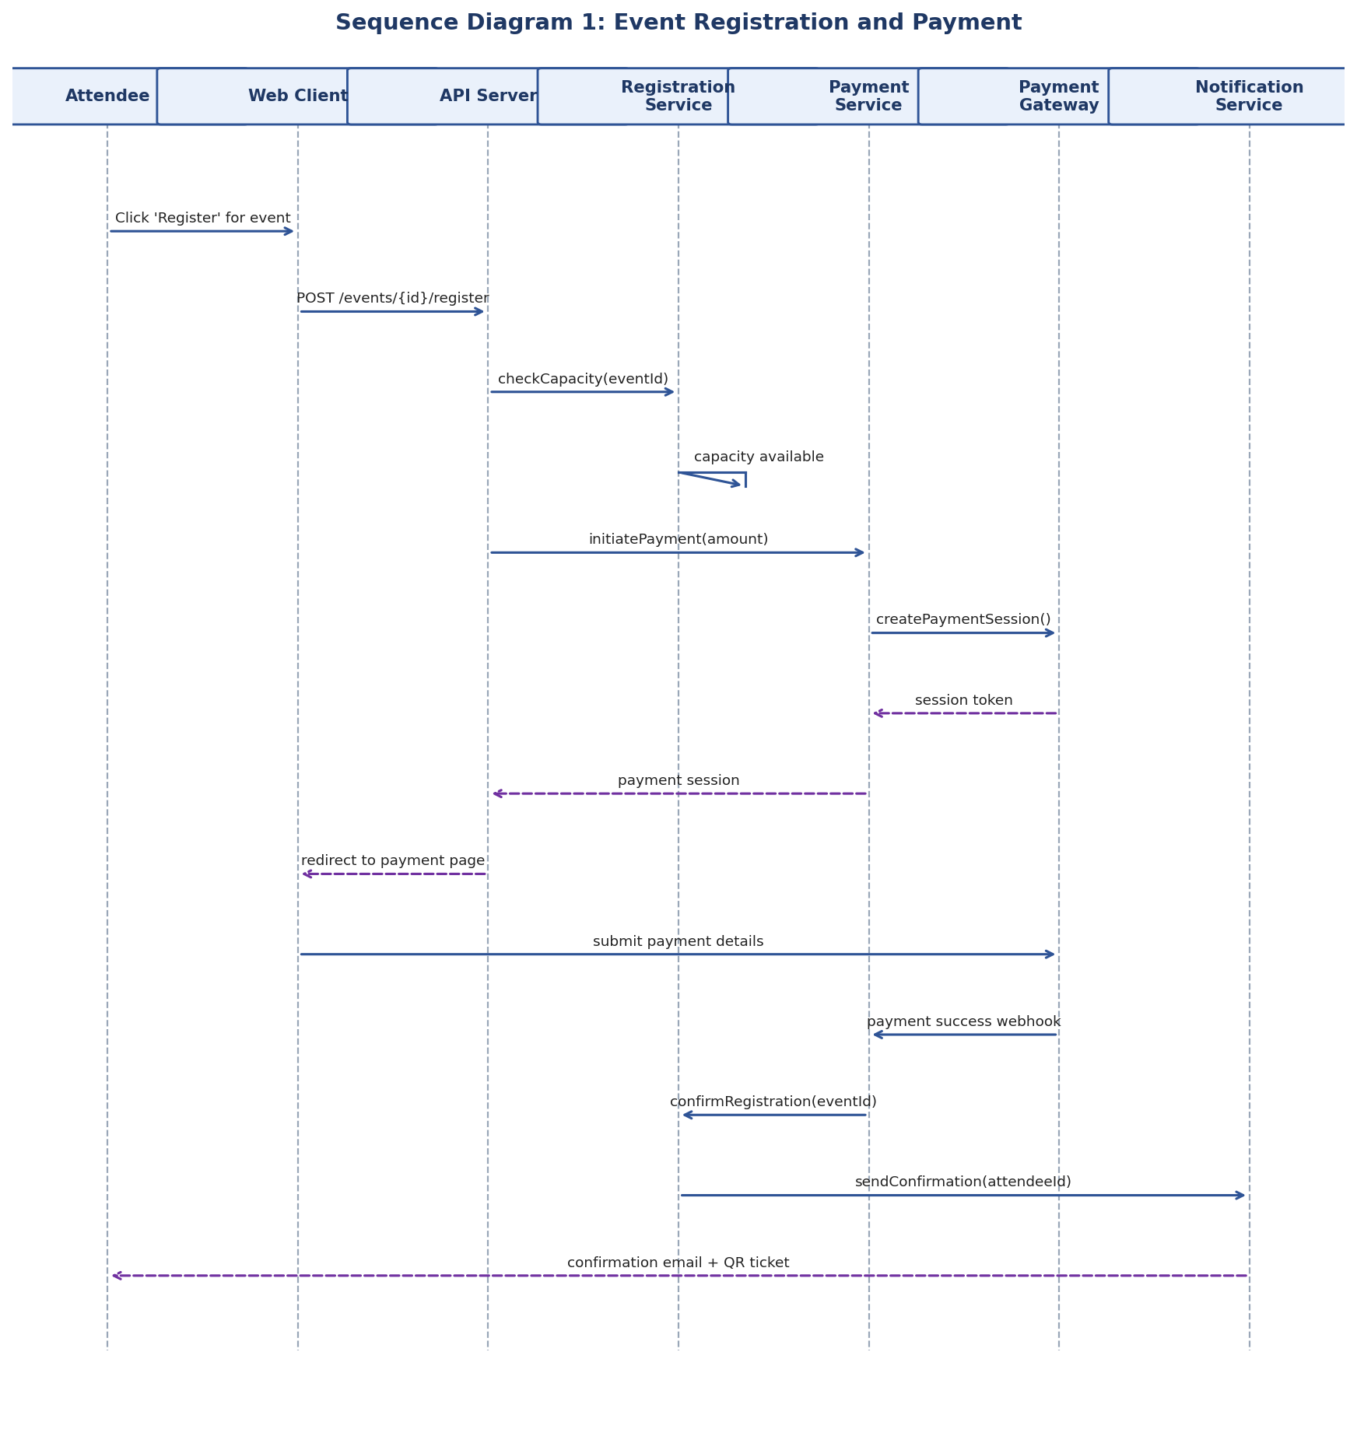
Figure 2 — Sequence diagram: Event registration and payment.
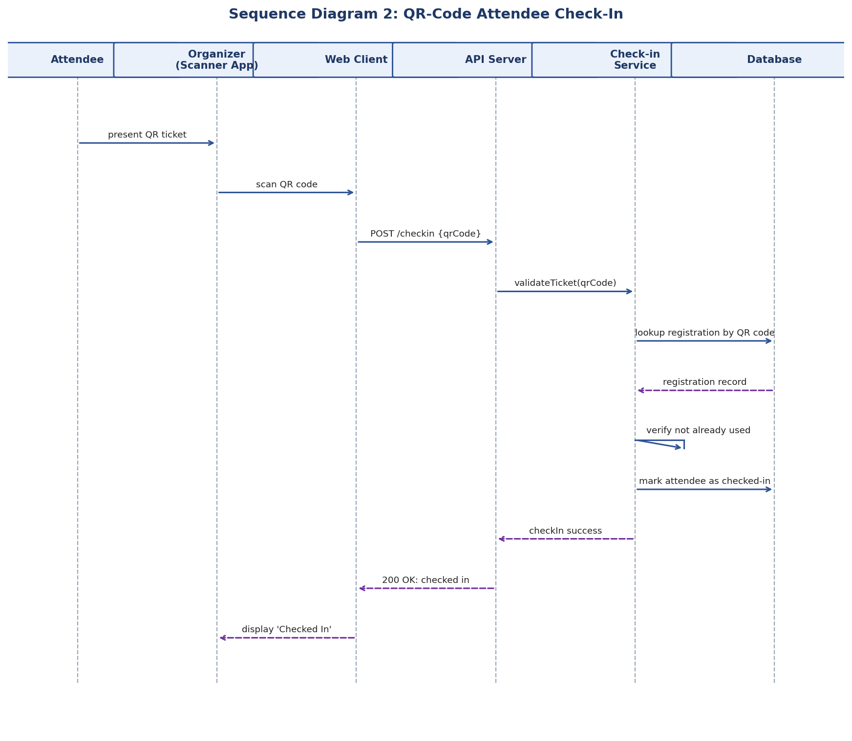
Figure 3 — Sequence diagram: QR-code attendee check-in.

4.3 API Design
Representative endpoint definitions for two core components (Registration & Waitlist Service and QR Check-in Service):

Register for an Event
Method: POST
Endpoint: /api/events/{eventId}/register
Request: { attendeeId }
Response: { status: 'confirmed' | 'waitlisted', registrationId, qrTicketCode }
Errors: 401 Unauthenticated, 404 Event not found, 409 Registration already exists

Check In an Attendee
Method: POST
Endpoint: /api/checkin
Request: { qrTicketCode, eventId }
Response: { status: 'checked_in', attendeeName, checkedInAt }
Errors: 400 Invalid QR code, 403 Not authorized to check in for this event, 409 Ticket already used

4.4 Error Handling, Logging & Monitoring
All API errors return a standardized JSON envelope: { error: { code, message } }, with no sensitive data (passwords, raw card numbers, full QR codes) ever included in logs. Monitoring tracks: registration failure rate, payment failure rate, average API response time, and QR check-in duplicate-scan rate, with alerting thresholds to be defined during implementation.

4.5 UX Design
The Organizer console emphasizes a short path from 'Create Event' to a published listing (target under 5 minutes per the SRS usability requirement). The Attendee-facing pages prioritize fast event discovery (search/filter above the fold) and a minimal-friction checkout. The check-in screen is optimized for a staff member scanning in rapid succession, with a clear large-text success/failure indicator per scan.

4.6 Open Issues & Next Steps
- Confirm final backend stack (Node.js/Express vs. Python/Django) after the first sprint's architecture spike.
- Select specific payment gateway and notification provider and finalize their API contracts.
- Define the queueing mechanism for notification dispatch (e.g., a lightweight job queue) before implementing reminders at scale.

5. Appendices
5.1 Glossary: EMS, RBAC, REST, JWT, QR, TLS, RTM — see Section 1.4 for definitions.
5.2 References: SRS v1.3, Software Test Plan, IEEE 42010 (architecture description), OWASP Top 10, PCI-DSS.
5.3 Tools: Graphviz/PlantUML (diagrams), draw.io, Postman/Swagger (API design and testing).

