Advanced Database Technologies
Practical Journal: Queries and Outputs
Index
Practical | Title
1 | Object Oriented Database Management System (PostgreSQL)
2 | XML Database (BaseX)
3 | Temporal Database (PostgreSQL)
4.1 | MongoDB - CRUD Operations
4.2 | Redis - CRUD Operations
5 | Temporal Database (PostGIS Spatial Queries)
6.1 | HBase - CRUD Operations
6.2 | Apache Cassandra - CRUD Operations
7 | MapReduce Functions (MongoDB)
8.1 | Indexing and Ordering Operations (MongoDB)

PRACTICAL NO. 1
Object Oriented Database Management System (PostgreSQL)
Aim: Create different types that include attributes and methods. Define tables for these types by adding a sufficient number of tuples. Demonstrate insert, update and delete operations on these tables. Execute queries on them.
Steps:
1. Install PostgreSQL from https://www.postgresql.org/download/windows/
2. Set the password as: admin123
3. Open Program Files > PostgreSQL > version (17) > bin and copy the path.
4. Open Environment Variables and paste the path in System Variables > Path > New.
5. Open Command Prompt and run: psql -U postgres (enter the password admin123).

Create a Database
Query 1
CREATE DATABASE labdb;
Output:
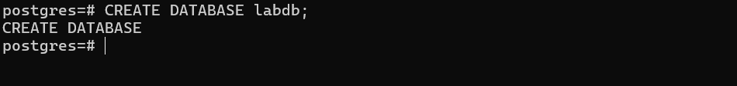

Connect to the Database
Query 2
\c labdb
Output:

Create a User-Defined Type
Query 3
CREATE TYPE Person AS ( first_name TEXT, last_name TEXT, age INT );
Output:

Create a Function (Method)
Query 4
CREATE OR REPLACE FUNCTION get_full_name(p Person) RETURNS TEXT AS $$
BEGIN RETURN p.first_name || ' ' || p.last_name; END;
$$ LANGUAGE plpgsql;
Output:
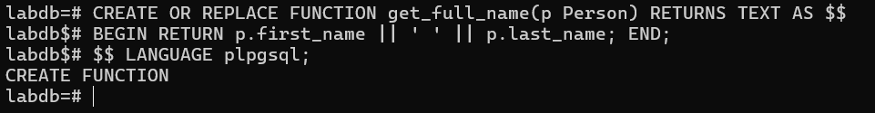

Create a Table using the Type
Query 5
CREATE TABLE students ( id SERIAL PRIMARY KEY, info Person );
Output:
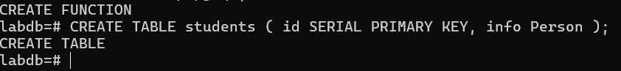

Insert Data (Objects)
Query 6
INSERT INTO students (info) VALUES
(ROW('Rohit', 'Sharma', 23)), (ROW('Amit', 'Sharma', 22)),
(ROW('Riya', 'Patel', 21)), (ROW('Sneha', 'Joshi', 25)),
(ROW('Rahul', 'Kumar', 24)), (ROW('Ananya', 'Mehta', 22)),
(ROW('Aditya', 'Gupta', 23)), (ROW('Tanya', 'Rao', 21)),
(ROW('Karan', 'Singh', 24)), (ROW('Isha', 'Shah', 22));
Output:
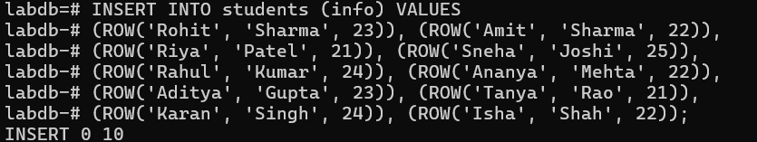

SELECT Queries - [1] Show all records
Query 7
SELECT * FROM students s;
Output:
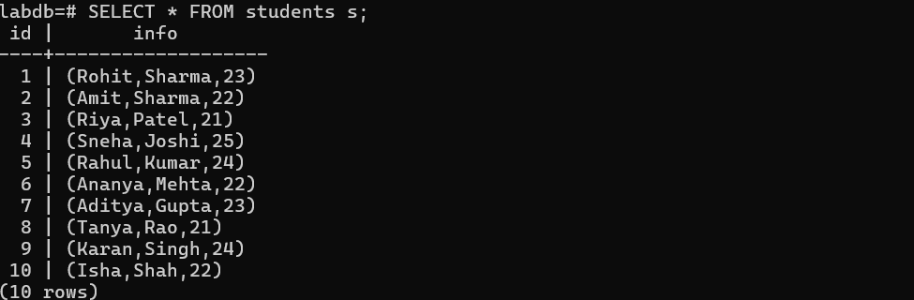

[2] Access individual attributes
Query 8
SELECT s.id, (s.info).first_name, (s.info).age FROM students s;
Output:
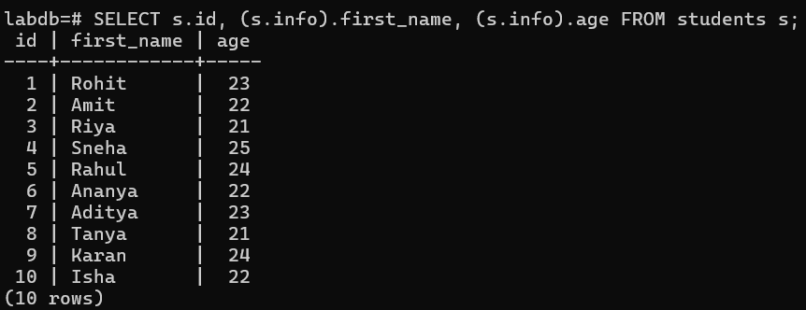

[3] Use the function (method)
Query 9
SELECT s.id, get_full_name(s.info) AS full_name FROM students s;
Output:
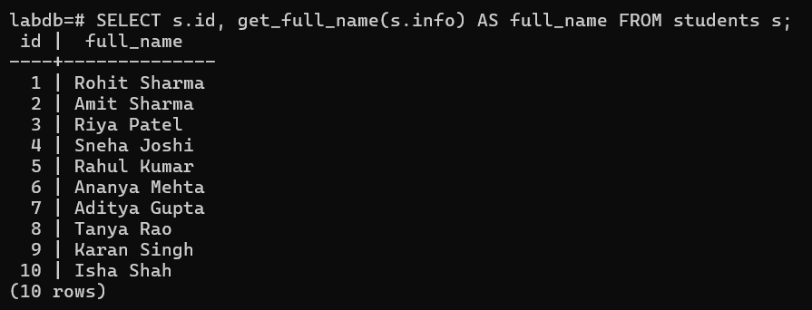

[4] Conditional query
Query 10
SELECT get_full_name(s.info), (s.info).age FROM students s WHERE (s.info).age > 23;
Output:
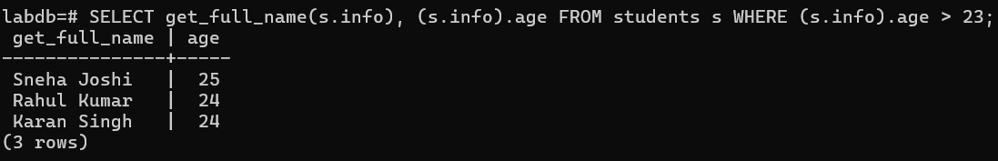

UPDATE Queries - [1] Update single record
Query 11
UPDATE students SET info = ROW((info).first_name, (info).last_name, 26) WHERE (info).first_name = 'Sneha';
Output:

[2] Update multiple records
Query 12
UPDATE students SET info = ROW((info).first_name, (info).last_name, (info).age + 1) WHERE (info).age < 23;
Output:

DELETE Queries - [1] Delete one record
Query 13
DELETE FROM students WHERE (info).first_name = 'Riya';
Output:

[2] Delete multiple records
Query 14
DELETE FROM students WHERE (info).age < 22;
Output:
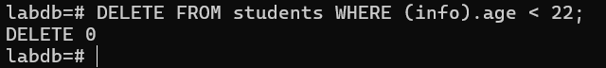

Advanced Queries - [1] Sort by age
Query 15
SELECT get_full_name(s.info), (s.info).age FROM students s ORDER BY (s.info).age DESC;
Output:
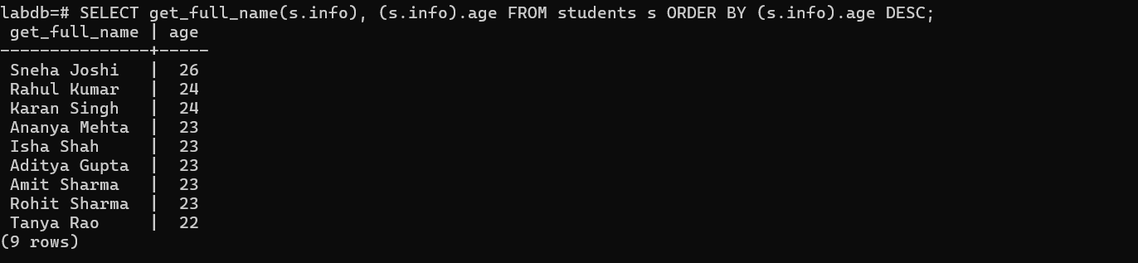

[2] Count students older than 23
Query 16
SELECT COUNT(*) FROM students WHERE (info).age > 23;
Output:
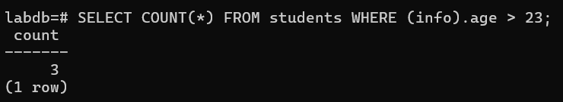

[3] Search by last name
Query 17
SELECT get_full_name(s.info) FROM students s WHERE (s.info).last_name LIKE 'Sh%';
Output:
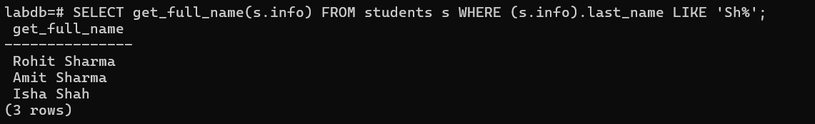

[4] Limit results
Query 18
SELECT get_full_name(s.info), (s.info).age FROM students s ORDER BY (s.info).age LIMIT 5;
Output:
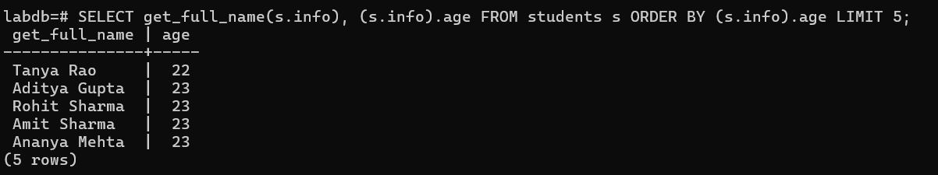

PRACTICAL NO. 2
XML Database (BaseX)
Aim: Create an XML database and demonstrate insert, update and delete operations on these tables. Issue queries on it.
Steps:
1. Download the BaseX zip file from https://basex.org/download/
2. Extract the file in the C drive.
3. Open the basex folder, go to bin, and type cmd in the path bar to open Command Prompt.
4. Start the BaseX CLI by running: basex.bat

Create New Database with 10 Rows
Query 1
CREATE DB students
<students>
<student id ="1"><name>Mohan</name><age>23</age></student>
<student id ="2"><name>Akash</name><age>22</age></student>
<student id ="3"><name>Rohan</name><age>24</age></student>
<student id ="4"><name>Meena</name><age>21</age></student>
<student id ="5"><name>Sneha</name><age>25</age></student>
<student id ="6"><name>Vikas</name><age>25</age></student>
<student id ="7"><name>Anjali</name><age>22</age></student>
<student id ="8"><name>Rahul</name><age>24</age></student>
<student id ="9"><name>Neha</name><age>23</age></student>
<student id ="10"><name>Kiran</name><age>26</age></student>
</students>
Output:

Connect / Open Database
Query 2
OPEN students
Output:

Display All Data
Query 3
XQUERY /students
Output:

Insert New Row
Query 4
XQUERY insert node <student id ="11"> <name>Arjun</name> <age>20</age> </student> into /students
Output:

Check
Query 5
XQUERY /students
Output:
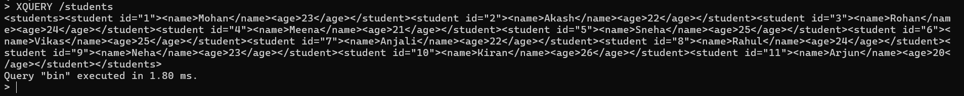

Update Row (Change Age)
Query 6
XQUERY replace value of node /students/student[@id="5"]/age with "24"
Output:
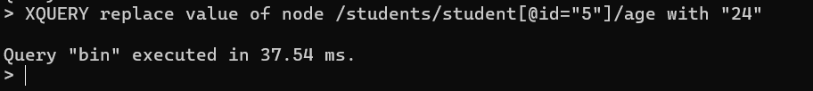

Check
Query 7
XQUERY /students/student[@id="5"]
Output:

Delete Row
Query 8
XQUERY delete node /students/student[@id="3"]
Output:
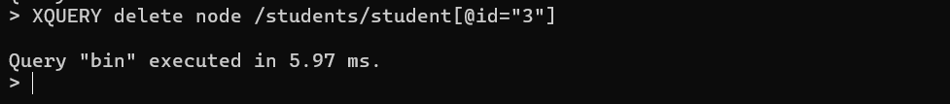

Check
Query 9
XQUERY /students
Output:

Run Queries - [1] Get all names
Query 10
XQUERY /students/student/name
Output:
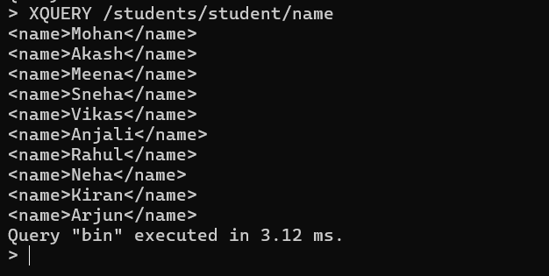

[2] Get students older than 23
Query 11
XQUERY /students/student[age > 23]
Output:
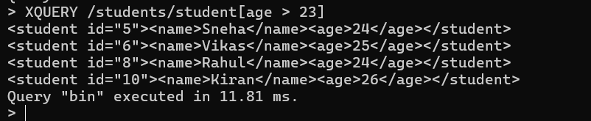

[3] Count total students
Query 12
XQUERY count(/students/student)
Output:
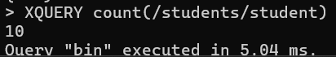

Close Database
Query 13
CLOSE
Output:
