Advanced Database Technologies
Practical Journal: Queries and Outputs
Index
Practical | Title
1 | Object Oriented Database Management System (PostgreSQL)
2 | XML Database (BaseX)
3 | Temporal Database (PostgreSQL)
4.1 | MongoDB - CRUD Operations
4.2 | Redis - CRUD Operations
5 | Temporal Database (PostGIS Spatial Queries)
6.1 | HBase - CRUD Operations
6.2 | Apache Cassandra - CRUD Operations
7 | MapReduce Functions (MongoDB)
8.1 | Indexing and Ordering Operations (MongoDB)

PRACTICAL NO. 1
Object Oriented Database Management System (PostgreSQL)
Aim: Create different types that include attributes and methods. Define tables for these types by adding a sufficient number of tuples. Demonstrate insert, update and delete operations on these tables. Execute queries on them.
Steps:
1. Install PostgreSQL from https://www.postgresql.org/download/windows/
2. Set the password as: admin123
3. Open Program Files > PostgreSQL > version (17) > bin and copy the path.
4. Open Environment Variables and paste the path in System Variables > Path > New.
5. Open Command Prompt and run: psql -U postgres (enter the password admin123).

Create a Database
Query 1
CREATE DATABASE labdb;
Output:
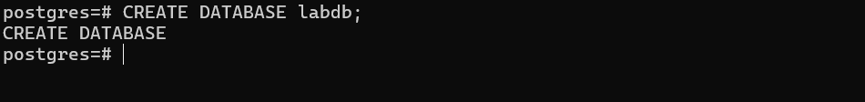

Connect to the Database
Query 2
\c labdb
Output:

Create a User-Defined Type
Query 3
CREATE TYPE Person AS ( first_name TEXT, last_name TEXT, age INT );
Output:

Create a Function (Method)
Query 4
CREATE OR REPLACE FUNCTION get_full_name(p Person) RETURNS TEXT AS $$
BEGIN RETURN p.first_name || ' ' || p.last_name; END;
$$ LANGUAGE plpgsql;
Output:
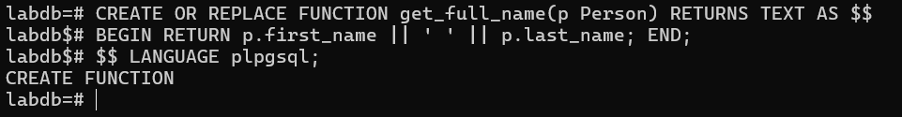

Create a Table using the Type
Query 5
CREATE TABLE students ( id SERIAL PRIMARY KEY, info Person );
Output:
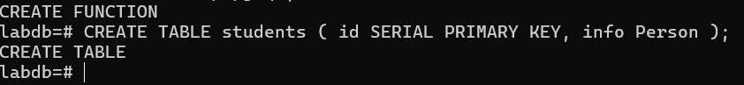

Insert Data (Objects)
Query 6
INSERT INTO students (info) VALUES
(ROW('Rohit', 'Sharma', 23)), (ROW('Amit', 'Sharma', 22)),
(ROW('Riya', 'Patel', 21)), (ROW('Sneha', 'Joshi', 25)),
(ROW('Rahul', 'Kumar', 24)), (ROW('Ananya', 'Mehta', 22)),
(ROW('Aditya', 'Gupta', 23)), (ROW('Tanya', 'Rao', 21)),
(ROW('Karan', 'Singh', 24)), (ROW('Isha', 'Shah', 22));
Output:
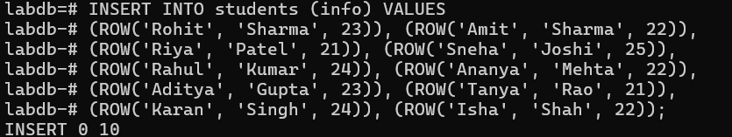

SELECT Queries - [1] Show all records
Query 7
SELECT * FROM students s;
Output:
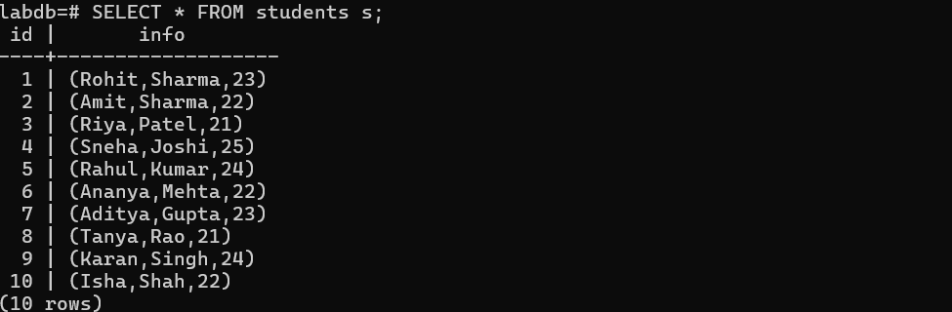

[2] Access individual attributes
Query 8
SELECT s.id, (s.info).first_name, (s.info).age FROM students s;
Output:
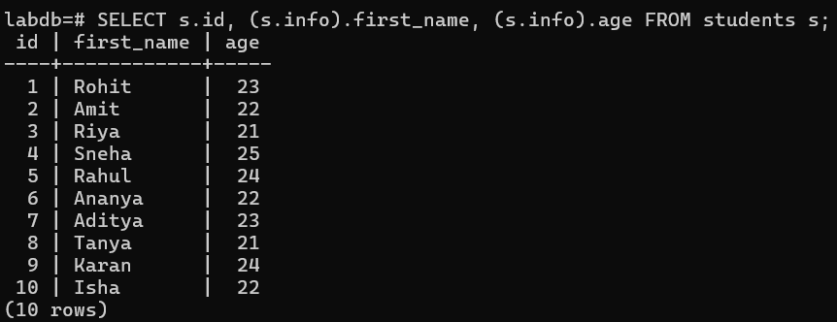

[3] Use the function (method)
Query 9
SELECT s.id, get_full_name(s.info) AS full_name FROM students s;
Output:
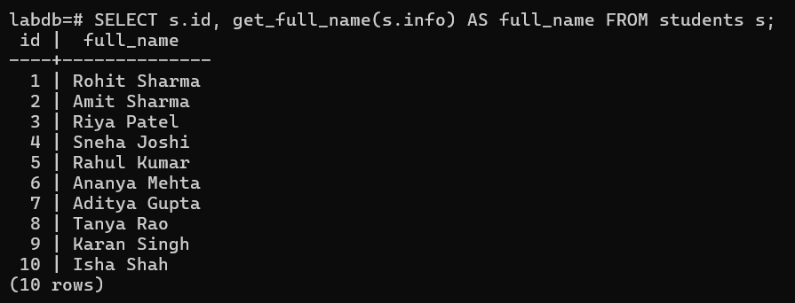

[4] Conditional query
Query 10
SELECT get_full_name(s.info), (s.info).age FROM students s WHERE (s.info).age > 23;
Output:
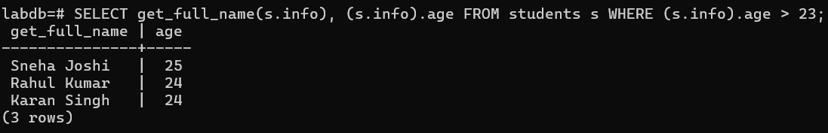

UPDATE Queries - [1] Update single record
Query 11
UPDATE students SET info = ROW((info).first_name, (info).last_name, 26) WHERE (info).first_name = 'Sneha';
Output:

[2] Update multiple records
Query 12
UPDATE students SET info = ROW((info).first_name, (info).last_name, (info).age + 1) WHERE (info).age < 23;
Output:

DELETE Queries - [1] Delete one record
Query 13
DELETE FROM students WHERE (info).first_name = 'Riya';
Output:

[2] Delete multiple records
Query 14
DELETE FROM students WHERE (info).age < 22;
Output:
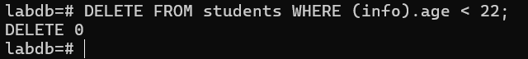

Advanced Queries - [1] Sort by age
Query 15
SELECT get_full_name(s.info), (s.info).age FROM students s ORDER BY (s.info).age DESC;
Output:
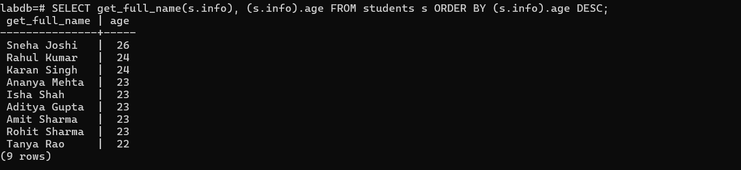

[2] Count students older than 23
Query 16
SELECT COUNT(*) FROM students WHERE (info).age > 23;
Output:
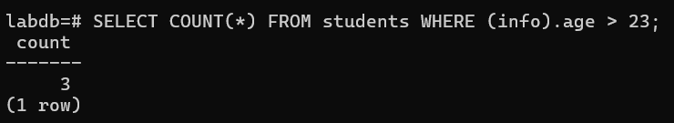

[3] Search by last name
Query 17
SELECT get_full_name(s.info) FROM students s WHERE (s.info).last_name LIKE 'Sh%';
Output:
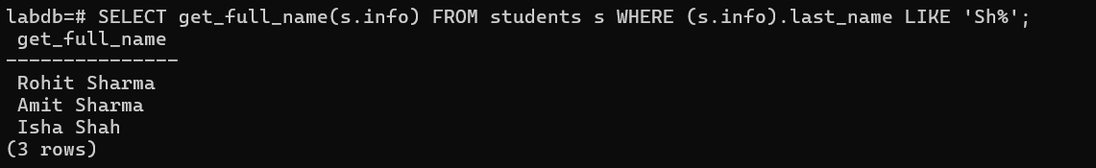

[4] Limit results
Query 18
SELECT get_full_name(s.info), (s.info).age FROM students s ORDER BY (s.info).age LIMIT 5;
Output:
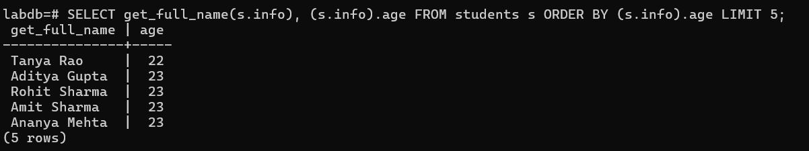

PRACTICAL NO. 2
XML Database (BaseX)
Aim: Create an XML database and demonstrate insert, update and delete operations on these tables. Issue queries on it.
Steps:
1. Download the BaseX zip file from https://basex.org/download/
2. Extract the file in the C drive.
3. Open the basex folder, go to bin, and type cmd in the path bar to open Command Prompt.
4. Start the BaseX CLI by running: basex.bat

Create New Database with 10 Rows
Query 1
CREATE DB students
<students>
<student id ="1"><name>Mohan</name><age>23</age></student>
<student id ="2"><name>Akash</name><age>22</age></student>
<student id ="3"><name>Rohan</name><age>24</age></student>
<student id ="4"><name>Meena</name><age>21</age></student>
<student id ="5"><name>Sneha</name><age>25</age></student>
<student id ="6"><name>Vikas</name><age>25</age></student>
<student id ="7"><name>Anjali</name><age>22</age></student>
<student id ="8"><name>Rahul</name><age>24</age></student>
<student id ="9"><name>Neha</name><age>23</age></student>
<student id ="10"><name>Kiran</name><age>26</age></student>
</students>
Output:

Connect / Open Database
Query 2
OPEN students
Output:

Display All Data
Query 3
XQUERY /students
Output:

Insert New Row
Query 4
XQUERY insert node <student id ="11"> <name>Arjun</name> <age>20</age> </student> into /students
Output:

Check
Query 5
XQUERY /students
Output:
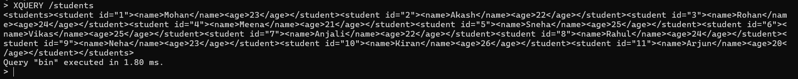

Update Row (Change Age)
Query 6
XQUERY replace value of node /students/student[@id="5"]/age with "24"
Output:
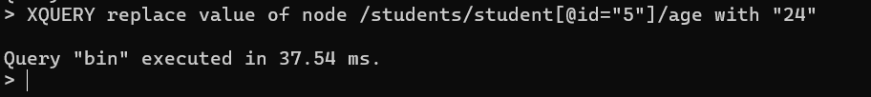

Check
Query 7
XQUERY /students/student[@id="5"]
Output:

Delete Row
Query 8
XQUERY delete node /students/student[@id="3"]
Output:
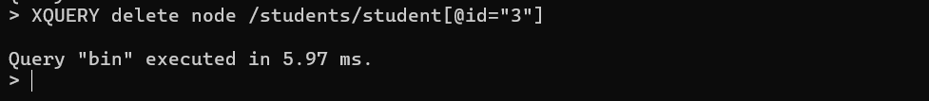

Check
Query 9
XQUERY /students
Output:

Run Queries - [1] Get all names
Query 10
XQUERY /students/student/name
Output:
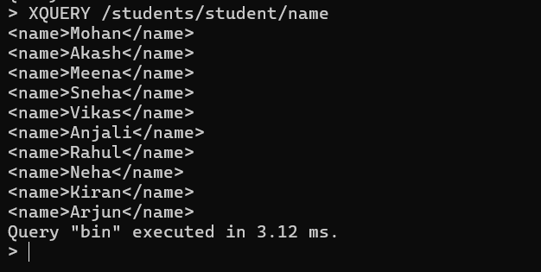

[2] Get students older than 23
Query 11
XQUERY /students/student[age > 23]
Output:
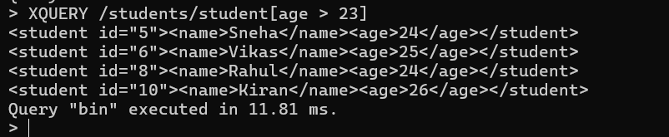

[3] Count total students
Query 12
XQUERY count(/students/student)
Output:
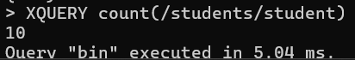

Close Database
Query 13
CLOSE
Output:
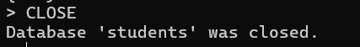

PRACTICAL NO. 3
Temporal Database (PostgreSQL)
Aim: Create a temporal database and issue queries on it.
Steps:
1. Open Command Prompt and run: psql -U postgres (enter the password admin123).

Check connection
Query 1
\conninfo
Output:
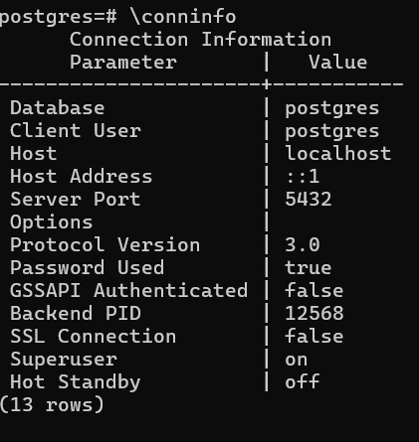

Create Database
Query 2
CREATE DATABASE temporal_db;
Output:
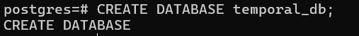

Connect to DB
Query 3
\c temporal_db
Output:

Create Table (Employees) - valid_from = record start date, valid_to = record end date
Query 4
CREATE TABLE employees ( emp_id SERIAL PRIMARY KEY, emp_name VARCHAR(50), position VARCHAR(50), salary NUMERIC(10,2), valid_from DATE NOT NULL, valid_to DATE NOT NULL );
Output:
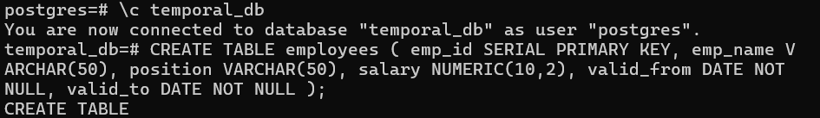

Insert 10 Employees
Query 5
INSERT INTO employees (emp_name, position, salary, valid_from, valid_to) VALUES
('Rahul Sharma', 'Developer', 50000, '2025-03-01', '2025-08-31'),
('Rahul Sharma', 'Developer', 60000, '2025-09-01', '2025-12-31'),
('Sneha Patil', 'Tester', 40000, '2025-03-15', '2025-10-15'),
('Amit Joshi', 'Manager', 80000, '2025-03-01', '2025-06-30'),
('Amit Joshi', 'Manager', 85000, '2025-07-01', '2025-12-31'),
('Kiran Deshmukh', 'Developer', 52000, '2025-04-01', '2025-12-31'),
('Meera Kulkarni', 'Tester', 42000, '2025-03-05', '2025-09-30'),
('Meera Kulkarni', 'Tester', 45000, '2025-10-01', '2025-12-31'),
('Vikram Rao', 'Developer', 55000, '2025-03-01', '2025-12-31'),
('Anita Singh', 'HR', 45000, '2025-05-01', '2025-12-31');
Output:
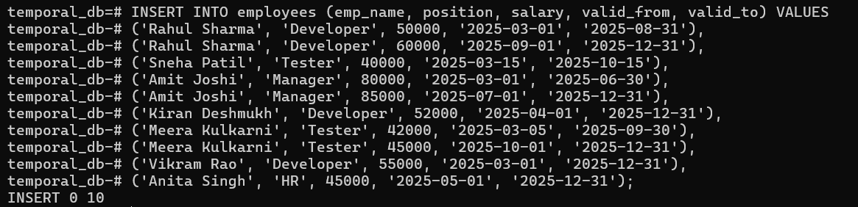

Check Data
Query 6
SELECT * FROM employees ORDER BY emp_name, valid_from;
Output:
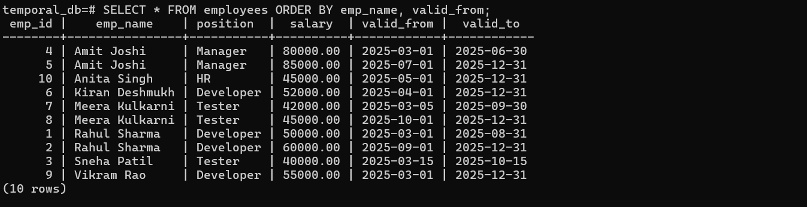

Salary Updates (Temporal Update) - [1] Rahul Sharma: 50,000 -> 60,000 from 2025-09-01
Query 7
UPDATE employees SET valid_to = '2025-08-31' WHERE emp_name = 'Rahul Sharma' AND salary = 50000;
Output:

Query 8
INSERT INTO employees (emp_name, position, salary, valid_from, valid_to) VALUES ('Rahul Sharma', 'Developer', 60000, '2025-09-01', '2025-12-31');
Output:

[2] Amit Joshi: 80,000 -> 85,000 from 2025-07-01
Query 9
UPDATE employees SET valid_to = '2025-06-30' WHERE emp_name = 'Amit Joshi' AND salary = 80000;
Output:

Query 10
INSERT INTO employees (emp_name, position, salary, valid_from, valid_to) VALUES ('Amit Joshi', 'Manager', 85000, '2025-07-01', '2025-12-31');
Output:

[3] Meera Kulkarni: 42,000 -> 45,000 from 2025-10-01
Query 11
UPDATE employees SET valid_to = '2025-09-30' WHERE emp_name = 'Meera Kulkarni' AND salary = 42000;
Output:

Query 12
INSERT INTO employees (emp_name, position, salary, valid_from, valid_to) VALUES ('Meera Kulkarni', 'Tester', 45000, '2025-10-01', '2025-12-31');
Output:

Expire Employee [Scenario: Sneha Patil leaves company on 2025-10-15]
Query 13
UPDATE employees SET valid_to = '2025-10-15' WHERE emp_name = 'Sneha Patil';
Output:

Queries - [1] All Employees
Query 14
SELECT * FROM employees ORDER BY emp_name, valid_from;
Output:
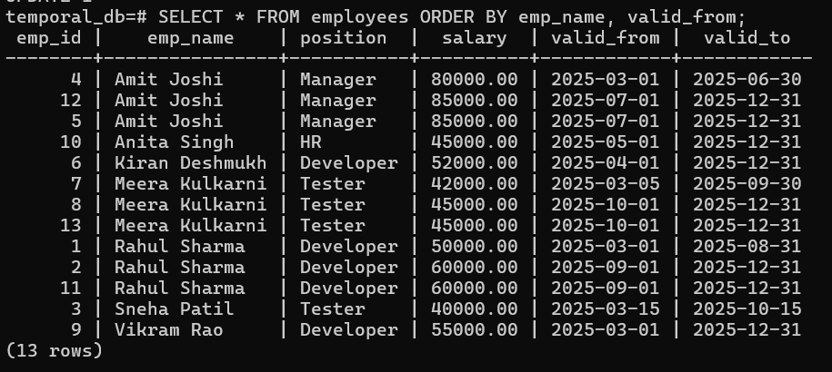

[2] Current Employees
Query 15
SELECT * FROM employees WHERE '2025-09-25' BETWEEN valid_from AND valid_to ORDER BY emp_name;
Output:
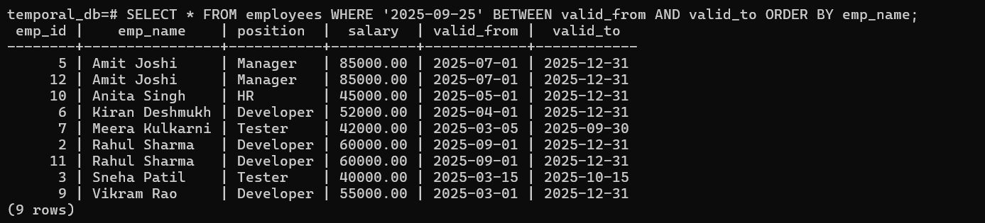

[3] Employee History - Rahul Sharma
Query 16
SELECT * FROM employees WHERE emp_name = 'Rahul Sharma' ORDER BY valid_from;
Output:
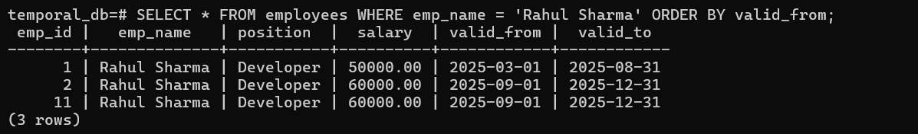

[4] Employees at Specific Date (2025-08-15)
Query 17
SELECT * FROM employees WHERE '2025-08-15' BETWEEN valid_from AND valid_to ORDER BY emp_name;
Output:
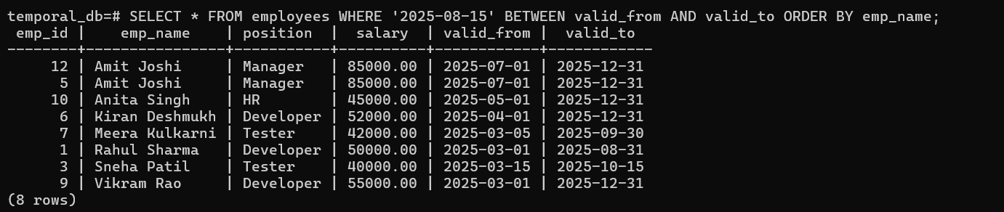

[5] All Salary Changes (History)
Query 18
SELECT emp_name, position, salary, valid_from, valid_to FROM employees ORDER BY emp_name, valid_from;
Output:
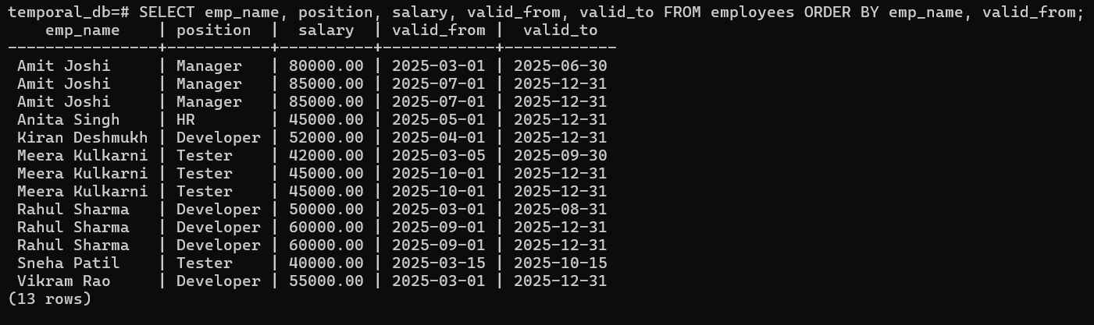

PRACTICAL NO. 4.1
MongoDB - CRUD Operations
Aim: Demonstrate the Accessing and Storing and performing CRUD operations in MongoDB.
Steps:
1. Download MongoDB Community Server (MSI): https://fastdl.mongodb.org/windows/mongodb-windows-x86_64-8.2.0-signed.msi
2. Install it: Next > Accept & Next > Complete > Next > Install.
3. Download Mongosh (ZIP): https://downloads.mongodb.com/compass/mongosh-2.5.8-win32-x64.zip
4. Extract the folder and add its bin folder path to the System Variable (Path).
5. Open PowerShell as Administrator and run: mongosh

Create & Switch to a Database
Query 1
use mycollege
Output:
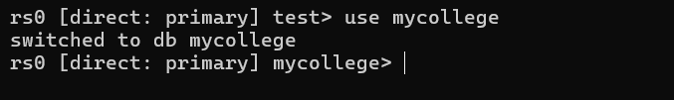

Check Current Database
Query 2
db
Output:
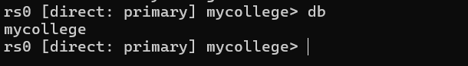

Create a Collection (Table Equivalent)
Query 3
db.createCollection("students")
Output:
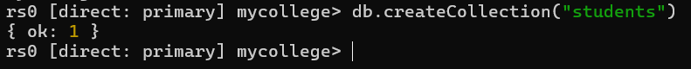

Insert Records (CREATE)
Query 4
db.students.insertMany([
{ roll: 1, name: "Rohan", age: 23, course: "MSc CS" },
{ roll: 2, name: "Shravani", age: 22, course: "BSc IT" },
{ roll: 3, name: "Meera", age: 24, course: "MCA" },
{ roll: 4, name: "Amit", age: 21, course: "BSc CS" },
{ roll: 5, name: "Neha", age: 25, course: "MBA" },
{ roll: 6, name: "Rohit", age: 23, course: "MSc Math" },
{ roll: 7, name: "Pooja", age: 22, course: "MCom" },
{ roll: 8, name: "Kiran", age: 24, course: "MSc CS" },
{ roll: 9, name: "Sahil", age: 21, course: "BCA" },
{ roll: 10, name: "Anjali", age: 23, course: "BSc IT" }
]);
Output:
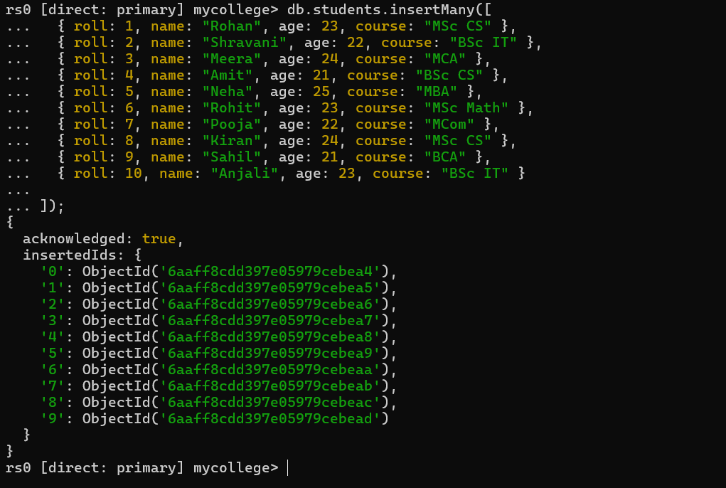

View All Databases
Query 5
show dbs
Output:
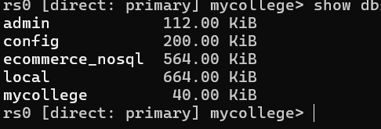

View Collections in Current DB
Query 6
show collections
Output:
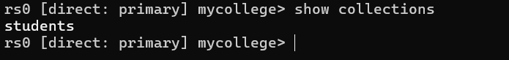

Read Data (READ) - [1] Show all
Query 7
db.students.find()
Output:
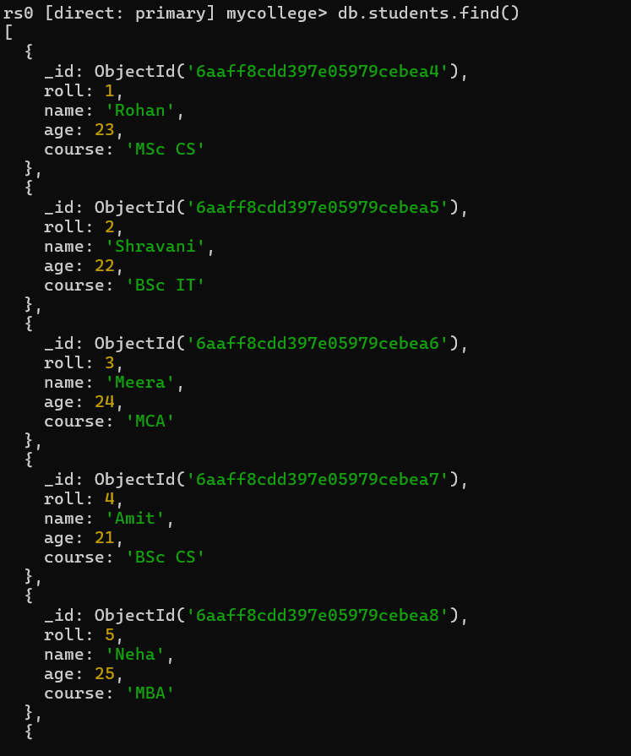

[2] Pretty format
Query 8
db.students.find().pretty()
Output:
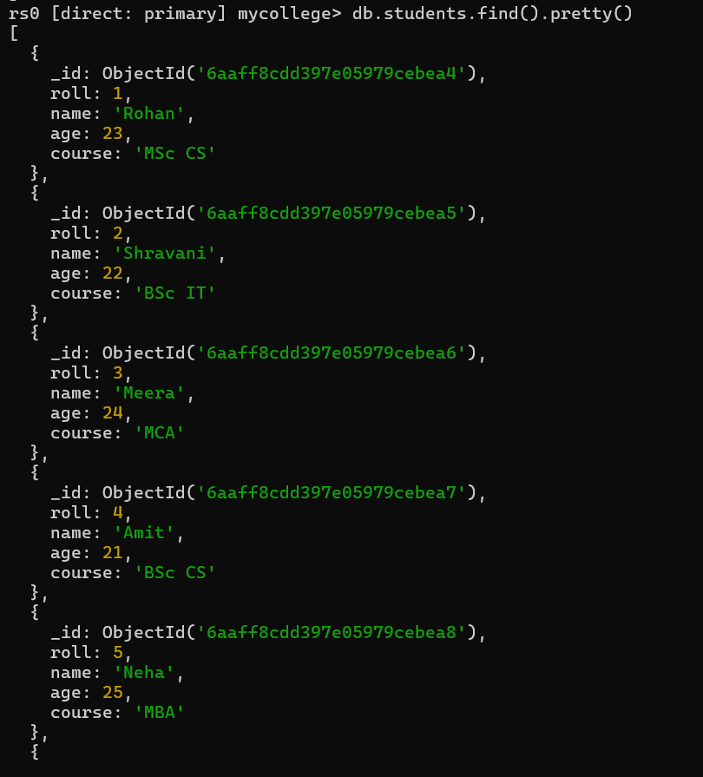

[3] Filter (age > 22)
Query 9
db.students.find({ age: { $gt: 22 } })
Output:
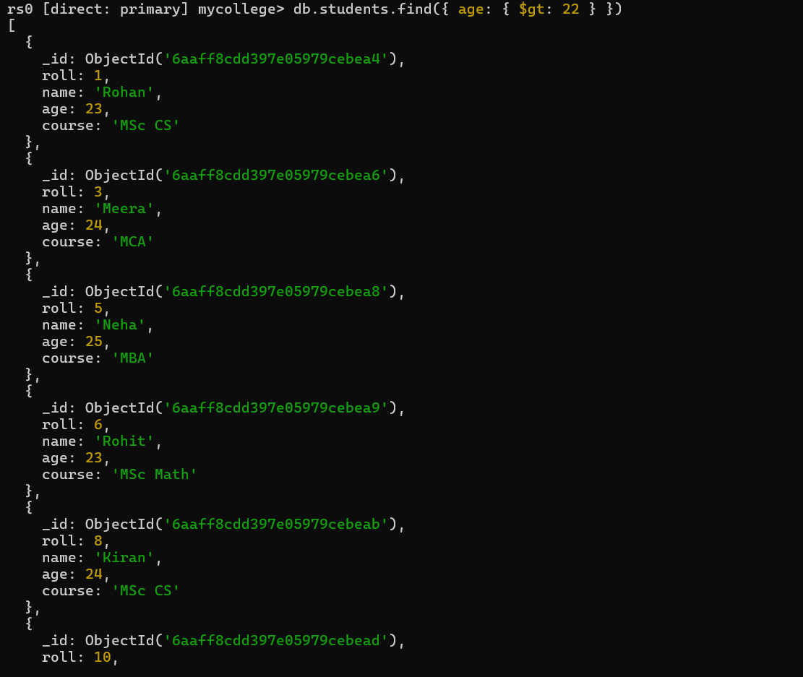

Update Data (UPDATE) - [1] Update single
Query 10
db.students.updateOne( { roll: 1 }, { $set: { course: "AI & ML" } } )
Output:
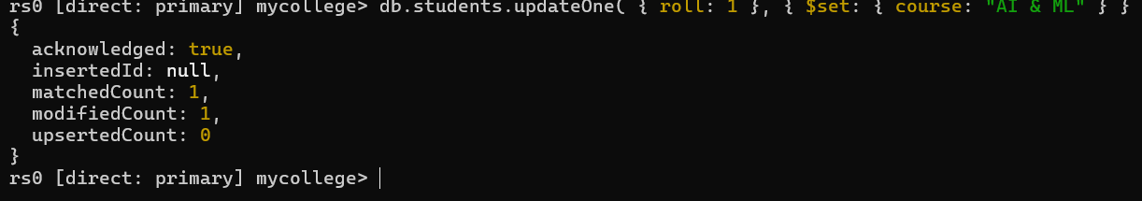

[2] Update multiple
Query 11
db.students.updateMany( { age: 22 }, { $set: { course: "Data Science" } } )
Output:
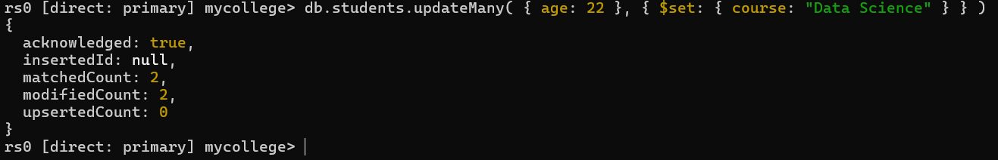

Delete Data (DELETE) - [1] Delete single
Query 12
db.students.deleteOne({ roll: 10 })
Output:

[2] Delete multiple
Query 13
db.students.deleteMany({ age: { $lt: 23 } })
Output:

Schema View (Describe Collection Equivalent)
Query 14
db.students.findOne()
Output:
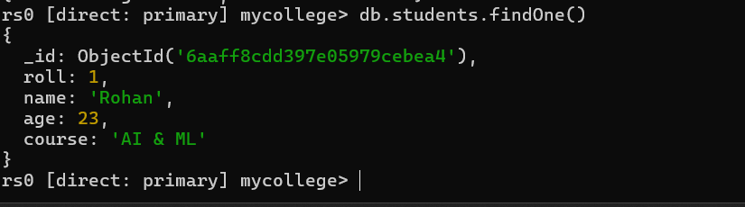

Alter Table Equivalent (Add New Field)
Query 15
db.students.updateMany( {}, { $set: { grade: "Pending" } } )
Output:
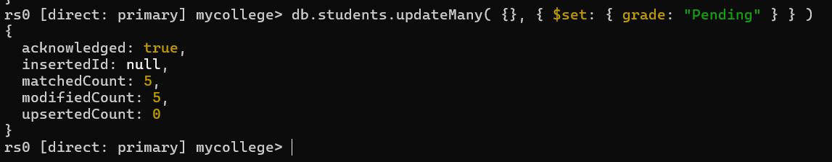

Drop Collection (Drop Table Equivalent)
Query 16
db.students.drop()
Output:
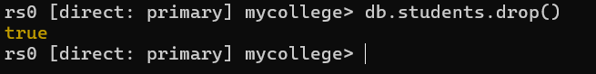

Drop Database
Query 17
db.dropDatabase()
Output:
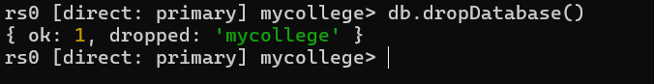

PRACTICAL NO. 4.2
Redis - CRUD Operations
Aim: Demonstrate the Accessing and Storing and performing CRUD operations in Redis.
Steps:
1. Open PowerShell as Administrator and install WSL (first time): wsl --install, then restart the PC.
2. Set the user account as "admin" or "admin1" and password "admin123". Then run: sudo apt update, sudo apt upgrade -y, sudo apt install wsl
3. If already installed, check with: wsl --list --verbose
4. If stopped, start with: wsl -d Ubuntu
5. Install Redis: sudo apt install redis-server -y
6. Start Redis server: sudo service redis-server start
7. Enter the Redis CLI: redis-cli

Test if Redis is running
Query 1
ping
Output:
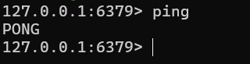

Redis has 16 databases (0-15). Default is 0
Query 2
SELECT 1
Output:
- 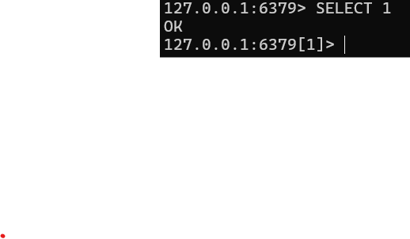

Create (SET) 10 records
Query 3
SET student:1 '{"name":"Mohan","age":20,"course":"CS"}'
SET student:2 '{"name":"Neha","age":21,"course":"IT"}'
SET student:3 '{"name":"Rahul","age":22,"course":"CS"}'
SET student:4 '{"name":"Sita","age":20,"course":"IT"}'
SET student:5 '{"name":"Amit","age":23,"course":"CS"}'
SET student:6 '{"name":"Priya","age":21,"course":"IT"}'
SET student:7 '{"name":"Rohan","age":22,"course":"CS"}'
SET student:8 '{"name":"Anita","age":23,"course":"IT"}'
SET student:9 '{"name":"Vikas","age":24,"course":"CS"}'
SET student:10 '{"name":"Tina","age":22,"course":"IT"}'
Output:
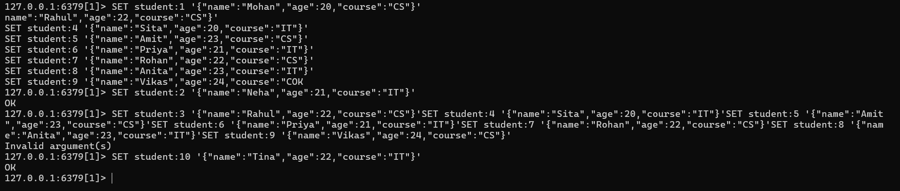

Read (GET) records
Query 4
GET student:1
Output:
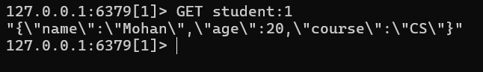

Query 5
GET student:5
Output:
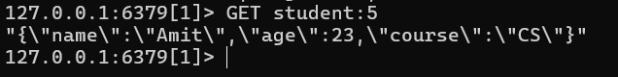

Update a record
Query 6
SET student:3 '{"name":"Rahul","age":23,"course":"CS"}'
Output:
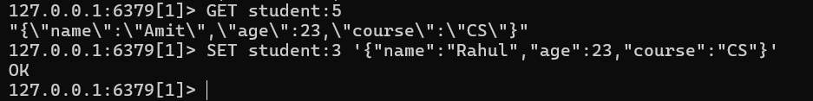

Check update
Query 7
GET student:3
Output:
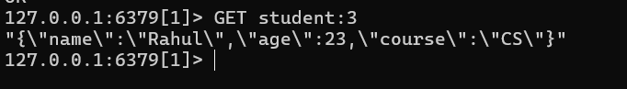

Delete a record
Query 8
DEL student:7
Output:
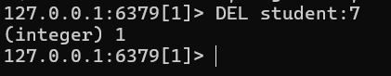

Check all keys
Query 9
KEYS *
Output:
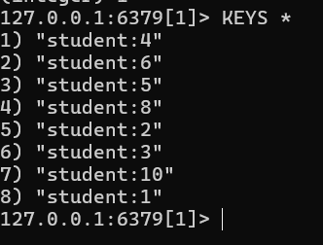

Delete all keys - Current DB only
Query 10
FLUSHDB
Output:
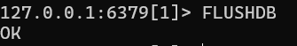

Delete all keys - All DBs
Query 11
FLUSHALL
Output:
[ Paste output screenshot here ]

PRACTICAL NO. 5
Temporal Database (PostGIS Spatial Queries)
Aim: Create a temporal database and issue queries on it.
Steps:
1. Open PowerShell as Administrator; first-time install: wsl --install (otherwise check: wsl --list --verbose; if stopped run: wsl -d Ubuntu)
2. Update packages: sudo apt update && sudo apt upgrade -y
3. Install Postgres-PostGIS: sudo apt install -y postgresql postgis
4. Start the server: sudo service postgresql start (check: sudo service postgresql status)
5. Switch to psql CLI: sudo -u postgres psql
6. Create the PostGIS user and database (queries below), then log in with: psql -U gisuser -d gisdb -h localhost
7. If an authentication error occurs, fix pg_hba.conf (sudo nano /etc/postgresql/16/main/pg_hba.conf) and restart: sudo service postgresql restart

Creation of DB and PostGIS user
Query 1
CREATE USER gisuser WITH PASSWORD 'gis_pass';
Output:
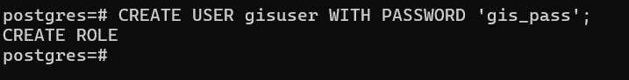

Query 2
CREATE DATABASE gisdb OWNER gisuser;
Output:
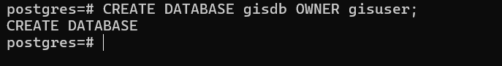

Query 3
\c gisdb
Output:
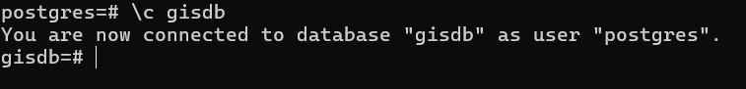

Query 4
CREATE EXTENSION postgis;
Output:
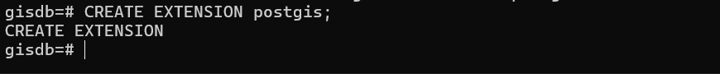

Create the table
Query 7
CREATE TABLE places ( id SERIAL PRIMARY KEY, name TEXT, geom GEOMETRY(Point, 4326) );
Output:

Insert the records
Query 8
INSERT INTO places (name, geom) VALUES
('Mumbai', ST_GeomFromText('POINT(72.8777 19.0760)', 4326)),
('Delhi', ST_GeomFromText('POINT(77.1025 28.7041)', 4326)),
('Bengaluru', ST_GeomFromText('POINT(77.5946 12.9716)', 4326)),
('Hyderabad', ST_GeomFromText('POINT(78.4867 17.3850)', 4326)),
('Chennai', ST_GeomFromText('POINT(80.2707 13.0827)', 4326)),
('Pune', ST_GeomFromText('POINT(73.8567 18.5204)', 4326)),
('Kolkata', ST_GeomFromText('POINT(88.3639 22.5726)', 4326)),
('Ahmedabad', ST_GeomFromText('POINT(72.5714 23.0225)', 4326)),
('Jaipur', ST_GeomFromText('POINT(75.7873 26.9124)', 4326)),
('Lucknow', ST_GeomFromText('POINT(80.9462 26.8467)', 4326));
Output:
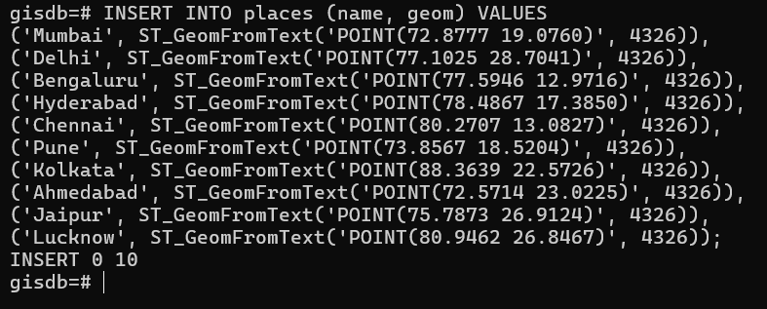

Read the data
Query 9
SELECT * FROM places;
Output:
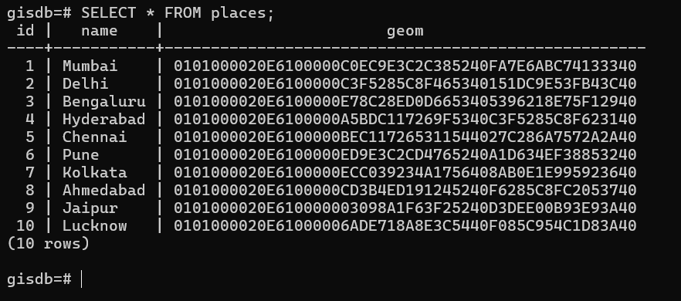

Queries on Spatial Data - [1] Distance between 2 cities (in meters)
Query 10
SELECT p1.name AS city1, p2.name AS city2, ST_Distance(p1.geom::geography, p2.geom::geography) AS distance_meters
FROM places p1, places p2 WHERE p1.name = 'Mumbai' AND p2.name = 'Pune';
Output:
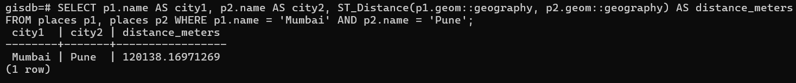

Find distance from Mumbai in KM
Query 11
SELECT name, ST_Distance( geom::geography, ST_SetSRID(ST_MakePoint(72.8777, 19.0760),4326)::geography ) / 1000 AS distance_km FROM places;
Output:
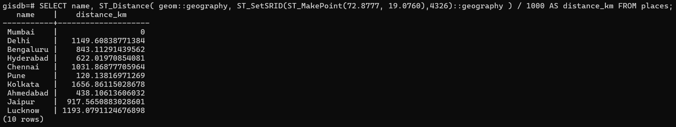

Cities within 100 km radius
Query 12
SELECT name FROM places WHERE ST_DWithin( geom::geography, ST_SetSRID(ST_MakePoint(72.8777,19.0760),4326)::geography, 100000 );
Output:

Polygon Query
Query 13
SELECT name FROM places WHERE ST_Intersects( geom, ST_GeomFromText( 'POLYGON((73.5 18.3, 74.2 18.3, 74.2 19.0, 73.5 19.0, 73.5 18.3))', 4326 ) );
Output:

[2] List of cities within a given range
Query 14
SELECT name FROM places WHERE ST_DWithin( geom::geography, ST_GeogFromText('SRID=4326;POINT(72.8777 19.0760)'), 300000 );
Output:

[3] Nearest city
Query 15
SELECT name, ST_Distance(geom::geography, ST_GeogFromText('SRID=4326;POINT(72.8777 19.0760)')) AS dist FROM places ORDER BY dist ASC LIMIT 1;
Output:

PRACTICAL NO. 6.1
HBase - CRUD Operations
Aim: Demonstrate the Accessing and Storing and performing CRUD operations in HBase.
Steps:
1. Install Docker Desktop for Windows from https://docs.docker.com/get-started/get-docker/ and complete sign-up/verification, then restart the system.
2. Open PowerShell as Administrator and start the HBase container: docker run -d --name hbase -p 2181:2181 -p 16010:16010 -p 9090:9090 harisekhon/hbase
3. Check the status: docker ps
4. Open the HBase shell: docker exec -it hbase hbase shell

Create db [namespace]
Query 1
create_namespace 'college'
Output:
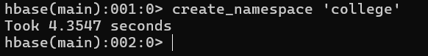

See all namespaces
Query 2
list_namespace
Output:
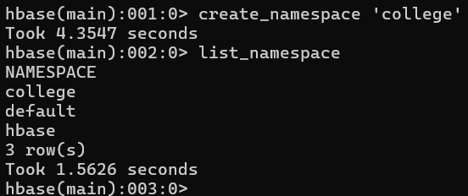

Change the namespace
Query 3
alter_namespace 'college', {METHOD => 'set', 'PROPERTY_NAME' => 'college'}
Output:

Create the table in college namespace [info & academic = column families]
Query 4
create 'college:students', 'info', 'academic'
Output:
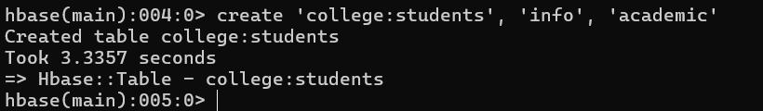

See the table
Query 5
list
Output:
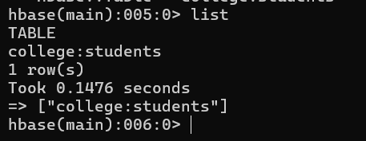

Insert the data in table
Query 6
put 'college:students', '1', 'info:name', 'Pranay'
put 'college:students', '1', 'info:gender', 'Male'
put 'college:students', '1', 'academic:course', 'MScCS'
put 'college:students', '1', 'academic:marks', '85'
put 'college:students', '2', 'info:name', 'Riya'
put 'college:students', '2', 'info:gender', 'Female'
put 'college:students', '2', 'academic:course', 'BScIT'
put 'college:students', '2', 'academic:marks', '78'
put 'college:students', '3', 'info:name', 'Amit'
put 'college:students', '3', 'info:gender', 'Male'
put 'college:students', '3', 'academic:course', 'BScCS'
put 'college:students', '3', 'academic:marks', '82'
put 'college:students', '4', 'info:name', 'Sneha'
put 'college:students', '4', 'info:gender', 'Female'
put 'college:students', '4', 'academic:course', 'MScIT'
put 'college:students', '4', 'academic:marks', '88'
put 'college:students', '5', 'info:name', 'Rohit'
put 'college:students', '5', 'info:gender', 'Male'
put 'college:students', '5', 'academic:course', 'BCom'
put 'college:students', '5', 'academic:marks', '75'
put 'college:students', '6', 'info:name', 'Kiran'
put 'college:students', '6', 'info:gender', 'Female'
put 'college:students', '6', 'academic:course', 'MCA'
put 'college:students', '6', 'academic:marks', '90'
put 'college:students', '7', 'info:name', 'Nikhil'
put 'college:students', '7', 'info:gender', 'Male'
put 'college:students', '7', 'academic:course', 'MBA'
put 'college:students', '7', 'academic:marks', '80'
put 'college:students', '8', 'info:name', 'Pooja'
put 'college:students', '8', 'info:gender', 'Female'
put 'college:students', '8', 'academic:course', 'MScCS'
put 'college:students', '8', 'academic:marks', '92'
put 'college:students', '9', 'info:name', 'Raj'
put 'college:students', '9', 'info:gender', 'Male'
put 'college:students', '9', 'academic:course', 'BScIT'
put 'college:students', '9', 'academic:marks', '70'
put 'college:students', '10', 'info:name', 'Asha'
put 'college:students', '10', 'info:gender', 'Female'
put 'college:students', '10', 'academic:course', 'MCom'
put 'college:students', '10', 'academic:marks', '88'
Output:
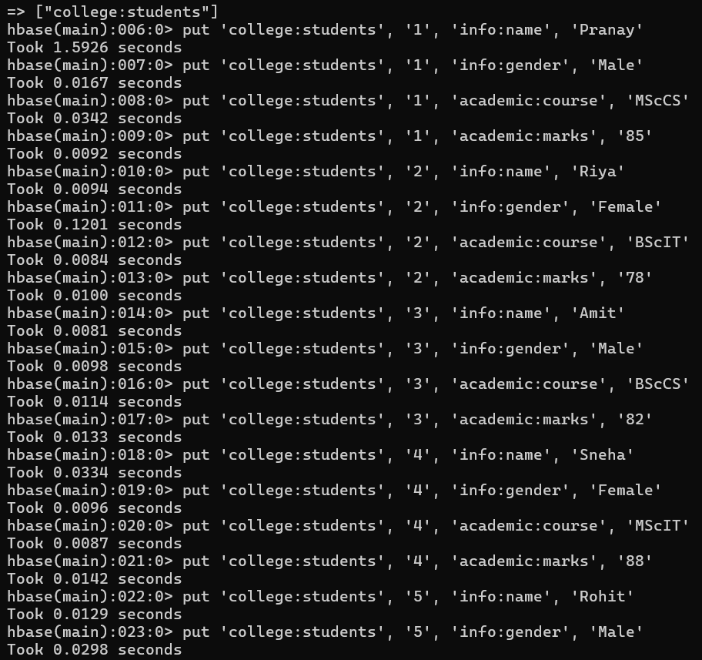
To see all rows
Query 7
scan 'college:students'
Output:
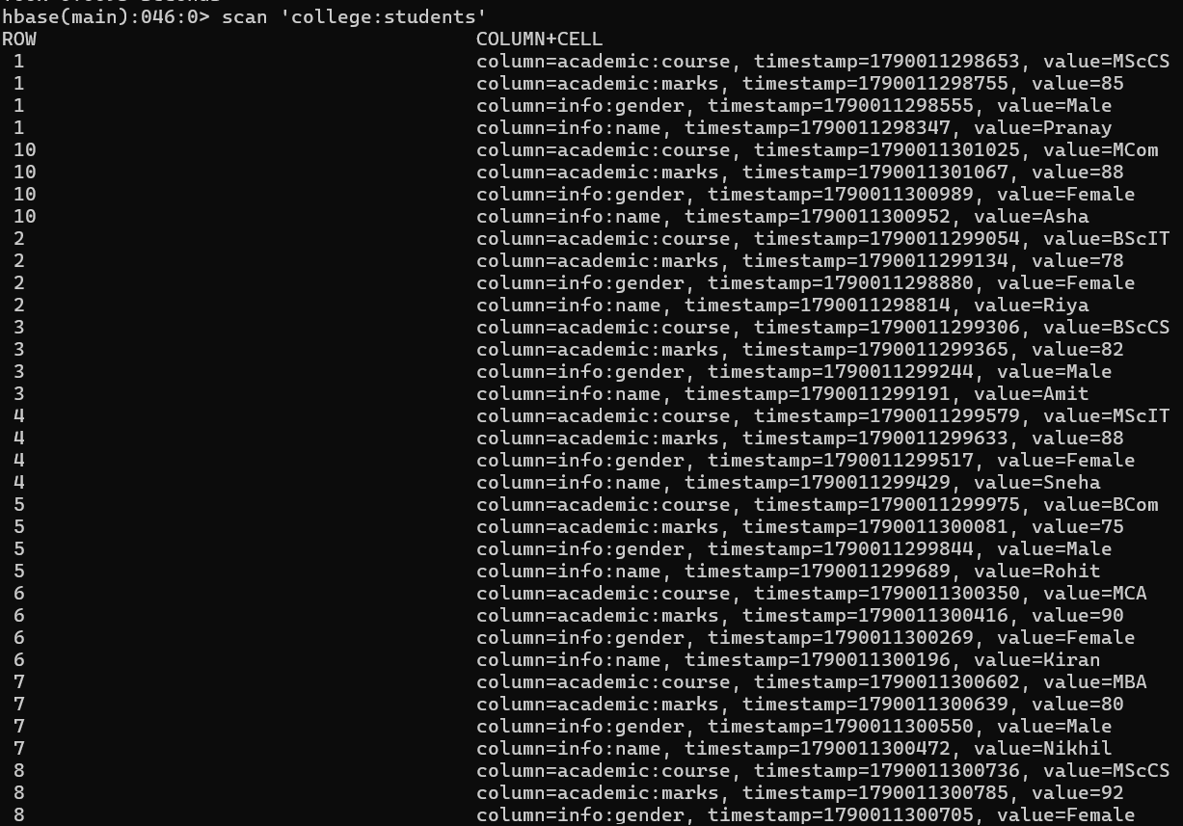

To get specific row
Query 8
get 'college:students', '3'
Output:
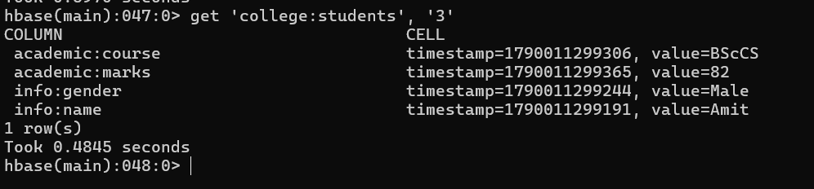

To get specific column
Query 9
get 'college:students', '3', 'academic:course'
Output:
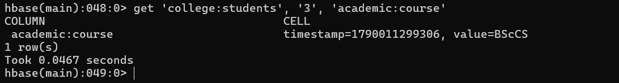

Update
Query 10
put 'college:students', '3', 'academic:marks', '89'
Output:

Delete
Query 11
delete 'college:students', '5', 'academic:marks'
Output:
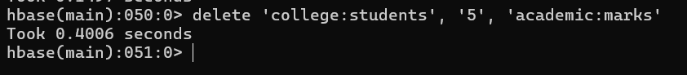

To delete whole row
Query 12
deleteall 'college:students', '5'
Output:

Alter table - [1] add new column family
Query 13
alter 'college:students', 'personal'
Output:
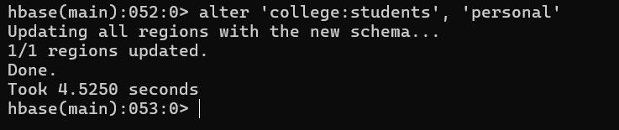

[2] to see all column families
Query 14
alter 'college:students', 'personal'
Output:
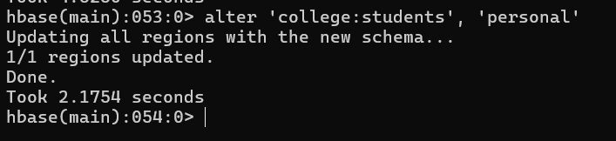

[3] to delete column family
Query 15
alter 'college:students', {NAME => 'personal', METHOD => 'delete'}
Output:
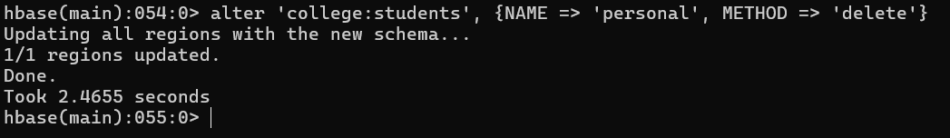

To disable and delete the table
Query 16
disable 'college:students'
Output:
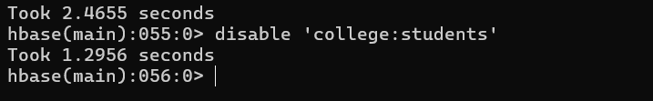

Query 17
drop 'college:students'
Output:
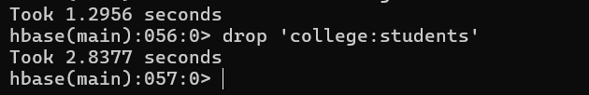

To exit from HBase shell
Query 18
exit
Output:

PRACTICAL NO. 6.2
Apache Cassandra - CRUD Operations
Aim: Demonstrate the Accessing and Storing and performing CRUD operations in Apache Cassandra.
Steps:
1. Install Docker Desktop (as in Practical 6.1) and restart the system.
2. Open PowerShell as Administrator and start the Cassandra container: docker run -d --name cassandra -p 9042:9042 cassandra
3. Check the status: docker ps
4. Open the CQL shell: docker exec -it cassandra cqlsh

Create keyspace
Query 1
CREATE KEYSPACE mydb WITH replication = {'class':'SimpleStrategy', 'replication_factor':1};
Output:
[ Paste output screenshot here ]

Query 2
USE mydb;
Output:
[ Paste output screenshot here ]

Creation of table
Query 3
CREATE TABLE students ( id int PRIMARY KEY, name text, age int, grade text, city text );
Output:
[ Paste output screenshot here ]

Select Queries
Query 4
SELECT * FROM students;
Output:
[ Paste output screenshot here ]

Specific columns
Query 5
SELECT name, grade FROM students;
Output:
[ Paste output screenshot here ]

Using WHERE filter
Query 6
SELECT * FROM students WHERE id = 3;
Output:
[ Paste output screenshot here ]

Using ALLOW FILTERING
Query 7
SELECT * FROM students WHERE grade = 'A' ALLOW FILTERING;
Output:
[ Paste output screenshot here ]

Update, Delete and Count Queries
Query 8
UPDATE students SET city = 'Bangalore' WHERE id = 2;
Output:
[ Paste output screenshot here ]

Query 9
DELETE city FROM students WHERE id = 8;
Output:
[ Paste output screenshot here ]

Query 10
DELETE FROM students WHERE id = 4;
Output:
[ Paste output screenshot here ]

Query 11
SELECT COUNT(*) FROM students;
Output:
[ Paste output screenshot here ]

Alter Table
Query 12
ALTER TABLE students ADD email text;
Output:
[ Paste output screenshot here ]

Query 13
ALTER TABLE students DROP email;
Output:
[ Paste output screenshot here ]

Truncate (all data deletion only)
Query 14
TRUNCATE students;
Output:
[ Paste output screenshot here ]

Table delete
Query 15
DROP TABLE students;
Output:
[ Paste output screenshot here ]

Keyspace delete
Query 16
DROP KEYSPACE mydb;
Output:
[ Paste output screenshot here ]

Exit from shell
Query 17
exit;
Output:
[ Paste output screenshot here ]

PRACTICAL NO. 7
MapReduce Functions (MongoDB)
Aim: Demonstrating MapReduce in MongoDB to count the number of female (F) and male (M) respondents in the database.
Steps:
1. Download MongoDB Community Server and Mongosh if not already downloaded (refer to Practical 4.1).
2. Open PowerShell and run: mongosh

Create and Switch DB
Query 1
use surveyDB
Output:
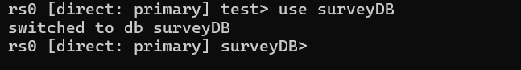

Insert Respondents Data
Query 2
db.respondents.insertMany ([
{ name: "Aarav", gender: "M", city: "Mumbai" },
{ name: "Simran", gender: "F", city: "Delhi" },
{ name: "Rohit", gender: "M", city: "Delhi" },
{ name: "Neha", gender: "F", city: "Pune" },
{ name: "Kiran", gender: "M", city: "Pune" },
{ name: "Pooja", gender: "F", city: "Mumbai" },
{ name: "Rahul", gender: "M", city: "Mumbai" },
{ name: "Aisha", gender: "F", city: "Mumbai" },
{ name: "Vikas", gender: "M", city: "Delhi" },
{ name: "Meena", gender: "F", city: "Delhi" },
{ name: "Suresh", gender: "M", city: "Pune" },
{ name: "Sneha", gender: "F", city: "Pune" },
{ name: "Aditya", gender: "M", city: "Nagpur" },
{ name: "Priya", gender: "F", city: "Nagpur" },
{ name: "Manoj", gender: "M", city: "Pune" },
{ name: "Riya", gender: "F", city: "Delhi" },
{ name: "Amit", gender: "M", city: "Mumbai" },
{ name: "Shreya", gender: "F", city: "Pune" }
])
Output:
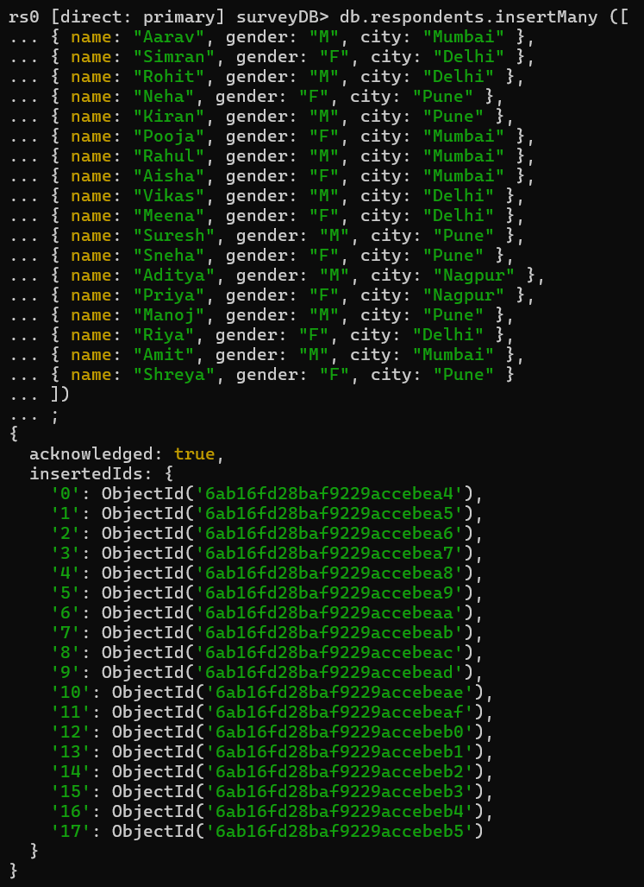

Verify the Data
Query 3
db.respondents.find().limit(5).pretty()
Output:
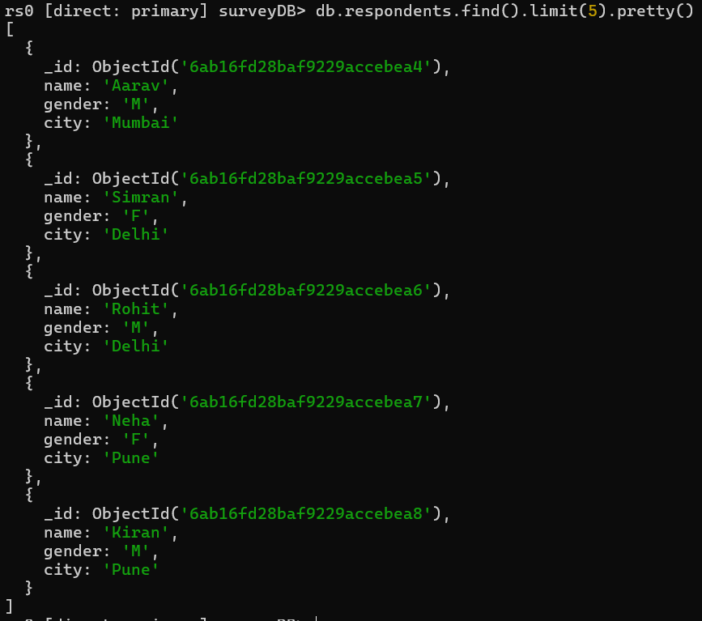

Write Map Function
Query 4
var mapFunction = function() { emit({ city: this.city, gender: this.gender }, 1); };
Output:

Write Reduce Function
Query 5
var reduceFunction = function(key, values) { return Array.sum(values); };
Output:

MapReduce Operation
Query 6
db.respondents.mapReduce( mapFunction, reduceFunction, { out: "city_gender_count" } )
Output:
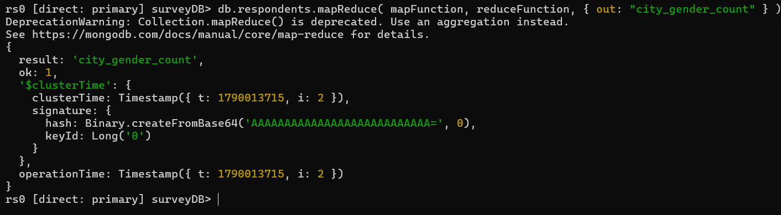

View the Output collection
Query 7
db.city_gender_count.find().pretty()
Output:
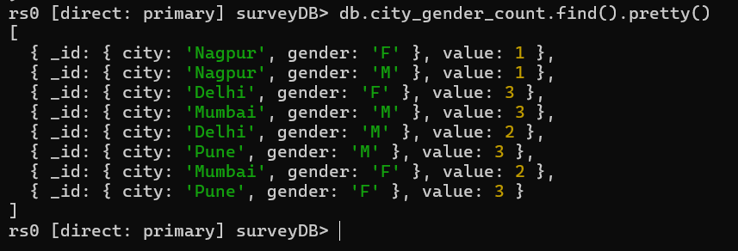

PRACTICAL NO. 8.1
Indexing and Ordering Operations (MongoDB)
Aim: Demonstrate the indexing and ordering operations in MongoDB.
Steps:
1. Open Docker and check that it is running.
2. Open PowerShell as Administrator and start MongoDB: docker run -d --name mongoDB -p 27017:27017 mongo
3. Open the shell: docker exec -it mongoDB mongosh

Create and Switch Database
Query 1
use companyDB
Output:
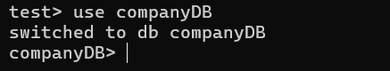

Create Collection and Insert Records
Query 2
db.employees.insertMany([
{ emp_id: 101, name: "Aarav", age: 25, department: "IT", salary: 60000 },
{ emp_id: 102, name: "Simran", age: 30, department: "HR", salary: 55000 },
{ emp_id: 103, name: "Karan", age: 28, department: "Finance", salary: 65000 },
{ emp_id: 104, name: "Riya", age: 26, department: "IT", salary: 70000 },
{ emp_id: 105, name: "Vikram", age: 35, department: "Admin", salary: 50000 },
{ emp_id: 106, name: "Neha", age: 27, department: "Finance", salary: 72000 },
{ emp_id: 107, name: "Raj", age: 24, department: "IT", salary: 61000 },
{ emp_id: 108, name: "Anjali", age: 29, department: "HR", salary: 58000 },
{ emp_id: 109, name: "Pratik", age: 31, department: "Finance", salary: 67000 },
{ emp_id: 110, name: "Meera", age: 33, department: "Admin", salary: 53000 }
])
Output:
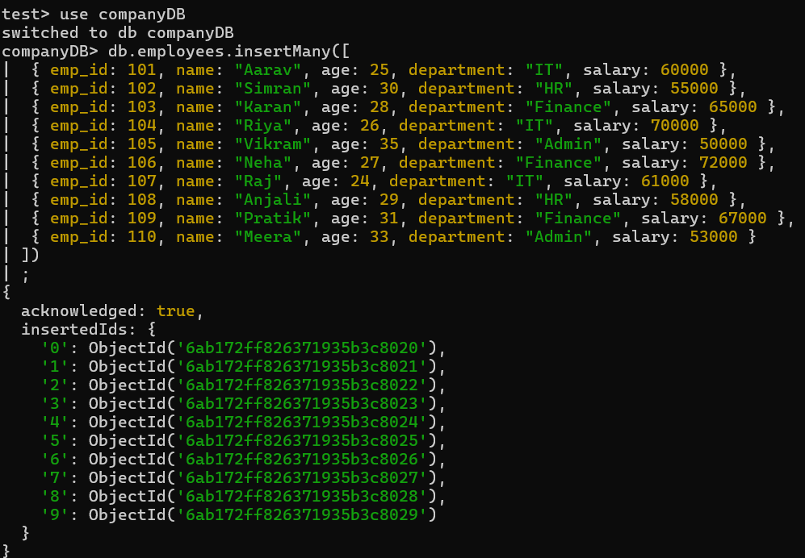

Display All Records
Query 3
db.employees.find().pretty()
Output:
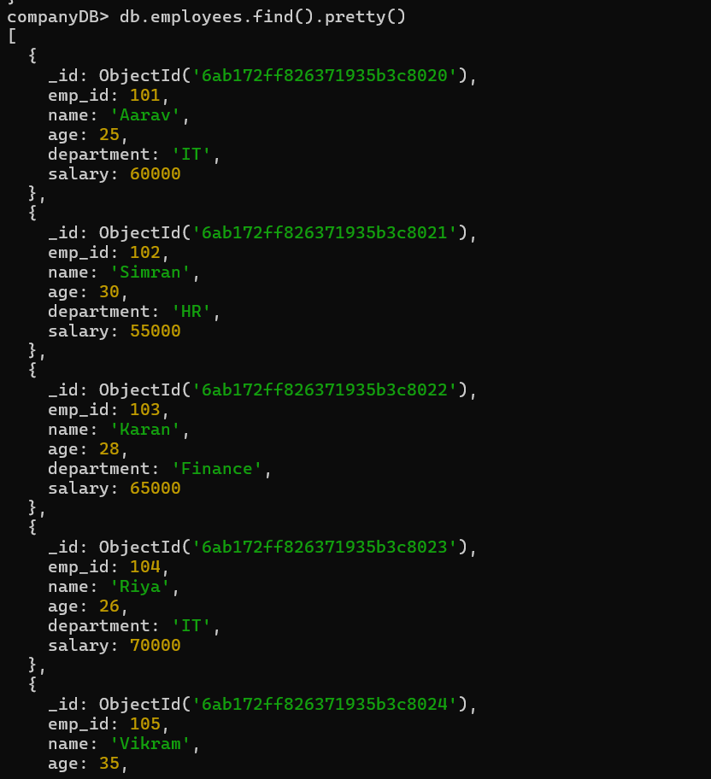

Create Index on Salary
Query 4
db.employees.createIndex({ salary: 1 })
Output:

View Existing Indexes
Query 5
db.employees.getIndexes()
Output:
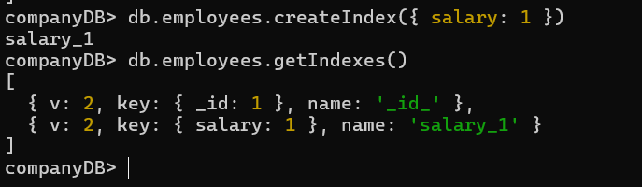

Ordering (Sorting) - [1] Ascending Order (Lowest to Highest Salary)
Query 6
db.employees.find().sort({ salary: 1 })
Output:
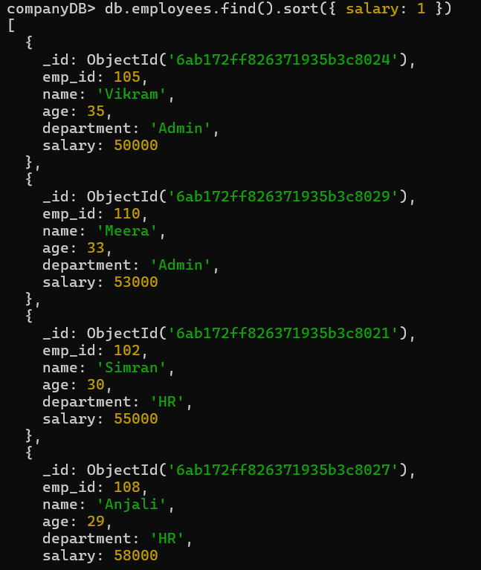

[2] Descending Order (Highest to Lowest Salary)
Query 7
db.employees.find().sort({ salary: -1 })
Output:
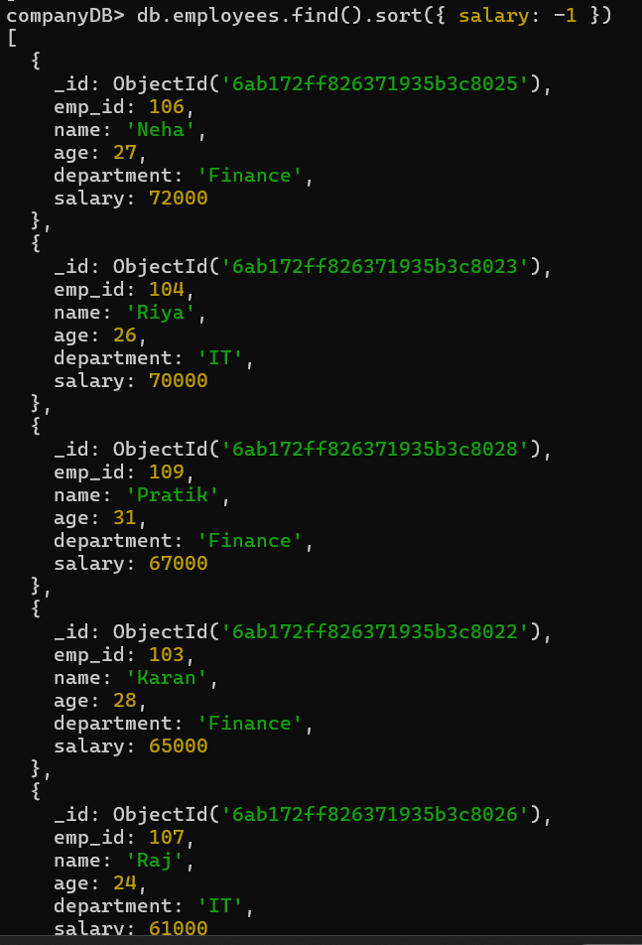

Create Compound Index (Multiple Fields)
Query 8
db.employees.createIndex({ department: 1, salary: -1 })
Output:

Check Again
Query 9
db.employees.getIndexes()
Output:
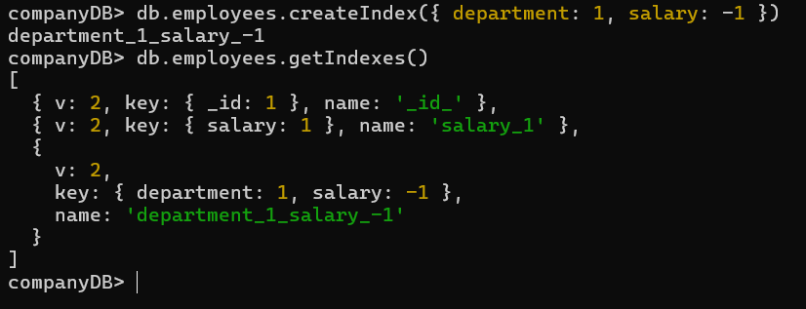

Query Using Index
Query 10
db.employees.find({ department: "IT" }).sort({ salary: -1 })
Output:
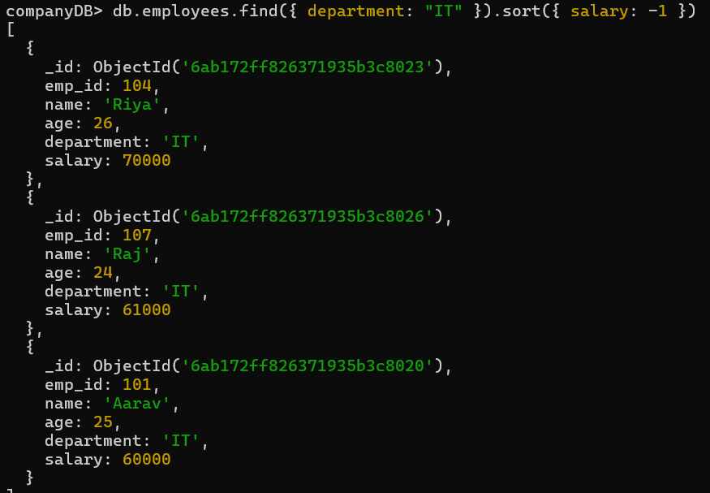

Drop Index
Query 11
db.employees.dropIndex("salary_1")
Output:
