DDL:

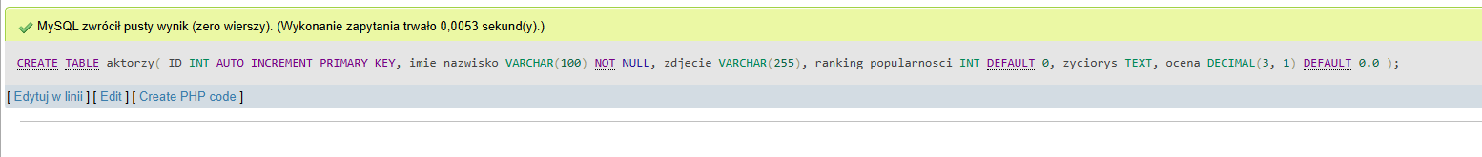



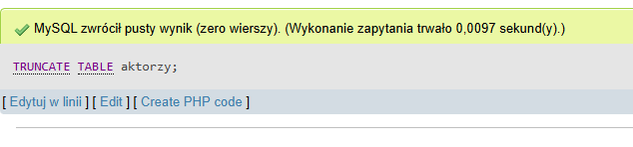

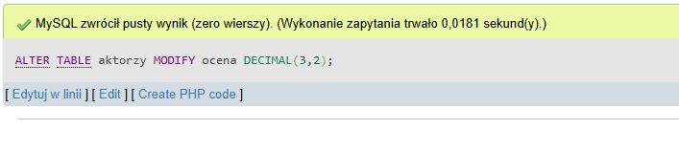

DML: 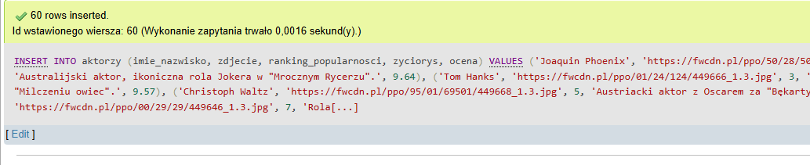

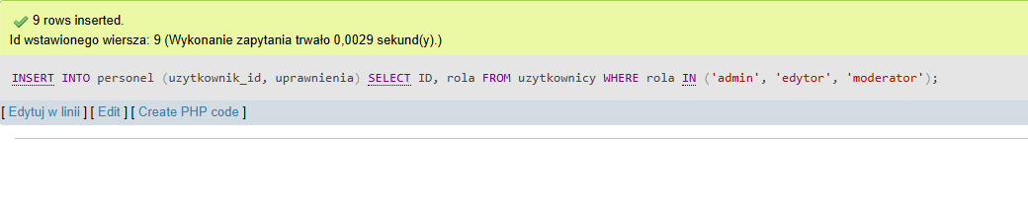



DCL:



