Part A:
1. Create a new React Native project named MyFirstApp. Display:
• A text message(e.g., “Welcome to My React Native App”).
• A picture (local or from the web).
• A button that, when pressed, changes a text message on the screen.
Use a consistent and readable layout and colour scheme.
Bonus Task
Add a simple TextInput where users can enter their name and display a personalized greeting.
import React, { useState } from 'react';
import { View, Text, Image, Button, TextInput, StyleSheet, SafeAreaView } from 'react-native';
import Constants from 'expo-constants';
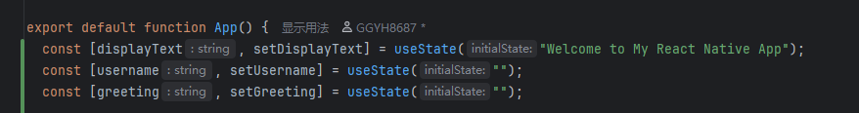
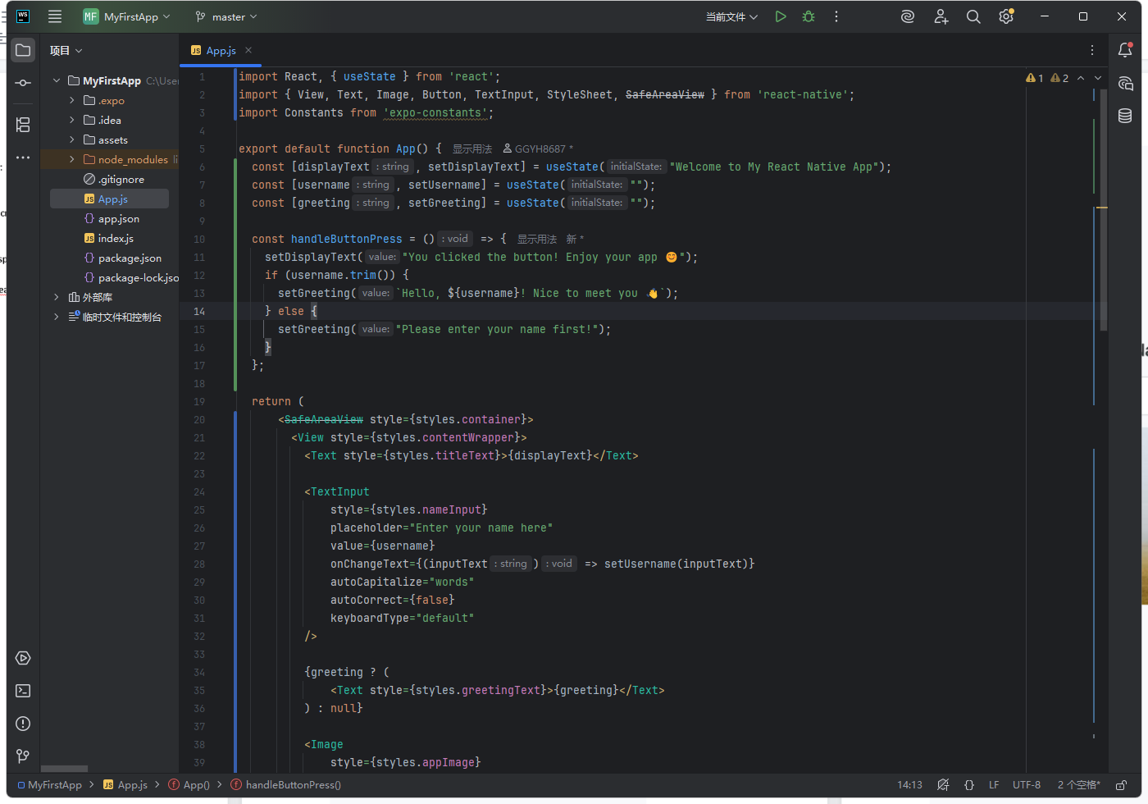
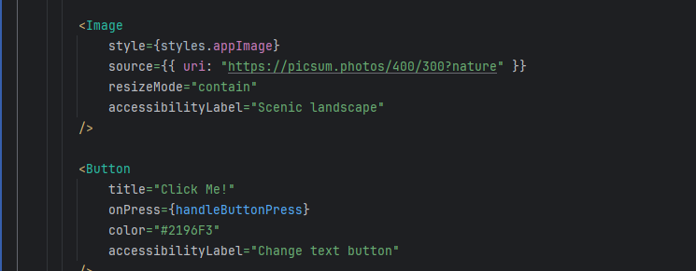
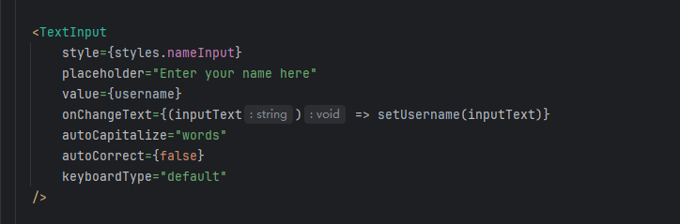
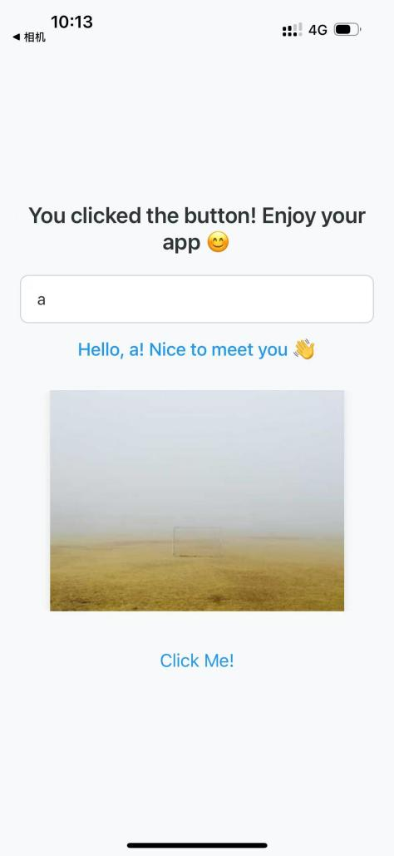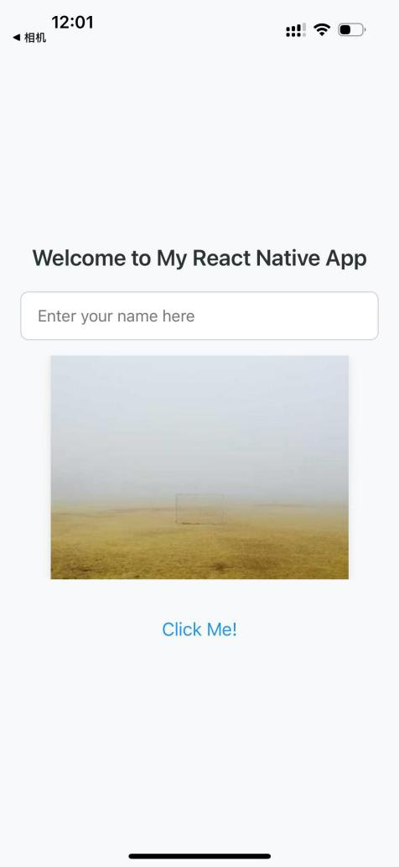
Part B:
Complete the following tasks using Example Code 1 (Red-Note project) from Moodle.
1. Modify the displayed text “Xiaohongshu style practice”: 1) change it to “CS385FZ Practical
Project – Xiaohongshu_v1”, 2) change the text colour from black to red (#FF0000).
2. The header title “Index” appears in the header bar of the screen, change the title from “Index” to
“Welcome” and align in the centre.
Hint: the title can be modified by updating the <Stack.Screen> component in the _layout.tsx file.
3. Make each post clickable so that when the user taps on an image, the app navigates to a detail
page showing the full post.
Hints:
• TouchableOpacity turns any React Native component into a pressable element with a
built-in fade animation. It’s ideal for wrapping images or views that should respond to
user taps.
• Use the asChild prop in Link to combine it cleanly with touchable components.
4. Replace the images of the posts with ones that match the content of each post.
Hint: You can find suitable images on the Internet, save them in the assets folder, and then
update the image property in the posts.ts file accordingly.

- Enable click support for images.
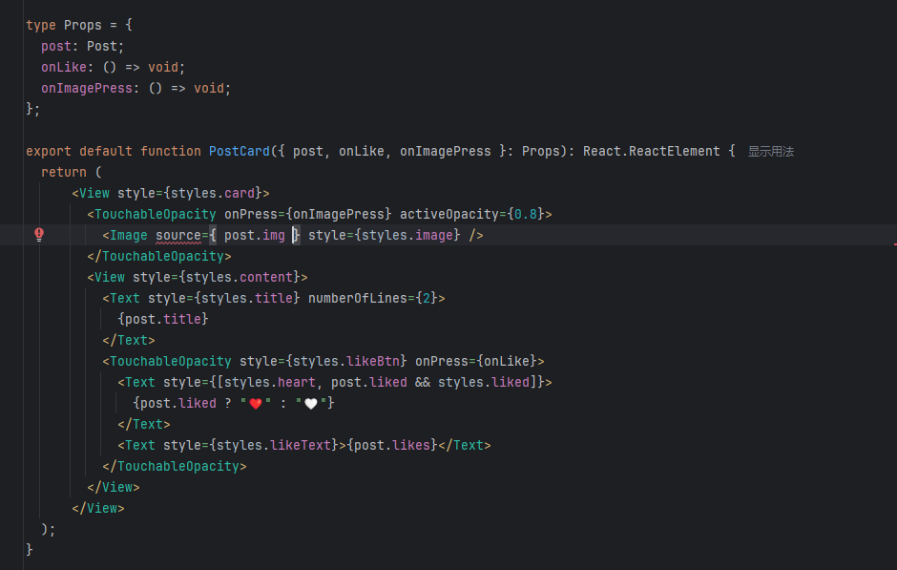
- Pass the jump logic
