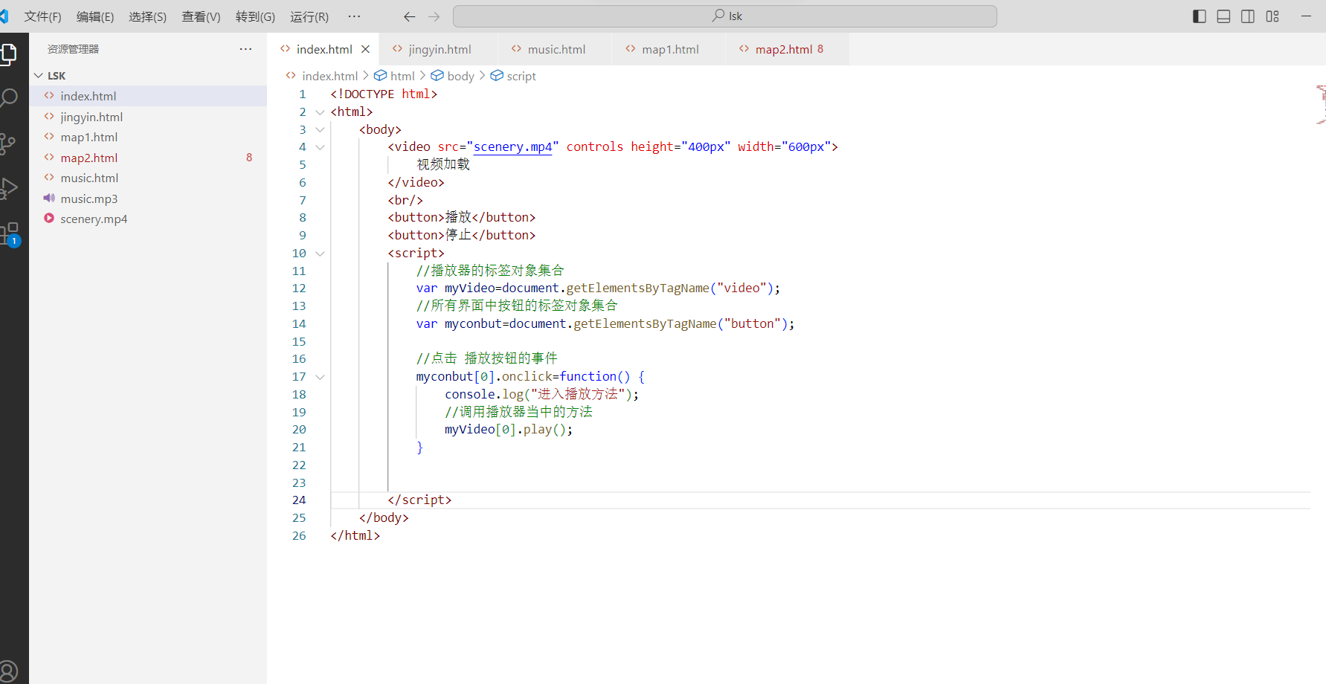

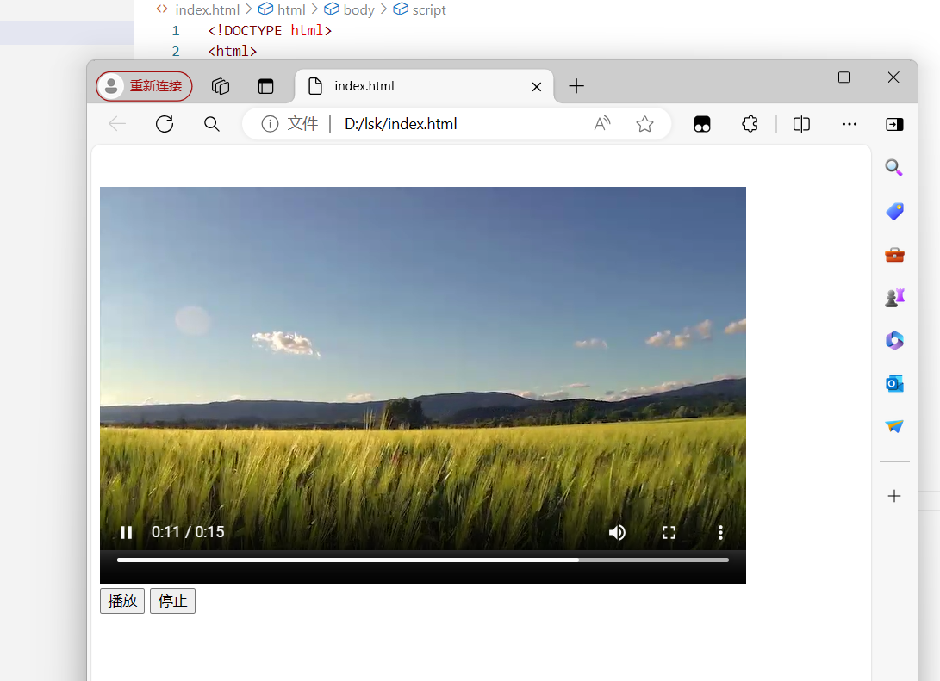

<!DOCTYPE html>

<html>

<body>

<video src="scenery.mp4" controls height="400px" width="600px">

视频加载

</video>

<br/>

<button>播放</button>

<button>停止</button>

<script>

//播放器的标签对象集合

var myVideo=document.getElementsByTagName("video");

//所有界面中按钮的标签对象集合

var myconbut=document.getElementsByTagName("button");

//点击 播放按钮的事件

myconbut[0].onclick=function() {

console.log("进入播放方法");

//调用播放器当中的方法

myVideo[0].play();

}

</script>

</body>

</html>

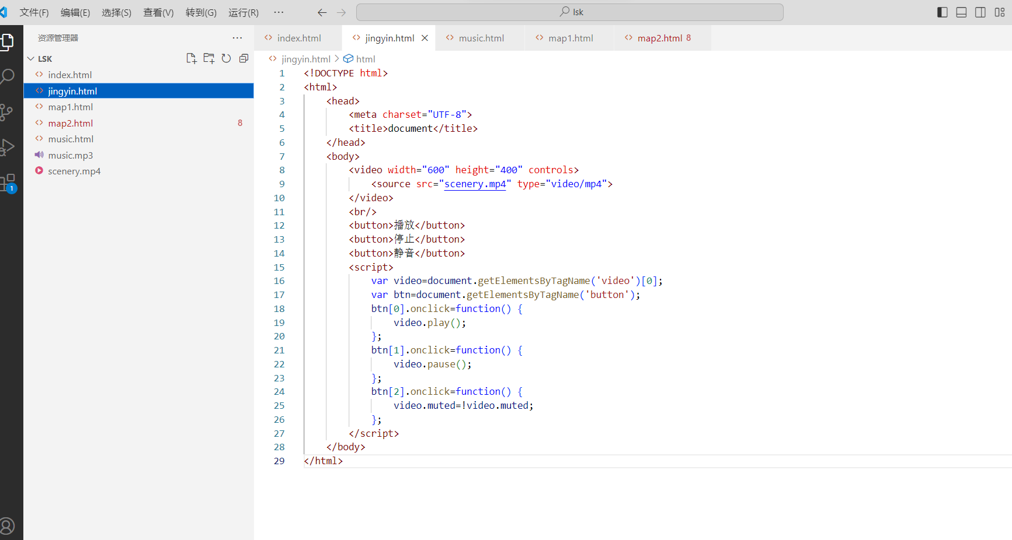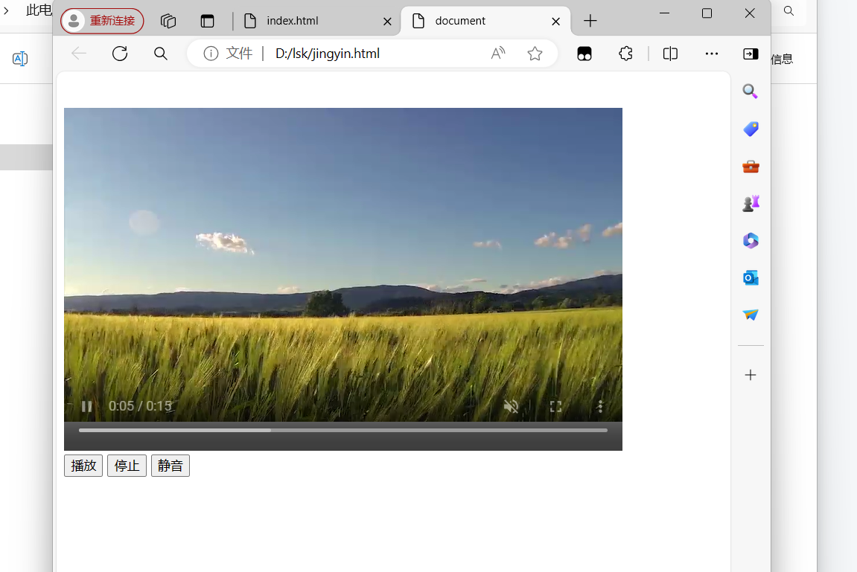

<!DOCTYPE html>

<html>

<head>

<meta charset="UTF-8">

<title>document</title>

</head>

<body>

<video width="600" height="400" controls>

<source src="scenery.mp4" type="video/mp4">

</video>

<br/>

<button>播放</button>

<button>停止</button>

<button>静音</button>

<script>

var video=document.getElementsByTagName('video')[0];

var btn=document.getElementsByTagName('button');

btn[0].onclick=function() {

video.play();

};

btn[1].onclick=function() {

video.pause();

};

btn[2].onclick=function() {

video.muted=!video.muted;

};

</script>

</body>

</html>

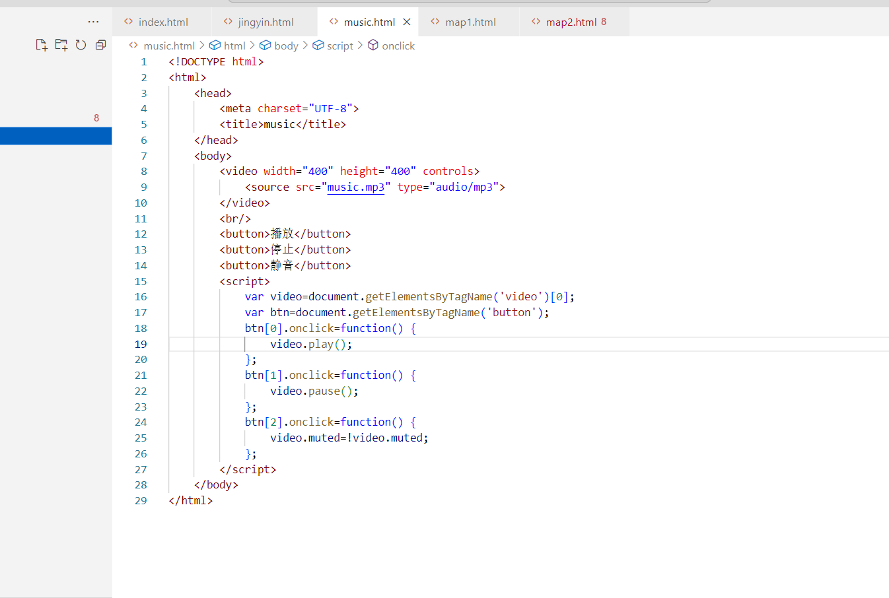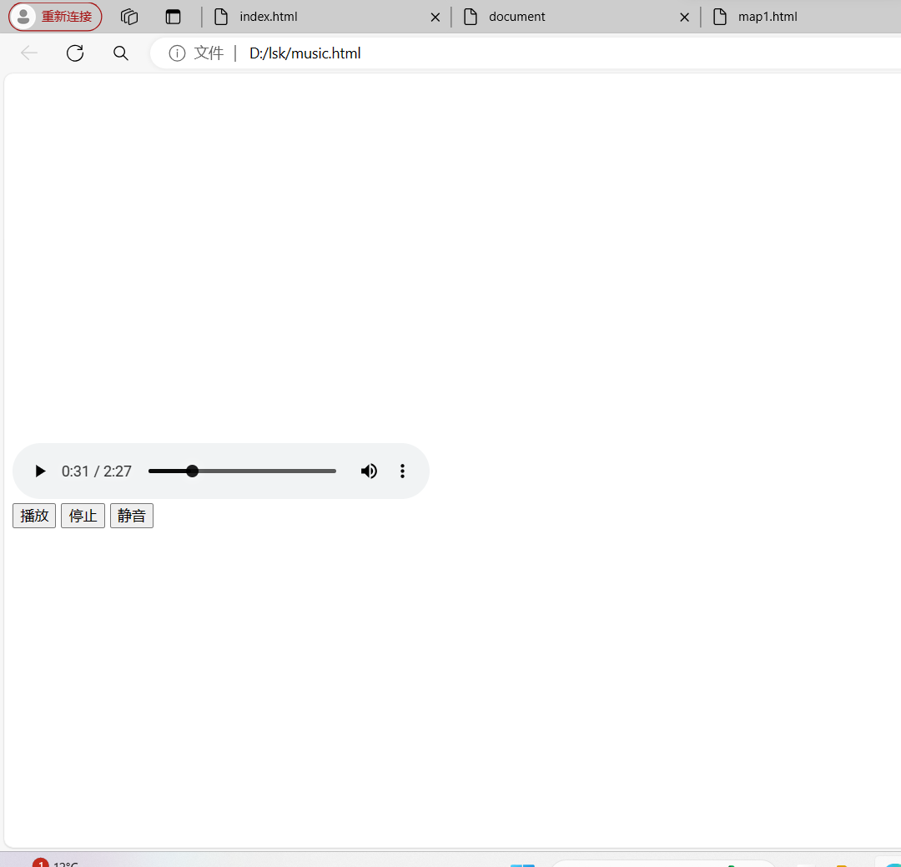

<!DOCTYPE html>

<html>

<head>

<meta charset="UTF-8">

<title>music</title>

</head>

<body>

<video width="400" height="400" controls>

<source src="music.mp3" type="audio/mp3">

</video>

<br/>

<button>播放</button>

<button>停止</button>

<button>静音</button>

<script>

var video=document.getElementsByTagName('video')[0];

var btn=document.getElementsByTagName('button');

btn[0].onclick=function() {

video.play();

};

btn[1].onclick=function() {

video.pause();

};

btn[2].onclick=function() {

video.muted=!video.muted;

};

</script>

</body>

</html>